Raising a Sales Invoice in SIPS

After logging on to SIPS, you will see the following home screen

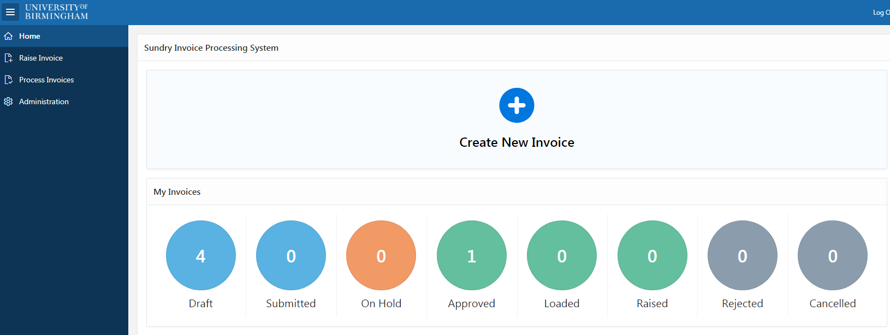

- Draft will show invoices you have started but not completed or submitted for approval
- Submitted shows invoices submitted but not yet approved
- On Hold shows invoices that are in query during approval
- Approved are those which have been submitted and approved by the invoicing team and are awaiting upload to Fusion
- Loaded shows those which have been approved and successfully loaded to Fusion
- Raised shows forms which have loaded to Fusion and have been sent to the customer
- Rejected shows invoice requests that were rejected by the invoicing team at approval stage
- Cancelled shows invoices that were raised and later cancelled

- Click on “Create New Invoice” at the top of the page

You can also click on “Raise Invoice” in the left hand tool bar. This brings you to a page with all invoices that you have raised and from here you can view the status, edit, or use “Create new invoice” in the top right hand corner.

The mandatory fields have a red asterisk next to the title

  - The first four boxes (light grey) cannot be edited:
    - Unique “ID” for the invoice (automatically generated, and required when contacting the invoicing team with queries after submission). The invoice type
    - “Type” - This will always default to “Invoice”
    - “Status” – Shows the current status of the invoice, to help you identify which stage it is at
    - “Payment Term” – When payment is due - Automatically generated for invoice type.
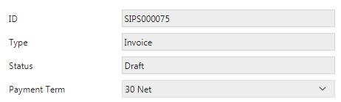

  - “Business Unit” – Select the appropriate Business Unit from dropdown menu.
For University invoicing select “UOB Business Unit”
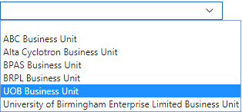

  - “Currency Code” – Select Invoice currency from dropdown list

  - “Customer” – Click on “search dialogue” button, to right of text box

Type part or all of customer name into the dialogue box and press search, which will show all matching options.

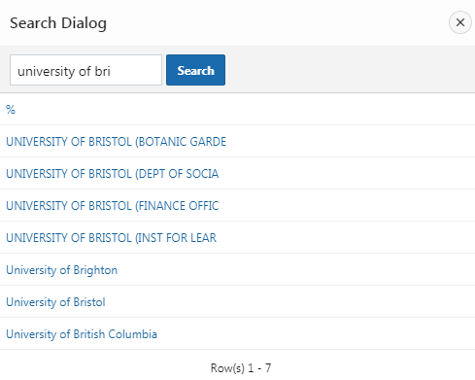
Click on your required company. If it does not exist then a new company will need to be set up in Fusion by the invoicing team, via the new company request form. Please refer to the finance intranet page for details.

  - “PO Number” – This is now a required field and a valid Purchase Order number must be entered. If you do not have the PO number you will need to contact the company for this.

  - “FAO” – Populate only if the invoice is to be flagged for the attention of a particular person at the customer address

  - “Billing Site” – Select from dropdown where the invoice will be addressed to

  - “Delivery Site” – Select from dropdown the delivery site of goods/services provided, if different.
If new addresses need to be added to either the billing or delivery site then you will need to request this to be added by the invoicing team, via the new site request form
  - “Special Requests / Comments” can be populated if you wish to add any additional information to the invoice

Please populate this field when an invoice needs to be raised via Portal (such as Coupa or Tungsten) and explicitly state that the invoice needs to be raised by portal. When authorisation is carried out by the Invoicing team they will see this note and action accordingly.
- You will now need to add the invoice line(s)

There are two options for this, you can either “add line”, or “add memo line”. The memo line will quick fill the account code based on the selection you have made from the first drop down. If you raise a particular invoice often then this quick selection will make it easier by auto populating the account details.
If you are raising a particular invoice on a regular basis please contact the invoicing team to add memo line details to the system – your request must include a description, explaining how often it is used, and the account code that is needed.
The remaining boxes under memo lines (quantity, unit price and tax code) are addressed below under “add line”.
The majority of invoices will create a completely new line, as follows.
- Click on “Add line”, which becomes available when mandatory fields have been completed.
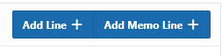
  - “Description” – Line description of goods/services

  - “Quantity” – Quantity of goods/services provided

  - “Unit Price” – Amount per individual unit

  - “Tax Code” – Select the relevant tax code from the drop down. Please query with your finance team, account person or taxperson for guidance if unsure.

  - “Account code”
    - Click on search box to right of text box:

    - The following screen will open
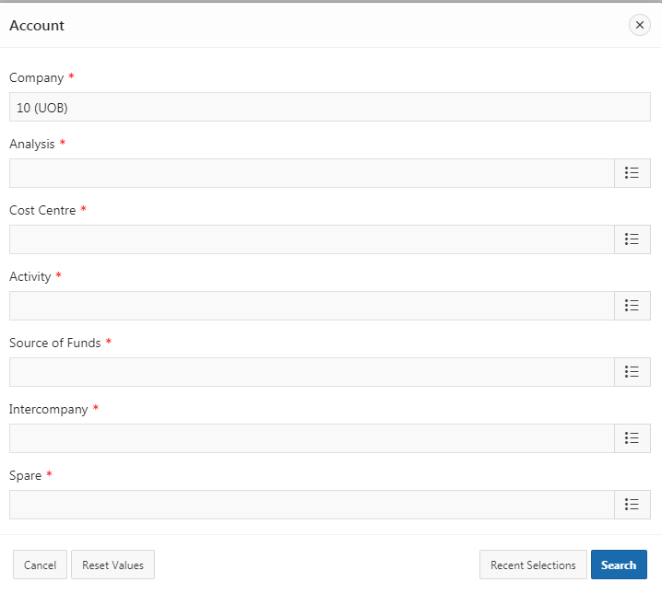
    - Click on the search symbol for each row 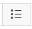 to view all applicable codes for that element of the account code

    - If you are unsure which selection to use next, you can press the “search” button at the bottom right hand of the page after each selection, which will show all available valid account codes based on the information already entered.

    - If you are invoicing for the same account as previously used, you can also use the “Recent Selections” button. This is found next to the search button, and will show the most recent accounts codes you have used.

    - When the selection has been made, or all lines have been completed, click on “search”.

    - You should have one account code visible. Click on select.

    - This will open a new screen to confirm the details are correct. Click “OK” to proceed.

    - This will add the account code take you back to the “Line Item” screen

    - The “VAT Inclusive” Box will default as “No”. This will not usually need to be changed, but can be if the price shown includes VAT. If you change this, a pop up will ask you to alert you of the change before proceeding.

    - Click on “Create” to complete the line.

  - Repeat the above steps for “Add Line” as many times as necessary

- If you wish to add any attachments to your invoice, you can do so using the “Attachments” button in the top right hand corner of the screen and select the file you would like to attach.

- When you are happy with the information entered, click “save changes” and then “submit invoice”.
The invoice has now been submitted.
Press the “Home” button from the left hand menu to return to the home screen.
--------------------------------------------------------------------------------------------------------------------------------------
The invoice will now show under the “Submitted” icon on your dashboard, until it is approved by the Invoicing Team.
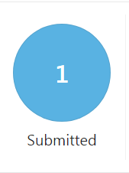
As it moves through the process, this will be reflected on the dashboard, per the categories explained on page 1 of this guide.

