A simple priority planner
Important! Do it now | Do it now.  (Although it is less important)
Important! Do it soon. Not yet. | Not important (yet!).  Just monitor these.

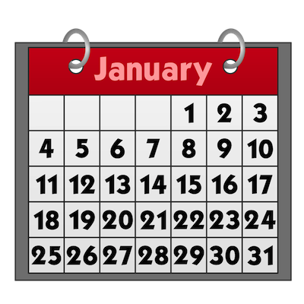
Some ways to find out more about task management tools

Donovan, K. (nd). Top 15 Time Management Apps and Tools.
Life hack blog. Available at: http://www.lifehack.org/articles/technology/top-15-time-management-apps-and-tools.htmlo,
(Accessed: 7 February 2017).

Sandlaker E. (2016) Manage your priorities, not your time, to get the important work done.
Available from: http://lifehacker.com/manage-your-priorities-not-your-time-to-get-the-impor-1782341311
(Accessed: 7 February 2017)

More information?
For some reading on task management, see:
University of Birmingham. Library Services. (2016) Resource List: learning to learn. Available:
Https://bham.rl.talis.com/lists/E542D369-A7BA-B314-7574-D084E5A3EA06.html
(Accessed: 7 February 2017)

Helen Cooper and Michael Shoolbred.
University of Birmingham New Main Library
Academic Skills Centre
February 2017

