Using Big Blue Button for webinars

Big Blue Button is the conference software which is integrated with Canvas. The Canvas Community guidelines suggest that you might use them for ‘virtual lectures, virtual office hours, and student groups. They can also be used to demonstrate technologies or troubleshoot technology issues online. Conferences can accommodate as many users as needed, though the recommended guideline is a limit of 100 users’.

Preparing for the session
If you need a microphone, you can book a teaching room on campus, or use a laptop or device with a built in microphone. Muting the volume on your computer (i.e. teaching room speakers) still allows the sound to be picked up by recipients of the webinar. This is useful to do if the students are not going to speak, to avoid getting feedback in the microphone, and not having to listen to your own voice coming out of the webinar.
Make sure the ‘Conferences’ tab is visible to students in the left hand navigation of the Canvas course beforehand. You can do this via the ‘Settings’ menu and clicking on the Navigation tab. Here are some more detailed instructions on how to do this.
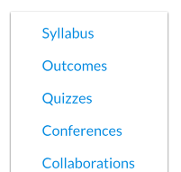

Setting up a webinar

- On the Canvas course, go to the ‘Conferences’ tab in the left hand navigation menu:
- Click on the blue ‘+Conference’ button at the top of the page:
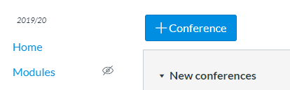
- In the box that appears (see image below), type the name of
your webinar – include the date/time in the name so that it is
clear for students which one they should join; select whether
you want to be able to record the webinar; and tick the box for ‘No time limit’, in case your webinar runs over.
You can also type a short description, which will display below your conference in Canvas:
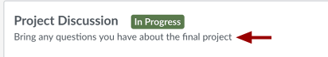
description

Depending on the Canvas course you are using, you may wish to send an invitation to all members of the Canvas course to join the webinar, e.g. if it is a compulsory webinar. Most of the time you will want to untick that box though, to avoid spamming students with unnecessary notifications. Another way to alert students about upcoming conferences would be to create course events in the Calendar.
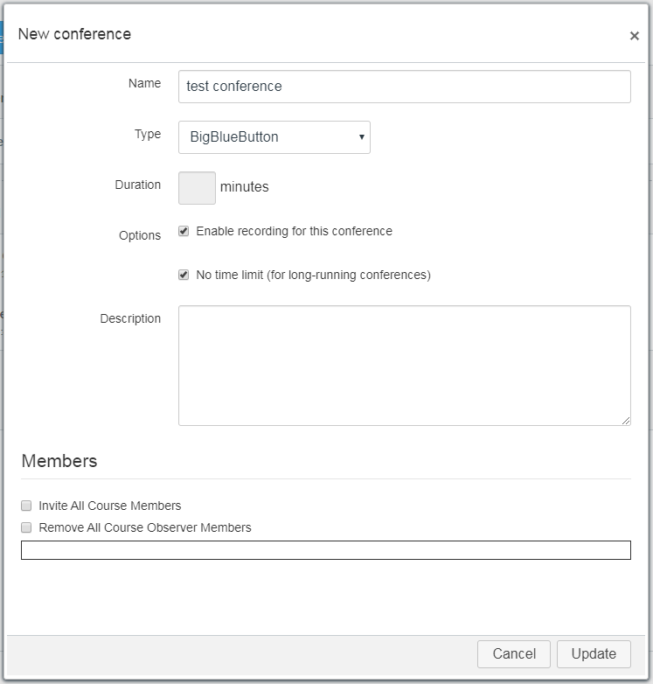

- Once you have filled in this box you will be taken back to the Conferences page. Click on the Start button next to your Conference to go into it:
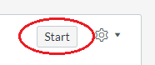
- You will be asked how you want to join the audio of the Conference. If you are going to be talking while you present then select ‘Microphone’:
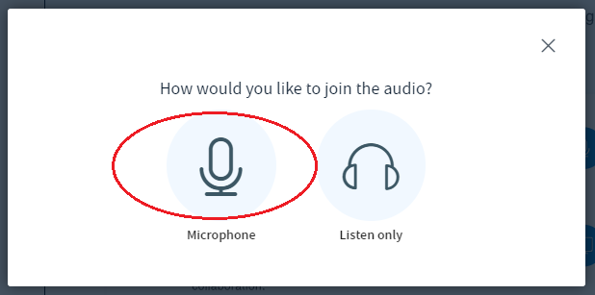

- You will now be taken to the webinar interface. The next part of the handout will run through some of the features available on this.

Features of the Big Blue Button interface

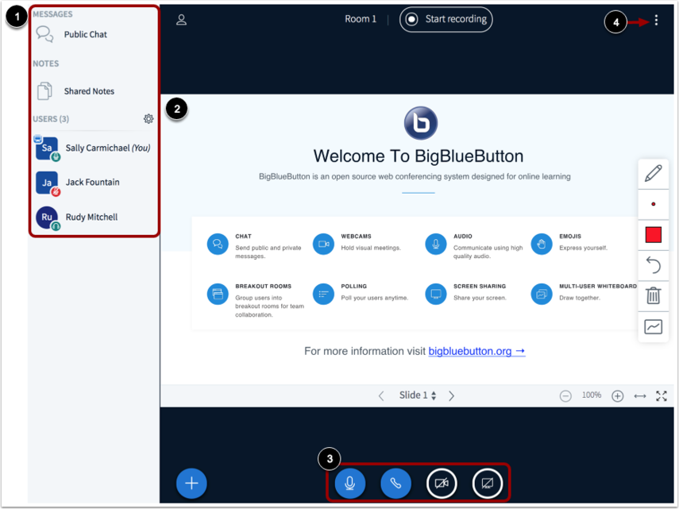
The Conferences interface contains a variety of tools to help you moderate and participate in your webinar. You will also notice the mouse acts as a laser pointer. The interface consists of the following areas (marked on the image above): User Menu [1], Presentation Window [2], Conference Tools [3], Options Menu [4]. More detail about each of these will follow below.

User Menu – Users, Chat, Notes
Users: From the User Menu, you can view all the users in the conference [1].
Chat: You can also chat with conference participants and contribute to shared notes. To open the conference chat, click the Public Chat link [2]. There is an option to save or copy the chat by clicking the three dots at the top of the chat: . Students can also send you Private Chat messages by clicking on your username.
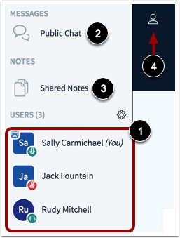

Notes: To open the Shared Notes, click the Shared Notes link [3]. This is a collaborative text editing space. It is also anonymous, so could be used for students to type concerns or questions or thoughts anonymously.
The symbol at the end of the Notes toolbar allows you, and the students, to export the notes, e.g. as a Word document.
The User Menu is open by default. To close the User Menu, click the Users icon [4]. To get the user menu back, click the icon again, and also click Public Chat [2] if you want to get the chat window back again.

Manage Users
The cog [1] at the top of the User Menu allows you to manage settings for all users.
Users can set their status icon to represent how they are feeling. The ‘Clear all status icons’ link [2] will clear users' status icons.
[3] allows you to Mute all users, or Mute all users except presenter. You will probably want to do this so that you do not get background noise from students while you are presenting.
The Lock viewers link [4], allows you to restrict viewers from using specific features, such as sharing their webcam, sending chat messages, editing the Shared Notes, being able to see other participants in the Users List.
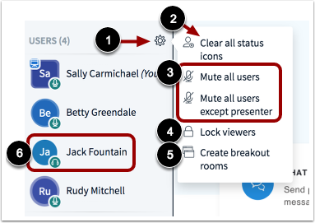

[5] You can also create breakout rooms, so that students can work in smaller groups. You can either put them into groups yourself, or students can select their own groups – e.g. based on the topic they would like to work on.
[6] To private chat with a user, remove a user from the conference, or promote a user to presenter or moderator, click the name of the user.
[7] Also in this menu is the option to save usernames – which will give you a text file with the names of all the participants.
Also in the Manage Users menu there is an option (not shown here) called ‘Write Closed Captions’ – which allows someone to type live subtitles of what is being said. Viewers can then ‘tune in’ to the subtitles, and there is the option to write subtitles in different languages – note that you have to do this yourself, it doesn’t translate them.

Presentation Window
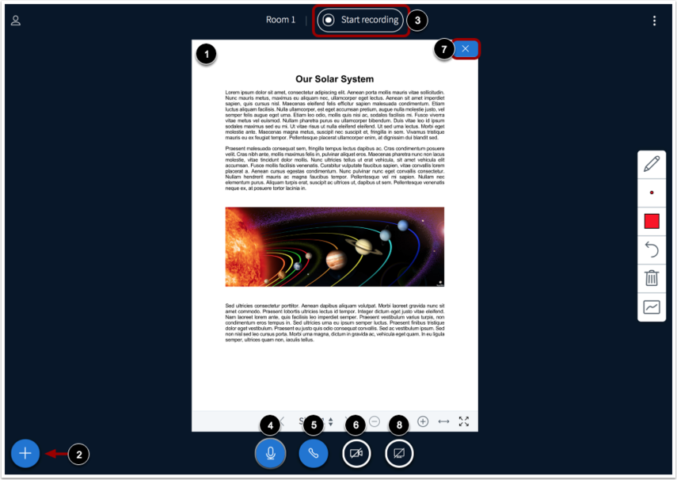
[1] This is where the presentation will display after you have uploaded it.
[2] This is where you can upload a PowerPoint to the conference, start a poll, or share an external video. When uploading a PowerPoint, you can also set the option for students to be able to download your presentation (A), and don’t forget to press Confirm (B) after you have uploaded it:
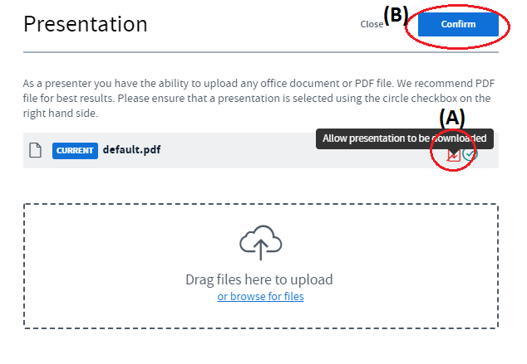
It is possible to upload several presentations or documents and have them ready here, to quickly select them when you need them.
The Add button [2] also allows you to share an external video, e.g. YouTube. The advantage of doing it this way rather than just sharing your screen is that the students won’t see all the switching of tabs—the video will just appear in front them. Note that shared external videos will not appear in the recording of the conference.
Polls – also in the ‘Add’ button [2] there is the option to start a poll. After clicking ‘Start a poll’ the following will appear where the Chat screen was positioned:
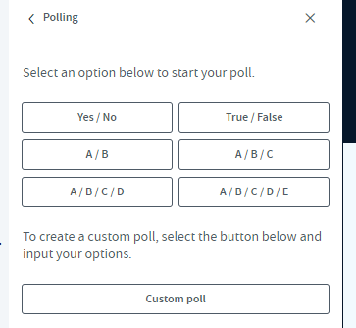
This means that you can pre-write your poll questions on slides, and then when you get to that slide, just go to ‘Start a poll’ and then select the type of question it is. Students will be able to view your question slide and select their answer choice.
Alternatively, for more spontaneous questions, you can press ‘Custom poll’ and type your own poll answers. This could be useful if something comes up during the webinar, so you could ask a question and instead of having to read everyone's answers in the chat, you can see at a glance what they think. Also the students’ votes will be anonymous to each other.
As the presenter, you will see the poll choices come in, and then you can publish them to the viewers when you are ready:
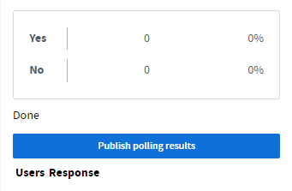
[3] This is the button you press to start recording the conference.
[4] Mute or unmute your microphone.
[5] Leave or join the conference audio.
[6] This is where you can enable your webcam.
[7] If webcams are enabled, you can close the presentation window and display only webcams by clicking this.
[8] To share your computer screen.

Annotation Tools
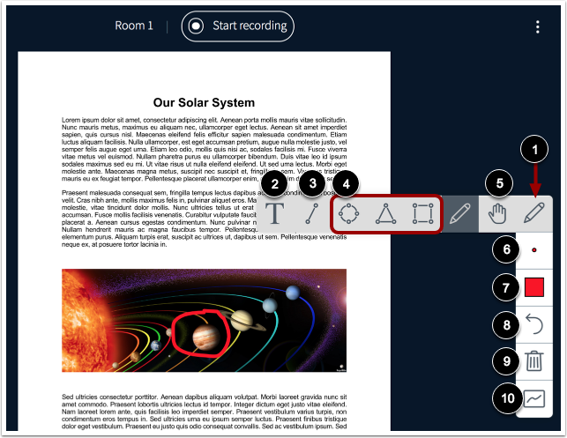
The Conferences interface includes several tools that you can use to annotate the presentation window:
[1] Use a pencil to draw in the presentation window. To view all annotation tools [2, 3, 4 and 5], click and hold the Pencil icon.
[2] Create text annotations.
[3] Create line annotations.
[4] Create shape annotations.
[5] To pan a document that has been zoomed in.
[6] To adjust the thickness of an annotation.
[7] To adjust the color of the annotation.
[8] To undo the most recent annotation.
[9] To delete all annotations that you have created.
[10] Multiuser Whiteboard – Enabling this will allow all users to use the annotation tools. You will probably want to make sure this is disabled so that students cannot draw on your slides.

Options Menu
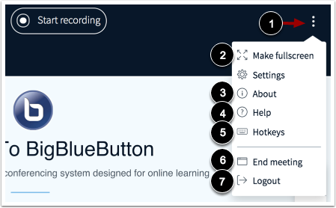
[1] Opens the Options menu.
[2] View the conference in fullscreen mode.
[3] View information about the interface.
[4] View help tutorials.
[5] View hotkeys.
[6] End the conference.
[7] Logout of the interface.

For ‘Settings’ see below.

Settings Menu
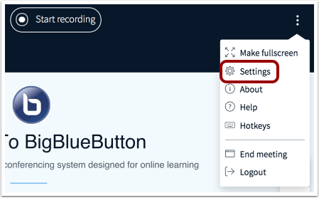
To open the Settings menu, click the Settings link.
The settings box will appear:
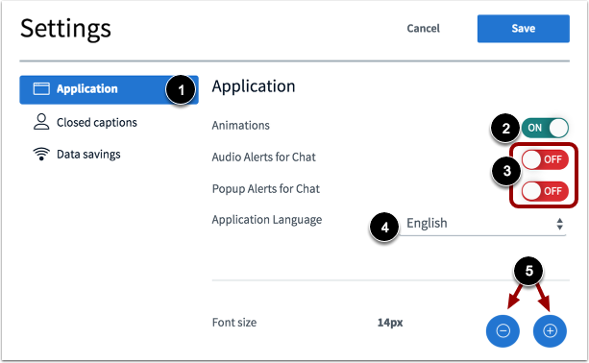
[1] Application settings allow you to enable or disable animations that display when a user is speaking [2], get audio or popup alerts for new chat messages [3], change the language of the interface [4], adjust the font size of the interface [5]. Students also have these options within their view.
Data savings settings [6] enable you to save your bandwidth by enabling/disabling webcams or enabling/disabling desktop sharing. This could be useful if you have more than 50 students on your conference. Students also have this option on their view.

Concluding a conference
Depending on whether you specified a time limit, your conference may conclude by itself (when the last person has left), or for conferences with no time limit you may have to conclude it manually.
Note: A conference can be concluded directly from the logout menu in the conferences interface (see Options Menu above). However, the Conferences page does not currently update the status and will still show the conference as ‘In Progress’ (see image below). So if a new user joins the conference, a new meeting with the same name will be created. To prevent new users from joining the conference, always return to the Conferences page in Canvas and click the conference End button:
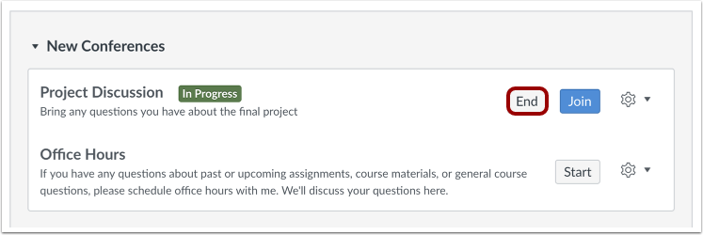
Once the conference has concluded, the conference will appear in the Concluded Conferences section on the Conferences page. This may take a few minutes.

Recordings
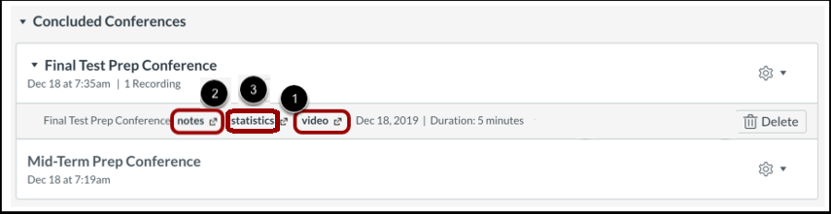
To view the recording and additional details, click on the name of the conference. To replay the conference, click the Video or Presentation link [1]. If your conference included shared notes, you can view the notes by clicking the Notes link [2]. You can view conference statistics by clicking the Statistics link [3].
More information about the statistics follows on the next page.

Statistics
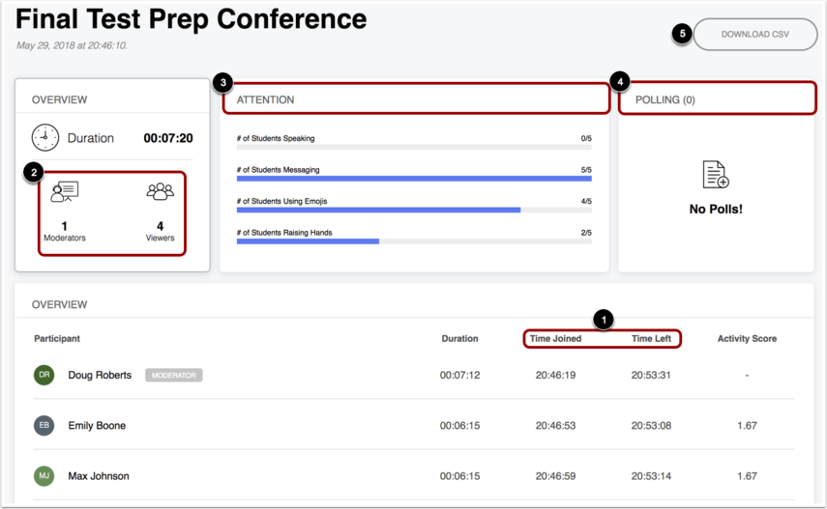
In ‘statistics’ you can view metrics about student participation in the recorded session, such as length of time in the session [1], number of moderators and participants [2], and the number of students who spoke, messaged, used emojis, or raised their hands during the conference [3]. It also includes information about polls [4] and you can also download a spreadsheet with who answered what in any polls [5].
Note that the University of Birmingham has the premium version of Big Blue Button, and so there is no time limit on how long the recordings are kept for.

Running the webinar
Ensure communication is clear to students about how to access the webinar.
Open the conference in plenty of time prior to the start time in order to allow students time to join and prepare their equipment and confirm everything is working.
Decide whether you are going to record the conference.
It is also possible to add external people to the Conference, for example employers, or graduates. You can send them the link once you have opened the Conference:
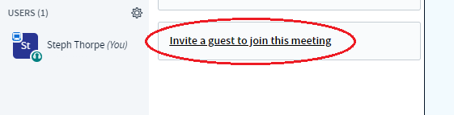
This will generate a link which you can then email to the external person.

Tips for running webinars with students
- Monitor public chat (and private chat if you get a notification).
- Notice whether anyone has ‘raised their hand’ – we don’t know how students will use this function; as they are used to communicating by emoji, so they may expect their status to be noticed.
- Think about whether you want to ‘lock’ any of the functions.
- Keep students on ‘mute’ to avoid background noise and distractions.
- Keep the whiteboard set so that only you can write on it (unless using for an activity).
- Think about whether you will need to kick a student out of the session.

Further information:
More information about creating conferences: https://community.canvaslms.com/docs/DOC-12687
Using the conferences interface: https://community.canvaslms.com/docs/DOC-12848-415265961
Ideas for using conferences as an instructor: https://community.canvaslms.com/docs/DOC-10738
Planning a webinar document from Cardinal Stritch University: https://stritch.instructure.com/courses/2566/files/1623433?module_item_id=564423

Acknowledgements: Most of the images on this page have been taken from the Canvas Community website. Some of the information has been taken from here as well.

