How to give access to Canvas to non-UoB email addresses, such as employers, graduates, or colleagues from other institutions

- Go to the IT Service Desk universityofbirmingham.service-now.com and log in.
- Click on ‘Make a request’ (the shopping basket icon).
- Click on ‘New Canvas Supplementary User’ (in the top left box):
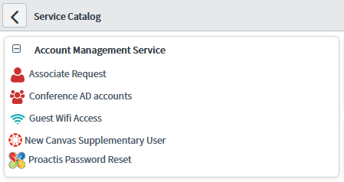
- Fill in the details of the person you are requesting the account for, and the reason you are requesting the account. You will be the ‘sponsor’ of their account.
- IT will process the request and send you the account details, copying the person in. When you get the account details back, add the person to the course in the usual way through the ‘People’ tab. Alternatively they can now self-enrol on any of our courses through the CN website using the username and password.

