Contents
Settings: Looking under the Hood………………….Page 2
Building Professional Content in Pages…………...Page 13

Workshop Lead: Danielle Hinton (Instructional Design Consultant – CoSS)

Professional Development Gateway
https://www.birmingham.ac.uk/university/professional-development-gateway/index.aspx
HEFi: Birmingham Digital
https://www.birmingham.ac.uk/university/hefi/birmingham-digital/index.aspx

Settings: Looking under the Hood

Contains
- Course Details
- Sections
- Navigation
- Apps
- Feature Options
- General Good Stuff (Student View, Course Stats, End this Course, Import/Export Course Content, Validate Links in Course)

Settings: General

There are a number of options available in Settings that you need to know about.

Student View

You can view a course the same way that your students view your course through Student View. Enabling Student View creates a Test Student in your course. You can activate Student View in your Course Settings.

To see the student's perspective on Canvas, use Student View to view the course, post and reply to discussions, submit assignments, view grades, view people, view pages, view the syllabus, view quizzes, view the calendar, and view the scheduler (if enabled).

Attendance, conferences, conversations, collaborations, differentiated assignments, external apps, groups, peer reviews, and profiles do not work for the Test Student. You will see only what you, as the instructor, allow your students to see.

Import Course Content **

You can copy course content such as assignments, modules, pages, and discussions from previous Canvas courses into existing courses selecting to either import the whole course package or just parts.

Validate Links in Content

As an instructor, you can verify all external links (Links to an external site.)Links to an external site. throughout your course to ensure they are valid. You can check these links using the course link validator, which searches through course content and returns invalid or unresponsive external links in both published and unpublished content. However, please note that some links flagged as unresponsive are inaccessible by Canvas servers and will still work for students.

The link validator also includes deleted links. Deleted links are links that are still in the course, but their linked content has been deleted (such as a course file or page).

Settings: Import Course Content

1. Open your Quick Wins Sandbox course

2. In Course Navigation, click the Settings link.

3. Click the Import Course Content link.

4. Select Content Type
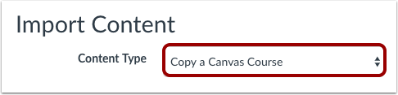
In the Content Type drop-down menu, select the Copy a Canvas Course option.

4. Select Content Type & Search

In the Search for a Course box type Quick Wins With Canvas (1 Nov 2017)

5. Select Migration Content
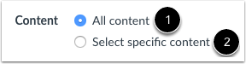
To import all content from the course, select the All Content radio button [1].
If you want to select specific content, click the Select specific content radio button [2].

Note: If you select the specific content option, you are required to select the content you want to import after you review the remaining page options. After you start importing the content, the import selection cannot be canceled.

6. Import Course
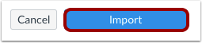
Click the Import button.

7. View Current Jobs
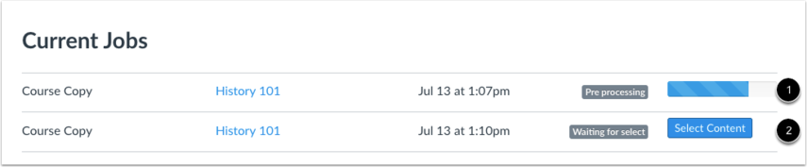
The Current Jobs section displays the status of your import. Running reports display a menu bar with the time remaining to complete the import [1].
If you chose to select specific content in your course, the current job will show as Waiting for Select [2], which means you must select the content you want to import.

Settings: Course Details
In the Course Details tab, you can view the details of your course, its name, what your quota is, and what license that you’ve attached to this content inside of your course. You can also view the course status. If the course cannot be unpublished, the hover text will notify you accordingly.
There are a number of the Course Details elements that it is important to be aware of.
Note: If you change anything settings you must save via the Update Course Details button
- Name: This affects the name that appears on course of the Dashboard. Your department may have a specific format, so if so please don't change this without consultation
- Course Code: This affects the name that appears on the course on the course breadcrumbs
- License: This ranges from private (our normal default) to public and then a variety of Creative Commons licenses
- Visibility: This rages between Course, Institution (open access to UoB) or Public (open access)
More options include a range of important options. Some key ones include:
- Show Recent Announcements on the Homepage: if you believe that students are not access Announcements you may wish to switch this option on
- Let students attach files to discussions: is an important option especially used in distance learning courses
- Hide totals in student graphs summary: This maybe an important to switch off from an Admin point of view - student then can't see the auto calculated grade totals
- Hide grade distribution graphs from students: It is important to discuss implications for students before this feature is turned on.

Settings: Navigation
As a teacher, you can control which links appear in Course Navigation. Canvas includes a set of default Course Navigation links that are shown by default and cannot be renamed. Depending on your course configuration, other links may be available and may be customizable.
Links to sections that don't have any content and that students cannot create content for will automatically not be shown to students and will be faded for your view. For example, if there are no learning outcomes set for the course, you will see the faded Outcomes link, but students will not see the link at all. Configured External Apps may create additional Course Navigation links.
Disabling a course navigation link creates the following redirects:
- Hidden only (cannot be disabled but still accessible via direct URL): Discussions, Grades, and People
- Page disabled; redirected to home page: Announcements, Assignments, Conferences, Collaborations, Files, Modules, Outcomes, Quizzes, pages, Syllabus
- Page disabled; won't appear in navigation: Any LTI links, such as Attendance, Chat, and SCORM
Reordering and hiding Course Navigation links for Announcements, Assignments, Discussions, and Files also affects the course tabs in the Dashboard course view .
Note: Navigation links that cannot be disabled require the URL access to display related data in other Canvas areas. Access to hidden pages may be further restricted by changing specific student permissions in Canvas. Contact your Canvas admin for assistance.
Reordering your navigation
Step 1. Drag and drop items to reorder them in the course navigation
Step 2. Always save your actions
Adding to the Navigation
You can add to a course navigation options with either internal Canvas links or external websites using the Redirect app. Advice on using this app please view the instructions - Settings: Canvas Apps

Settings: Canvas Apps
Apps are an easy way to add new features to Canvas. They can be added to individual courses, or to all courses in an account. Once configured, you can link to them through course modules and create assignments for assessment tools.
Go to Settings and then select the Apps tab
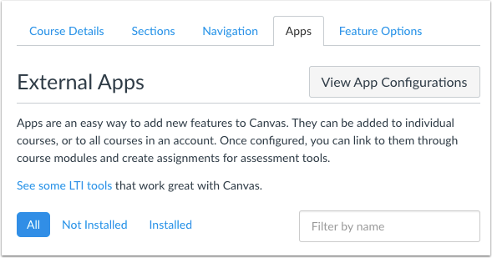
Search by name or browse.

Note that not all apps are available as they may link to subscription services.

Redirect App
Add links to external web resources that show up as navigation items in your course navigation. Whatever URL you specify is loaded within the content pane when users click the link.
To configure this app you specify the text and URL you’d like to add to navigation elements, then check the area you’d like it added to. User navigation will only appear if this app is installed at the root level.
Search or browse for the Redirect App
Click on icon, then the + Add App
Complete the Name (of the internal or external webpage you want to appear), then the URL and select 'show in course navigation' .
You might want to link to internal materials:
- weeks / themes (eg materials in the module area creating a quick index of content),
- other related courses (eg Module 1, Module 2, Module 3),
- groups (general or all)
or external websites eg
- blogs, Resource Lists, Bank of Assessed Work, professional bodies
Save by selecting the Add App button
Refresh the page by selecting the F5 key. You will now see your link in the navigation of your course.

Add Functionality to the Rich Text Editor Toolbar (YouTube, Vimeo, Khan Academy, TED-Ed or Google Maps
If you add one of the video sites, a new icon will show up in your course rich editor toolbar (pages, discussions, announcements etc) letting you search and click to embed videos in your course material.
Google Maps is a web based mapping service offered by Google Inc. It allows you to find addresses, businesses, and points of interests. This LTI Tool allows anyone to embed a Google Map into the course via the Rich Text Editor.
Screencast-O-Matic
Screencast-O-Matic is an easy-to-use, powerful lecture capture, flipped learning and video publishing solution including recorder, video editor, video cms and more.
Work directly within Canvas to capture, publish, and share video. With our fast, free screen recording app designed for Windows, Mac, and Chromebooks you can record your desktop and/or webcam to create compelling videos. You have the option to add narration and system sound to your recording. Our powerful video editing tools enable you to deliver compelling videos to your students, add animation, mix in other media, automate captioning, and much more.
Twitter
Embed lists of recent tweets or individual tweets from Twitter. Lists can be derived from search results, or from a user’s twitter feed.
Flat (Music)
Create, compose, collaborate, play, and print your sheet music using the world’s most simple and intuitive web-based music writing and composition software. Just like Google Docs, you can collaborate in real-time on your music notation.

Canvas 24/7 support
There is now an enhanced support service for all staff and students to help you make the most of Canvas.
The support is available 24/7 via live web chat or UK freephone. You can also report a problem directly to the Canvas support team. You can access this via the HELP button on the left hand tool bar.

View Course Analytics
- Home
- View Course Analytics (button on the right and side of screen)
General Overview
Individual Students

Building Professional Content in Pages

- Using Template pages
- Page History
- Display and layout options
- Duplication options
- Integration of images, links, YouTube, record yourself, maths etc
- Integrate a simple but powerful timeline into Canvas

Template Pages

You can duplicate a page in your course. When a page is copied, the word Copy is added to the end of the page name.
Duplicating a page defaults the copied page to an unpublished status. All items in the page are duplicated including the page name, content, and options.
- Go to Pages
- Select the cog of the page you want to duplicate
- Select the duplicate option
- Edit the new page

Page History

When you can edit course pages, you can view the page history and see the date, time, and author of any changes made to the page. Page editors can also roll back the page content to a previous version of the page.
Page Cog

View Revision History

Timelines
TimelineJS is an open-source tool that enables anyone to build visually rich, interactive timelines. Beginners can create a timeline using nothing more than a Google spreadsheet

Tips & tricks
- Keep it short. We recommend not having more than 20 slides for a reader to click through.
- Pick stories that have a strong chronological narrative. It does not work well for stories that need to jump around in the timeline.
- Write each event as a part of a larger narrative.
- Include events that build up to major occurrences — not just the major events.

Media sources
TimelineJS can pull in media from a variety of sources. Twitter, Flickr, YouTube, Vimeo, Vine, Dailymotion, Google Maps, Wikipedia, SoundCloud, Document Cloud and more!

Instructions
https://timeline.knightlab.com/#make (Links to an external site.)Links to an external site.

