How to add a new PDF, PowerPoint or other document to Canvas

- Click the edit button at the top left of the page you want to add the file to:
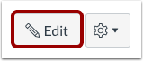
- Place your cursor where you wish to insert your file.
- On the menu on the right hand side, click the ‘Files’ tab:
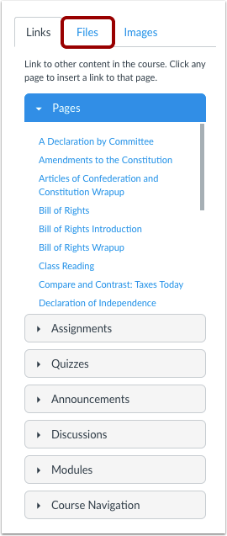
and choose the file from your computer.

4. If the file is already on the course, click its name in the list [a]. If you are adding a new file, click ‘Upload a new file’ [b]:
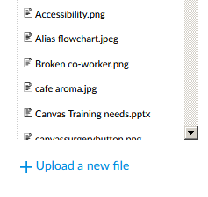
[a]
[b]

- Find out the size of the file:
If you have received the files by email, it will state the size on the attachment:

Otherwise use your computer to find out the size of the file:
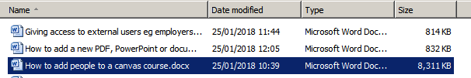
There are 1000 kilobytes in a megabyte, so if the size is larger than a thousand, write it in megabytes. So the example selected above (8311KB) would be 8.3MB.

- Within the hyperlink, write the file type and file size in brackets after the filename, e.g.:

- Click the ‘save’ button:
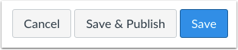

You can preview the document by clicking the icon next to it.

EXCEPTION: If the document you are uploading is a Careers Network Handout please send it to the Info Team inbox as these are uploaded in a special way.

