How to add an image to a Canvas page and resize it

This process will work the same way when adding images anywhere in Canvas, such as Announcements, Discussions, Quizzes, etc.

It is advised that you create a folder within the Files section of the course to store all the images. This will make locating and managing files easier in the long run.

Adding an image:
- Navigate to the Page you wish the image to appear on and click on the Page Edit button:
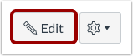
- Place your cursor where you wish to insert your image.
- On the menu on the right hand side, click the ‘Images’ tab:
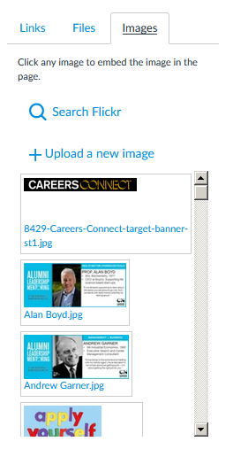
[b]
[a]

4. If the image is already on the course, you will see it in the list [a] – click on it to insert it. If you are adding a new file, click ‘Upload a new image’ [b] and select the file from your computer by clicking on the Choose File button. You will also be able to select where the file will be stored, from the Folders drop-down list [c]. Then click ‘Upload’.
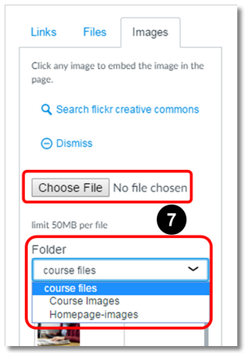

[c]

- Click the ‘save’ button:
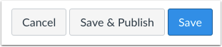

Additional information
When you upload a new image (step 4), it will ask you to add ‘Alt Text’. This consists of a phrase or word which describes the image.
Adding alternative text to images is a core principle of web accessibility. Visually impaired users using screen readers will be reading this text.

Re-sizing an image

- Click on the Edit button at the top of the page and click on the image that you wish to resize.
- In the Rich Content Editor you will see the image icon, click on this:
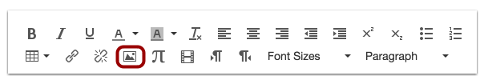
- It will bring up this box:
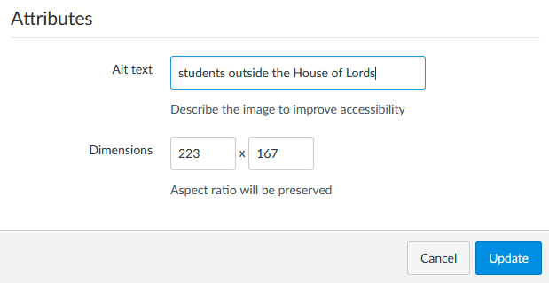
Dimensions are the size of an image as it would appear on the screen in pixels. When you change one value the other changes automatically to match it, so that the image does not get distorted.
- Type in the size you want in the width box. The height box will change automatically. Click on the Update button to save the change. You may need to experiment with trial and error until you are happy with the size of the image on the page.

Copyright
The Media in Canvas course by Birmingham Digital provides information on copyright and the associated potential impact on using images and videos: Legal aspects and copyright

Birmingham Digital have also put together some instructions on using Canvas to search the Flickr online image repository, which provides you with access to a wealth of potential images: Adding images to canvas - Flickr

Advanced
If you would like to know more about using the <img> html tag and resizing your images responsively for different devices, have a look at the page produced by Birmingham Digital on this: Unit 4 - Images and HTML editor

