How to create an image of a presentation slide to display presentations on Canvas

Decide what size you are going to have your images before you start. Make sure you know what dimensions in pixels (px) your images need to be, if you are matching existing ones. It is best to get all the images the right size before you upload them, as otherwise they may not line up properly. This guide will show you how to create and resize your images.
As an example, the image in Figure 1 below measures 300x225 pixels. Figure 2 measures 250x187 pixels.
You would be able to fit three of these in a row on a Canvas page, as in Figure 3.
Figure 1: 300x225 pixels Figure 2: 250x187 pixels

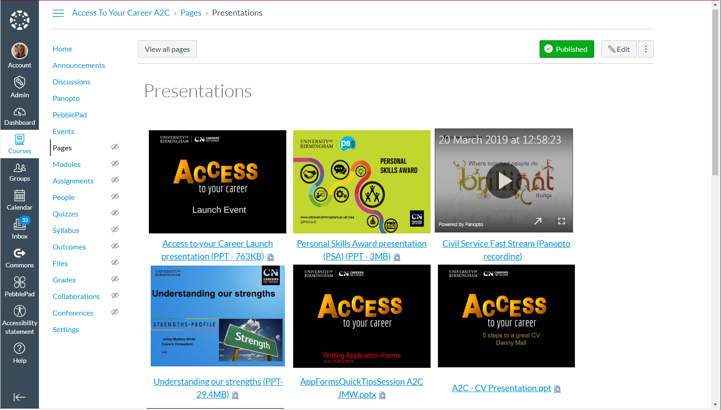
Figure 3: example of six presentations displayed on a Canvas page.
Important note about aspect ratio and image size
When resizing an image, the dimensions of the image will stay fixed at the correct aspect ratio, so if, for example, one of your presentations is widescreen, you will not be able to get it into the exact same dimensions without it distorting. In this situation, make sure just the width of all the images are the same.

Creating your image
Step 1: Open the PowerPoint presentation that you would like to create an image of. Make sure you are on the title slide.
Step 2: In the File menu, click ‘Save As’:
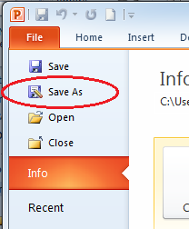

Step 3: Find the folder you want to save the image to, but before pressing Save, click the drop-down arrow on the ‘Save as type’ option:
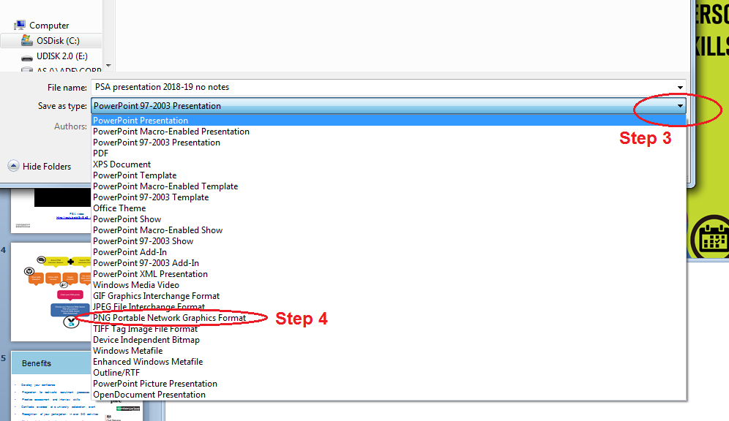
Step 4: Select ‘PNG Portable Network Graphics Format’.
Step 5: Click ‘Save’.
Step 6: On the dialogue box that appears, click ‘Current Slide Only’:
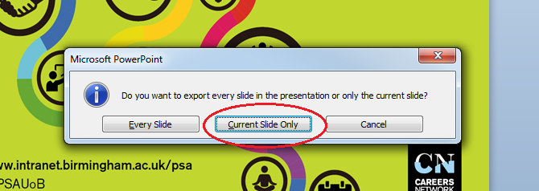

Step 7: If you look in the folder location you selected when saving, you will see that there is now a .png image of the title slide. The image will be very large, so you will probably want to resize it – see below.

Resizing an image
Step 1: In ‘My Computer’, go to the folder with the image in.
Step 2: Right-click on the image, hover over ‘Open with’, then select ‘Paint’ on the menu that appears:
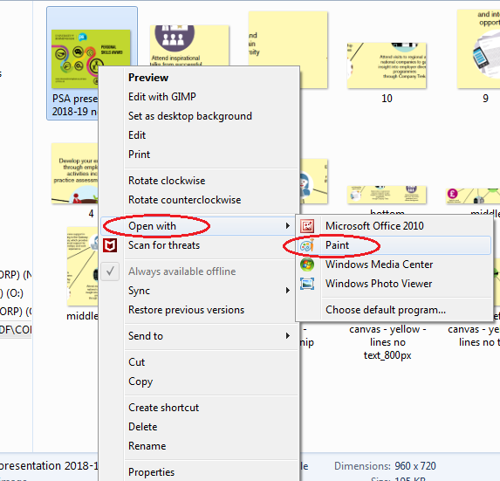
Step 3: The image will now open in Paint. On the menu at the top, click on ‘Resize’:
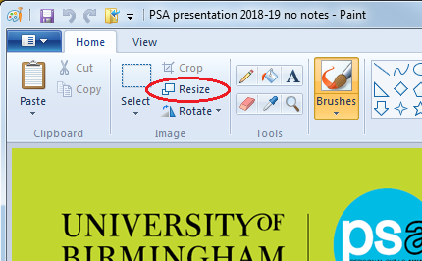

Step 4: On the menu that appears, select the ‘Pixels’ button. Make sure that the ‘Maintain aspect ratio’ box is ticked, and then in the text box marked ‘Horizontal’, type the width you would like your image to be:
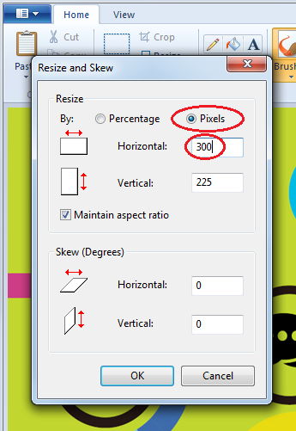

Note that the height (the box labelled ‘Vertical’) will adjust automatically, to maintain the aspect ratio and prevent the image from being distorted.
Step 5: Click OK.
Step 6: The image will now resize and you will be able to save it, by going to either ‘Save’ or ‘Save As’ depending on whether or not you want to overwrite the original image. Tip: ‘Save As’ is found by clicking on this button:
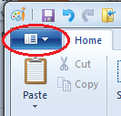
Step 7: Now you can upload the image to Canvas in the usual way and insert it in to your page.
If you would like instructions on inserting an image on Canvas, have a look at this handout: \\Adf\corp\AS\Careers\TEAMS\INFO TEAM - AEF\Canvas\Help guides\How to add or resize an image on a canvas page.pdf
Step 8: You will need to write some accompanying text on the Canvas page stating the title of the presentation, and make sure to include the format and file size, so that viewers can choose whether to download it – e.g. they may be visually impaired, or on a metered data connection. See example below:

Step 9: Upload the presentation file to Canvas and link it to the text you have just written, and to the image as well if you want.
For instructions on how to upload and link to a file, and how to find out the size of a file, have a look at this handout:
\\Adf\corp\AS\Careers\TEAMS\INFO TEAM - AEF\Canvas\Help guides\How to add a new PDF, PowerPoint or document to Canvas.pdf

