How to embed Panopto recordings on Contensis

- Login to Panopto using your Canvas ADF username and password. If you do not have the software, please install it from myapplications.bham.ac.uk.

- Select the ‘Manage Recordings’ tab from the top navigation bar, and then the ‘Manage My Recordings’ link.
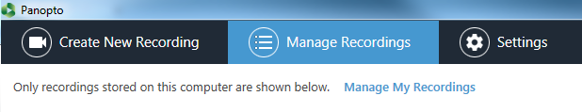
- On the recording you would like to download, please select ‘settings’.
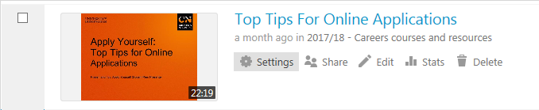
- Please select ‘Outputs’ on the left hand navigation, and then the ‘Download Podcast’ link.
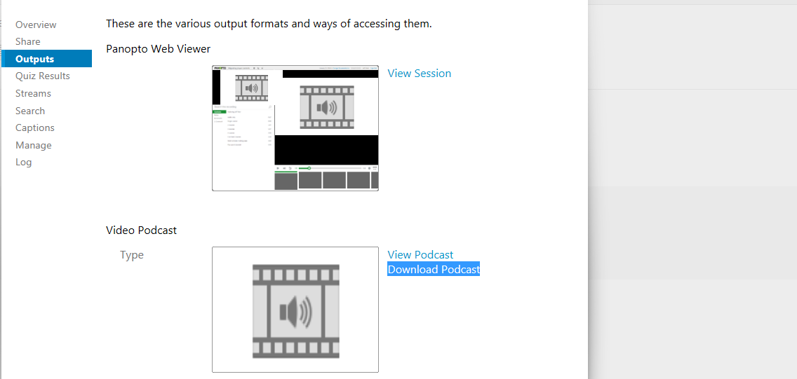

- Please save the downloaded MP4 file locally to your computer.
- Login to the YouTube CN account, and upload the file.
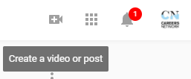

- Copy the YouTube URL for the video from the address bar of your browser. For example: https://www.youtube.com/watch?v=ZQvNnxOSgOo

- Log into Contensis and navigate to the location page you wish the recording to appear. Edit the page, and in the section you would like to add the video, right click and select ‘Video Player’ from ‘Insert Webcontrol’ option.
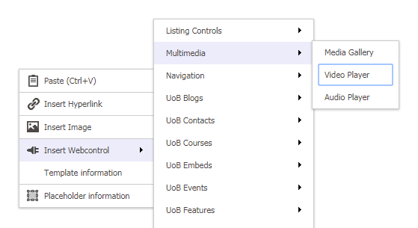

- Copy the YouTube URL into the ‘Video’ text box, and select ‘Save'.
