How to embed Youtube videos on Canvas

Acknowledgement: This handout is a copy of this page from Birmingham Digital: https://canvas.bham.ac.uk/courses/24057/pages/unit-5-embedding-external-videos-youtube [Accessed 25 January 2018]

Embedding YouTube videos in Canvas

The first step is to search YouTube for suitable resources. Wherever possible you should link to the original source of the recording.

Step 1 - Copy the YouTube URL for the video from the address bar of your browser. For example: https://www.youtube.com/watch?v=ZQvNnxOSgOo

Step 2 - Log into Canvas and navigate to the location (page, discussion etc) you wish the recording to appear.

Step 3 - Click on the Edit button.

Step 4 - Paste the URL into the page, where you want the video to appear, and the YouTube box should be automatically inserted. (The Canvas integration with YouTube means that any YouTube videos are automatically embedded in any feature that uses the Rich Content Editor.)
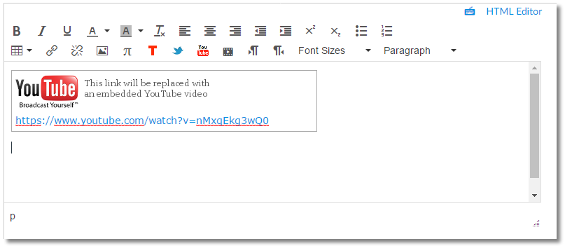
Step 5 - Click Save.

The embedded YouTube video will then appear on the page, ready for your students to view.

