CaREERS neTWORK
&
Tableau
User Guide

Contents
1. Accessing Tableau and Careers Network Data 3
1.1. Projects Page 3
1.2. Workbooks Page 4
1.3. The ‘Views’ page 5
2. Using Dashboards and Workbooks 5
2.1. Filter Pane 6
2.1.1. Single Selection Radio Button 7
2.1.2. Single Selection Drop Down List 7
2.1.3. Multi Selection Drop Down List 7
2.1.4. Date Range Selection 7
2.1.5. Dynamic Filters 8
2.1.6. Managing Filters 10
2.1.7. Resetting Filters 10
2.2. Options Toolbar 11
2.2.1. View 11
2.2.2. Download 13
2.2.2.1. Download: Image 14
2.2.2.2. Download: Data 14
2.2.2.3. Download: Crosstab 16
2.2.2.4. Download: PDF 16
2.2.3. Comments 17

Accessing Tableau and Careers Network Data
Tableau Server is accessible on any web browser.
Type tableau.bham.ac.uk into the URL bar.
This should automatically connect you to the various Projects that is accessible in your account. If you are not automatically connected then type in your UoB login credentials and ‘Sign In’.
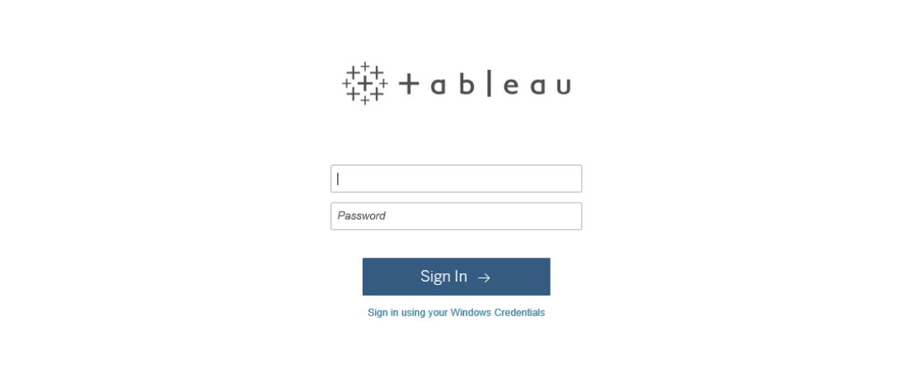

Projects Page
All Projects are in alphabetical order.
Click the Project book ‘Careers Network’ to gain access to Careers Network related Workbooks.
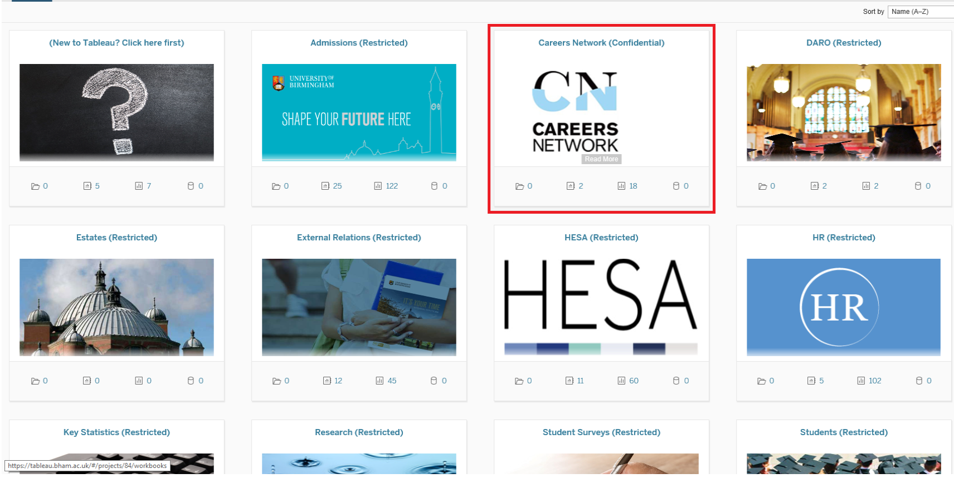

Workbooks Page
A Workbook contains various Views (worksheets and dashboards) that have been designed by the administrator.
Click on a Workbook to see its dashboards and worksheets.
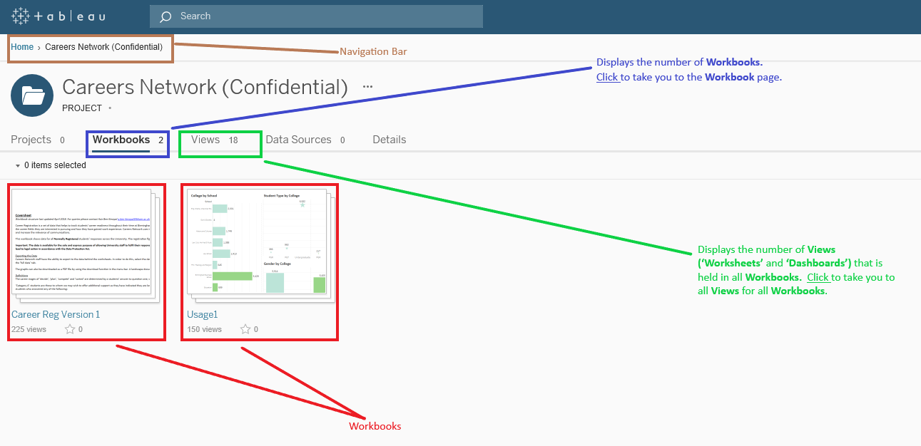
Some of the Workbooks include:
- Career Registration - Contains various Views relating to all 3 questions: Career Stage, Sector Interests and Work Experience. Users are able to use the filters available to drill into the data to see data at various levels, e.g. College, School, Department, Category A, etc.

Views have been designed to monitor engagement in the current academic year for each career stage. These Views are particularly useful to determine engagement for priority groups, i.e. Category A.

Users can also export lists of students on selections made. Emails and telephone numbers will also be included allowing users to target groups.

- Appointments and Events Engagement – Contains various dashboard Views that either show no. attendances or no. students engaged for the appointments and events we deliver.

Appointments and Events data has been joined to allow users to see total students engaged rather than look at engagement at each level

Some Views have also been designed to allow users to see the trend for the last five years.

- Verint – Contains Views allowing users to see both no. correspondence for queries and the no. students with enquiries.

Users can interact with the Views to see trends or breakdowns of selections made.

The Views tab takes you to all the various dashboards that are held within the Project. Please note that once a Workbook has been selected, the Views tab will only show those that are held within that Workbook. It is recommended not to select the Views page from this screen.

Tip: The Navigation bar allows the user to easily go back into a previous area that was selected prior to your current page.
Click on a Workbook to see its dashboards and worksheets.

The ‘Views’ page
This page holds all dashboards and worksheets within the Workbook selected.
Please note that the default order of the tiles (Views) is date the View was published to Tableau.
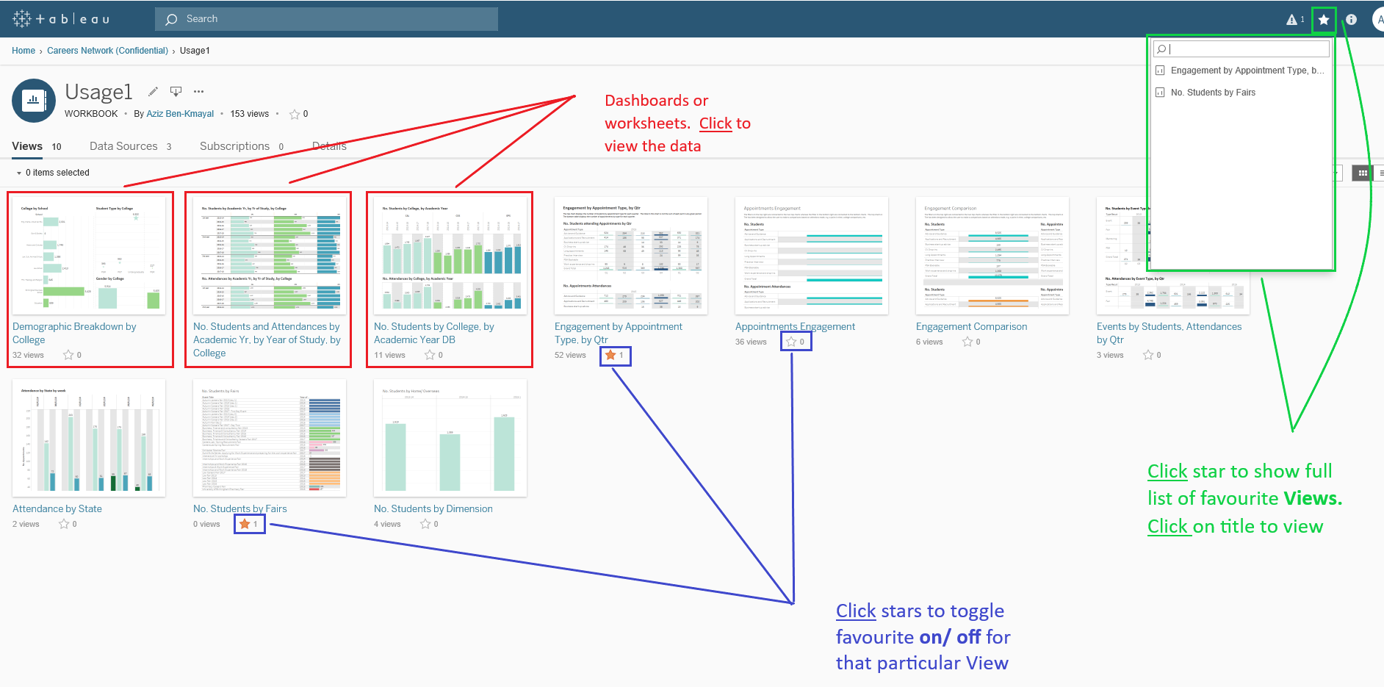
Click on tile to open that dashboard or worksheet.
Tip: As Careers Network data is held on 3 Workbooks it is highly recommended to set frequently visited Views as favourites. Favourites are accessible on any page within the UoB account by clicking on star located at the top right of the screen.
Click on the star in the tile to toggle favourites on and off. A gold star indicates that View as a favourite and will appear on the favourites list.

Using Dashboards and Workbooks
A user will see a similar screen like the one shown below.
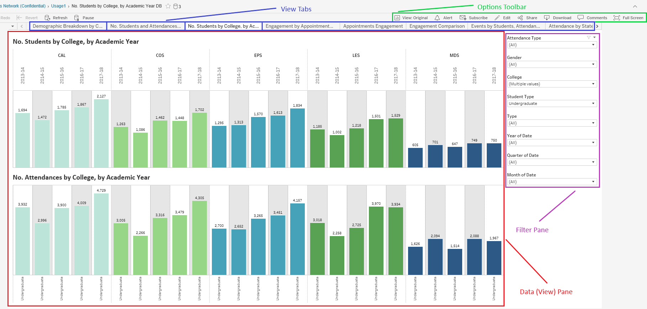
This page will consist of the:
- Data Pane - where all tables and charts are displayed. It may consist of one or many tiles. The data pane may interact with many or no filters.

- Filter Pane - Allows user to interact and drill into the data displayed. Filters can be either dynamic or static.

The chart’s legends is held in this pane.

- Views Tab - All dashboards and worksheets that are in the selected Workbook are accessible here

- Options Toolbar – There are various options available. Some of the options have no use but some are extremely useful, i.e.
  - View: Allows the user to save filter selections that they have made that they can revert back to for future use. Users can save many Views and have the ability to manage delete and make them public to other users.
  - Share: This function allows users to copy and paste the site URL to send to other users. This will only be possible if staff have the permission to see the Workbook
  - Download: Allows the user to export data into Excel. The user can also use this option to save to PDF or a .png image file for printing purposes
  - Comments: Users can leave comments on any View for other users to see. Snapshots of the screen can also be pasted in the comments area. Please note that comments in this View cannot be downloaded
The remainder of Chapter 2 will provide a step by step guide in how to use this page. What is displayed in the Data Pane will start at Chapter 3.

Filter Pane
There are various filter types used in the various dashboards/ workbooks. Below is a description of the majority of filters used.

Single Selection Radio Button
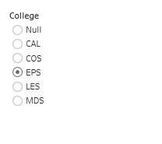
Allows the user to select one of the options that are available. This filter is used on the workbooks/ dashboards that are designed to allow users to look at one group, e.g. data for one particular college.

Single Selection Drop Down List
Some lists may be too large to use a Radio Button Single Selection filter. In this case, a drop down list will be used. Click on the drop down bar to show the available options and select your desired choice.
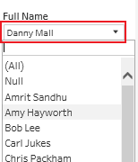

Multi Selection Drop Down List
Very similar to the Single Selection Drop Down but user has the ability to select multiple options. Click on the drop down bar to show the available options and click on the box to the left to toggle that selection on and off.
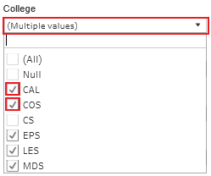

Date Range Selection
Allows user to select a date range. Click on any of the two dates and a date picker will appear.
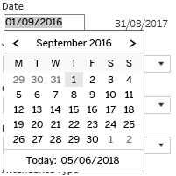
You can scroll back and forth to find your desired date.
Alternatively, type in the date.

Dynamic Filters
All filters that appear on any given View interact with each other. Once a selection is made in one filter all others in the View will only show choices available that relate to the previous selection. This allows users to drill down into the data with ease eliminating the need to see what data is available based on previous selections made. The example below shows how we can refine our department options using both college and school level filters.
We can see at the default level that all departments are available for selection. This is an extensive list with many options available.

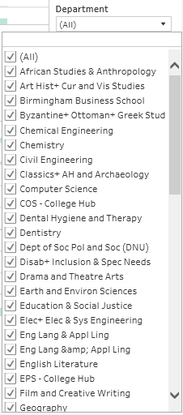
Click the College drop down list and select to ensure that only one of the Colleges is selected. CAL has been selected in this instance.
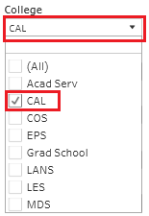
If we now look at the Department filter we can see that the list has changed to show all departments for CAL.
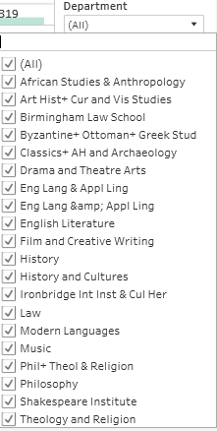
We are able to still refine this list further by using the School filter.
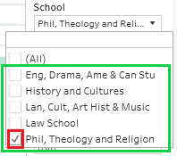
We can also see that the school list has been refined to only show those that exist within CAL. If we select one of the school options, in this case ‘Phil, Theology and Religion’ then the user will only see departments that sit within that school.
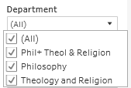
This relation between filters also works on relationship between dates, etc. Furthermore, dynamic filters work for various types of combinations, for e.g. if the first MDS appointment in the data source falls on the 16th June 2015 then the date range selection filter will show that date in the from area.

Managing Filters
It is important for the user to ensure that they are managing the filters they have selected. It is easy to forget that they may have one switched on and forgot to reset it before interrogating the data leading to incorrect being displayed and shared. Therefore, it is critical that users are aware that filters are applied. This can be identified by looking at what is displayed in the filter drop down box.
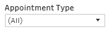
‘All’ appearing in the drop down box represents all available options have been selected. This should be your default position before drilling into the data again.
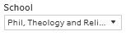
A value appearing in the drop down list represents that that choice has been selected.
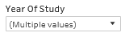
If ‘Multiple Values’ is displayed in the drop down box then some, not all, choices has been selected.
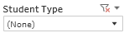
This represents that no option(s) have been selected. When this is the case then it is likely that the Data Pane is empty.

Resetting Filters
If the above sign appears when hovering over of the filter boxes it means a filter has been applied. User can click this button to reset the filter.
Please note that there is no option to reset all filters.

Options Toolbar
Users will likely interact with the Options Toolbar just as much as they will Filter Pane for the reasons mentioned on page 6. We will take you through each of these options and their uses.

View
This function will be extremely important for all users. The CN Tableau Workbooks are designed for all CN staff but is more than likely that each user will only be interested in a few specific areas, e.g. data for a particular college. So, rather than keep interacting with the filters each time you log in to see the same View, the user is able to save it and then select it any time they wish.
To do this, click on the View: Original button on the Options Toolbar.
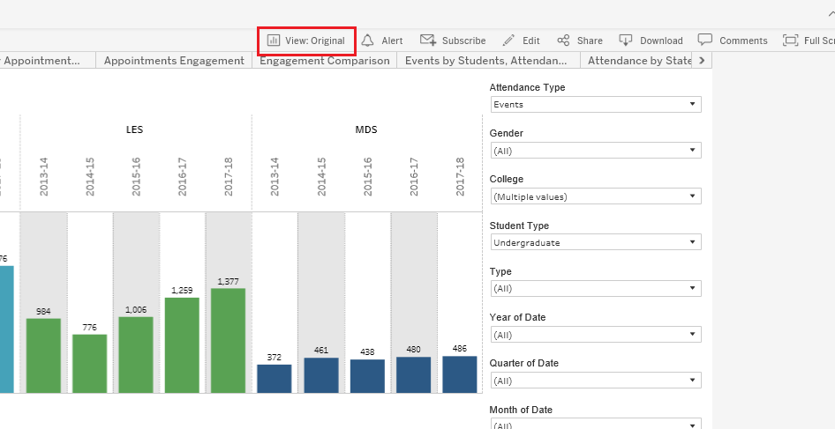
A window will now open in the middle of the screen.
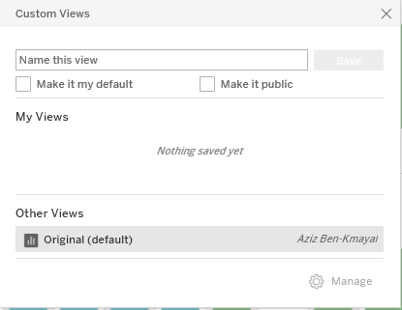
Type the title that you would like this View to have.
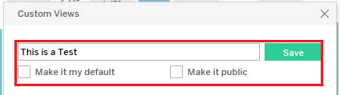
You also have the option to:
- Make it my default: this allows this View to be the default the next time you access this sheet.
- Make it public: this creates a view that all users are able to select. This is not recommended as we have many Tableau users in CN and could create an extensive list of Views that all CN staff will see.
Click Save when title and selection is done.
Once a View has been saved the name of the title will appear on the Options Toolbar
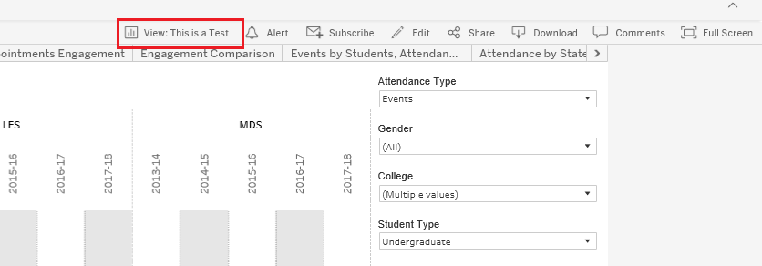
Saved Views can be deleted or renamed by selecting the View button again.
This will open up the same window but with a few slight changes.
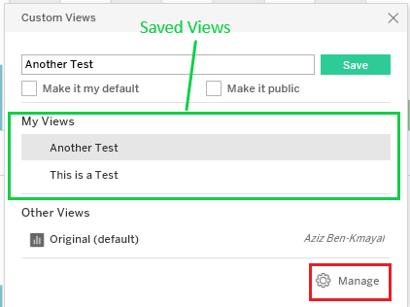
Ensure the View you wish to delete or rename and click on ‘Manage’.
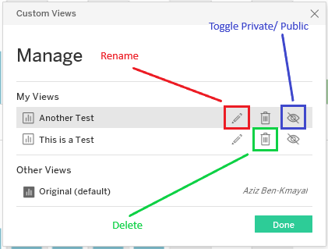
The saved Views will now show three icons that will appears to the right. Select whatever choice you wish and follow the instructions:
- A text field appears to rename the View
- A deletion validation appears to Delete
- Toggle the eye icon on/ off to make it public or private.

Download
This section will allow users to export the underlying data source (Career Registration only), create images (.png files) or convert the View to PDF. Crosstab downloads to Excel are also available for export.
Select ‘Download’ to find the options available.
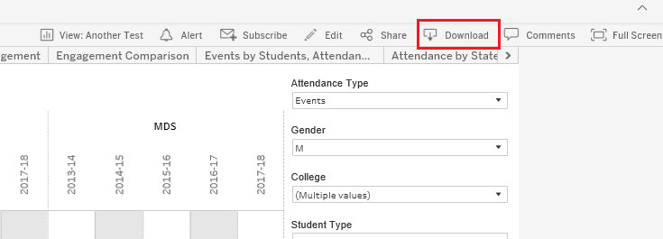
Once selected a new window will open

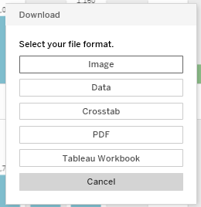
Each option serves a different purpose.

Download: Image
Click the ‘Image’ option and a new small window will appear to ‘Cancel’ or ‘Download’.
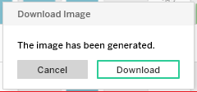
Select Download to generate the image. After a few moments, the web browser will provide you the option to ‘Open’, ‘Save’ or ‘Cancel’.
Please note: This is the option that appears in Internet Explorer and each web browser will differ.
If you agree to ‘Open’ then the default image software, e.g. open in Paint or Photo on Windows 10, will open to allow the user to make edits to the image, print, etc.

Download: Data
Selecting the ‘Data’ option allows the user to export the data into an CSV (Excel) file providing the underlying student level raw data.
Please note: choosing this option without highlighting a single/ multiple bar(s) will provide all records that are used in the view. Also, the ‘Data’ option will not be available on Dashboards that use multiple visuals.
A new window will open once the ‘Data’ option has been selected.
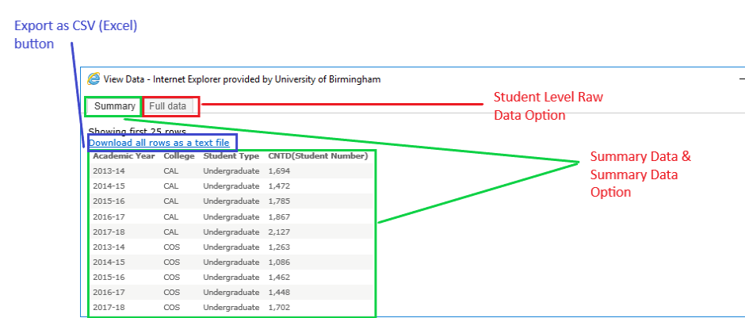

The default position (Summary), has little use so can be ignored but clicking on the ‘Full data’ tab will allow users to access the student level data.
You will now see the data, record by record, and any other value that relates to the view. Ticking the ‘Show all columns’ box will show all of the underlying data for that record. Ticking this box is not necessary for the purpose of Career Registration.
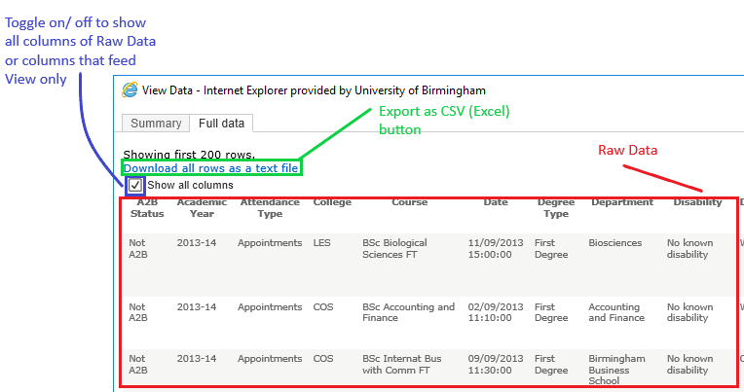

Click on ‘Download all rows as a text file’ to access the CSV (Excel) file.
Your web browser will then provide you with the option to ‘Open’, ‘Save’ or ‘Cancel’.
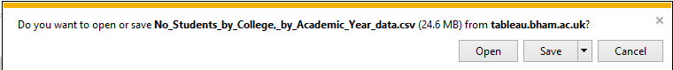
This option will differ depending on web browser.
Select ‘Open’ to view the data.
Please note: the file will may default to a ‘Unicode text’ when attempting to save the file. It is recommended that you save the file as an Excel workbook.

Download: Crosstab
This function creates a table of at least two of the variables that is displayed on the data pane.
Select ‘Crosstab’ to start the export.
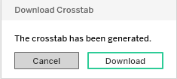
Select ‘Download’
Select ‘Open’ to see the data.

Download: PDF
Selecting PDF will provide the nest option for users of they want to share the dashboards/ worksheets with others as it provides a professional view, including the filters that have been selected. Users can also set the size of the document.
Select ‘PDF’ to generate the export.
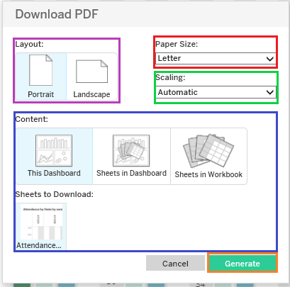
A new window will appear providing options to generate the PDF.
Please ensure you follow these instructions to ensure it displays correctly on the PDF.
Layout: select ‘Landscape’ as all visualisations have been designed to fit this layout.
Paper Size: In most situations it is recommended to select A4.
Scaling: select ‘At most 1 page wide’ to ensure it fits on to one page.
Content: ‘This Dashboard’ will be the go to option as there is no need to select the other options.
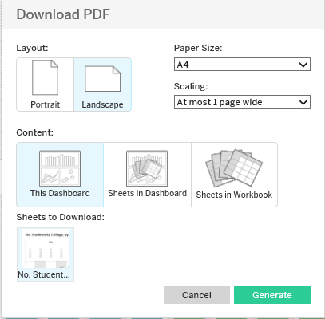
Once you are happy with your selection then press ‘Generate’. A new window will open.
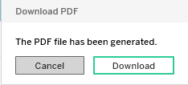
Select ‘Download’
Select ‘Open’, ‘Save’ or ‘Cancel’ when the web browser option opens.

Comments
This is a very useful tool to communicate with fellow staff who have access to the CB Workbooks. Not only can you have a conversation while on a given View, users are also able to share their View with others in the comments section. Conversations are saved and can be accessed at any time.
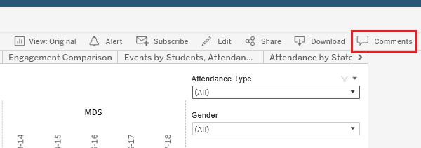
Select ‘Comments’.
The ‘Comments’ pane will appear on the right hand side of the screen.
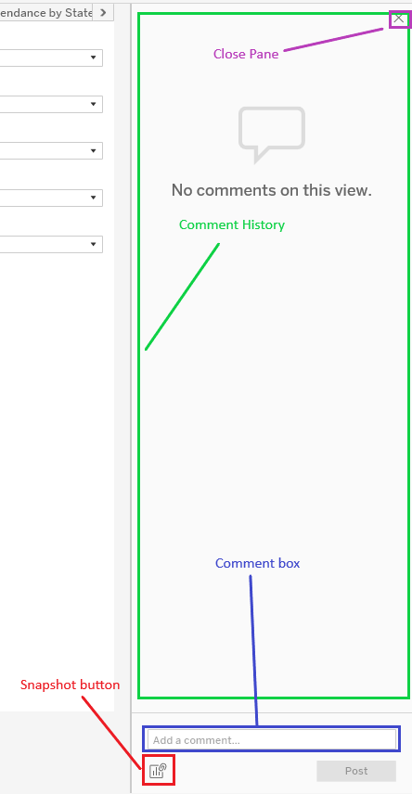
Type in a comment and press ‘Enter’ or click ‘Post’.
The message will now appear in the Comment View with the name of the individual who posted it and the timestamp.
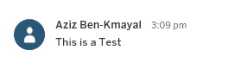
Users are also able to take a snapshot of the View that they have on screen. Click the ‘Snapshot’ button to save this View. The snapshot will appear below the ‘Comment Box. The user can also type in a comment to go with the Snapshot if necessary.
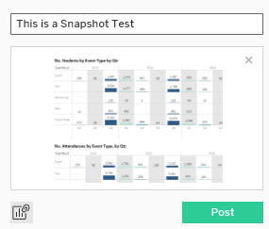
If comment is given then press ‘Enter’ to post it to the Comment Box or alternatively click ‘Post’. Both the comment and snapshot will be added to the Comment View.
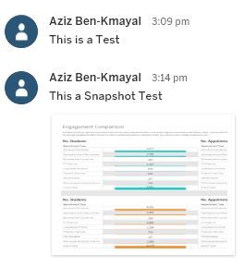
Other users now have the possibility to access your saved data by hovering over the snapshot. If they click on the ‘View’ button that has now appeared on the snapshot they should now see that shared dashboard/ worksheet where took the snapshot.
