Depositing data in the UBIRA eData repository

- Go to https://edata.bham.ac.uk/

- Click login on the top left grey menu and login with your university credentials.

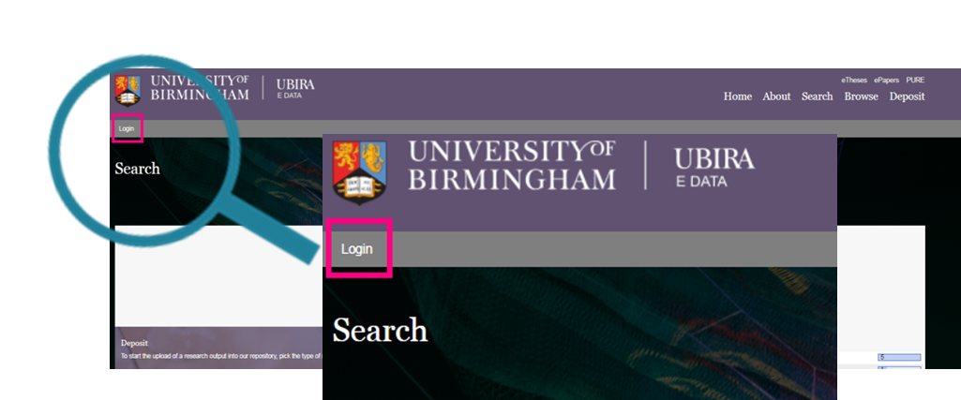

- Once logged in, your main screen will provide an overview of your deposits so far. To upload a new dataset, click “New item” on the top of your deposit dashboard.
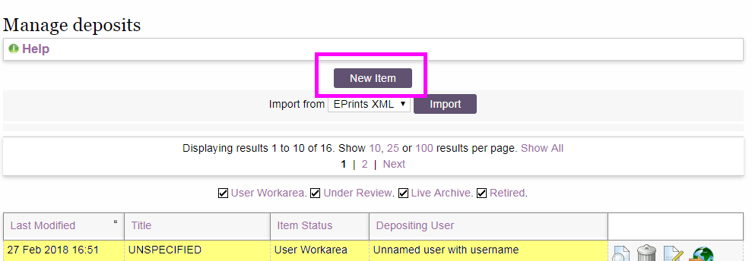

- Upload your dataset files by clicking on “Chose File” and then “upload”. Your dataset should be in an open file format to allow wide re-use. File size is limited to 10 GB. If you would like to deposit bigger files, please contact us at research-data@contacts.bham.ac.uk
Tip: Note down the DataSet # on top of the page if you want to know the DOI for this record before it is minted.

- For each uploaded file, a section will appear asking for some information about the file just uploaded. Note that additional files will be added at the bottom of the page, so you might need to scroll down to see this section for your latest upload.
The minimal information that you will need to provide for each file are access option and licence.
  - 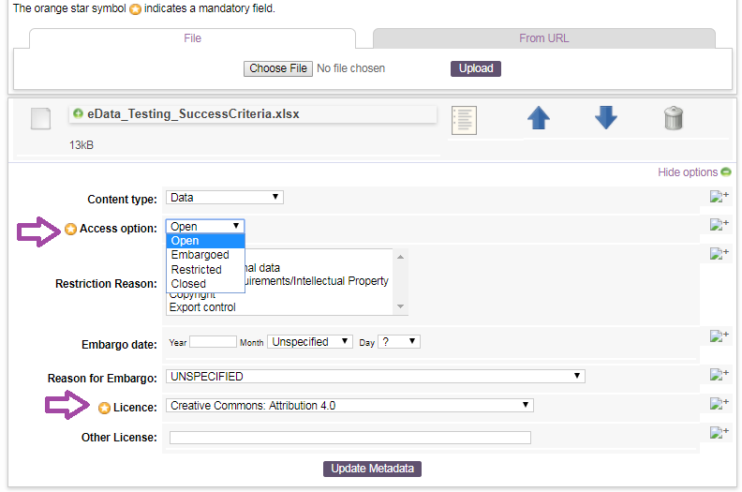
  - Which access option should I pick?
We recommend data to be “open” whenever possible. However, you can also embargo the data and not make it accessible for a period of time or restrict access to data. Data should be restricted if they are of sensitive nature (e.g. still containing personal information as you couldn’t fully anonymise the data). Requests to access the data will be reviewed by an internal panel and data will only be released under appropriate re-use conditions.
  - Which licence should I chose? (open and embargoed files only)
We recommend licensing data under an open licence that allows for wide re-use. In line with various major funders, we thus recommend choosing a CC0 or CC-BY licence, permitting all kinds of re-use – in the case of a CC-BY licence under the condition that the original creators are credited.
If your dataset contains personal data, please provide a copy of your consent form and participant information sheet!

- Click “next” once you have entered all the information about your files. If you would like to stop the deposit at this stage and return later, please click “save and return”. To delete everything you have entered so far, click “cancel”.

- The next page provides you with a submission form to enter as much information as possible to increase the re-usability of your dataset. Fields highlighted with a yellow star are mandatory and need to be filled before you can deposit the dataset. Clicking on the “+” icon on the right will provide you with a description of the information to be provided in the field.

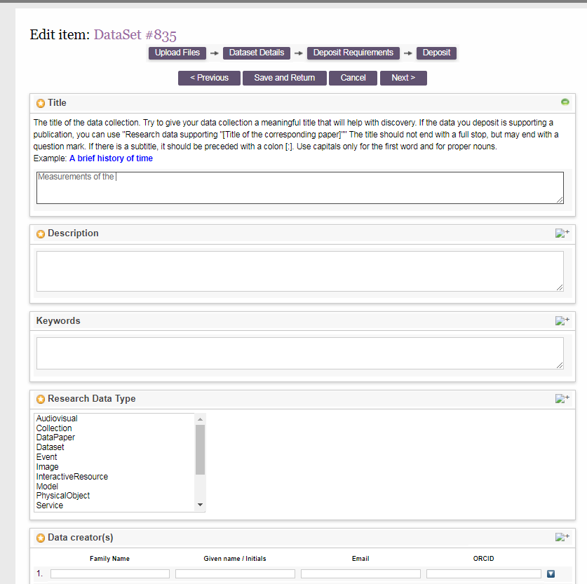

The main information you should provide includes:
  - Title – If your data is supplementing a publication, a popular title is "Research data supporting "[Title of the corresponding paper]" or similar. If you want to promote your dataset as a standalone research output, a meaningful title is recommended.
  - Description – a description of the dataset and why and how the dataset was produced. If you want to provide full documentation of the dataset, we recommend you upload a readme file.
  - Keywords – provide keywords describing the dataset. They can be the same as the ones describing you publication.
  - Research Data Type – pick the most appropriate type describing your dataset. A full set of definitions is available in Appendix A.
  - Data creators – List all the individuals that were involved in creating the dataset. Email and ORCID information is a plus.
  - Date – this is usually the publication date for the data set, thus the day it is approved. As this is difficult to predict, just provide the current month and year and choose “publication” as date type unless you think a different option is more suitable.
  - Managing organisational unit – pick your College
  - UoB School, Department or Institute – provide the name of your School, Department or Institute
  - Contact details – provide a main contact for the dataset. This is especially important if your dataset is embargoed or access restricted as there might be requests for the dataset in the meantime that we would forward
  - Funder – the funders supporting the research the dataset resulted one. If you want to choose more than one funder, press ctrl+alt and select all the relevant funders
  - Project/Grant – provide your grant reference
  - Related Resources – link to any other related resources here. This can be the paper this dataset is supplementary to or the project’s website. Provide the title of the related resource and an URL.
There are additional metadata fields that you can expand and fill if they are relevant to the dataset you deposit.
Click “next” once you have entered all the information about your files. If you would like to stop the deposit at this stage and return later, please click “save and return”. To delete everything you have entered so far, click “cancel”.
- Agree to the deposit requirements statement to let us know that you have considered data protection legislation, your funder and contract requirements and the University Research Data Management Policy before depositing your dataset.

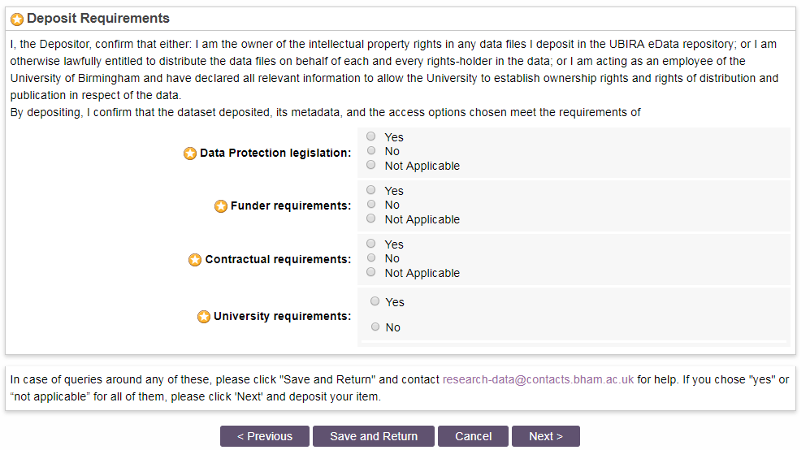

- Click next and either “Deposit Item Now” or “Save for Later” if you want to come back to the record later to add or edit any information.

- Your deposit is not publicly available until it has been approved by a member of the Digital Assets team in the Library who will contact you if further information or clarity is required. A DOI will be minted once the record is approved.
If you noted down the DataSet # at the start, your DOI will be https://doi.org/10.25500/eData.bham.xxxxxxxx where xxxxxxxx will be the DataSet # complemented to 8 digits with 0. So if your DataSet # is 956, the DOI will be https://doi.org/10.25500/eData.bham.00000956 but you should check once the record is approved to confirm.

Appendix A: Description of research data types

Research data type | Description | Examples and notes
Audiovisual | A series of visual representations imparting an impression of motion when shown in succession. May or may not include sound. | May be used for films, video, etc.
Collection | An aggregation of resources, which may encompass collections of one research data type as well as those of mixed types. A collection is described as a group; its parts may also be separately described. | A collection of samples, or various files making up a report.
DataPaper | A factual and objective publication with a focused intent to identify and describe specific data, sets of data, or data collections to facilitate discoverability. | A data paper describes data provenance and methodologies used in the gathering, processing, organizing, and representing the data.
Dataset | Data encoded in a defined structure. | Data file or files.
Event | A non-persistent, time-based occurrence. | Descriptive information and/or content that is the basis for discovery of the purpose, location, duration, and responsible agents associated with an event such as a webcast or convention.
Image | A visual representation other than text. | Digitised or born digital images, drawings or photographs.
InteractiveResource | A resource requiring interaction from the user to be understood, executed, or experienced | Training modules, files that require use of a viewer (e.g., Flash), or query/response portals.
Model | An abstract, conceptual, graphical, mathematical or visualization model that represents empirical objects, phenomena, or physical processes. | Modelled descriptions of, for example, different aspects of languages or a molecular biology reaction chain.
PhysicalObject | An inanimate, three-dimensional object or substance. | Artefacts, specimens.
Service | An organized system of apparatus, appliances, staff, etc., for supplying some function(s) required by end users. | Data management service, or long-term preservation service.
Software | A computer program in source code (text) or compiled form. Use this type for all software components supporting scholarly research. | Software supporting scholarly research.
Sound | A resource primarily intended to be heard. | Audio recording.
Text | A resource consisting primarily of words for reading. | Grey literature, lab notes, accompanying materials.
Workflow | A structured series of steps which can be executed to produce a final outcome, allowing users a means to specify and enact their work in a more reproducible manner. | Computational workflows involving sequential operations made on data by wrapped software and may be specified in a format belonging to a workflow management system, such as Taverna (http://www.taverna.org.uk/)

