University Open Access Fund Policy

Background
The publishing landscape has become increasingly complex as the transition to Open Access progresses. Whilst Research England’s REF Open Access Policy promotes a Green Open Access route, key funders advocate a Gold route and have made available funding to support this. In the case of Wellcome and several other medical charities, as well as UKRI, this takes the form of block grants provided to Universities to pay Article Processing Charges (APCs). Publishers have taken a variety of paths to accommodating both the Green and Gold Open Access routes and navigating the Gold route in particular is complex as publisher charges are often closely tied to journal subscriptions.
The University is in receipt of block grants from UKRI and the Charities Open Access Fund (COAF) and maintains its own Internal Open Access Fund (IOAF), all of which are managed centrally by Library Services. Through the successful pursuit of an Open Access agenda alongside a growth in published outputs and stricter funder mandates for Open Access, those funds are increasingly stretched. Increased demand for and costs of Gold Open Access have required deferral of a significant overspend (31%) from the 2017/18 UKRI open access budget to the 2018/19 UKRI grant, highlighting the need for more considered use of available Open Access funding. This policy lays out how each of the three centrally managed Gold OA funds are to be used and managed effectively, along with the responsibilities of Researchers, Colleges and Library Services in publishing via the Gold OA route.

Rationale
This policy aims to ensure that:
- Academic freedom to publish in the journals that are most appropriate, is maintained
- Authors are able to comply with funder Open Access mandates
- APC funding is distributed fairly across the University
- The University actively engages and supports the transition to Open Access
- The University receives the best value for money possible from the subscription and publishing activities its purchases from publishers
The policy is underpinned by the rationale that the transition to Open Access is better served by supporting Fully Open Access Journals and those publishers which are using Hybrid publishing in a transitionary manner, rather than as an additional revenue stream.

Scope
- This policy should be read by researchers, research managers, research administrators and library staff
- The policy covers the publication via the Gold OA route of research articles in scholarly journals. The funds in question are not available to fund other forms of Open Access scholarly publishing such as Monographs

Policy Statement

Open Access Funds and eligibility
- Library Services are responsible for management of the Internal Open Access Fund, the Charity Open Access Fund (COAF) and the UKRI Open Access Block Grant, including all required reporting associated with these funds
- The Internal Open Access Fund (IOAF) is only available for University of Birmingham authors who choose to publish in a reputable Fully Open Access journal, where no alternative funding is available. Alternative funding includes both projects funded by one of the COAF charities or UKRI, and funding which makes alternative arrangements for payment of APCs. The IOAF may be used as a last resort, funds permitting, where either the COAF or UKRI block grant have been fully spent and an author is publishing in a Fully OA journal.
- Within any given financial year, once the Internal Open Access Fund has been fully committed, no further funds will be available until the start of the subsequent financial year. In such circumstances, Library Services will contact publishers on behalf of authors to request a fee waiver, but where this is not granted authors will need to either:
  - Seek alternative funding
  - Publish in an alternative journal which does not require payment of an APC
  - Wait for funding to become available at the start of the next academic year
- The Charity Open Access Fund (COAF) is made available to any University of Birmingham author in receipt of a qualifying research grant to pay Gold OA APCs as required by the relevant charity’s Open Access Policy. This covers publication in both reputable Fully Open Access titles and qualifying Hybrid Open Access titles
- Within any given funding period (October to September), should granted funds become fully committed, Library Services will notify COAF and where possible secure additional funds or advise authors on permitted use of the research grant itself, depending on individual charity policy. If no further funding can be secured:
  - authors publishing in Fully Open Access titles may be entitled to utilise the IOAF (Para.2)
  - authors publishing in Hybrid titles will be required to publish behind a paywall and take a compliant Green OA route as advised by Library Services in negotiation with the relevant charity
- The UKRI Block Grant is made available to primarily support the payment of APCs, but may also be used to fund other institutional services which facilitate delivery of the RCUK Policy on Open Access. As such a proportion of the block grant is set aside to fund non-APC activities including:
  - A proportion of staff costs dedicated to the administration of the block grant
  - Up front publisher charges to secure discounted / no cost APCs, where such deals provide value for money
  - Research systems which support the open access agenda (e.g ORCID, Datacite)
- The UKRI Block Grant is not sufficient to meet all of the requests for APC payments from potentially qualifying authors and offers no top-up mechanism. As such the University will attempt to meet the UKRI expectations for research organisations by allocating funds in a transparent manner which will best achieve the aims of the UKRI Open Access policy.
- The UKRI Block Grant is made available to any University of Birmingham author in receipt of a qualifying research grant to pay Gold OA APCs for articles published in a reputable Fully Open Access journal or a hybrid journal published by a University endorsed publishers (see Para. 10 for exceptions) which meet the requirements of the UKRI Open Access Policy.
- A full list of University endorsed publishers is maintained on the Library Services Open Access web pages (https://intranet.birmingham.ac.uk/openaccess/ukri). Publishers are included on the list if they are demonstrably supporting the transition to Open Access by either:
  - Making a substantial proportion of their titles Fully Open Access
  - Providing the University of Birmingham a reasonable total cost of ownership for titles, demonstrated by the offsetting of a significant proportion of APC charges against subscription costs.
  - Engaging in community led schemes which substantially reduce the administrative burden of Open Access (e.g. JISC Router)
- The UKRI Block Grant will be made available for publication in hybrid titles which are not on the University endorsed publisher list if they meet the compliance requirements of the UKRI Open Access Policy and either:
  - The paper is funded by the MRC and the journal does not allow a Green embargo shorter than 6 months
  - An exception request is submitted to library services on the Exceptional APC request form and forward for approval to the relevant Director of Research or their proxy. Such approval is typically only given for papers of 4* quality which will also have significant impact beneficial to either the public good or reputation of the University of Birmingham, should immediate and wide-scale access be provided.
- Restrictions on spending against the UKRI block grant (Para. 8) are designed to ensure funds remain available for eligible papers throughout the grant period. A review of spending will be carried out three months ahead of the grant period end date. Any predicted underspend will be made available to colleges via Directors of Research to retrospectively make Gold any eligible high quality, papers in non-University endorsed journals which are deemed to have demonstrated significant impact since publication.
- Should the UKRI block grant become fully committed within a given grant period (April to March):
  - authors publishing in Fully Open Access titles may be entitled to utilise the IOAF, if funds permit (Para. 2)
  - authors publishing in Hybrid titles will be required to publish behind a paywall and take a compliant Green OA route
- Should any OA funds become fully committed during the relevant funding period, this will be communicated to Research Committee members and relevant information for authors will be placed on the library Open Access web pages so that it is visible at the point of application

Requesting APC funds
- All requests to fund APCs from one of the three central funds must be made via the standard or exception APC request forms available from the Library Open Access web pages, by an author on the paper who is also an employee of the University of Birmingham
- Library Services are responsible for reviewing all requests for use of central Gold OA funds which will include:
- Ensuring the proposed journal meets relevant funder requirements
- Ensuring the proposed journal publisher is authorised for use of the specific Gold OA fund and processing any exception requests received
- Identifying the most appropriate Gold OA fund
- Applying any applicable cost saving plans and advising the author of how to take advantage of these
- For articles proposed for publication in Fully Open Access journals, confirmation of the availability of funding must be received from Library Services before the article is submitted to the journal
- For articles proposed for publication in Hybrid Open Access journals, the article may be submitted for publication prior to contacting library services, but confirmation of the availability of funding must be received from Library Services before agreeing a Gold OA charge and requesting an invoice
- Any queries authors may have regarding eligibility for use of Gold OA funds or publisher T&Cs may be directed to the dedicated library services mailbox (openaccesspublications@contacts.bham.ac.uk)
- Where authors are found to be in breach of paragraphs 16 or 17, Library Services will advise them and their Director of Research via email. Where such breaches involve hybrid articles funded by UKRI and published in a title that is not authorised for use of that fund, Library Services will contact the publisher to request that the article is published behind a paywall at no charge and the author will be responsible for ensuring the Author Accepted Manuscript (AAM) of the article is made available via the Green OA route in PURE immediately.
- All articles, irrespective of publication route, must have a record created in PURE, along with a copy of the author accepted manuscript or the final published version depending on licence and publisher permissions
- Authors must ensure that all relevant funders are acknowledged in papers for which APC requests are made. Where multiple funders are acknowledged, Library Services will identify the most appropriate fund and ensure that over the year, costs are distributed fairly and evenly between the COAF and RCUK funds.
- For articles published in collaboration with other institutions, authors must ensure that multiple papers resulting from that collaboration are distributed fairly between institutions for APC payment.

Ineligible Costs
- Centrally managed Open Access funds may not be used to pay for:
- Additional page charges above and beyond the quoted APC rate
- Colour charges

Procedures
Key author workflows are provided in Appendix 1

Responsibilities

Library Services
- Budget management
- Identification of and access to publisher offsetting deals which reduce the total cost of ownership (subscription charge + APC charge) for the University
- Review and approval of APC requests
- Author guidance
- Post publication verification
- Funder Compliance monitoring
- Invoice payment
- Reporting (including both mandatory reporting in line with funder requirements and monthly and annual spending reports for Research Committee)

Directors of Research
- Approval of exceptional requests

Researchers
- Submitting requests for APC payment according to this policy
- Acknowledge funder in research papers
- Recording publications in PURE

Definitions
Article Processing Charge (APC) | Fee levied by some publishers of Fully Open Access and Hybrid Journals to make a paper available on an open access basis.
Fully Open Access Journal | A journal which uses a funding model that does not charge readers or their institutions for access to any content, nor provide any other barrier to access.
Green Open Access | Articles are made openly available and discoverable for free to readers by depositing a copy in a repository. Publishers may require that the copy deposited is the author accepted manuscript and may require an embargo period before the article is made open
Gold Open Access | The final published version of an article is made openly available and discoverable for free to readers via the publishing journals web site, often for payment of an APC. Most funders which provide APC support require articles published in Fully Open Access journals to be made available under a CC-BY licence at the point of publication to maximise reuse.
Hybrid Journal | A Journal which charges a subscription to individuals and institutions for access to the full content, but which also publishes some content (typically paid for via an APC) on a Gold Open Access basis
Reputable Journal | The rise of pay to publish models in scholarly publishing has seen some disreputable practice emerge to take advantage of APC funding without providing the full academic rigour expected around quality control, peer review and other good publishing practice. It is important that authors ensure they are publishing in reputable journals. A useful tool to assess the trustworthiness of a journal from an unknown publisher is https://thinkchecksubmit.org/
Total Cost of Ownership | The total cost to the University for both access to and publishing in a particular journal or journal package. For hybrid journals, we would expect publishers embracing the transition to open access to be transparent about how APCs charges are offset against subscription charges to avoid significant escalation of the total cost of ownership.

Policy Review
October 2019

Appendix 1 – Gold OA Author Workflow

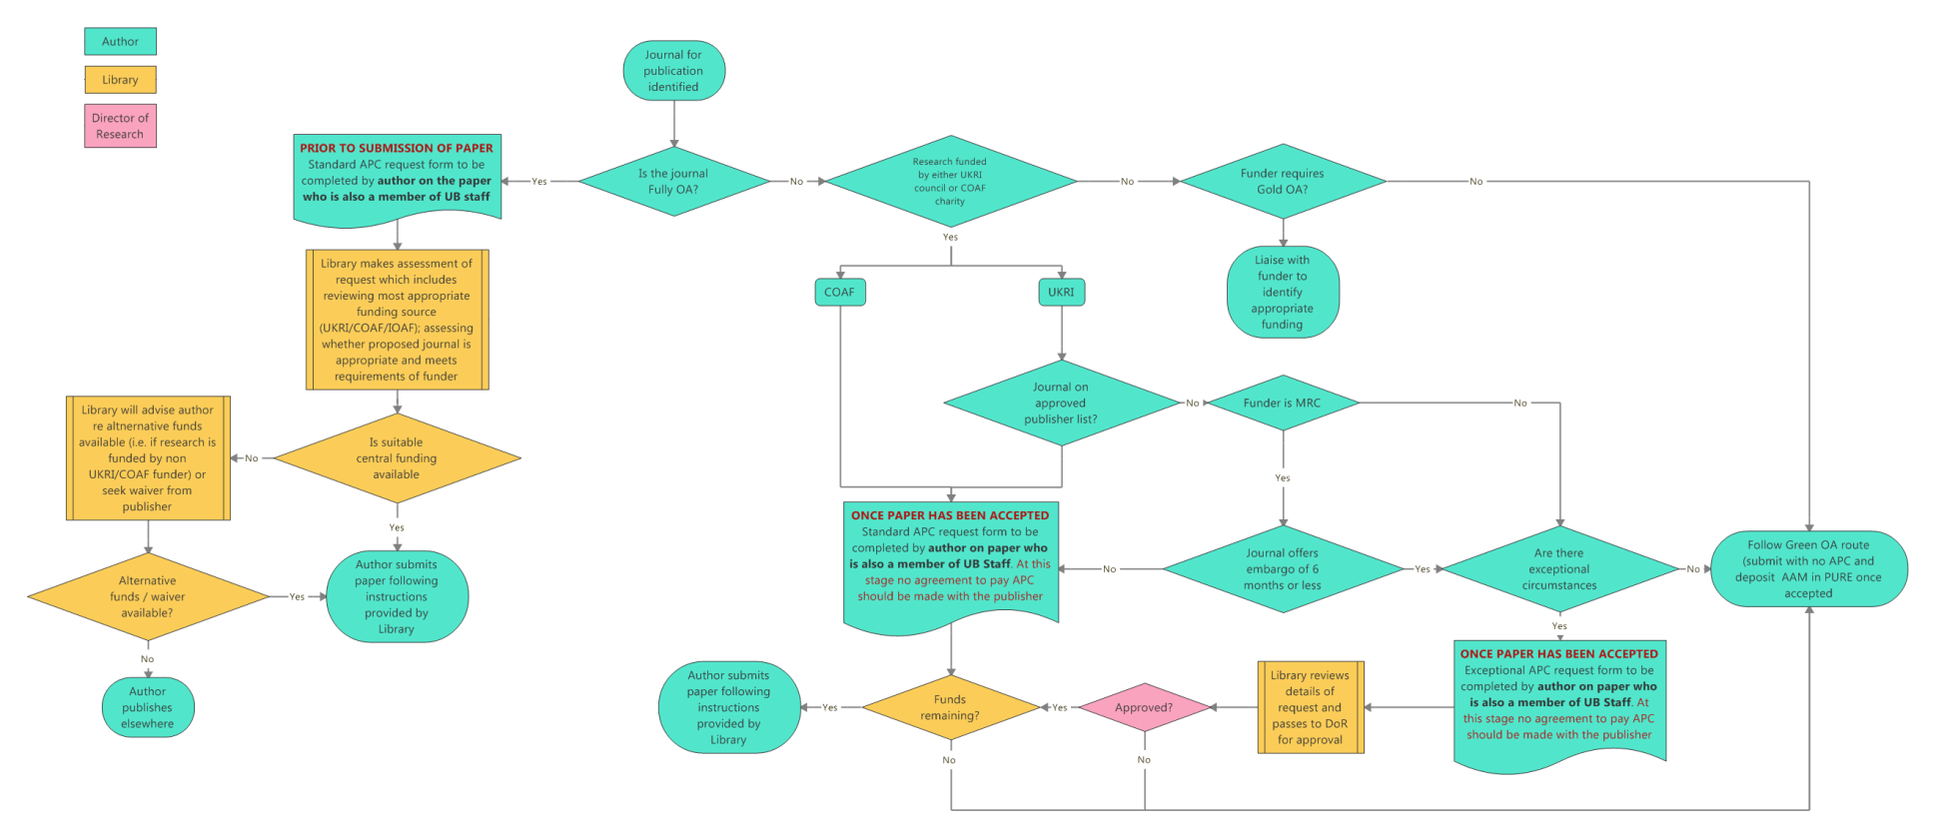

Library Services can advise on research funder policies in relation to OA monographs and it should be noted that while Wellcome only fund journal articles via the COAF, they require monographs and chapters to be made available on an Open Access basis and make funds available directly to authors for such activity
For example, NIHR and H2020 would expect authors to make provision for the payment of APCs from the original research grant
https://wellcome.ac.uk/funding/guidance/charity-open-access-fund
Those which meet the licence and repository deposit requirements imposed by the relevant charity’s OA Policy
The UKRI Open Access Policy acknowledges that we are in a transitionary phase towards open access and states that “Institutions may use the block grant in a manner they consider will best deliver the RCUK Policy on Open Access in a transparent way that allocates the funds fairly across the disciplines and across researchers at different states in their careers” (p. 3). It further provides provision for researchers who do not have access to funding for APCs during the transition period to publish via the Green route in journals with longer embargoes of 12 / 24 months (STEM / arts, humanities and social sciences) (p.6) . As such, it is legitimate for authors for whom block grant is no longer available under the present University policy on Gold Open Access Funding, to publish in titles of their choosing so long as those titles offer the less stringent Green Open Access embargo periods compatible with the REF OA policy and the AAM is deposited in PURE accordingly.
RCUK (now UKRI) Open Access Policy - https://www.ukri.org/funding/information-for-award-holders/open-access/open-access-policy/
The MRC Open Access Policy does not allow any extension of the Green embargo irrespective of funding available and takes precedence over the UKRI policy

