Development Needs Analysis
GRS1

“The Development Needs Analysis process is about exploring what you are hoping to get out of your research programme and identifying the support that’s required to help you get there.” - Professor Gavin Schaffer, Postgraduate Dean

Successful and timely completion of your research degree will depend on developing a mixture of subject-specific skills, intellectual skills such as critical thinking, and more generic skills like communication and enterprise. Many of these skills will also be important in your future life, whatever career or life choices you make.

The Development Needs Analysis (DNA) form uses Vitae’s Researcher Development Framework (RDF) to help you create a personal development plan. This will require you to think about your current skills, pinpoint gaps in your knowledge, and identify areas for future development. The RDF articulates the knowledge, behaviours and attitudes of excellent researchers from postgraduates to established academic leaders and is endorsed by the UK Research Councils.

You can find advice on completing the DNA in Appendix 1, suggested development activities listed by RDF Domain in Appendix 2, and an abbreviated version of the RDF in Appendix 3. Some examples are also given in the form (in italics) to help you.

Personal Development Plan

RDF Domain A: Knowledge and intellectual abilities

RDF Descriptor | Planned activity | What will I achieve? | Support / resources | Deadline

RDF Domain B: Personal effectiveness

RDF Descriptor | Planned activity | What will I achieve? | Support / resources | Deadline
B2.5 Work-life balance | Discover sources of support and advice across the University  Build my social network amongst my peers | I know where to turn to for support/advice on a range of wellbeing issues  I have one or two peers I share my experiences with for mutual benefit | University intranet, College/School welfare officers, my mentor  PGR Community at Westmere | Within 3 months of programme start date  ongoing

RDF Domain C: Research governance and organisation

RDF Descriptor | Planned activity | What will I achieve? | Support / resources | Deadline
C1.1 Health and safety | Contact local Health & Safety representative to find out about and attend relevant training | I understand health and safety issues as they relate to my research, and adopt responsible working practices | Local Health & Safety rep | Within 3 months of programme start date
C1.2 Ethics and principles and sustainability | Discuss ethical implications of project with supervisor  Attend appropriate ethics training, if available | I understand and apply relevant codes for ethical conduct of my research  My supervisor has applied for ethical approval for my research project | My supervisor and relevant ethical review forms | Within 6 months of programme start date
C2.2 Project planning and delivery | Attend a workshop/online course on data management planning  Write a data management plan (DMP) | My DMP is signed off by my supervisor for GRS3 | Library Services’ workshops and Canvas course  My supervisor | Within 9 months of programme start date

RDF Domain D: Engagement, influence and impact

RDF Descriptor | Planned activity | What will I achieve? | Support / resources | Deadline

These development activities:
- are in the best interest of the postgraduate researcher;
- require support/resources which are available;
- will be reviewed regularly, at least annually.

The postgraduate researcher is responsible for ensuring these development activities are carried out.

 | Name (printed) | Signature | Date
Postgraduate researcher

Supervisor

Co-supervisor(s)

Appendix 1: How to complete the DNA

- The completed DNA form is an action plan for your development activity over the next 12 months. For each of the domains of the RDF, identify a few (2-4) priority areas for development and the development activities that will enhance your abilities in these areas.
- The form provides space for you to indicate how you will know when you have achieved your goal for development in this area (“what will I achieve?”) and a space for when you want to achieve this by (“deadline”). This is to help you ensure your action plan activities are SMART (Specific, Measureable, Achievable, Relevant, Timely).
- The form also provides space for you to indicate the people and resources which will support you in meeting your development needs.
- You should complete the form in discussion with your supervisor.

Carrying out a personal skills gap analysis

Set out here is a systematic, step-wise approach to identifying your development needs and putting together your development action plan for your DNA form. You’re welcome to follow this process to complete your form.

- Identify areas of priority
Think about the skills, knowledge and behaviours that a postgraduate researcher in your position would particularly need to possess during the next 12 months. Vitae’s Researcher Development Framework (RDF) is there to help you do this, by articulating in 63 descriptors (in 4 domains and 12 sub-domains) the knowledge, behaviours and attributes of successful researchers, as compiled following extensive interviews with researchers and other key stakeholders in research. See Appendix 3 for an abbreviated version of the RDF. It is suggested that you select between two and four descriptors from each domain of the RDF; this will ensure your development aims are realistic, and also that you are developing as a well-rounded researcher. Do not forget to include priorities which relate to your future intended career, as well as those which will support your current research activity.

If you have recently started your research programme, you may find the Getting Started in Research Lens on the RDF useful to help you identify appropriate priorities.

- Make notes on your previous experience and skill in these areas
For each of the areas of priority that you have identified, write down examples of your previous activity in this area, being as specific as possible. This is an opportunity to acknowledge your existing abilities and recognise your strengths. Discuss these with your supervisor to ensure you have accurately reflected your current abilities.

- Set out clearly what you want to be able to achieve in these areas within the next 12 months
The key here is to be specific and realistic about the outcomes you are hoping for. What exactly will you achieve? For example, “I’d like to be better at communicating my research” could be more usefully articulated as “I want to be able to confidently present my research to a specialist audience via an oral presentation”. Again, your supervisor can support you in identifying realistic and relevant goals.

If you are referring to the full RDF to help you understand what progression in these areas might look like, please remember that the RDF applies to researchers across their entire research career, so as a general guideline, you will be looking to achieve phases 1 & 2 over the course of a doctoral research programme.

- Is there a gap between your existing skills and where you need to be?
Looking at your notes from steps 2 and 3, you should be able to identify whether or not you feel there is a development gap. If your previous experience indicates that you are already capable of achieving your aim without further development, that’s great – you do not need to record this on your DNA development plan, or you can record this by proposing your development activity is “learning by doing” the outcome you identified in step 3.

If you have identified a development gap, you can start to think about what you might need to do to close that gap.

- Identify SMART development activities and any support you need to help you close the gap
When choosing development activities, remember to take account of your learning preferences and what’s available to you (see Appendix 2). Ensure that your activities are SMART:
Specific – record this under “planned activity”
Measureable – referring to step 3, record this under “what will I achieve?”
Achievable – this should be built in from step 3
Relevant – this should be built in from step 1
Timely – record this under “deadline”

If you will need any support (e.g. from your supervisor) or resources (e.g. conference fee), record this under “support/resources”. Be as specific as possible.

Appendix 2: Development opportunities

The following development opportunities and resources are available to all PGRs, in addition to any School- or College-level opportunities that may be available to you:

- PGR Development workshops and online courses
- UoB PGR Development blog
- University Graduate School Engagement Activities
- Library Services Research Support
- Research Support from IT Services and Digital Skills Training

RDF Domain A: Knowledge and intellectual abilities

Links to related advice and resources for Knowledge and intellectual abilities from Vitae

RDF Domain B: Personal effectiveness

PGR Careers Advice at the University of Birmingham
Counselling and wellbeing at the University of Birmingham
Links to related advice and resources for Personal effectiveness from Vitae

RDF Domain C: Research governance and organisation

Links to related advice and resources for Research governance and organisation from Vitae

RDF Domain D: Engagement, influence and impact

Introduction to learning and teaching in higher education for postgraduates (ILT) at the University of Birmingham
Links to related advice and resources for Engagement, influence and impact from Vitae
Think: Public Engagement

Appendix 3: Abbreviated Researcher Development Framework from Vitae

It is strongly recommended that you familiarise yourself with the full RDF, as available via Vitae’s website. However, for those encountering the RDF for the first time, you may find the following abbreviated version helpful for familiarisation.

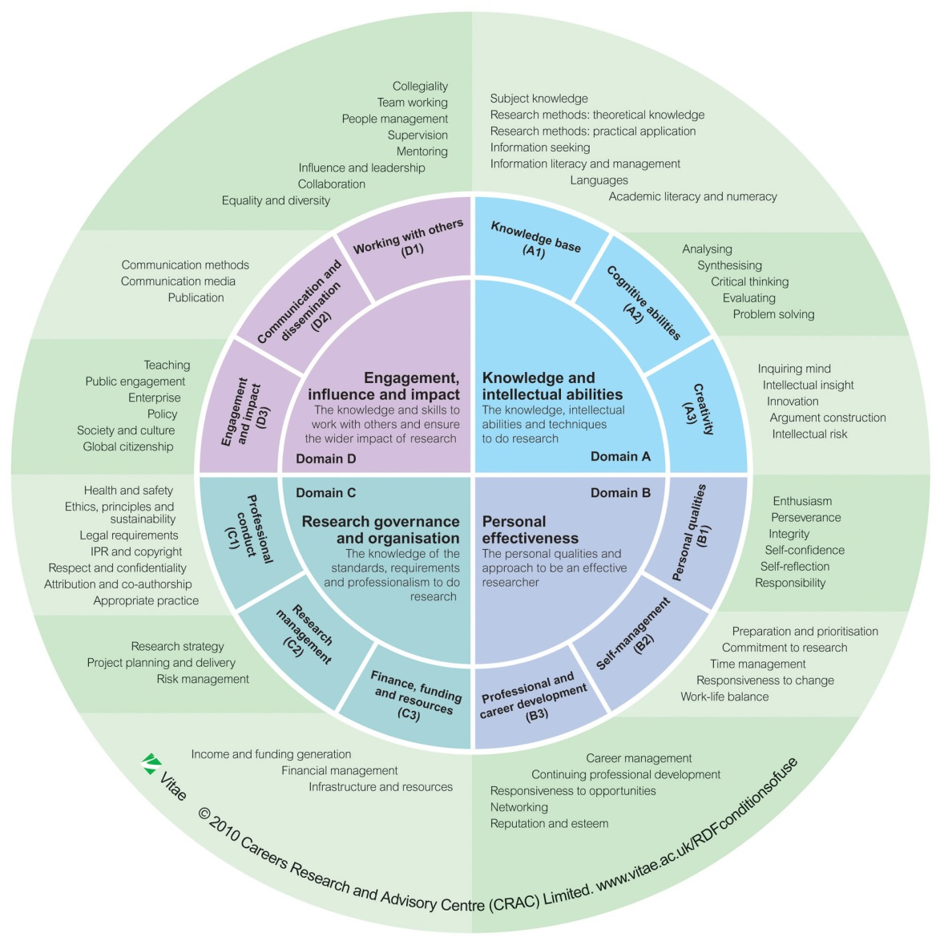
Domain A: Knowledge and intellectual abilities
The knowledge, intellectual abilities and techniques needed to be able to carry out excellent research
A1. Knowledge base:  - Subject knowledge  - Research methods – theoretical knowledge  - Research methods – practical application  - Information seeking  - Information literacy and management  - Languages  - Academic literacy and numeracy | Do you have….  Knowledge of:  - The area of research, the advances within it and its relationships with other research areas  - The methods and experimental techniques appropriate for research design  - Sources of information, bibliographic software and other information technologies  - Literacy and numerical skills and language abilities appropriate for research  Behaviour to:  - Make original contributions to knowledge  - Identify, apply and develop methods and experimental techniques appropriate for research projects  - Conduct effective and comprehensive information searches  - Record, manage and handle information/data using appropriate bibliographic software and other information technologies
A2. Cognitive abilities:  1. Analysing  2. Synthesising  3. Critical thinking  4. Evaluating  5. Problem solving | Do you have…  Behaviour to:  - Analyse and evaluate findings using appropriate methods  - Think originally, independently and critically; develop theoretical concepts  - Critically synthesise information from diverse sources  - Evaluate progress, impact and outcomes of research  - Recognise and validate problems; formulate and apply solutions to a range of research problems  Attitude to:  - Be willing to give and receive constructive criticism
A3. Creativity:  1. Inquiring mind  2. Intellectual insight  3. Innovation  4. Argument construction  5. Intellectual risk | Do you have…  Behaviour to:  - Develop new ways of working; have novel ideas and realise your potential  - Identify new trends; create new opportunities  - Develop convincing and persuasive arguments to defend research  - Take intellectual risks; challenge the status quo  Attitude to:  - Take a creative, imaginative and inquiring approach to research  - Be open to new sources of ideas

Domain B: Personal effectiveness
The personal qualities, career and self-management skills required to take ownership for and engage in professional development
B1. Personal qualities:  1. Enthusiasm  2. Perseverance  3. Integrity  4. Self-confidence  5. Self-reflection  6. Responsibility | Do you have….  Attitude to:  - Approach research with enthusiasm, passion and confidence  - Be resilient and persevere in the face of obstacles  - Be self-reflective; seek ways to improve performance and strive for research excellence  - Be pro-active, independent, self-reliant and take responsibility for self and others  - Show integrity
B2. Self-management:  1. Preparation and prioritisation  2. Commitment to research  3. Time management  4. Responsiveness to change  5. Work-life balance | Do you have…  Behaviour to:  - Anticipate and respond to directions and trends in research  - Plan, prioritise and conduct research in proactive way  - Deliver research projects and results on time and effectively  - Develop awareness of, and help to achieve work-life balance for self and colleagues  Attitude to:  - Have a strategic approach to research  - Have focus, commitment and ambition  - Be flexible and responsive to change
B3. Professional and career development:  1. Career management  2. Continuing professional development  3. Responsiveness to opportunities  4. Networking  5. Reputation and esteem | Do you have…  Knowledge of:  - Career and employment opportunities inside and outside academia  Behaviour to:  - Take ownership of and manage professional development  - Show commitment to continuing professional development and enhancing employability  - Maintain and develop relevant skills set and experience in preparation for a wide range of opportunities within and outside academia  - Actively network for professional and career purposes and seek to enhance research reputation and esteem  - Decide between career options and plan accordingly

Domain C: Research governance and organisation
The knowledge of the standards, requirements and professional conduct that are needed for the effective management of research
C1. Professional conduct:  1. Health and safety  2. Ethics and principles and sustainability  3. Legal requirements  4. Intellectual property rights and copyright  5. Respect and confidentiality  6. Attribution and co-authorship  7. Appropriate practice | Do you have…  Knowledge of:  - Health and safety issues, confidentiality and ethical requirements of his/her research field  - The legal requirements and regulations relating to the area of research and the research environment  - The principles of intellectual property rights (IPR) and copyright issues, as they relate to research, its commercialisation and dissemination Organisational and professional requirements and environmental impact of research  - The concept of corporate social responsibility  Behaviour to:  - Respect, acknowledge and attribute the contribution of others  - Seek to protect, where appropriate, the intellectual assets arising from research and to maximise the wider value of research findings  - Act with professional integrity in all aspects of research governance  - Use institutional/organisational resources responsibly and appropriately Seeks ways of working in a sustainable manner
C2. Research management:  1.Research strategy  2. Project planning and delivery  3. Risk management | Do you have…  Knowledge of:  - The contribution of research to the health of disciplines and institutional missions  - Project management tools and techniques  Behaviour to:  - Apply appropriate project management tools and techniques  - Set goals and plans and manage resources to deliver results  - Effectively assess and manage risks  - Evaluate the effectiveness of research projects
C3. Finance, funding and resources:  1. Income and funding generation  2. Financial management  3. Infrastructure and resources | Do you have…  Knowledge of:  - The requirement for research income generation and financial management  - Mechanisms for funding, the range of funding sources and the processes for making applications  - Local administrative systems, reporting procedures and infrastructure processes  Behaviour to:  - Responsibly manage finances, resources and infrastructures related to research

Domain D: Engagement, influence and impact
The knowledge, understanding and skills needed to engage with, influence and impact on the academic, social, cultural, economic and broader context
D1. Working with others:  1. Collegiality  2. Team working  3. People management  4. Supervision  5. Mentoring  6. Influence and leadership  7. Collaboration  8. Equality and diversity | Do you have…  Behaviour to:  - Actively work in an inclusive, respectful and constructive way with colleagues, stakeholders and research users  - Recognise and acknowledge the contribution of others and own part in team success  - Build relationships in academic and commercial contexts; approachable and interact constructively with others; manage expectations and resolve conflict  - Supervise, mentor and develop the potential of less experienced researchers and colleagues through support and advice  - Lead, motivate and influence where appropriate; persuade through listening and convincing discussion  - Build and sustain collaborative relationships and work pro-actively to create and develop knowledge with a range of stakeholders, including researchers, funders and users of research  Attitude to:  - Respect the inclusive and collegial manner in which researchers conduct relationships within and beyond academia  - Recognise the potential for working in sustained partnerships with a range of stakeholders to generate new ideas, insights and maximise the potential for wider societal and economic impact  - Respect individual difference and diversity
D2. Communication and dissemination:  1. Communication methods  2. Communication media  3. Publication | Do you have…  Knowledge of:  - Appropriate communication and dissemination mechanisms for different audiences  - The importance of engaging in the processes of publication and dissemination of research results and impacts  Behaviour to:  - Communicate effectively in both written and oral modes with a range of audiences formally and informally through a variety of different techniques and media  - Actively engage in publication and dissemination of research results and impacts
D3. Engagement and impact:  1. Teaching  2. Public engagement  3. Enterprise  4. Policy  5. Society and culture  6. Global citizenship | Do you have…  Knowledge of:  - Global, organisational, cultural, economic, and environmental contexts, and the wider impact of research  - The social and ethical implications of research, and public attitudes to these issues  - The range of mechanisms to support knowledge transfer and maximise the impact of research in academic, economic and societal contexts  Behaviour to:  - Engage with and share research through research-informed and student-focused teaching  - Contribute to increasing public awareness, engagement and understanding of research and associated impacts  - Identify innovative trends, ideas and applications; be enterprising and entrepreneurial within and beyond academia  - Work collaboratively with all stakeholders to create, develop and exchange research knowledge to influence and benefit policy development, society and the economy; seeks new outlets and promotes the application of research in innovative ways  - Appreciate and work with diversity and difference in research and education

