SELLY OAK SHUTTLE BUS SERVICE

**TERM TIME ONLY TIMETABLE**

**Monday - Friday**

|  |  |  |  |  |  |  |  |  |  |  |  |
| --- | --- | --- | --- | --- | --- | --- | --- | --- | --- | --- | --- |
| **Ring Road – Down from Guild Bridge** | **8.30** | **9.30** | **10.30** | **11.30** | **12.30** | **13.30** | **14.30** | **15.30** | **16.30** | **17.30** | **18:00** |
| **Opposite New T&L Building** | **8.32** | **9.32** | **10.32** | **11.32** | **12.32** | **13.32** | **14.32** | **15.32** | **16.32** | **17.32** | **18:02** |
| **Selly Oak , Weoley Park Road** | **8.39** | **9.39** | **10.39** | **11.39** | **12.39** | **13.39** | **14.39** | **15.39** | **16.39** | **17.42** | **18.12** |
| **Opposite New T&L Building** | **8.48** | **9.48** | **10.48** | **11.48** | **12.48** | **13.48** | **14.48** | **15.48** | **16.48** | **17.52** | **18.20** |
| **Ring Road – Down from Guild Bridge** | **8.50** | **9.50** | **10.50** | **11.50** | **12.50** | **13.50** | **14.50** | **15.50** | **16.50** | **17.54** | **18.22** |

**Term Time only Service also service will not run on Bank Holidays 2nd May; 2nd and 3rd June 2022**

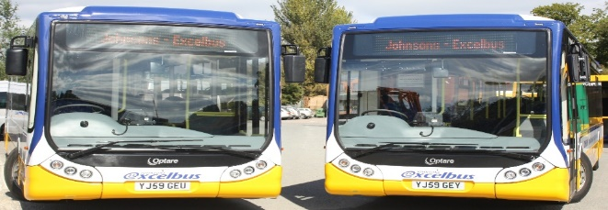**Operational Dates excluding Weekends and Bank Holidays**

**20 Sept – 17 Dec 2021  
10 Jan – 1 Apr 2022  
25 Apr – 24 Jun 2022**