**Athena Swan Silver application form for departments**

**Applicant information**

|  |  |
| --- | --- |
| Name of institution | University of Birmingham |
| Name of department | School of English, Drama and Creative Studies (EDACS) - formerly English, Drama, American and Canadian Studies |
| Date of current application | 31.05.2023 |
| Level of previous award | Bronze |
| Date of previous award | June 2018 |
| Contact name | Dr Rachel Sykes |
| Contact email | r.sykes@bham.ac.uk |
| Contact telephone | 07792 441201 |

|  |  |
| --- | --- |
| **Section** | **Words used** |
| An overview of the department and its approach to gender equality | 2,480 / 2,500 |
| An evaluation of the department’s progress and success | 2,166 / 2,000 |
| An assessment of the department’s gender equality context | 3,349 / 3,500 |
| Future action plan* |  |
| Appendix 1: Culture survey data* |  |
| Appendix 2: Data tables* |  |
| Appendix 3: Glossary* |  |
| **Overall word count** | 7,995/ 8,000 |

*These sections and appendices should not contain any commentary contributing to the overall word limit

**Overall word limit: 8000 words**

Table of Contents

**Applicant information** 1

**Section 1: An overview of the department and its approach to gender equality** 3

**1. Letter of endorsement from the head of the department** 3

**2. Description of the department** 5

**3. Governance and recognition of equality, diversity and inclusion work** 7

**4. Development, evaluation and effectiveness of policies** 9

**5. Athena Swan self-assessment process** 11

**Section 2: An evaluation of the department’s progress and success** 17

**1.** **Evaluating progress against the previous action plan** 17

**2.** **Evaluating success against department’s key priorities** 44

**Section 3: An assessment of the department’s gender equality context** 47

1. Culture, inclusion and belonging 47

I. Student profile ………………………………………………………………………………………………………………. 47

II. Staff profile …………………………………………………………………………………………………………………… 48

III. Recruitment …………………………………………………………………………………………………………………. 49

IV. Awarding ……………………………………………………………………………………………………………………….50

V. Career development …………………………………………………………………………………………………….. 52

VI. Student inclusion………………………………………………………………………………………………………….. 53

VII. Staff inclusion …………….………………………………………………………………………………………………. 53

VIII. Leadership………………………………………………………………………………………………………………….. 54

2. Key priorities for future action 56

**Section 4: Future action plan** 59

1. Action plan 59

**Appendix 1: Culture survey data** 77

**Appendix 2: Data tables** 101

**Appendix 3: Glossary** 128

**Section 1: An overview of the department and its approach to gender equality**

In Section 1, applicants should evidence how they meet Criterion A:

* *Structures and processes are in place to underpin and recognise gender equality work*

Recommended word count: 2500 words

## Letter of endorsement from the head of the department (426 words)

Please insert (with appropriate letterhead) a signed letter of endorsement from the head of the department.

 

School of English, Drama and

Creative Studies,

College of Arts and Law,

University of Birmingham,

Edgbaston, Birmingham,

B15 2TT

31st May 2023

**Athena SWAN Silver application**

Dear colleagues,

Heads of School at the University of Birmingham are appointed for a four-year term, so that as we write this covering letter to our School’s application for an Athena SWAN Silver award, we are hard at work in the transition of leadership of the School of English, Drama and Creative Studies (EDACS), from Tom to Dan. The application below represents our shared vision for the School through the next five years, and our shared commitment to the collective undertaking outlined in the application.

When Tom started his term as Head of School in August 2019, his predecessor (Professor Andrzej Gasiorek) proudly arranged a literal handover of our School’s Bronze award certificate, the first held by a School in the College of Arts and Law at our University. Tom’s decision, that we should display our certificate publicly in our School office, rather than in the Head of School’s office, has – we hope – served as an index of the way we have made a collective and collaborative commitment to the principles and practices embedded in the Athena SWAN framework, continued in this application.

The period during which we have held our Bronze award (2018-2023) has been marked in EDACS by substantial change, both within and without. We have worked together but apart through the pandemic and its aftermath; over the same period, colleagues in EDACS have worked with principle and propriety through many periods of industrial action. The successes recorded here, then, are even more special and significant for us – especially the work done to increase student diversity; develop successful mentoring and workshops around promotions, study leave, and performance review; and close awarding gaps across a range of metrics.

The challenge over the next few years, as is so ably documented in the application, is to continue these objectives and embed new actions as we face significant sector-wide challenges to our funding and student recruitment – in particular, actions devoted to recognising and making EDI work more visible across the School, improving the way the School’s management structures communicate out into the School, and reviewing our facilities, as well as further processes and training methods to support the inclusive teaching and research we do.

It is a pleasure to be endorsing the fantastic application submitted here, and the exceptional work done by our colleague, Dr Rachel Sykes, in leading and lead-authoring this document alongside our impressive Self-Assessment Team. We are confident that you will find in this application both the evidence of our sustained delivery against the commitments made in 2018, and the ambition that will take our School forward.

Yours faithfully,

  
Professor T E Lockwood

Professor of English Literature

[t.e.lockwood@bham.ac.uk](mailto:t.e.lockwood@bham.ac.uk)

Current Head of School (2019-2023)

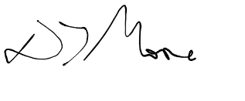

Dr D T Moore

Associate Professor of English Literature

[d.t.moore@bham.ac.uk](mailto:d.t.moore@bham.ac.uk)

Incoming Head of School (2023-2027)

## 2. Description of the department (399 words)

Please provide an introduction to the department.

One of the largest schools in the **College of Arts and Law** (CAL), the School of **English, Drama, and Creative Studies** (EDACS) formed in 2008 when the **University of Birmingham** (UoB) was reorganised into colleges. Today, EDACS consists of 5 departments – **Drama and Theatre Arts** (DTA), **English Language and Linguistics** (ELAL), **English Literature** (ELIT), **Film and Creative Writing** (FCW), and the **Shakespeare Institute** (SI) – across three sites, with ELIT, ELAL, and FCW at UoB’s Edgbaston campus, DTA based on the Selly Oak campus, and the SI in Stratford-upon-Avon (**Figure 1**).

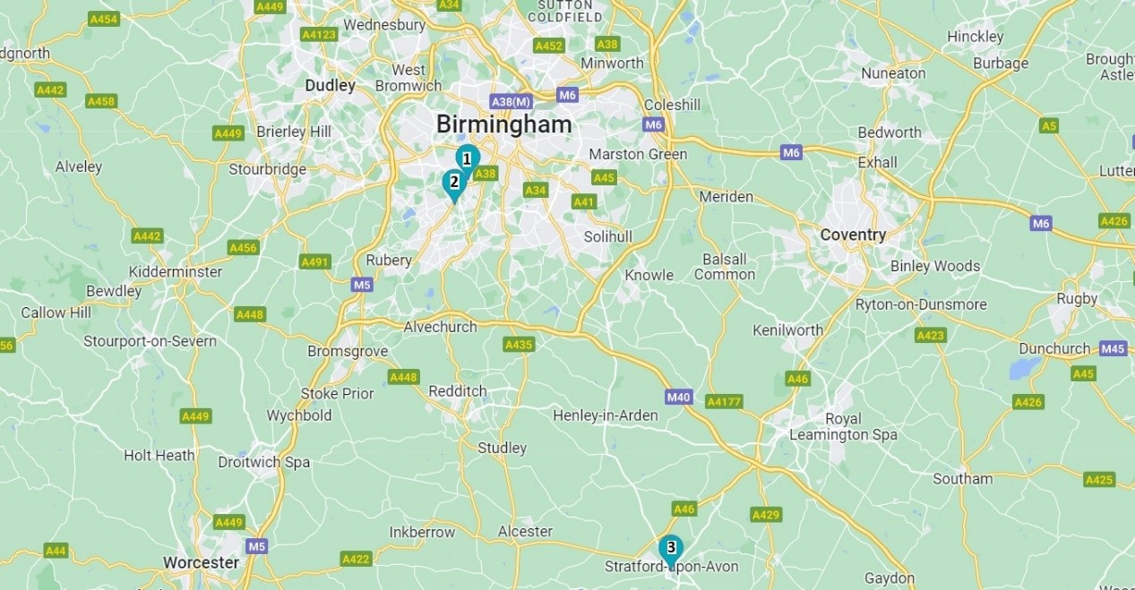

**Figure 1:** *map of EDACS locations: (1) Edgbaston campus, (2) Selly Oak campus, (3) Shakespeare Institute.*

The School received its **Athena SWAN** (AS) Bronze Award as the School of English, Drama, and American and Canadian Studies in 2018 but changed its name in 2019, following the closure of its American and Canadian Studies degree programmes. As of 2020/21, the last census date for this application, EDACS has 1,235 **undergraduate** (UG) students (83.3% female), 610 **postgraduate taught** (PGT) students (67% female), and 225 **postgraduate research** (PGR) students (63.9% female). Students can enrol on 13 single and joint honours UG and 11 PGT programmes, many of which are ranked highly both nationally and internationally. UoB is currently listed 90th globally for Arts and Humanities degrees in the Times Higher Education 2023 rankings, while the 2023 *Guardian* League Table ranks Creative Writing as 1st in the UK, English as 21st, and Drama as 37th.

EDACS is staffed by 118 academics (52% female) and 8 **professional services** (PS) colleagues (63% female).[1] EDACS’s research environment is fostered through 8 distinct and collaborative **research centres** (RCs) (**Figure 2**) dedicated to local and global public engagement, impact-led initiatives, and training for EDACS’s global postgraduate community. Six smaller research networks were created in 2020, to capture a greater proportion of staff and strengthen EDACS’s capacities in, for example, sign language and popular fiction. In 2020/21, EDACS grant income was approximately £824,000.

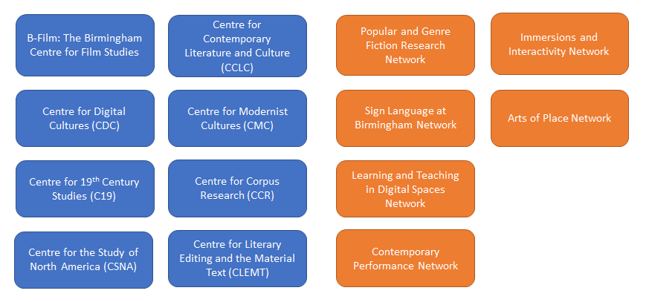

**Figure 2:** *EDACS RCs (in blue) and networks (in orange).*

Between EDACS’s applications for AS Bronze and Silver, its recruitment picture changed significantly. Our 2018 award discussed a 32.6% increase in UG student numbers since 2013, and an increase in academic staff from 95 in 2016/17 to 118 in 2020/21. In line with national trends, however, student numbers in EDACS are trending down, peaking at 2,195 in 2019/20, dropping to 2,080 in 2020/21, and 1,978 in 2021/22. Acknowledging EDACS’s slowed expansion, our Silver application remains committed to equality in recruitment processes, while emphasising staff welfare, whole career mentoring, and flexible and equitable working for existing staff and students.

## 3. Governance and recognition of equality, diversity and inclusion work (459 words)

Please provide a description of your equality, diversity and inclusion (EDI) structures, staff and department-level resources.

EDACS has two EDI-focussed committees: since 2016, the EDACS **Athena SWAN Self-Assessment Team** (AS SAT)and since 2021, **EDACS EDI Committee** (EDIC). The AS SAT and EDIC are led by the AS Lead and **EDI Officer** (EDIO), respectively; both committees include PS staff, academics, and students from across EDACS’s five departments.

The AS SAT and EDIC work alongside 5 other School committees (**Figure 3**) – detailed in Section 1.4. Each committee lead attends a fortnightly meeting of EDACS’s senior management team, the **School Executive Committee** (SEC), where they review School-level policy and report the work of their committee. To embed EDI processes in student experience, the AS SAT and EDIC work with EDACS sub-committees like the UG and PG **Staff-Student Fora** (SSF) to publicise relevant policy with student representatives.

**Figure 3:** *EDACS’s committee structure as of 2021/22.*

**Leadership**

The AS Lead and EDIO roles were introduced in 2016 and retain separate but collaborative responsibilities. Both roles were added to the SEC in 2019; formal role descriptors were also written in 2020 to ensure equitable division of responsibilities and necessary areas of collaboration (**AP-S 1.1**). Both the AS lead and EDIO serve a three-year term and receive 100 points in UoB’s **Workload Allocation Model** (WAM), the nominal equivalent of 165 hours work. These roles are appointed following advertisement to and interview of interested academic staff, a stipulation for all School roles made in EDACS’s **Action Plan** (AP) for AS Bronze (**AP-B 5.5**).

A current barrier to EDI governance in EDACS is a lack of applications for School roles, including EDIO. The last EDIO left their post in January 2022, and despite repeated calls for applications, no-one has applied; EDACS has appointed an interim EDIO from the SEC, who shares EDI work with the EDACS AS Lead. Acknowledging that the absence of self-nominated EDIO candidates reflects a wider downturn in staff engagement since the pandemic, this application prioritises the incentivisation of and training for leadership in EDI (**AP-S 1.1**) to re-establish the EDIC under new leadership by September 2023.

**Committee membership**

While the AS SAT is responsible for the Self-Assessment Process in Section 1.5, the EDIC further embeds EDI in EDACS’s governance and structures (**AP-S 1.2**). All academic staff on the SAT receive 25 WAM points – around 15 hours work – with 125 additional points available depending on work anticipated or completed (**AP-S 1.1**). EDIC members have no fixed WAM allocation, but 125 points are available for their yearly participation, allowing colleagues to attend meetings and complete work flexibly and informally.

In 2022, following concerns for staff workload and wellbeing raised by the AS **Staff Culture Survey** (SCS), EDACS created a **Wellbeing Collective** (WC) with 5 department representatives – receiving 10 WAM points each – led by the acting EDIO (**AP-S 1.3**). In its first year, the WC provided informal reporting routes for staff concerns, working with – but not for – EDACS’s senior management team and marking EDACS’s efforts to support staff wellbeing and inclusion holistically as well as intersectionally.

## 4. Development, evaluation and effectiveness of policies (401 words)

Please provide the processes in place for developing, evaluating and revising departmental policies (where relevant), and for evaluating the implementation of institutional policies.

University Senate at UoB acts as the primary vehicle for regulating and directing academic work, including policy development and evaluation.[2] Senior management attend the **University Executive Board** (UEB), which monitors each Colleges’ implementation of policy and strategy, including EDI. At UEB, management also meet with 9 **Deputy Pro-Vice-Chancellors** (DPVC): since 2019, this number includes a DPVC for Equalities, who oversees strategic priorities in EDI and the University's Equality Executive Group.

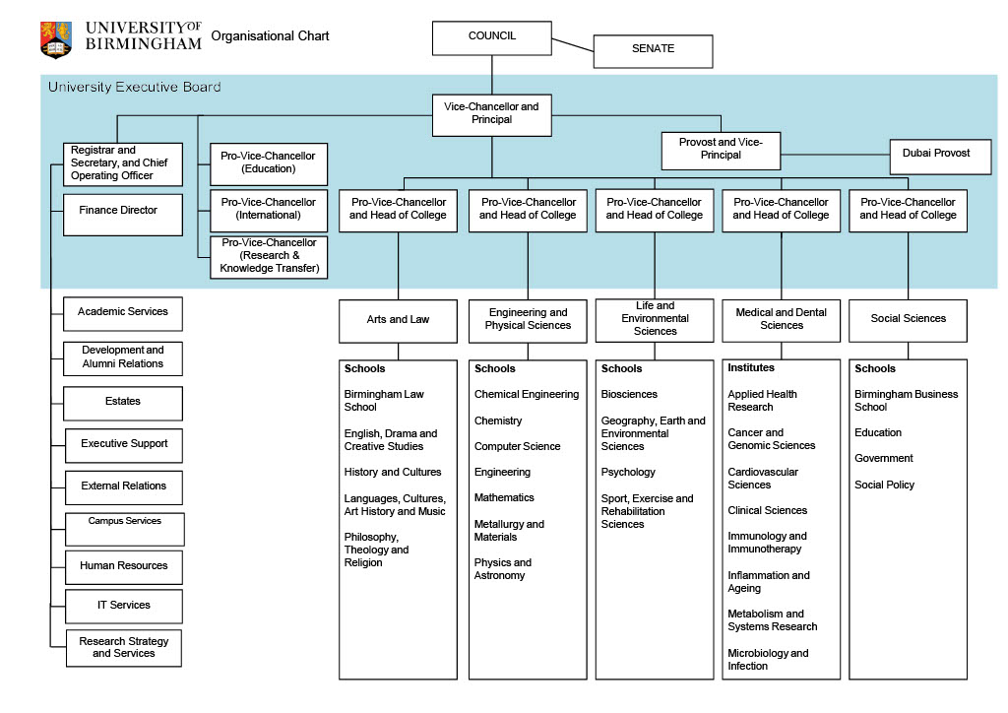

**Figure 4:** *UoB’s organisational chart.*

UEB recommendations reach EDACS through college structures. Policy comes primarily through CAL Board, chaired by the **Head of College** (HoC) and attended by CAL thematic leads, including a CAL-level EDIO and 5 **Heads of School**(HoS). The CAL EDIO is responsible for implementing UoB’s EDI strategy, addressing local EDI priorities through a CAL EDI Action Plan, and chairing CAL EDIC, attended by EDACS EDIO and/or the AS Lead.

At School level, the SEC (**Figure 3**) is the primary point of connection to UoB and CAL structures and the main body for developing, evaluating, and implementing EDACS-specific policy. The HoS chairs the SEC, which includes the School’s thematic leads – EDACS’s **Head of Research** (HoR), **Head of Education** (HoE), EDIO, and AS Lead – all **Heads of Department** (HoD) and 3 PS representatives: EDACS **Head of Operations** (HoOps), **Academic Administration and Quality Assurance Manager** (AAQM), and the School Administration Manager.

Policy is typically drafted and presented by SEC members in response to UoB or CAL prompts when local areas for improvement are identified. The relevant thematic lead assumes or delegates responsibility for proposals to one of 3 EDACS committees that review and update local policy: **Education Committee** (EC), EDIC, and **Research Committee** (RC).

Once policy is agreed at committee level, the lead includes it in their monthly report at SEC or flags it for the immediate attention of EDACS’s senior management team. Both the EDIO and AS Lead provide EDI-related feedback, which allows early intervention across a broad range of EDI concerns, and improves the quality of analysis, decision-making, and action planning conducted at SEC.

After presenting new policies at SEC, either revisions will be requested – with the possibility of resubmission– or the document approved. New policy is then reported to UoB through CAL and UoB-level committees, helping to share best practice. Policy is communicated to staff via departmental meetings, weekly email bulletins, and/or whole-School Briefings at the start of each semester. All EDACS’s bulletins and Briefing materials are published on Canvas, UoB’s **virtual learning environment** (VLE). Relevant policy is introduced to students via SSF-UG and PG.

## 5. Athena Swan self-assessment process (795 words)

Please provide an overview of who was involved in the preparation of this application, how it was prepared, and what plans are in place to support the department’s future gender equality work.

The EDACS AS SAT was established in March 2016 by invitation to all staff in EDACS and discussions with volunteers. The EDIO and HoS are standing members; administrative support is provided by the School Administrator. The first SAT served from 2016 through the submission of EDACS’s AS Bronze (2018) and until the submission process for AS Silver began (2020). This ensured continuity from application writing through to post-award maintenance of the AP, while creating opportunity to distribute workload beyond the original pool of volunteers.

**SAT composition**

|  |  |  |  |
| --- | --- | --- | --- |
| Name | Gender | Role, contract | Profile and application responsibility |
| e.g. Rachel Sykes (ELIT) | Other (non-binary) | Academic – Associate Professor, FT, permanent | AS Lead 2020-2023; WC member.  Co-established and co-runs popular second and third year UG option modules in gender and sexuality studies for ELIT.  First generation school leaver and university student, with a background in union, LGBTQ+, and environmental activism. |

**Figure 5:** *EDACS SAT – March 2023.*

The current SAT (**Figure 5**) represents all 5 EDACS departments, including members from different staff groups, contract types, and levels of seniority, with varied relationships to AS touchstones like gender, sex, and workplace equality. Where volunteers were not forthcoming –from smaller departments like DTA and the SI, non-white staff, and/or staff on fixed term contracts – targeted invitations were sent via email. Not every offer was taken up, for reasons ranging from workload and periods of leave to concerns about overburdening minoritized staff with EDI work.

Given the often-confidential nature of application data and survey results, and the complex administrative burden it might place on students, the SAT enacted student consultation (**AP-B 3.1**) through the SSF-UG and PG, with that feedback supplementing the data collection methods listed below.

**Data collection and consultation**

Quantitative data was collected from HR records and the **Banner Interface Record Management System** (BIRMS); this was benchmarked against the sector using figures from the **Higher Education Statistics Agency** (HESA) (**Appendix 2 – A2**). Our planned submission date (March 2023) made our last census point the academic year 2020/21, but following industrial action in 2022/23, the SAT received an extension until May 2023. Data for 2021/22 became available in April 2023; updated figures are referenced only where necessary.

Qualitative feedback came from the EDACS SCS (**AP-B 3.5**) in 2018, 2020, and 2022. As our last census point was 2020/21, this application largely draws on SCS 2020, with additional graphs included to map responses to key questions over time (**Appendix 1 – A1**). Questions for each SCS were drafted by the SAT and approved by EDACS SEC, ensuring continuity between surveys whilst also incorporating feedback and contextual factors like the Covid-19 pandemic.[3]

After each SCS, the SAT ran focus/action groups addressing priority issues identified in the survey and minuting suggested actions anonymously. Opportunities for staff and/or students to meet individual members of the SAT – to share anecdotal experience, concerns, or suggestions – were provided by advertising SAT contact details and hosting an anonymous EDI and AS Feedback Form on the Staff Canvas Hub.

Qualitative student feedback was facilitated by EDI and year-group student representatives, UG and PG SSFs, the **Postgraduate Researcher Experience Survey** (PRES), the **National Student Survey** (NSS), and the EDI Student Survey circulated by the EDIC in July 2021. The SAT also piloted a PGR SCS in 2021, which received limited engagement. A revised version of this survey will open in 2023 (**AP-S 1.4**).

**Application planning and writing**

In the year before submission, the SAT met bi-monthly, changing their meeting focus from potential actions, priorities, and policy changes to planning and writing workshops.

In response to falling SCS response rates (**Figure 6**), the SAT developed new ways of collecting qualitative feedback, introducing an anonymous feedback form, and leading sessions at whole-School away days in 2021, 2022, and 2023. Through these methods, the SAT gathered feedback in ‘real time’: sharing drafts, posing questions, and creating discussion space that led to increased and more active engagement from EDACS staff.

|  |  |  |  |  |  |
| --- | --- | --- | --- | --- | --- |
| **Year** | **Survey opened** | **Response #** | **Total staff** | **% of total staff** | **% m, f, other** |
| 2018 | June 2018 | 103 | 128 | 80% | 39% m, 58% f, 3% other |
| 2020 | October 2020 | 56 | 126 | 44% | 39% m, 50% f, 11% other |
| 2022 | October 2022 | 56 | 126 | 44% | 33% m, 57% f, 10% other |

**Figure 6:** *SCS participation rate.*

A core writing team (AS Lead, HoS, and AP writers) drafted the application, sharing with the SAT, SEC, and School in sections. For this work, the AS Lead received double their regular WAM points; each SAT member participated according to their capacity. After incorporating EDACS feedback, the application was reviewed by UoB’s AS team. Final changes were approved by the SAT and SEC for submission.

**Future plans**

After submission, the SAT will meet termly to discuss emerging issues and oversee the AP. The next AS Lead will be appointed in summer 2023 following advertisement; the current lead will remain on the SAT for at least one-year post-submission to ensure effective handover. Each member of the SAT will volunteer responsibility for at least one future action, with updates fed back to the AS Lead at each termly meeting.

Moving forward, the SAT will address its representative limits and workload distribution (**AP-S 1.1**). There is no official WAM available for PS staff, so their participation in the self-assessment process depends on existing workload. In the current SAT (**Figure 5**), male and senior staff are underrepresented; future volunteer calls need to be targeted and better incentivised. The SCS will also be simplified, circulated in June, and better advertised. The AS Lead meet any SAT members with less than 50% meeting attendance to see what support they require to attend, revisit the WAM available for SAT members, particularly in application writing periods, and use School Away Days for SAT recruitment and SCS completion (**AP-S 1.5**).

**Section 2: An evaluation of the department’s progress and success**

In Section 2, applicants should evidence how they meet Criteria D and E:

* *Progress against the applicant’s previously identified priorities has been demonstrated*
* *Success in addressing gender inequality has been evidenced*

Recommended word count: 2000 words

## 2.1. Evaluating progress against the previous action plan (1,256 words)

Please provide a critical evaluation of your most recent action plan and any other actions you have initiated since your award.

|  | **Action required** | **Rationale** | **Timescale** | **Oversight / Implementation** | **Original measure** | **Progress since 2018** | **RAG rating** |
| --- | --- | --- | --- | --- | --- | --- | --- |
| **3. The self-assessment process** | | | | | | | |
| 3.1 | **Add UG representative to AS SAT** | To ensure representation at all School levels. | Spring 2018 | HoS | Appointment of undergraduate representative to AS SAT. | **2020/21:** UG reps invited to AS meetings, but – following feedback from UG reps – the SAT decided that UG consultation was best enacted through the SSF-UG.    **2021/22:** UG representation on the SAT facilitated through the SSF-UG, which the AS Lead/EDIO will either attend or feed/receive information through the **Student Experience Officer** (SEO), who now sits on the SAT. | **Green**: good progress - the original action was revised and a similar outcome achieved.    UG representation and consultation is facilitated through the SSF-UG, with the AS Lead/EDIO receiving or feeding information either in person or via SEO or EDI student representatives. |
| EDACS AS Lead |
| 3.2 | **Non-binary gender classification**  EDACS AS communication and SCS will include non-binary gender descriptors. | At the moment of Bronze application, UoB only allowed staff to classify themselves as either female or male thus not allowing for non-binary identification, which has subsequently changed. | Summer 2018 | EDACS AS Lead | 100% of EDACS AS communications and surveys will include non-binary gender descriptors by 2020. | **2018:** SCS incorporates non-binary and trans gender descriptors into all comms.    **2019:** UoB expands its staff classifications to male/female/other.    **2020:** the SAT expand SCS gender descriptors.    **2022:** the SAT redesigns the SCS to allow multiple choice answers: for example, a member of staff can now indicate they are a non-binary and trans, or both trans and a woman. | **Green:** good progress – action complete.    100% of AS communications and surveys include multiple gender descriptors, now allowing for multiple answers. |
| 3.3 | **Maintain Canvas Staff Hub** | Focus groups and SCS indicated need for centralised site for staff-related information and policies. | Created March 2016    Yearly reports by EDIO each September | HoS | 90% of staff respondents agree that information is easily available, as indicated on Summer 2020 SCS. | **2018-present:** the HoS and School administrator maintain the Canvas Staff Hub, reviewed yearly. Newly uploaded information is signposted in the weekly School bulletin.    The EDIO and AS Lead maintain the EDI section of the Staff Hub, including an AS portion of the Hub where SAT minutes, initiatives, and details of progress against our 2018 award are stored. | **Amber:** partial progress - the action was taken but outcome not achieved.    The EDACS Staff Hub has been regularly maintained, but only 55% of respondents agreed that information is transparently presented or available in SCS 2020.    The action is therefore ongoing. |
| EDIO |
| 3.4 | **Update School with AS SAT Meetings**   **Maintain and post minutes from AS SAT meetings.** | Ensure ongoing development of action plan and feedback loop and continued communication with School staff. | Summer 2018, 2020 | EDACS AS Lead | 100% of minutes from termly-meetings uploaded to Staff Hub within one week of meeting. | **2018-2022:** the AS Lead uploads minutes from the SAT’s termly meeting within a week.    **2022-2023:** during the application writing stage, the SAT’s bi-monthly meetings became writing workshops. An outline of these sessions was posted to Canvas, but no minutes were taken. | **Green:** good progress – action complete.    100% of AS SAT minutes/session outlines are uploaded to Canvas after sign-off from the SAT. |
| 3.5 | **Update AS SAT SCS**  SAT will oversee the updating, delivery, and analysis of SCS in Summer 2018 and 2020. | To provide baseline data for the writing and submission of the AS Bronze award, in the first instance, and to direct subsequent AS policy, increase diversity, and future applications. | First EDACS AS SAT SCS: April 2016    Next EDACS AS SAT SCS due: Summer 2018, Summer 2020 and every two years thereafter | EDACS AS Lead | Increased response to EDACS AS SAT SCS from 71 in 2015-16 to over 90 in 2018 and 100 in 2020. | **June 2018:** the first post-submission SCS is circulated.    **May 2020:** the second SCS is delayed by the first lockdown and UoB pivot to education, allowing the SAT time to write questions related to pandemic working.    **October 2020:** the second SCS is circulated.    **October 2022:** the third SCS is circulated. | **Amber:** partial progress – the action was taken but outcome not achieved.    The SAT updated the SCS in 2018, 2020, and 2022, overshooting its target of 90 respondents with 103 in 2018.    However, participation rates have since dropped to 56 respondents in both 2020 and 2022.    The action is therefore ongoing. |
| **4. A picture of the department** | | | | | | | |
| 4.1 | **Increase student diversity**  Increase outreach efforts to foster gender and ethnic diversity. Increase male role models in outreach, recruitment, and early intervention. | Sector wide and school wide gender imbalance – EDACS lags slightly behind Russell Group in gender diversity. | Parity with Russell Group ratio: 2020 | EDACS EDIO | Goal of reaching parity with RG gender balance (26.2% male as of 2015/16).  20% increase in A2B applications by 2020. | **2018-present:** while staff presence at open days is divided evenly, male academics have been encouraged to take up outreach and recruitment positions in the School and departments by HoDs and HoS.    **2020:** the second outcome measure was met, with A2B entrants increased by 211%: EDACS had 9 in 2017/18 and 29 in 2020/21. | **Amber:** partial progress – the action was taken but the outcome partially achieved.    Gender parity at UG briefly improved in 2016/17 to 30.2% male, but had dropped by 2020/21 to 16.7% male, compared to the sector equivalent of 32.9% **(A2 1.1, 1.2**)**.**    Between 2017-2022, ethnic diversity did improve slightly: the overall proportion of white UGs fell by 13.8% (86.3% to 72.5%), with significant increases in the percentage of UGs registered as Asian (4.4% to 10.2%) and Black (2.1% to 4.5% - just above the Russell Group average of 4% but below national averages of 8%).  A2B entrants also increased dramatically, by 211%.    With more to do, the action is therefore ongoing. |
| EDACS Outreach Lead |
| 4.2 | **MA Pipeline**  Enhance 3rd-year dissertation research supervision by to increase recruitment of MA students. | Fewer women than men are continuing to PG studies following undergraduate work. Targeted recruitment during research development activities should build confidence and increase PG uptake. Research Centres lead activities. | From summer 2017 | HoDs | Increase percentage of women entering MA program by 10% by 2020. | **2020-present:** enhancements made to dissertation provision at department level, including the introduction of a dissertation or extended essay module/lecture series in ELIT, DTA, and ELAL and writing workshops in all departments with an UG presence.    During the same period, RCs increase the number of events that 1) correspond to UG syllabi and 2) build links between UG, PGT, and PGR communities. | **Green:** good progress – action complete.    The percentage of women recruited to EDACS’s PGT programmes has increased from 54.4% female in 2016/17 to 67% female in 2020/21, moving from below to above the sector average and exceeding our target with a 12.6% increase (**A2 1.5, 1.6**)**.** |
| RC Leads, monitored by AS SAT |
| 4.3 | **Postgraduate attainment**  Collect data on and monitor the gender balance of PGT students achieving a merit or distinction; review assessment processes with external examiners; monitor gender balance of recruitment of PGT to PhD programmes, with attention to the attainment of PT students. | In the years 2013–16, significantly more FT female PGT students were awarded a merit or a distinction (70%) than male students (30%) but this trend is reversed for PT PGTs where 40% of female PT PGT students are awarded a merit or distinction compared to 60% of male students. | Next EDACS AS SAT SCS: Summer 2018 | HoDs | Data to be assessed and deployed in discussions of the Education Working Group in order to inform policy and develop support for female PGTs.    Success will be measured by an increase of merit/distinction amongst female PT PGTs rising from 40% to 50% by 2020. | **2018-present:** SAT monitors gender balance of recruitment and awarding gap at PGT.    **2018:** AS Lead presents data to Education Working Group to discuss and develop support for female PGTs.    **2019:** assessment processes discussed and revised following consultation with external examiners.    **2021:** documentation formalising MA dissertation supervision support provided by departments. | **Green:** good progress – action complete.    Among FT PGT students, male attainment has increased from 19.5% of distinctions in 2016/17 to 22% in 2020/21, with the percentage of male PGT students rising from 8% to 15% of EDACS’s total (**A2 2.3**).    Among PT PGT students, female attainment also rose: 47% of distinctions and merits were awarded to women in 2016, compared to 56% in 2020/21 (**A2 2.4**). |
| EDACS AS SAT, Heads of PGs |
| 4.4 | **Workshops for promotion application process and preparation** | To increase promotion of women to higher academic ranks. | Summer 2018 and each year thereafter | EDACS HoS | By 2020, 20% increase in yearly number of applicants for promotion from among eligible population. | **2018-present:** promotions workshops held yearly.  **2020-present:** one-to-one meetings with the HoS also offered to all staff applying.  Unsuccessful applicants offered follow-up feedback meetings with HoS and – on request – paired with new applicants to help them through the process. | **Green:** good progress – action complete.    Promotions workshops have been held yearly since 2018.    Although HR were unable to estimate the eligible pool of applicants, promotions rates have improved: in 2021, women at Grade 9 (Senior Lecturer/ Associate Professor/ Reader) make up 44% of the total, an increase from 38% in 2017. The proportion of women for all Grade 10 positions (Professor) also grew slightly, from 42% in 2017 to 48% in 2021 (**A2 3.2**). |
| EDACS School Communication Officer |
| 4.5 | **Exit interviews**  AS and/or EDIO to offer optional exit interviews, which might shed light on instances of perceived gender discrimination and how to remedy them. | Our data-gathering revealed that in 2016 a greater proportion of female staff (14%) than male staff (3%) voluntarily left their role. | Clarify policy with UoB and implement interviews: September 2018    Analysis of interviews by: September 2020 | EDACS AS SAT | Offer optional exit interviews to all leavers, with 50% uptake by 2020. | **2020:** the incoming AS Lead began developing EDACS’s exit interview format with EDIO and previous AS Leads.    **2020-21:** when clarifying policy with UoB, HR encouraged the AS Lead and EDIO to wait, pending a new format they were piloting centrally.    **2021:** with final sign-off by the SAT and SEC, the EDIO and AS Lead begin exit interviews. | **Green:** good progress – action complete.    Although delayed, exit interviews began in 2021, run by the AS lead and EDIO, with 75% take-up by the beginning of 2023.    Analysis of the interviews will form the basis of a future action. |
| EDACS EDIO |
| 4.6 | **Unconscious bias training**  Make enhanced, bespoke EDACS unconscious bias training (three-hour workshop) available to all EDACS staff, initiating refresher courses for current EDACS staff who have already participated. | EDACS AS SCS, 44.3% of staff reported having undertaken no unconscious bias training and many reported finding the shorter version unsatisfactory. | Offer termly bespoke sessions: 2018-2020 | EDACS EDIO | 50% of EDACS staff to complete bespoke (enhanced) unconscious bias training by September 2020. | **2017:** EDACS develops bespoke half-day unconscious bias training with UoB’s **People and Organisational Development** (POD) team.    **2019:** according to POD, at least 20% of EDACS staff had attended the training by 2019, a figure which was likely exceeded as records are incomplete.    **2020:** the POD staff who co-designed and delivered the training left UoB.    **2020-present:** an online unconscious bias training remains available to all staff – and required of REF panels, those involved on hiring committees, etc. – although POD reports it isn’t possible to provide completion rates because of the platform used.    **2021:** the EDIC, led by the EDIO and AS Lead, chaired a discussion of the merits and limits of unconscious bias training, committing to the development of alternative training strands – e.g. inclusive classroom practices, trans awareness training – from both internal and external sources.  2023 – UoB REF process now follows best practice developed in EDACS for bias training among assessors. | **Amber:** partial progress – the action was taken but the outcome only partially achieved.    The action was started, with unconscious bias training developed and run from 2017-2020. However, the training was discontinued due to staff leaving UoB and the pandemic delaying the development of a replacement course.    Following an EDIC review of unconscious bias training, the EDIO and AS Lead developed and ran new forms of EDI training, but – in lieu of an alternative – the action needs to be restarted, with bespoke training available for REF and interview panels.  UoB is also following EDACS in making unconscious bias training a requirement of REF readers, singling out our School as a model of good practice. |
| **5. Supporting and advancing women’s careers** | | | | | | | |
| 5.1 | **Junior staff members on interview panels –** ECR / MCR discussions | To increase diversity on the interview panels, a junior academic staff member is now required on all panels. | Policy established: 2018  Review as part of SCS 2018 and 2020 | EDACS HoS | 100% of panels to have junior staff members by 2020. | **2019:** junior academic staff (ECRs or staff at UoB less than 5 years) required on every interview panel.    **2021:** after discussions between SAT and SEC, ECR presence is replaced by the EDIO or a representative EDIC member. The EDIO develops a set of questions on EDI to be used in all interviews.    **Spring 2022:** CAL restates its requirements for panels, restricting the number of staff present on the panel and emphasising the importance of external output. Gender balance of the panel is maintained and the EDIO’s questions remain in use. | **Green:** good progress, action achieved.    The action was started, achieved, but permanently discontinued as EDI became better embedded in recruitment processes, and composition of panels became more regulated at College-level to ensure this attention. |
| HoDs |
| 5.2 | **Mentoring**  A new working group on the PDR process and formulate best practices for refining the three tiers of mentoring (probationary mentoring, post-probationary mentoring via PDRs, and research mentoring), initiated by HoS in Summer 2018. | Research mentoring tends to focus exclusively on the probationary period, while mid-to-late career mentoring for research academics lacks a formal structure. There is also some perception that the quality of support depends somewhat on the luck of the draw. | Implemented by HoDs: September 2018    Review and best practice document issued: September 2018 and every year thereafter | EDACS HoS | From September 2018, the matching process has been tailored to the needs of specific individuals by asking mentees about their expectations and requirements.    90% satisfaction with mentoring experience and opportunity by Summer 2020 SCS. | **2018:** staff were consulted via whole school surveys – including the SCS – on their post-probationary mentoring needs. A new mentoring request form was devised.    **2021:** following the creation of departmental research leads, mentoring is refocused at a departmental level. The AS Lead and EDIO consult with departmental research leads on how to include EDI concerns in future requests for mentoring. | **Amber:** partial progress – the action was taken but outcome not achieved.    The SCS 2018 shows 55% of respondents indicated satisfaction with their mentoring experience; this rose to 64.3% in SCS 2020, which is still 25% under target**.**    Since 2018, whole career mentoring and the difference between **early** (ECR) and **mid-career researchers** (MCR) has also replaced concerns for ECR mentoring in the SCS free-text comments and subsequent focus groups.    The action is therefore ongoing. |
| HoDs |
| 5.3 | **EDACS committee membership**  Ensure transparency on the composition of School committees (Research Committee, REF Reading Panel, Education Committee, and School Executive Committee) and raise awareness of which administrative roles serve on which committees by posting to online Staff Hub. | Our focus groups report little awareness of the rationale behind committee composition. Greater transparency will encourage more women to apply for academic-administrative roles and thus serve on prominent committees. | Initiated with first EDACS AS SAT SCS: April 2016    Next review: Summer 2018 and every two years thereafter | EDACS HOS | Increased levels of staff awareness of policy (90%) on Summer 2020 SCS. | **2018-present:** School administrator, AS Lead, and EDIO hold yearly review of committee documents. | **Amber:** partial progress – action was taken but outcome not achieved.    The composition of all School committees is available on the Canvas Staff Hub and updated regularly.    In SCS 2020, 66% of respondents in some way agreed that School policy was transparently available and enacted; 64.3% agreed that they were encouraged and able to join committees.    The action is therefore ongoing. |
| EDACS **Head of Operations** (HoOp) |
| 5.4 | **Training for career development**  Targeted recruitment for participants for Aurora Leadership Programme and similar programmes for Emerging Leaders and Emerging Research Leaders. Details to be publicised on the EDI Canvas site and on the Staff Hub; mentors to encourage potential candidates in PDR. | In 2016/17 three EDACS staff members participated in the Aurora Leadership programme. As take-up dropped off in 2017-2018, AS SAT will aim to expand future iterations. | Implemented 2018 | HoS | Increase participation of female staff in leadership programmes by 25% in 2018 and 50% in 2020. | **2018-present:** through a mix of targeted and advertised recruitment, as well as mentoring, women are encouraged to participate in external career development programmes like Aurora, Emerging Leaders, etc.    **2020**: an external limit was placed on how many colleagues can be put forward: only 1 candidate per School per year. | **Amber:** partial progress – action was taken but outcome not achieved.    Although the action was undertaken in the ways specified by the AP, the target of increased participation couldn’t be reached due to changes dictated by the training organisations.    The action is therefore ongoing, as the SAT proposes better integrating training needs into PDR documentation. |
| EDIO and AS Lead, all staff acting as mentors |
| 5.5 | **School administrative roles**  Advertise with full descriptions for all available administrative academic positions, soliciting and reviewing all applications. | Our focus groups report a lack of clarity of roles and process for applying. A standardised process will help to ensure gender parity and transparency. | Fully implement for roles by: Spring 2018. | EDACS HoS | 100% of all relevant School-level administrative roles advertised and vetted through stated process by 2018-2019. | **2018-present:** 100% of all School-level administrative roles – including AS Lead – are now advertised, vetted, and appointed following an interview with HoS and relevant managers. | **Green:** good progress – action complete. |
| 5.6 | **Career development opportunities for PT staff**  Offer and encourage regular networking and training opportunities to flexible or PT staff; add language to Research and Education bulletins to encourage uptake among PT staff. | 25% of PT staff surveyed did not think EDACS offers the same opportunities for networking to those working flexibly or on PT contracts. | Implemented 2018 | EDACS HoS | Decrease percentage of dissatisfied PT staff to only 5% by Summer 2020 SCS. | **2018-present:** targeted and advertised networking and training opportunities for flexible and PT staff supported by mentors, managers, and School-wide bulletins. | **Amber:** partial progress – action was taken but outcome not achieved.    In the SCS 2020, 80% of PT respondents reported being satisfied with career development opportunities, an increase of 5% - but not the anticipated 15% - since 2016**.**    The action is therefore ongoing and linked to the suggested reform to PDR documents in 5.4. |
| EDACS EDIO |
| 5.7 | **Career Development for PGs and ECRs**  Creation of School Early Career Officer; increased professionalization workshops offered by School PG leads and Research Centres. | Postgraduate Taught Experience Survey #s need improvement: agreement that “good advice is available for making career choices” was 56% in 2014, 50% in 2015 and 65% in 2017. | Position created: September 2017    Review of success: AS SAT SCS 2020 | EDACS HoS | Increase ECR satisfaction by 25% as gauged by the PTES. | **2018:** after further discussion with the SEC, it was decided that an EDACS ECO would not be created without first reforming mentoring processes, particularly as new members of staff remain on probation – and therefore overseen by their line manager as well as their mentor – for up to three years.    SCS’s in 2018, 2020, and 2022 also showed some confusion about the difference between ECR and MCR career stages, and a growing concern for a lack of MCR, rather than ECR, mentoring.    **2020-present:** RCs increased the annual number of networking and professionalisation workshops for PGs and ECRs, with 10% of their funding now predicated on PGR training.    Separating out PGR from academic ECR experience, the SAT believes further ECR support is required, continuing and reframing the action in AP-S. | **Amber:** partial progress – some aspects of the action were taken but outcome not achieved.    The satisfaction level in the PTES was 46% (2018), 57% (2019), and 49% (2021).    The action has therefore been reformulated and is ongoing. |
| EDACS **Early Career Officer** (ECO) |
| 5.8 | **Meetings preparing for and returning from family leave**  Schedule meetings with the HoD before the leave begins and several weeks before return, supported by briefing sheet and scheduling prompts from School administrators. | Lack of awareness of options for returning to work both before, during, and after leave. Allowing those returning to choose the terms of their return (i.e. dropping one of their “three legs”). | Implemented autumn 2018 | EDACS Operations Manager and School Administration Manager | Meetings offered to 100% of leavers.    25% increase of awareness of policy by Summer 2020 SCS. | **2018-present:** 100% of leave takers are offered meetings preparing for and returning from leave.    Returnees can also dictate the terms of their return by dropping one of the ‘three legs’ of their contract. | **Green:** good progress – action complete.    100% of meetings offered after 2018.    In the SCS 2020, 87% of respondents who’d taken family leave since 2018 were happy with the advice and support provided**.** |
| EDACS Operations Manager |
| 5.9 | **Establish working group and develop policy for cover and support during family leave** | Policy regarding PGR supervision cover, in particular, is currently unclear and/or implemented inconsistently across EDACS. | Working group created: 2018    Policy suggestions collected and forwarded to HoS: 2020 | HoS | Working group created by September 2018; policy formalised by 2020. | **2018:** focus group created following SCS 2018.    **2019:** School document completed and uploaded to Staff Hub. Progress interrupted by consultation with CAL Graduate School.  **2022:** action begun again. | **Amber:** partial progress – some aspects of the action were taken but outcome not achieved.    A School document was developed in consultation with staff and former EDACS HoS. The process was interrupted by CAL Graduate School, who wanted to consult on policy.  The document was then not included in the handover between former and current HoS.  The AS SAT has restarted the action, in consultation with staff. |
| HoS/AS Lead |
| 5.10 | **Further data collection**  Gather UoB and CAL data on gender equality with additional regards to race, ethnicity, religion, ability, and sexuality amongst employees. | Gender balance of staff in EDACS is close to parity (48%female, 52% male in 2016-17) yet 88.6% of staff identify as white and 74.3% as heterosexual. | Initiated with first EDACS AS SAT SCS: April 2016    Next review: Summer 2018 and every two years thereafter | EDACS AS SAT | EDACS EDIO will further develop questions for the next AS SAT SCS and use the collected data to inform and advise the future composition of EDACS Committees (hiring, promotion, etc.). | **2018, 2020, 2022:** categories for gender, ethnicity, religion, age, sexuality, disability have been revised and expanded with each SCS, in consultation with the EDIO and EDIC. | **Green:** good progress – action complete.    Expanded data collection nuanced our picture of gender, sexuality, disability, and religion in the School, although responses to questions about ethnicity didn’t change: 88.6% of respondents identified as white in SCS 2016 and 87.5% in SCS 2020 and 2022.    In 2020, the EDIO also developed a set of questions and parameters for use in hiring, promotions, and study leave panels.    Future actions look to address the whiteness of the staff profile, noted in Section 3.1 of this application. |
| EDACS EDIO, EDACS Operations Manager and HoS |
| 5.11 | **External committee membership**  Initiate data collection on staff participation in external committees and related offices. | Currently there is no data capture on staff participation on external committees and EDACS AS SAT will survey staff. | Initiated with second EDACS AS SAT SCS: Summer 2018    Next review: Summer 2020 and every two years thereafter | AS Lead | Reporting of 100% data collected in 2018 SCS and 2020 SCS to School administration. | **2020-present:** external committee membership has been added to EDACS’s WAM and collected centrally.    The School office sends out yearly requests for disclosure to all academic staff. | **Green:** good progress – action amended and complete.    External committee membership has been added to EDACS’s WAM model, with the School office sending out yearly request for disclosure to all academic staff. |
| EDACS AS SAT |
| 5.12 | **Childcare**  Align teaching hours with availability of childcare for staff with caring duties. | 2016 AS SAT SCS and Focus groups relay concerns relating to the last hour of standard UoB teaching day (1800-1900 hours) extending beyond childcare facilities on campus, which conform to the standard national day nursery opening hours of 8-6. It is also noted that staff at the Shakespeare Institute in Stratford do not have access to co-located University-run childcare facilities. | Parents working group to propose policy: summer 2018.    Policy enacted: for academic year 2018/19. | HoDs/HoS | Enact EDACS timetabling policy for relevant staff.  25% increase in staff satisfaction as reported in Summer 2020 SCS. | **2018/19:** EDACS’s SAT sent requests to the university nursery, asking for them to extend opening times.  The nursery rejected these requests due to staffing issues and their belief that opening longer would be detrimental to child wellbeing.    The same year, UoB centralised timetabling, removing EDACS’s ability to bring teaching hours in line with available childcare hours. | **Red**:action discontinued.    Childcare is considered in departmental teaching allocations through conversation with HoDs or through flexible working requests with HR.    Flexible working and timetabling remain key priorities for AP-S, pending further changes to timetabling in 2023/24. |
| AAQM with HoDs |
| 5.13 | **Outside speakers and representatives**  Commit to gender parity of invited speakers, chairpersons, and outreach speakers as part of required vetting procedures. | 44% of respondents felt like the School did not use a diverse range of spokespersons and representatives. | Vetting implemented: September 2017 | EDACS School Administration Manager and HoS | 75% of respondents agree that EDACS offers diverse range of spokespersons on 2020 SCS. | **2018/19:** the annual RC report form introduced a new box for RC leads to reflect on EDI concerns in their centre, including the diversity of external speakers.    **2022/23:** to further embed EDI in RC practice, addressing gender parity and inviting a diverse range of speakers will be made a condition of future funding by the HoR. | **Amber:** partial progress – the action was taken but the outcome wasn’t achieved.    In SCS 2020, 53.7% of respondents felt that EDACS used a diverse range of spokespersons and representatives; 26.8% disagreed, an improvement of 17% but still under target**.**    The action is therefore ongoing. |
|  |

**Method and process of implementation**

The AS SAT is responsible for writing, updating, and implementing the AP. Whilst writing our Silver award application (May 2022-May 2023), bi-monthly SAT meetings focused on data analysis and measurable outcomes from the previous AP. A sub-group of AP writers then took responsibility for tracking future actions as the AS Lead managed application writing. Analysis of the effectiveness, outcome, resolution, or reframing of actions from AS Bronze was decided by quantitative and qualitative data analysis drawn from sources detailed in Section 1.5.

Regular feedback from staff and students and the inclusion of AS in the SEC has meant that the actions and priorities of the AP are subject to near-continuous discussion and revision. For example, as the hiring of permanent staff slowed between 2018 and 2020, SCS 2020 and focus groups documented a growing concern for MCR mentoring and promotions over ECR support. The action to appoint a School Early Career Officer (**AP-B 5.7**) was therefore superseded with more tailored forms of support, including enhanced offerings for PGRs, changes to career and research mentoring, departmental ECR advocates, and networking events for colleagues on fixed term contracts (**AP-S 2.7, 2.8**).

|  |  |  |
| --- | --- | --- |
|  | # | % of total |
| Green | 12 | 50% |
| Amber | 11 | 45% |
| Red | 1 | 5% |
| **Total actions** | 24 | 100% |

**Figure 7:** *percentage of actions by RAG rating.*

**Amber actions**

45% of actions from AP-B are rated amber and are therefore ongoing in AP-S. These actions have been taken but either didn’t achieve the desired outcome or are incomplete.

Several relate to School communications. The Canvas Staff Hub provides a centralised site for staff information and policies (**AP-B 3.3**) but only 55% – rather than 90% – of respondents in SCS 2020 agreed that information was transparently available. Similarly, the SCS ran in 2018, 2020, and 2022 (**AP-B 3.5**) but with a dramatic reduction in participation. These results link to external constraints: discoverability is low on UoB’s website, Intranet, and VLE, making information hard to find even when it’s available. Following staff complaints about email volume, EDACS uses weekly bulletins hosted on Canvas to share information – including the SCS and other AS updates – yet this relies on high levels of engagement with a lengthy document that must be downloaded to be searchable. AP-S acknowledges the continued challenge of communication preferences and the necessity of reengaging staff in the SCS (**AP-S 1.5**).

Other amber actions concern the diversity of the student body (**AP-B 4.1**) – expanded on in Section 3.1 – and School representatives. In SCS 2016, 44% of respondents thought EDACS didn’t ‘use a diverse range of people as spokespersons or representatives’ (**AP-B 5.13**). This shrank to 26.8% in 2020 and 23% in 2022 (**A1 2.28**). AP-S asks RC leads to comment on how EDI is considered in their programme in the annual report submitted to EDACS HoR, with gender parity now a condition of future funding (**AP-S 2.10**).

The remaining amber actions relate to training and career development. Opportunities are better publicised through School bulletins and departmental mentoring processes (**AP-B 5.2**), yet the satisfaction of PT respondents increased by 5%, missing our 20% target. The SAT proposes the introduction of a developmental needs analysis, similar to processes already carried out in PGR supervision, as part of every staff member’s annual review (**AP-S 2.6**).[4] This would also address the need to find alternative forms of leadership training (**AP-B 5.4**) and could include a section on EDI (**AP-B 4.6**).

The action with perhaps the most complicated history is enhanced unconscious bias training (**AP-B 4.6**). This training was developed and rolled out, with at least 20% of EDACS’s staff completing the course by 2019. When the trainer left UoB in 2020, the EDIO and AS Lead led a review of unconscious bias training at the EDIC, discussing evidence of its limitations. With online training still available via POD, both leads began developing and sourcing more bespoke forms of staff training – including sessions on online inclusivity, trans awareness, neurodiversity and mental health (**AP-S 2.3**) – to continue the aims of the action. It’s clear, however, that there is no easy replacement – particularly as a requirement for members of REF reading and interview panels – and the action should be restarted.

|  |
| --- |
| **Lesson:** *action points and their measures have not always aligned in AP-B: it was particularly difficult to reach 90% satisfaction amongst SCS respondents and less indicative following a drop-off in respondents. The SAT acknowledges the usefulness of ‘stretch but aims to provide more concrete outcome measures for AP-S, to increase legibility in the handover between AS Leads and SATs.* |

**Red actions**

One action is coded red and can be considered discontinued.

**AP-B 5.12** aimed to align teaching hours with availability of on-site childcare. This action stalled on two fronts: first, UoB introduced centralised timetabling in 2018/19, removing local autonomy in scheduling and second, SAT attempts to lobby the campus nurseries to open longer were unsuccessful.

In hindsight, the SAT considers extending nursery opening hours to be the wrong course of action as it is antithetical with staff’s right to a ‘whole life balance.’ We also acknowledge that local accommodations for parents, carers, and anyone with access needs remain unsatisfactory: 1-2-1 meetings with HoDs, HoS, and HoOp are currently the only route to log preferred working patterns outside of formal flexible working requests and changes in contract status. A lack of local control over timetabling alongside EDACS’s reliance on individual meetings has led to increased dissatisfaction amongst staff returning from parental leave, reflected in the free text comments of SCS 2018, 2020, and 2022 as well as anecdotal evidence fed back to the SAT.

Timetabling will change again for 2023/24, creating a more static blocked timetable with module times available earlier in the year. This has the potential to address some EDI and access concerns, but further local measures are required to ensure staff are well-informed about the new process (**AP-S 2.12**).

|  |
| --- |
| **Lesson:** *staff awareness has not improved in line with targets, even where information is available and regularly circulated in School Bulletins. AP-S recognises the complexity of communications preferences, making several new interventions* (**AP-S 2.1**)**.** |

**External barriers**

The period of EDACS’s AP-B spans the Covid-19 pandemic, an ongoing barrier to workplace equality and wellbeing that increased staff workload and decreased capacity to engage with EDI work (**AP-B 3.5**).

Although the AS Lead and EDIO achieved significant successes during this period – for example, writing and circulating guides to online inclusivity, which helped normalise sharing preferred names, pronouns, and content notes in online and in-person teaching – the pandemic temporarily paused initiatives like A2B (**AP-B 4.1**), study leave, budgets for PG teachers and CAL PhD funding, as well as internal and external training courses. It also added unprecedented responsive innovations – local guidance on shielding, caring responsibilities whilst working from home, and the potential long-term gendered impact of UoB’s ‘pivot’ to education – to the AS SAT’s agenda from 2020 onwards.

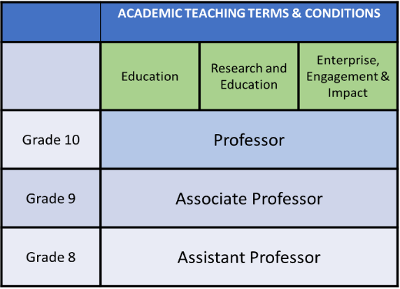

**Figure 8:** *the BACF, introduced in 2021/22.*

At an institutional level, changes to processes and policies on key AS issues like childcare – noted above – and promotions also proved challenging. In 2021/22, UoB introduced the **Birmingham Academic Career Framework** (BACF), revising career structures and titles –removing the role of Reader (**Figure 8**) – and introducing core pathways in **Research and Education** (R+E), **Education** (E), and **Enterprise, Engagement and Impact** (EEI).

Although EDACS continues to run well-received promotions workshops (**AP-B 4.4**), supplemented by 1-2-1 meetings with HoS, staff satisfaction with the promotions process has decreased: in SCS 2020, 78.6% of respondents felt supported and encouraged to apply for promotion but, in SCS 2022, only 61.6% felt the same (**A1 2.13**). Part of staff dissatisfaction seems related to the BACF’s new ‘points based’ system (**Figure 9**), which assigns numerical values to academic work in ways that respondents to SCS 2022 found ‘complex’, ‘time-consuming’, and ‘intimidating’.

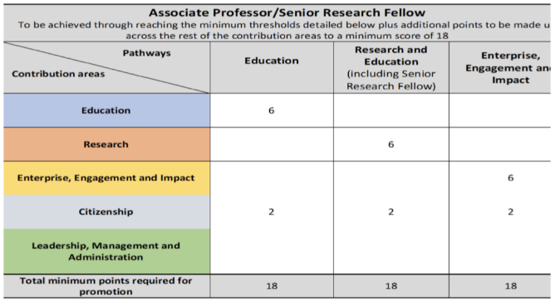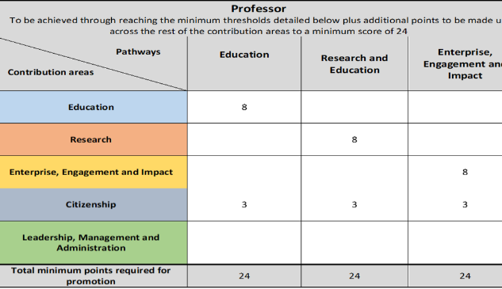

**Figure 9:** *points-based requirements for BACF promotions.*

With less knowledge and experience of this new promotions process, a key priority for AP-S will be whole-career mentoring, with actions for ECR advocacy and career planning (**AP-S 2.8**) and renewed provision for mid-career staff looking to bridge the now significantly larger gap between Associate Professor and Professor (**AP-S 2.4**) as well as mentorship for colleagues returning from family leave with an eye to promotion (**AP-S 2.9**).

## 2.2. Evaluating success against department’s key priorities (910 words)

Please describe the department’s key achievements in gender equality.

**Key priorities of AS Bronze (2018-2023)**

As part of the previous AS charter, EDACS’s AS Bronze application doesn’t identify specific priorities. The SAT has determined, however, that it focused on the following areas:

1. **Establishing and improving School communications and data collection:** including regular surveys and feedback mechanisms, clear descriptors, advertisement, and recruitment for School roles, and transparency of committee structures and membership.
2. **Improving diversity and closing the ‘awarding gap’ within the student population:** from UG through to PGR, with a focus on the ‘pipeline’ from UG to PGT and the differences in PT and FT experience.[5]
3. **Fostering equity in staff experience at all career stages:** fromhiring and early career support through promotions, career development, and management roles, and internal transparency of decisions and data within the School.
4. **Reducing barriers for inclusion amongst staff with caring responsibilities:** with a specific focus on childcare, timetabling, and flexible working processes.

The AS SAT had success across all identified priorities, with 95% of AP-B rated amber or green. EDACS showed the most advancement, however, in priorities 1 and 3.

**Areas of success**

**1) Establishing and improving School communications and data collection**

Many of the actions around communications and data collection have been fulfilled and exceeded. As well as completing **AP-B 3.4** – updating the School with AS SAT minutes – AS and EDI is now a standing item at the SEC and a regular item on department meeting agendas and School Away Days. **AP-B 3.2** aimed to include non-binary gender classification in all AS communications: this was superseded in SCS 2020 and 2022, which expanded recorded gender identities and recognised complexity in staff experience of both gender and sex through multiple answers (**AP-B 5.10**)**.**

**AP-B 5.11** proposed collecting data around staff participation on external committees to better understand the opportunities staff take up externally and analyse disparities for gender variance. The School now collects this data on an annual basis and incorporates relevant membership into WAM. Moving forward, the SAT commit to regular analysis of this data to develop a more nuanced understanding of institutional workload and the expectation/reward of external activity (**AP-S 2.12**). Formally constituted exit interviews began in 2021 (**AP-B 4.5**) and workshops for promotion are ongoing (**AP-B 4.4**). All School roles are now advertised (**AP-B 5.5**).

Progress has been made around family leave procedures (**AP-B 5.8**), with meetings offered to 100% of leave takers. In SCS 2020, 87% of respondents who’d taken family leave since 2018 were happy with the advice and support provided (**A1 2.12**). With more still to do to establish clearer local guidelines on the remission of duties (**AP-B 5.9**), the experience of care givers and leave takers remains a concern of AS Silver.

**3) Fostering equity in staff experience at all career stages**

A range of actions relating to staff and PG experience were also successful (**AP-B 4.2**). In 2016/17, EDACS was significantly behind the sector in its recruitment of women PGT students at only 54.4% but by 2020/21, the percentage increased to 67% (**A2 1.5**).

**AP-B 4.3** recommended a review of PGT data, assessment processes, and course structures at PGT; correspondingly, and alongside further efforts to improve mentoring of all PG students, the awarding gap between PGT students in EDACS has improved. Among FT PGT students – where male students underachieved – the awarding gap is shrinking: 19.5% of male students received distinctions in 2016/17, rising to 22% in 2020/21 (**A2 2.3**). Among PT PGT students – where female attainment trailed their FT equivalents – 47% of distinctions and merits were awarded to women in 2016/17, rising to 56% in 2020/21 (**A2 2.4**).

Efforts to increase transparency of committee composition (**AP-B 5.3**) and School administrative roles (**AP-B 5.5**)have been successful, with 64.3% of respondents to SCS 2020 agreeing that they felt aware of and able to apply for committee membership in EDACS. The SAT will build on this progress and, now the data is collected, write an analysis for School managers (**AP-S 2.1**).

Extremely well-received promotions workshops are now held annually (**AP-B 4.4**), supplemented by 1-2-1 meetings with the HoS. Although there is still a problem with EDACS’s ‘academic pipeline’ –discussed in Section 3.1 – EDACS is moving closer to gender parity at Grade 9 – where women made up 38% of total staff in 2017 and 44% in 2021 – and Grade 10 – 42% in 2017 and 48% in 2021 (**A2 3.4**).[6]

The inclusion of junior staff members on interview panels (**AP-B 5.1**) was achieved by 2019 but discontinued in 2021 to make room for the EDIO or equivalent representative. In Spring 2022, new CAL guidelines restricted the number of staff present on all panels, emphasising the importance of external input and making it impossible for either an ECR or EDIO to attend. Questions developed by the EDIO remain in use at all interviews and AP-S suggests an annual review of interview panel composition and questions by the EDIC (**AP-S 2.10**)**.**

**Applications of EDACS successes**

* **Management-led workshops on formal processes:** The well-received promotions workshop will be replicated in sessions on study leave and flexible working (**AP-S 2.11**).
* **Informal discussion groups:** The SAT will hold regular ‘town hall’ meetings on flexible working and access needs, EDI training requirements, and workplace wellbeing where staff can share their experiences and suggest future actions (**AP-S 2.13**).
* **Whole career mentoring:** Following changes to UoB career progression and increased confusion – reflected in each SCS – about academic career stages, we’ll integrate a training needs analysis into all annual review processes (**AP-S 2.6**), building on **AP-B 5.2** and departmental changes to mentoring already begun.
* **External consultation:** Exit interviews for academic staff (**AP-B 4.5**) began in 2021 after extensive consultations with PS and HR. Although consultation delayed the desired outcome by 2 years, it greatly benefitted the format and will inform future iterations of the SCS and other AS communications (**AP-S 1.5**).
* **Feedback mechanisms:** The SCS provides us with rich data on staff perspectives; we’ll therefore focus on developing UG and PG feedback, continuing the EDI Student Survey and PGR SCS in future iterations of the SAT (**AP-S 1.4**)**.**

**Section 3: An assessment of the department’s gender equality context**

In Section 3, applicants should evidence how they meet Criterion B:

* *Evidence-based recognition has been demonstrated of the key issues facing the applicant*

Recommended word count: 3500 words

## Culture, inclusion and belonging (2,475 words)

Please describe how the department ensures their culture and practices support inclusion and belonging.

**i. Student profile**

As of 2020/21, EDACS has 2,080 total students, 76.3% of whom are registered as female (**A2 1.1**). This total is made up of 1,235 UGs (83.3% female), 610 PGTs (67% female), and 225 PGRs (63.9% female) (**A2 1.2, 1.4, 1.6**). In EDACS’s EDI UG student survey, circulated in 2020, 65% of respondents praised the diversity of texts and authors taught in EDACS, 63% felt that their student experience had been improved by local commitments to preferred names and pronouns, and 60% agreed that EDACS’s teaching prioritised the ‘decolonisation’ of knowledge.

**Undergraduate**

Male UG students are a minority in all sector-equivalent data, but EDACS’s proportion of male UGs (16.7%) is 17.1% below average (**A2 1.3**). Conversion rates show that a slightly higher proportion (+7.1%) of female UG applicants receive offers compared to men; women applicants are also 4% more likely to accept (**A2 1.11**). Working with EDACS’s admissions tutors, we will refine actions begun in AP-B (**AP-B 4.1**) to bring the proportion of male UGs more in line with sector averages (**AP-S 2.2**).

Looking at UG population by ethnicity, EDACS has diversified slowly but consistently since our Bronze award in 2018 (**A2 1.8**). Between 2017 and 2022, the proportion of white UGs fell by 13.8% (86.3% to 72.5%), with increases in the percentage of UGs registered as Asian (4.4% to 10.2%) and Black (2.1% to 4.5%). We want to raise these figures several percentage points to meet CAL averages (**A2 1.9**). We’ll also lobby UoB to review and reformat the student data available to the AS SAT, to allow analysis of student populations based on gender, ethnicity, disability, age, and religion (**AP-S 2.2**).

**Postgraduate**

Both PGT and PGR populations in EDACS have a better gender balance than UG, with male PGT numbers 4.3% below and PGR 1.5% above the sector average (**A2 1.5, 1.7**). At PGT, the proportion of women increased from 54.4% in 2016/17 to 67% in 2020/21 (**A2 1.4**), bringing EDACS more in line with the sector since 2018. Because of targeted recruitment, the proportion of white PGTs also decreased from 67.1% in 2017/18 to 57.3% in 2022/23, with marked increases in the percentage of Chinese, Asian, and Mixed/Other identities chosen at registration (**A2 1.8**).

Similar improvements can be noted at PGR. In 2016/17, female PGRs made up 56.3% of EDACS’s total – 8.2% behind sector equivalents – but in 2020/21, this had risen to 63.6%, only 0.8% below the sector (**A2 1.7**). Problems are revealed, however, through intersectional analysis. In 2022/23, the proportion of white students is only 0.3% lower than in 2017/18, while proportions of Asian (7.9%) and Black (1.1%) PGRs are falling (**A2 1.10**). Diminishing numbers of women between UG, PGT, and PGR levels (**Figure 10**)also mirror the ‘pipeline’ or ‘process’ problem that persists through academic employment, which actions in AP-S are dedicated to (**AP-S 2.2**).

**Figure 10:** *academic pipeline in EDACS for 2020/21 – from UG to Professorial levels.*

**ii. Staff profile**

EDACS is staffed by 118 academics (52% female) and 8 PS colleagues (63% female) (**A2 3.0**). While the gender balance of academic staff remains stable since our Bronze award – reaching 51% female in 2016/17 and rising to 52% thereafter – the gender split in PS has improved, with a 7% rise in the proportion of male staff by 2020/21 (37%) bringing EDACS even with national averages.[7]

Staff diversity is low in other areas, where we also have limited data. 87% of respondents identified as white in SCS 2018, rising to 92% in SCS 2020 (**A1 2.3**) and 94% in SCS 2022. All three results indicate EDACS has a larger proportion of white staff than the RG average of 86% (**AP-S 2.10**).[8] A more positive picture appears in relation to gender and sexuality: no EDACS staff are registered as 'Other’ in HR records yet 5% of respondents to SCS 2020 identified outside the binary of male and female (**A1 1.1**)**.** 74% of respondents identified as heterosexual in SCS 2018; with new categories and multiple answers enabled for questions about gender and sexuality, this dropped to 71% in SCS 2020 (**A1 1.5**).

Similar revisions to questions about ability in SCS 2022 expanded our understanding of staff demographics. In 2020, 12.5% of staff respondents identified as disabled; in 2022, 27% of respondents said the same (**A1 1.3**). This data will inform future actions on timetabling, flexible working, and access to EDACS facilities (**AP-S 3.1**); through the EDIC, the AS SAT suggests further investigation into whether these changes are the result of hiring or staff identification. The care for and inclusion of trans and non-binary staff remains a School priority (**AP-S 3.2**).

**iii. Staff recruitment**

Following a 32.6% increase in UG numbers between 2013-2018, EDACS significantly expanded its academic staff. New wording was added to all job advertisements in 2016 to encourage and support a more diverse pool of applicants; this was returned to and revised in 2021 by the AS SAT and HoOps to enhance and expand clarity (**AP-S 2.10**).

The EDACS academic recruitment pipeline (**A2 7.4**) shows women outnumber men in shortlisting and appointments at all grades; at professorial level, they are in the minority of applications (40%) but majority of appointments (67%). 2017 was our biggest single year for recruitment, with 30 academic staff appointed at Grade 8 (60% female), 5 at Grade 9 (40% female), and 5 at Grade 10 (60% female) (**A2 7.3**). This increased the number of women in EDACS by 48%, although largely at Grade 8. The SAT has prioritised whole career mentoring in AP-S (**AP-S 2.4**) and specific actions relating to pay, promotions, and workplace advocacy (**AP-S 2.3**) to assist women’s progress to Grade 9 and above, where they remain a minority (**Figure 10**).

Mirroring HESA data, the PS recruitment pipeline (**A2 8.4**) shows a larger proportion of women at all grades. Applications, shortlisting, and appointments to Support (Grades 4-5) or Admin & Other (Grade 7) contracts are majority women. The only exception are applications to Admin & Other (Grade 6) contracts, where men make up a minority of applications (42%) but most appointments (67%).

Analysis of this discrepancy is complicated by the lack of clear figures on the employment of **Teaching Fellows** (TFs). TFs share terms and conditions of their employment with PS staff; both are therefore classed as ‘Administrative & Other Academic Related Staff’ by HR. Local records show that between 2017-2020 EDACS’s TF population shrank (**Figure 11**), following a local commitment to reduce institutionally funded short-term teaching contracts.[9] Further action is required, however: the SAT has asked for separate data sets (**AP-S 2.7**), which should be available from 2024; we also commit to focus groups on the gendered experiences of PS staff (**AP-S 3.3**) and, separately, of TFs (**AP-S 2.**) to further differentiate our knowledge.

|  |  |  |
| --- | --- | --- |
| **Department** | **2017-18 total** | **2020-21 total** |
| DTA | 3 | 2 |
| ELIT | 8 | 5 |
| ELAL | 4 | 2 |
| FCW | 4 | 0 |
| **EDACS total** | **19** | **9** |

**Figure 11.** *Local records of TF employment in EDACS.*

**iv. Awarding trends and ‘gaps’**

**Undergraduate**

Awarding data (**A2 2.1**) indicates that 420 students graduated from EDACS in 2020/21 – 355 female (84.5%) and 65 male (15.5%) – with women accounting for 87.5% of 1st degrees, 81.6% of 2:1s, and 66.7% of 2:2s. Sector equivalent data (**A2 2.2**) shows women received around 70% of 1sts and 2:1s between 2016-2021, putting EDACS behind sector averages for male attainment. Proportionate to their presence at final year, however, the awarding gap is less pronounced. 50% of EDACS’s graduating female students received a 1st, 46% a 2:1, and 2% a 2:2, compared to 38% of men graduating with a 1st, 53% a 2:1, and 7% a 2:2. Moreover, although the number of male students diminished over the period of our Bronze award, their attainment remained stable: 80 out of 85 men (94%) achieved a 1st or 2:1 degree from EDACS in 2016/17, dropping to 60 out of 65 (92%) in 2020/21. Continued analysis is therefore required to determine future actions (**AP-S 3.4**).

Awarding gaps emerge more starkly amongst students registered as non-white and/or disabled. University-wide data indicates that although the awarding gap between Black and white students (**A2 2.6**)improved between 2017/18 and 2018/19, dropping from 33.8% to -3.3%, it rose to 22.6% in 2020/21. The awarding gap between Asian and white identifying students (**A2 2.7**) hit its lowest for five years at 7.7% in 2020/21, but these figures fluctuated significantly during the period of EDACS’s Bronze award. Similarly, if less significantly, the awarding gap between students who have declared and students with no known disability (**A2 2.8**) was 3.9% in 2017/18, -0.4% by 2019/20, but rose to 3.8% in 2020/21. Once again, more nuanced engagement with and analysis of feedback from these student demographics is required for the SAT and EDIC to propose future actions (**AP-S 3.4**).

**Postgraduate**

At PGT, women’s attainment remains better on FT (**A2 2.3**) than PT modes of study (**A2 2.4**). In 2020/21, FT women students achieved 76% of distinctions and 89.2% of merits; PT women students obtained 63.3% of distinctions and 49.1% of merits. Although these numbers have improved since AS Bronze, both in terms of men’s attainment at FT and women’s at PT, the fact that women outnumber men in both modes of study but perform 20-40% better in FT study requires further action (**AP-S 3.4**). The ethnicity awarding gap at PGT (**A2 2.9**) has also increased, hitting a low of 6.6% in 2019/20 but rising to 21.9% in 2020/21, and 26.6% in 2021/22.

At PGR, degree completions by women have increased from 56.3% of total in 2016/17 to 63.6% in 2020/21 (**A2 1.7**). This brings EDACS more in line with sector averages where women make up 64.4% of all completions (**A2 1.8**). The SAT did not have access to comparable stats on ethnicity and will lobby UoB for further data to enable intersectional analysis (**AP-S 3.4**).

**v. Career development**

Mirroring student demographics, the EDACS pipeline (**A2 3.7**) shows that although women outnumber men in UG, PGT, and PGR studies (**Figure 9**), numbers diminish between each career stage. Women are over-represented in more junior roles: 48% of academic women in EDACS are employed at Grade 8 or below, compared to 32% of men, meaning that 52% of women and 68% of men are employed at Grade 9 and above. AP-S proposes departmental ECR advocates to help empower junior colleagues to make informed choices about the work most beneficial to their careers and increase EDACS’s number of senior women (**AP-S 2.**)**.**

In the 5 years since our Bronze award, there have been some local gains: the proportion of women at Grade 10 was 36% in 2015, 42% in 2017, and 48% in 2021, while the percentage of women at Grade 9 was 38% in 2017 and 44% in 2021 (**A2 3.3**). The introduction of the BACF in 2021/22 has, however, diminished local knowledge of, and some colleagues’ confidence in, promotions. A comparison of SCS responses to questions about EDACS’s encouragement of and support through the promotions process (**A1 2.13**) suggests that opinion improved between 2018 and 2020 but decreased in 2022. The SAT commits to further action including linking local mentorship to the BACF and promotions-specific peer mentoring (**AP-S 2.4, 3.5**). A report extracted from this application will also be fed to HoS and other members of the School Promotions Committee to provide developmental feedback on BACF to CAL, UoB, and HR (**AP-S 3.5**).

The BACF’s reformatting of existing contract types reveals further trends in women’s career advancement: its three streams highlight women’s preponderance in permanent education and fixed term research focused roles (**A2 3.2**). On R+E contracts, men are the minority at Assistant Professor/Lecturer grades but the majority at Associate Professor/Senior Lecturer and Professor grades (**A2 3.4**). E contracts – although much smaller in number – are primarily held by women, who make up 63% of Assistant Professors, 33% of Associate Professors, and 100% of Professors. These figures indicate that women find it harder to gain promotion based on their research and require different kinds of support from EDACS to progress (**AP-S 3.5**).

Pending disaggregated data of TF positions, demographic analysis of fixed term contracts is ongoing (**AP-S 2.7**). SCS 2018 showed that 62% of TFs felt work was not allocated fairly; this improved to 50% in SCS 2020, with respondents to all SCSs identifying more regular mentoring as a key priority for fixed-term contracts (**AP-S 2.7**).

PS staff apply for more senior positions via the usual UoB recruitment process. As such, there is no promotions process for PS and the AS SAT propose further analysis of PS staff satisfaction with their career advancement (**AP-S 3.3**)**.**

**vi. Student inclusion**

EDACS’s NSS results show high levels of overall satisfaction, declining over the course of the pandemic. School-wide, satisfaction was 98% in 2018, 87.5% in 2020, and 73.7% in 2022. EDACS is currently undertaking measures to address and improve overall satisfaction, which the EDIC and AP-S will support through dialogue with students about access and inclusion (**AP-S 2.2**).

For students, AS priorities like inclusion and belonging remain a concern. NSS responses to the question ‘I feel part of a community of staff and students’ have fallen: 69.2% of all respondents agreed in 2017, but only 60.5% agreed in 2022. The EDI Student Survey helpfully expanded our knowledge of what actions are required. While respondents praised EDACS’s advancements in diversifying curricula in the last 5 years, they listed their top priorities as: 1) educating staff and students on microaggressions; 2) hiring academic staff of colour; and 3) educating staff and students on neurodiversity. With staff training on neurodiversity introduced in May 2023, the SEO, EDIC, and AS SAT commit to the development of bespoke and extended training in EDI and inclusion as a priority area (**AP-S 2.3**).

**vii. Staff inclusion**

SCS 2020 shows general levels of staff inclusion are high: 76.7% of respondents agreed that the full range of their skills and experience were valued by their colleagues (**A1 2.14**) and 75% of respondents felt confident their line manager would deal effectively with complaints about harassment, bullying, or offensive behaviour (**A1 2.26**).

The picture is complicated, however, by questions about discrimination, with 38% of respondents to SCS 2020 agreeing that they’d felt uncomfortable because of their gender in the previous two years (**A1 2.20.i**); 76% of this figure were women. Addressing this concerning response is a key part of AP-S (**AP-S 3.6**), as well as making EDACS’s commitment to EDI more visible and meaningful for staff (**AP-S 1.1**). Only 52.2% of respondents to SCS 2020 agreed that EDACS was committed to diversifying its staff (**A1 2.27**) and 53.5% felt the School implements policies on equality and diversity in transparent and effective ways (**A1 2.27**).

Respondents also felt more confident that EDACS valued and supported EDI in teaching than in research (**A1 2.25.i**), highlighting a trend in staff opinion that the School values education more than research, particularly since the pandemic. Although the percentage of staff who agreed with both questions improved in SCS 2022 (**A1 2.25.ii**), AP-S will increase the visibility of EDI processes and policies and – as detailed in Section 1.3 – better incentivise involvement in EDI work (**AP-S 1.1**).

**viii. Leadership**

At the time of submission, 15 School roles are held by male academics, 15 by female academics, and 1 by a non-binary academic (**Figure 12**). Although the gender split is equitable overall, EDACS’s role distribution requires further analysis (**AP-S 2.1**)**.** Most School positions are education focussed and women hold 62% of all education-based appointments. This ratio flips, however, for whole School roles, which are currently 64% male.

As School workloads are reassessed, several deputy positions have been created; 100% of these are or have been occupied by women. The AS SAT will continue to monitor the composition of School roles, to ensure that deputy positions act as ‘pipelines’ to other roles, are adequately work loaded, and don’t remain disproportionately with women (**AP-S 2.5**).

|  |  |  |
| --- | --- | --- |
| **School roles (academic)** | **Gender of current role holder** | **Attends SEC?** |
| HoS | M | Y |
| HoD (DTA) | F | Y |
| HoD (ENGLIT) | M | Y |
| Deputy HoD (ENGLIT) | F |  |
| HoD (ELAL) | M | Y |
| HoD (FCW) | M | Y |
| Director (SI) | M | Y |
| Head of Global Engagement | M | Y |
| AS Lead | NB | Y |
| EDIO | M | Y |
| Sustainability Lead | F |  |
| Gender split: 64% m, 27% f, 9% other | | |
| **Education** | | |
| HoE | M | Y |
| Head of Quality Assurance and Enhancement | F | Y |
| PGT Lead | F |  |
| Senior Tutor | F |  |
| Assessment and Progress Lead | F |  |
| Appeals and Reasonable Diligence Officer | -- |  |
| Admissions and Recruitment Lead | F | Y |
| Extenuating Circumstances Officer | M |  |
| Deputy Extenuating Circumstances Officer | F |  |
| PGTA Coordinator | F |  |
| Staff-Student Liason | M |  |
| Academic Integrity Lead | -- |  |
| Employability and Enterprise Lead | F |  |
| International Exchange Officer | M |  |
| Digital Education Lead | M |  |
| International Student Authorised Absence Tutor | F |  |
| Student Academic Engagement Lead | F |  |
| Schools Engagement and Outreach Lead | M |  |
| Gender split (education): 38% m, 62% f | | |
| **Research** | | |
| HoR | F | Y |
| PGR Lead | M |  |
| Enterprise, Engagement and Impact Lead | M |  |
| Research Development Lead/Deputy HoR | F |  |
| Gender split (research): 50% m, 50% f | | |

**Figure 12:** *School roles in 2023.*

The composition of EDACS’s senior leadership roles – HoS, HoR, and HoE – will also be monitored**.** Currently, the SEC is attended by 8 men, 4 women, and 1 non-binary academic. Since EDACS became a School in 2008, 2 of 6 HoS have been women; since the creation of CAL, also in 2008, only 1 woman has been HoC compared to 3 men and only 1 interim female HoC compared to 3 interim males.

## Key priorities for future action (874 words)

Please describe the department’s key priorities for future action.

Data analysis shows that although EDACS has improved in several key areas – the ethnicity of UG and PGT students, for example, and the proportion of women staff at all grades – we have several areas in which we might target staff and student diversity as well as wellbeing.

**Key priorities of AS Silver (2023-2028)**

1. **Increase staff and student diversity and progression through the academic ‘pipeline’**

Our first aim is to address awarding gaps at UG. The SAT and EDIC will consult male and non-white UGs (**AP-S 3.4**) and develop core academic writing modules to help support the transition from school to university (**AP-S 3.4**). The EDIC will also make support for minority students and awarding gap data a regular item for discussion. Our second concern – highlighted by the EDI Student Survey and demographic questions in the SCS – is the ethnic diversity of our staff body and curriculum. EDACS commits to an annual review of recruitment processes, focusing on interview questions and training for all panel members (**AP-S 2.10**). The EDIC will also conduct a review of existing research and education specialisms in the School to identify gaps in current provision (**AP-S 3.7**). Third, EDACS has prioritised whole career mentoring, with an emphasis on more regular mentor meetings and check-ins for TFs and ECRs (**AP-S 2.4**), departmental ECR contacts and advocates, and the introduction of a development needs analysis to annual PDRs, to proactively identify training needs of all staff (**AP-S 2.7, 2.10**). Fourth, the AS SAT will monitor and analyse the gender composition of all EDACS committees, focusing particularly on leadership. Indivisible from our concern for staff workloads (detailed below), with this aim we hope to better incentivise School administrative work by establishing the place of administration in each career ‘pipeline’ and, ultimately, to increase the number of women in senior School roles (**AP-S 2.5**).

1. **Take a proactive approach to staff and student wellbeing, inclusion, and community**

In SCS 2020, 64.3% of respondents felt EDACS supported their mental health and wellbeing, with male respondents agreeing more than other genders (**A1** **2.6**). Free-text feedback from SCS 2020 and 2022 suggests that – particularly during the pandemic – EDACS supported staff well, but feelings of ‘powerlessness and dissatisfaction’ were amplified by UoB structures. Actions for AP-S therefore include the creation of the EDACS WC (**AP-S 1.3**) to provide local contacts – who are pointedly not also line managers – as a first call for staff concerns and requests. Second, mirroring the promotions workshop established by AP-B, we will run an annual training and information day to provide similar instruction on study leave and flexible working processes, as well as training in mental health first aid, recognising and handling microaggressions, and neurodiversity (**AP-S 2.11**). Third, we will create and maintain a document of yearly deadlines (**AP-S 2.13**) to increase awareness and forewarning of School and department meetings and anticipated assessment submissions, timetables for feedback, and other time sensitive paperwork. This will help recognise where clashes and pressure points occur for staff and students and enable better involvement in School life for colleagues with caring responsibilities and access needs (**AP-S 3.17**). After the isolation experienced by all staff and students during Covid-19, the AS SAT also prioritises the re-creation of an EDACS community in the next award period. All department and School meetings will continue to be hybrid (**AP-S 3.17**); they will also guarantee, rather than recommend, space for communal discussion to avoid feelings of powerlessness invoked by shorter, information-based sessions, which pandemic working often relied on. To support this aim, the AS-SAT also commits to more regular ‘town hall’ and discussion forums on key topics (**AP-S 2.13**).

1. **Address the burden of staff workload; incentivise and enable EDACS EDI work**

Applications for School roles have decreased in the last three years. Of particular concern to the SAT, staff availability for and confidence in their ability to complete EDI work has also diminished: the EDIO position is currently held by an interim member of staff and engagement with the SCS has halved (**Figure 6**). There are two issues here for which AP-S proposes action. First is staff workload. Only 50% of respondents to SCS 2020 felt their duties could be completed within an ‘average’ work week (**A1 2.2**); only 57% felt happy with their work/life balance (**A1 2.3**). Via the SEC, EDACS commits to annual reviews of its administrative processes to consult staff on what we can ‘stop doing’ locally (**AP-S 3.6**). We will also revise role descriptors for both the EDIO and AS Lead, with plans to do the same for EDIC and AS SAT membership (**AP-S 1.1**), including workload modelling that reflects workflow over time and key pressure points like the writing and circulation of surveys, training, and application writing.The second is training in and visibility of EDI. All EDACS Away Days now include a session on AthenaSWAN, EDI, or a related issue. In May 2023, we will hold our first training and information day, to integrate training in EDI with existing whole-School activities (**AP-S 1.1, 2.3**). We will continue to develop and source bespoke training in key areas identified by staff (trans inclusivity, sexism in educational settings) and students (neurodiversity, microaggressions, ‘decolonising’ the curriculum).The AS SAT is also consulting on a new and extended unconscious bias training – previously established as part of our AS Bronze but since discontinued due to staff shortages, with particular attention to its role in interviews and REF reading. These measures aim to improve staff perceptions of EDACS’s commitment to EDI, particularly in hiring and research, whilst also making it more possible for the often ‘invisible’ labour of inequality to be shared between staff.[10]

1. **Supporting parents, carers, and levelling access to career and workplace satisfaction.**

Many of the actions begun in AP-B were achieved in principle but did not reach target levels of staff or student satisfaction. Some of these actions related to family leave, flexible working, and timetabling – policies over which EDACS previously had greater control, but which were centralised in the past 5 years. AP-S will continue many of these actions, including clearer policy on duties before, during, and after family leave **(AP-S 2.8**), better mentoring in relation to periods of leave(**AP-S 2.4**), and better understanding of careers for part-time staff (**AP-S 2.6**). The SAT commits to enhanced support for all periods of leave, including annual management-led workshops on flexible working and opportunities for peer mentoring as well as termly discussion forums (**AP-S 2.11**).

**Section 4: Future action plan**

In Section 4, applicants should evidence how they meet Criterion C:

* *An action plan is in place to address identified key issues*

## Action plan

Please provide an action plan covering the five-year award period.

| **#** | **First ref** | **Objective and rationale** | **Actions and Timescale** | **Oversight** | **Outcomes and measures of success** |
| --- | --- | --- | --- | --- | --- |
| **Section 1 - Description of the department** | | | | | |
| **1.1** | p. 7 | **Better recognise and incentivise EDI work, particularly leadership**  To enable wider involvement with and participation in EDI work throughout the School, following diminishing responses to AS SCS and lack of applications for EDIO.  To ensure EDI work is credited and integral to the life of the School, not an optional extra, and shared between all colleagues. | 1. Increase WAM allocation for AS Lead and SAT members in application years (September 2023). 2. Introduce WAM for EDI engagement and/or as a defined part of ‘citizenship’ workload for all staff (September 2023). 3. Write and revise EDIO and AS Lead role descriptors, with new appointments made (Sept 2023). 4. Source and hold training in EDI, with a focus on leadership, including: EDACS training and information day (May 2023); integration of next SCS with School Away Day (June 2024). 5. Influence UoB to include institution wide SCS information around EDI (2024). 6. Pilot School-wide and potentially institutionally used courses on online inclusivity, sexism in the classroom, and teaching sensitive materials, funded via UoB’s education enhancement fund (2026). | HoS  EDACS EDIO + EDIC | EDIO and AS Lead roles filled by September 2023.  Obtain new source of data on UoB-wide perceptions of EDI, for analysis and the development of new policies.  SCS data around School support for EDI increases by 10% by 2024/26.  EDIC to lead on development of local training courses, with first course trailed by September 2024. |
| **1.2** | p.7 | **Create and maintain an EDIC**  To better embed EDI in EDACS governance.  To divide workload for EDI between the EDI and AS SAT, as well as the EDIO and AS Lead, which hold complementary and overlapping functions. | 1. Renew and ratify EDIC terms of reference at SEC (Oct 2023). 2. Appoint a new EDIO (Oct 2023). 3. Hold semesterly meetings, involving members from across the School to increase engagement with EDI work (Oct 2023 and continuing). | EDACS EDIO  HoS | Regular EDIC meetings held, with actions, issues and recommendations fed through to appropriate EDACS governance committees.  Minutes from each EDIC meeting uploaded to EDI section of the Staff Canvas Hub within a month and communicated to School colleagues. |
| **1.3** | p.7 | **Create and maintain an EDACS WC**  To support staff wellbeing and take proactive steps to improving experiences at work.  To separate out, where possible, EDI from welfare, acknowledging the overlap but not conflating the two. | 1. Establish WC (Sep 2022) with nominations for members from Departments/Institute. 2. Hold first exploratory meeting with School staff at Away Day (May 2023). 3. Establish terms, responsibilities, and resources, to be approved by SEC (Jan 2024). | EDACS EDIO  EDACS HoDs  HoS | Staff report they feel supported and have a good work/life balance in SCS 2024/26 increased by 10%.  Annual report of WC on their work, impact and priorities, to be delivered to SEC, with data used to develop future actions – based in part on feedback/focus groups. |
| **1.4** | p.15 | **Devise and run a biennial PGR SCS and questionnaires for PG Teaching Assistants**  The satisfaction level in the PRES was 46% (2018), 57% (2019), and 49% (2021).  The SAT proposes separating out AP-B 5.7, which combined PGR and ECR staff interests, and collecting further data on PG experience as both staff and students.  The PG SCS will differentiate between all staff and PGR experiences, tailoring broader questions to their experience of working and studying in the department. | 1. Revise the AS SCS for PGR students and staff (2024). 2. Circulate in the off year between SCS (2023 and continuing every two years). 3. Questionnaire and/or meeting offered to PG Teaching Assistants once each semester’s teaching has been completed to identify further forms of support (Dec 2023). | EDACS PGR Lead  AS SAT  EDACS HoDs | New data available on PGR experiences.  Analyse data from PGR SCS and report specific PGR findings, with the aim of shaping future actions at EDACS committees.  Increase in response rate for PGR SCS, with a success rate of 15 responses in January 2024 and thereafter rising by 5% of whole cohort every two years. |
| **1.5** | p.16 | **Increase engagement in the AS SCS**  To increase engagement with and completion of the SCS, to gain a fuller picture of staff experiences in EDACS.  Completion rates dropped from 80% in 2018 to 44% in 2020 and 2022. | 1. Simplify the AS SCS, introducing core questions recommended by AS (before 2024) 2. Circulate every SCS earlier in the year (June) to coincide with the end of teaching, and PDR cycle (June 2024 and ongoing). 3. Include survey completion sessions at School Away Days each May/June (2024 and ongoing).     Carried over from AP-B 3.5. | AS SAT | 65% completion rate by June 2024; rising to 70% for each survey thereafter. |
| **Section 2 – An evaluation of the department’s progress and success** | | | | | |
| **2.1** | p.19 | **Improve School communications, including transparency of EDACS’s EDI commitment and processes**  The EDACS Staff Hub has been regularly maintained, but only 55% of respondents to SCS 2020 agreed that information is transparently presented or available.  Staff engagement with and belief in EDACS commitment to EDI is also low. | 1. Maintain Canvas Staff Hub. 2. Review information organisation and presentation on Canvas (March 2024). 3. Introduce EDI and information sessions to School Away Days (May 2023). 4. Update and also simplify AS SCS (June 2024). 5. Include room for discussion in all School and department meetings, to ensure comprehension and retention (Sept 2023).     Carried over from AP-B 3.3, 3.5. | HoS  AS SAT  EDIO + EDIC | Biannual audit (each September and March) of Staff Hub confirms that information for the academic year is up-to-date and accessible.  65% of staff agree information is transparently present in SCS 2024. |
| **2.2** | p.21 | **Increase student diversity**  Male UG students are a minority in all sector-equivalent data, but EDACS’s proportion of male UGs (16.7%) is 17.1% below average.  Following improvements at UG and PGT, the proportion of white PGR students is only 0.3% lower than in 2017/18, while proportions of Asian (7.9%) and Black (1.1%) PGRs are falling. | 1. Focus groups with male and non-white students (June 2024). 2. Re-emphasise the presence of male representatives at outreach and open day activities (Sept 2023). 3. Influence UoB Planning and Strategy teams to reformat the student data available to the AS SAT, to allow analysis of student populations based on gender, ethnicity, disability, age, and religion (June 2026).     Carried over from AP-B 4.1. | EDACS Admissions Tutor      EDACS HoE    EDACS PGR Lead | Admissions data shows upward trend in % male UGs and non-white PGRs by 2024.  Russell Group gender parity in UG cohort is achieved by June 2026 (33.8% male).  Percentage of Black PGRs in EDACS is increased by June 2026 (from 1.1% to 6%). |
| **2.3** | p.26 | **Develop new and bespoke EDI training for EDACS**  An extended, bespoke course in unconscious bias was developed and run from 2017-2020. Discontinued due to staff leaving, a replacement is being developed by CAL.  Both staff and students have identified other areas for staff training which the AS SAT and EDIC will source and/or develop and run. | 1. Consult on new unconscious bias training for interview panels and REF readers (2024). 2. Training in Trans Awareness and Online Inclusivity first held in 2021-22 to be repeated every 3 years. 3. Annual training and information day, first held in May 2023 and then annually. 4. EDI bespoke training integrated into annual information days (May 2023 onwards). 5. Continue annual request for EDI funding within overall School budget. 6. Source and/or develop School training in:  * Trans inclusivity * Neurodiversity * Deaf awareness * Microaggressions * Online inclusivity * Sexism in the classroom     Carried over from AP-B 4.6 (unconscious bias training). | EDIO  AS Lead | All information days gather participant feedback on EDI training, with 70% of staff who complete the survey agreeing that the training has been constructive.  Focus groups held by SAT in 2024-25 evaluate training activities so far and identify areas for improvement. Feedback in focus groups demonstrates staff engagement with EDI training and constructive outcomes.  SCS 2026 reflects increased belief amongst staff in the transparency of EDI policy – from 53.5% to at least 65%. |
| **2.4** | p.28 | **Mentoring**  In SCS 2018, 55% of respondents indicated satisfaction with their mentoring experience; this rose to 64.3% in SCS 2020, which is still 25% under target**.**  Since 2018, whole career mentoring and the difference between ECR and MCR has also replaced concerns for ECR mentoring in the SCS free-text comments and subsequent focus groups. | 1. Hold focus groups to determine priorities of ‘whole career mentoring’ (initiate Sept 2023, completed Sept 2025). 2. HoR and RC to strategize how and where to map mentoring structures onto the BACF (initiate Sept 2023, completed Sept 2025). 3. Send out an anonymous request for feedback from TFs, RFs, and other ECRs and log named mentoring preferences (annually). 4. Set guidelines for mentoring at different career stages, with a particular emphasis on checking in more regularly with colleagues on fixed term contracts or returning from leave (Sept 2025).     Carried over from AP-B 5.2. | HoDs  HoR  HoS | Guidelines and good practice for ‘whole career mentoring’ developed in response to focus groups and anonymous feedback from TFs, RFs, and other ECRs.  Mentoring arrangements are evaluated at regular intervals, with official guidelines updated annually in response to feedback.  Satisfaction with mentoring at least 75% by SCS 2026. |
| **2.5** | p.30 | **Transparency of EDACS committees and gender parity of leadership roles**  The composition of all School committees is available on the Canvas Staff Hub and updated regularly. However, in SCS 2020 66% of respondents in some way agreed that School policy was transparently available and enacted, missing our target of 90%.  Given the need to incentivise and demystify School roles further, committee membership will be tackled alongside revised role descriptors for School roles, worked into PDR processes to generate interest, and linked to career pathways and training needs. | 1. Given that the composition of committees is now available, but the information still not easily accessed, the SAT will change focus, advising on possible revisions to role descriptors for all roles involved in EDACS committee structures (Sept 2023). 2. Administrative roles will be better integrated with PDR processes and shadowing/peer-mentoring featured more extensively in job handovers (initiated Sept 2023). 3. The AS SAT will be invited to review the composition of School committees and leadership roles annually, bringing their findings to School Away Days in the hopes of encouraging staff – and particularly women – into roles, and as counsel to SEC (annual).     Carried over from AP-B 5.3. | AS SAT    HoDs and HoS | Data collated at the end of each academic year by AS SAT to evaluate EDACS committee composition and leadership roles.  Annual report at School Away Day (every September) shows overall gender parity in leadership roles.  Increased percentage of respondents to the Staff Culture Survey agree that information is transparently available (SCS 2024: 70% of respondents agree; SCS 2026: 80% agree). |
| **2.6** | p.30 | **Training for career development**  Changes dictated by the training organisations have placed an external limit on the number of EDACS staff able to take Aurora and Emerging Leaders programmes.   The action is therefore ongoing, as the SAT proposes better integrating training needs into PDR documentation to find alternate opportunities for staff. | 1. Integrate a development needs analysis into PDR paperwork, to be completed yearly by staff and their line managers (June 2024).   Carried over from AP-B 5.4, 5.6. | AS SAT    HoDs and HoS | Annual review of career development training opportunities offered and taken up by EDACS staff, including completion rates and feedback on satisfaction with training (where available).  Increase in percentage of respondents to SCS happy with the training offered to them, including PT staff, to 80% of respondents in 2026. |
| **2.7** | p.38 | **Enhanced support for ECRs, including colleagues on fixed term contracts**  Feedback from ECRs, and particularly staff on fixed term contract, shows continued confusion about UoB processes, a lack of mentorship, and a lack of voice in advocating for themselves in their departments. | 1. Nominate a departmental ECR advocate who will act as someone who will work with, but not for, line management to provide new and early career staff with information (Sept 2023). 2. Particularly for TFs, who might not be with EDACS very long, the advocate’s role will be to signpost departmental processes, check-in and create community between TFs, and advocate for the ECRs to ensure regular mentoring. 3. The AS SAT will also lobby UoB for better data on non-permanent contracts, particularly TFs, and by internal and external sources of funding (2024). 4. A dedicated page on the Canvas Staff Hub will be created by the ECR advocates for recently hired ECRs, providing practical information and guidance for colleagues on fixed term contracts and/or new to UoB processes, building on existing one-off ‘Welcome to EDACS’ event each autumn (Sept 2024).   Modified from AP-B 5.7. | AS SAT  HoDs  HoS | Every department to have an ECR advocate by September 2024.  Positive feedback on communications and support in exit interviews with TFs and other ECRs concluding fixed term contracts.  Increased satisfaction at work for anyone who considers themselves an ECR, rising to 75% by SCS 2026. |
| **2.8** | p.34 | **Establish working group and develop cover policy for family leave**  A School document was developed in consultation with staff and EDACS former HoS. The process was interrupted by CAL Graduate School, who wanted to consult on policy. The document was then not included in the handover between former and current HoS.  The AS SAT has restarted the action, in consultation with staff. Per the last AP, policy in particular regarding PGR supervision cover and other mentoring responsibilities during family leave is currently unclear and/or implemented inconsistently across EDACS. | 1. This action was disrupted by the handover between HoS and needs to begin again. 2. A working group will be established (Sept 2023) to develop the SAT’s knowledge of what remains unclear for those on family leave, i.e. ‘I wish I could have known x…’ or ‘I would still like to know y…’ 3. This action will link to actions on mentoring and promotions to help empower those who take family leave within UoB processes and timelines.     Carried over from AP-B 5.9. | AS SAT    HoS | SAT report identifies actions and recommendations on family leave guidance and policy, based on outcomes from the working group (created in September 2023).  Clear guidance document on family leave formalised and publicised to staff by 2025. |
| **2.9** | p.40 | **Gender parity of external speakers**  In SCS 2020, 53.7% of respondents felt that EDACS used a diverse range of spokespersons and representatives; 26.8% disagreed, an improvement of 17% from the previous 44%, but still under our target from AP-B (75% agreed)**.** | 1. Commit to gender parity of invited speakers, chairpersons, and outreach speakers as part of required approval procedures (implemented Sept 2023) 2. As this action is carried over, an additional strategy is to make gender parity a condition of RC funding.     Carried over from AP-B 5.13. | HoR      AS SAT | Policy formalised on gender parity among invited speakers for internally funded events, implemented from September 2023 and tracked via annual review thereafter (every September).  SCS 2026: 70% of staff agree EDACS uses diverse speakers and representatives. |
| **2.10** | p.41 | **Increase staff diversity, through EDI process in recruitment and hiring**  Respondents to the EDI Student Survey and demographic questions in the SCS highlight EDACS’s low ethnic diversity amongst staff.  The SAT and EDIC commit to an annual review of recruitment processes, focusing on interview questions and training for panel members as well as current gaps in curriculum provision and specialism (i.e. in gender and sexuality studies, critical race theory, post/colonial theories). | 1. An annual review of EDACS hiring process run by the EDIC (Sept 2023 and ongoing) 2. Questions set by EDIO are currently used in all interviews; these should be reviewed annually with frameworks for the interviewers as well as interviewees. 3. This will be supplemented by new forms of training for panel members (**AP-S 2.3**). | EDIC and EDIO  AS SAT | Review of EDACS hiring process shows increase in training for panel members and inclusive hiring practices (September 2023, and annually thereafter).  10% of staff identifying as non-white in SCS 2026. |
| **2.11** | p.42 | **Management-led training sessions on flexible working and study leave**  EDACS’s well-received promotions workshop – established by AP-B – will be extended to sessions on study leave and flexible working to help demystify and reduce anxiety around these processes. | 1. Establish information sessions as part of a yearly training and information Away Day (May 2023). 2. Sessions take place annually, in May 2023 and every year thereafter, with link to annual PDR process. | HoS    HoOps | Positive feedback at events and in 1-2-1 line manager meetings indicate that staff feel more supported and informed following management-led training sessions.  Staff satisfaction with available information 75% by SCS 2026. |
| **2.12** | p.46 | **Work external to the institution – review importance, gender balance, and reward**  Now we have data capture on staff participation on external committees, we can explore its significance. | 1. Since AP-B, the School has collected information on external committee membership; the SAT now commits to analysing and interpreting the significance of external work and its impact on internally defined workloads (Report to SEC by Jan 2023).   Carried over from AP-B 5.11. | AS Lead | Report to SEC demonstrates significance of external work and makes recommendations on workload allocations. |
| **2.13** | p.47 | **Improve and re-create School community, including discussion groups, consultations, and feedback sessions** | 1. All department and School meetings will continue to be hybrid. 2. EDACS will produce a yearly calendar of events and deadlines to give ample time for attendance/involvement from staff and students (from Sept 2023). 3. Inbuilt discussion time will be guaranteed in every department and School meeting (initiated Sept 2023). 4. We’ll hold regular ‘town hall’ meetings about topics of concern and smaller discussion groups with AS SAT. 5. Opportunities for social activities will be reinstated from Sept 2023. | HoS      EDIO  AS SAT | Attendance of ‘town hall’ meetings indicates increasing staff community and engagement and gathers feedback to shape future actions and priorities.  Target of 80% agree that the School feels inclusive to all by SCS 2026. |
| **Section 3 – An assessment of the department’s gender equality context** | | | | | |
| **3.1** | p.50 | **Review EDACS facilities and processes for accessibility**  With new questions added to SCS 2022 about ability, 27% of respondents also identified as or are registered as having a disability, chronic illness, or neurodivergence.  The EDI Student Survey also indicates student demand for staff to be trained in their access needs and, particularly, neurodiversity. | 1. Provide training in disability awareness and assistance, including neurodiversity and deaf awareness (May 2023 and ongoing). 2. Assess EDACS learning materials for access and inclusion (by June 2024). 3. Review necessary adjustment process and signpost to colleagues (June 2024). 4. Consult (via focus groups) disabled colleagues to check for additional requirements or requests (June 2024 and ongoing). 5. Continue to work in partnership with CAL Facilities team, and UoB Estates team, as needed. | Estates  HoOps  HoS | New focus group data available.  Analyse SCS data and report to SEC by June 2024, with the aim of using such data to inform future policy and resource allocation.  80% of staff identifying as disabled agree that EDACS is an accessible workplace by SCS 2026. |
| **3.2** | p.50 | **Support for trans and gender non-conforming staff**  Self-reporting in the EDI Student Survey and each SCS shows an increase in trans and gender non-conforming staff. | 1. Continue to advocate for sanitary bins in more toilets and an increase of all gender toilets (completed by 2025). 2. Repeated Gendered Intelligence training on Trans Awareness (initiated 2021, ongoing), funded through School EDI budget. 3. Formalise School guide to pronoun sharing in-person, recognising and responding to microaggressions in the classroom, and modelling how to apologise (Jan 2024). 4. Improve the process for student complaints and establish a student EDI hub on Canvas (Jan 2024). | AS SAT        Estates | In SCS 2026, 90% of staff who identify as ‘other’ feel comfortable and included in EDACS.  Updated School guidance, to include concerns referral process for staff and student concerns, for academic year 2023-24. |
| EDIC |
| **3.3** | p.51 | **Focus groups on gendered experience of PS staff**  PS staff do not receive WAM for their involvement in AS and the SAT wants to develop better feedback mechanisms to make sure they are represented. | 1. Focus group held by December 2023. | AS SAT | Feelings of inclusion amongst PS staff at 80% by SCS 2026.  New focus group data on PS experiences.  Findings from focus group analysed and reported back to SEC, with SAT identifying future actions to be taken. |
| **3.4** | p.52 | **Address awarding gaps at UG and PGT**  At UG, EDACS has a pronounced awarding gap between white and black students, as well as disabled students.  At PGT, women’s attainment is still better on FT than PT modes of study. Although these numbers have improved since AS Bronze, both in terms of men’s attainment at FT and women’s at PT level, the fact that women outnumber men in both modes of study but perform 20-40% better in FT study requires further action. | 1. Focus groups to consult male and non-white UGs and develop mentorship pathways. (Dec 2023) 2. Develop core academic writing modules to help support the transition from school to university (introduced 2024-25). 3. The EDIC will also make support for minority students and awarding gap data a regular item for discussion (ongoing). 4. Lobby UoB for further stats on awarding at PGT (ongoing). | AS SAT    EDIC  HoS | UG awarding gap to shrink by at least 5% by 2026.  Obtain Uni-level data on PGTs, analyse and report to SAT for identifying future actions. |
| **3.5** | p.53 | **Promotions**  The introduction of the BACF in 2021/22 diminished local knowledge of and confidence in promotions.  A comparison of SCS responses to questions about EDACS’s encouragement of and support through the promotions process suggests that opinion improved slightly between 2018 and 2020 but decreased in 2022. | 1. Peer mentoring including draft reading and feedback initiated (Sept 2023). 2. This kind of mentoring should focus on matching those with experience of resubmitting promotions applications with first time applicants, as well as newly promoted colleagues with both kinds of applicant. 3. Mentoring to include specific promotions targeting and goal setting to structure the move between Grade 9 and 10 without the previous position of Reader (Sept 2023). | HoS  AS SAT | Increase rate of agreement (by 10%) to SCS questions regarding there being support and encouragement for applying for promotions in 2024 and 2026. |
| **3.6** | p.55 | **Discrimination, inequality, and staff culture**  While staff inclusion rates are high, 38% of respondents to SCS 2020 agreed that they’d felt uncomfortable because of their gender in the previous two years; 76% of this figure were women. | 1. Run focus groups to talk more openly about experiences of discrimination in the School (from Sept 2023) and isolate what kinds of situations (i.e. in seminars, lectures, meetings, and online/offline) micro or macro aggressions occur. 2. In line with other actions, develop courses on sexism in the classroom for both staff and students and continue to run courses that raise awareness of implicit or unconscious bias and approaches to EDI for staff (initiated summer 2023 and formalised by Sept 2025). 3. Survey managers with requests for training, where needed, and foreground open, honest discussion of inequalities in department and School meetings (from Sept 2023). | HoS  EDIC + EDIO  AS SAT + Lead | In SCS 2026, 90% of staff who identify as women, female, or in some way femme identified feel comfortable and included in EDACS. |

**Appendix 1: Culture survey data**

Please present the results of the core culture survey questions, and if desired, the results of any additional survey questions or consultation.

The EDACS SCS is circulated every two years: the SAT has access to responses from 2014, 2016, 2018, 2020, and 2022. This application focuses on data gathered since our Bronze award application was submitted in 2018, drawing largely on SCS 2020 – to match the census point of UoB data, 2020/21 - but referring, where questions have stayed the same, to surveys conducted in 2018, 2020, and 2022.

The results below prioritise the EDACS SCS circulated in October 2020. This survey was completed before AS published their revised charter with new and suggested ‘Core questions’ and the questions were therefore written by the EDACS AS SAT.

**EDACS Staff Culture Survey 2020**

### ***Section 1. EDACS Demographics***

### **Section 2: staff culture**

**Appendix 2: Data tables**

Please present the mandatory data tables, and if desired, any additional datasets.

Sector data was compiled by HESA. Internal data was taken from UoB’s Banner student records system and HR records. Both external and internal data show populations as **Full Person Equivalent** (FPE), not headcount, and are shown to decimal places to indicate where a degree is split across multiple subjects, like joint honors. Populations are rounded to nearest 5 FPE for display purposes in accordance with HESA’s rounding methodology. Percentages are based on unrounded values.

The latest collection point was 1st January 2022 and the latest academic year recorded is therefore 2020/21.

## Student data

## 1. Students at foundation, UG, PGT and PGR level

### **1.2. EDACS UG students**

### **1.4. EDACS PGT students**

### **1.5. EDACS sector equivalent - PGT students**

### **1.7. EDACS sector equivalent - PGR students**

### **1.8. EDACS UG Students - ethnicity**

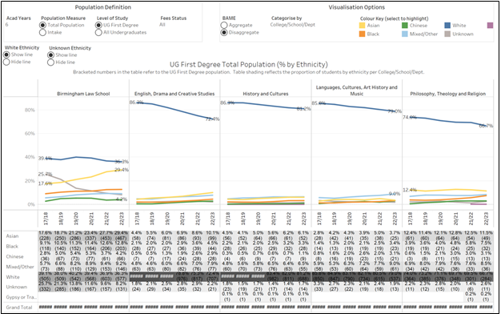

### **1.9. CAL UG Students - ethnicity**

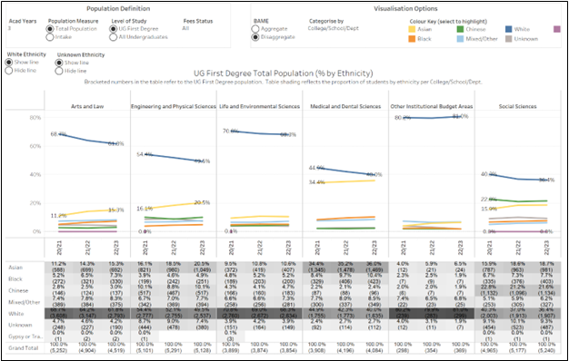

### **1.10. EDACS postgraduate pipeline – ethnicity**

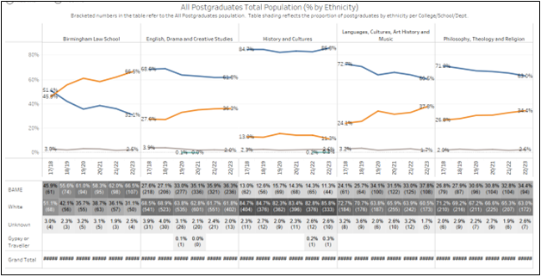

### **1.11. Applications**

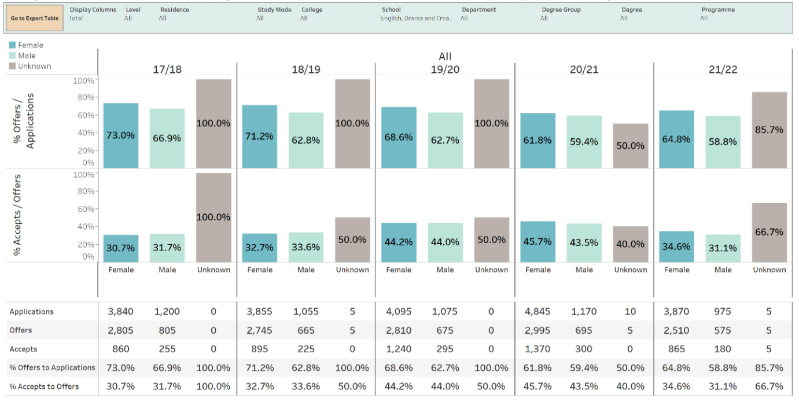

## 2. Degree attainment and/or completion rates for students at foundation, UG, PGT and PGR level

### **2.1. EDACS UG degree attainment**

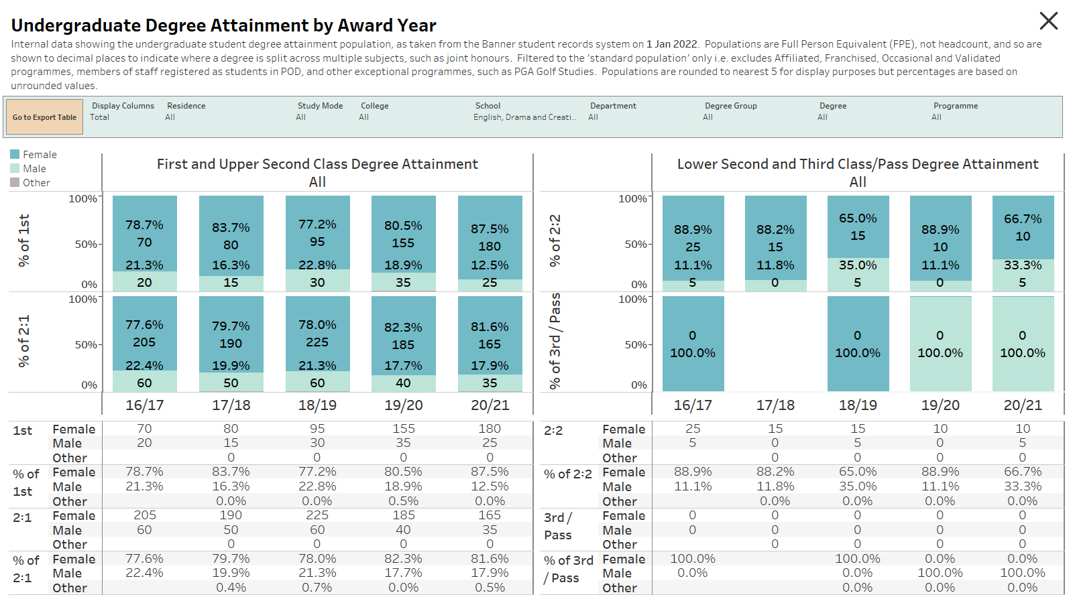

**

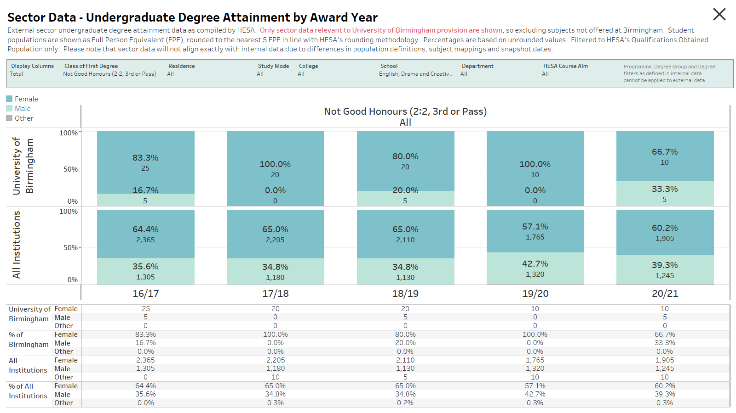

### **2.3. EDACS PGT degree attainment - FT**

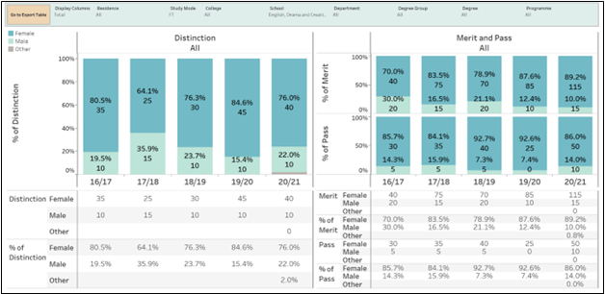

### **2.4. EDACS PGT degree attainment - PT**

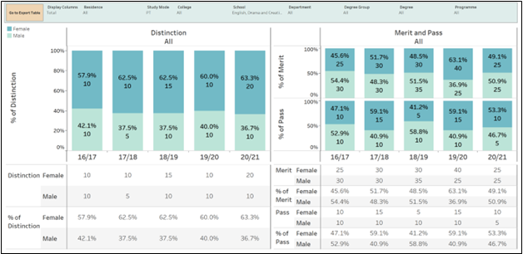

### **2.5. EDACS PGR degree completions**

### **2.6. CAL UG degree awarding gaps – ethnicity (Black compared with white identifying students)**

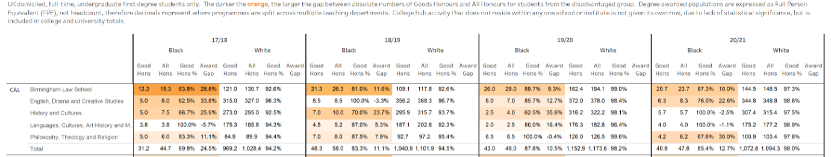

### **2.7. CAL UG degree awarding gaps – ethnicity (Asian compared with white identifying students)**

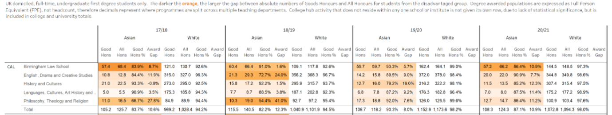

### **2.8. CAL UG degree awarding gaps – ability (declared compared to no known disability)**

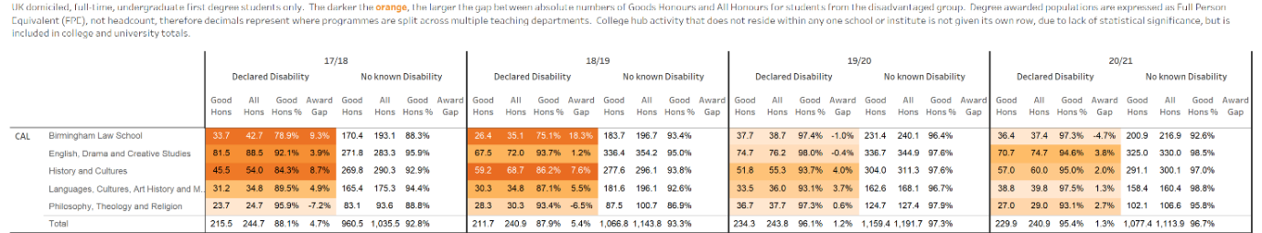

### **2.9. CAL PGT degree awarding gaps – ethnicity (BAME compared to white identifying)**

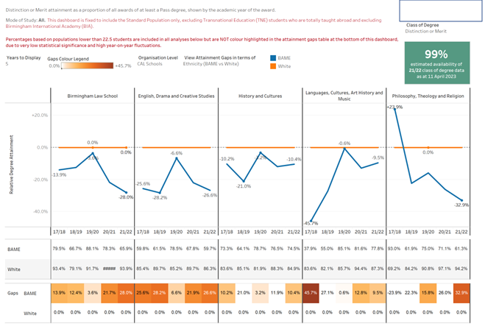

## Staff data

## 3. Academic staff by grade and contract function

### **3.1. All EDACS staff overview**

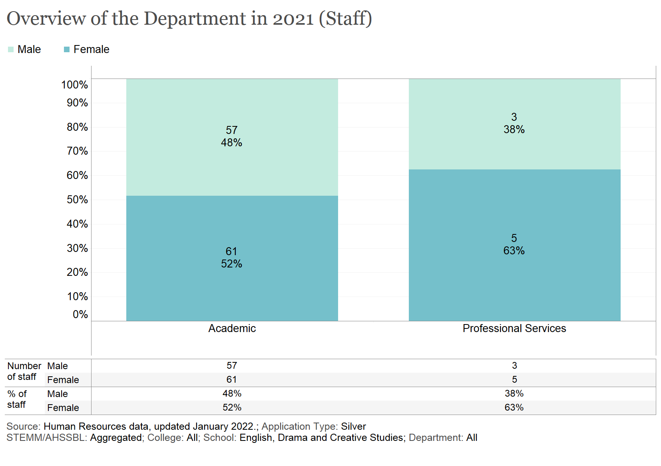

### **3.2. EDACS academic staff by contract function**

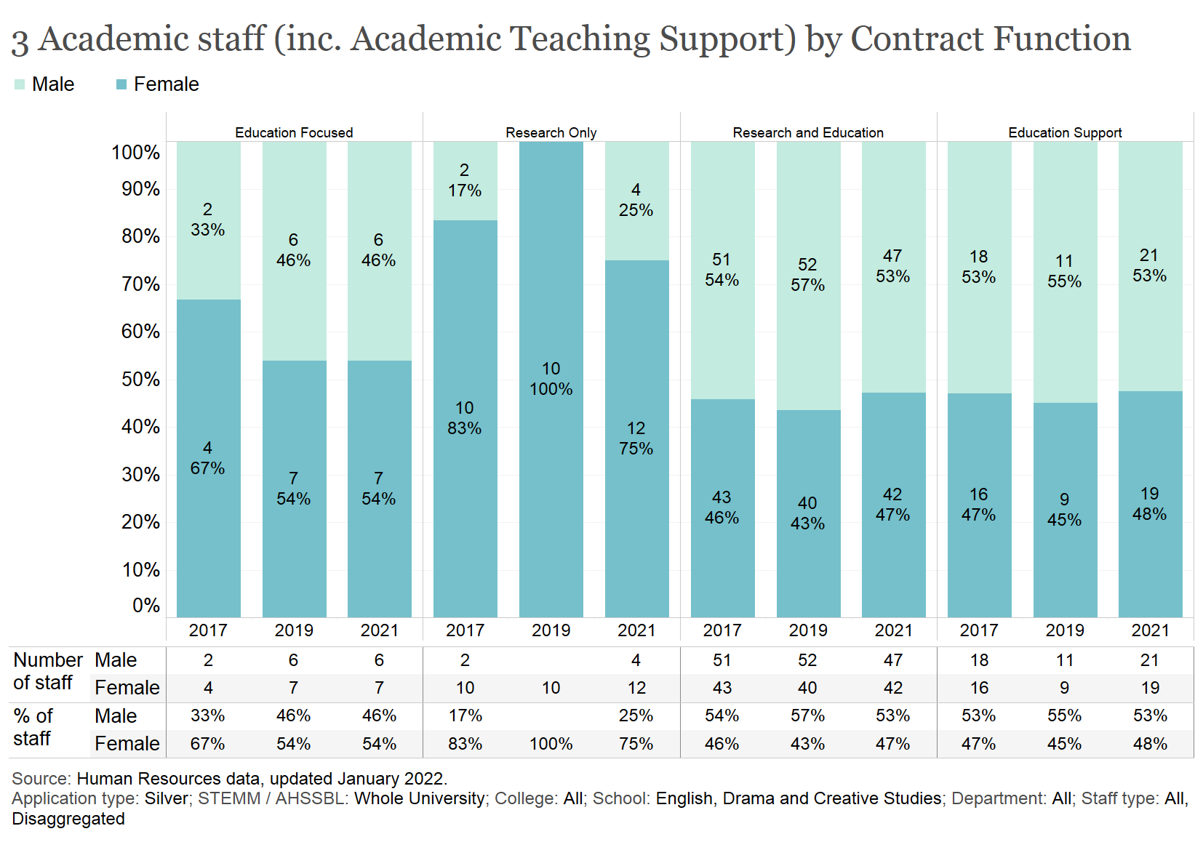

### **3.4. EDACS Research and Education contracts by grade and function**

### **3.5. EDACS Education-focused contracts by grade and function**

### **3.6. EDACS Research-only contracts by grade and function**

### **3.7. EDACS academic staff pipeline**

## 4. Academic staff by grade and contract type

### **4.1. EDACS academic staff by grade and contract type**

### **4.2. EDACS academic staff by mode**

### **4.3. EDACS academic leavers by mode (voluntary leaver’s scheme only)**

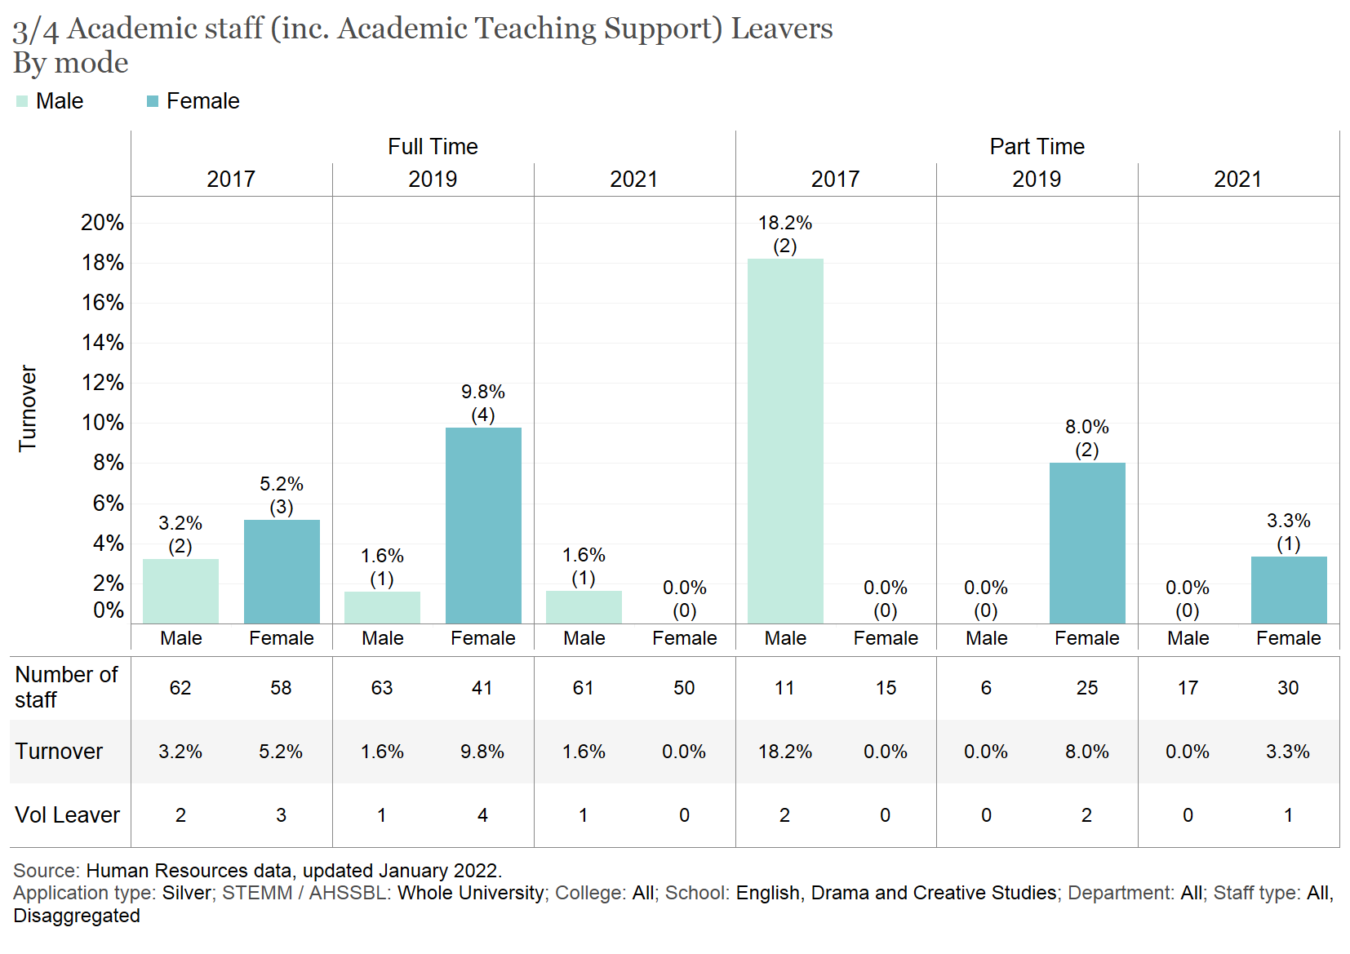

## 5. Professional Services (PS) staff by grade and job family

### **5.1. PS staff by grade and job family**

## 6. PS staff by contract type

### **6.1. PS staff by grade, job family, and contract type**

### **6.2. PS staff by contract type**

### **6.3. PS staff by mode**

### **6.4. PS leavers by mode**

## 7. Applications, shortlist and appointments made in recruitment to academic posts by grade

### **7.1. Academic recruitment by grade - applications**

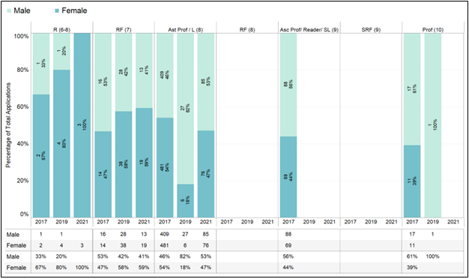

### **7.2. Academic recruitment by grade - shortlisted**

### **7.3. Academic recruitment by grade – appointed**

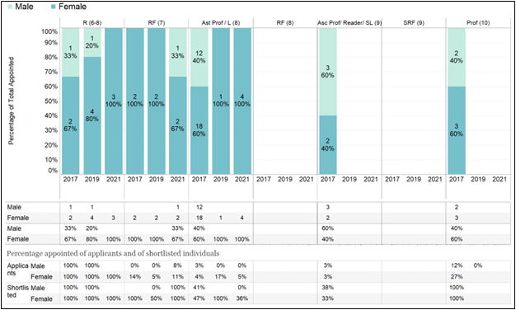

### **7.4. Academic recruitment pipeline**

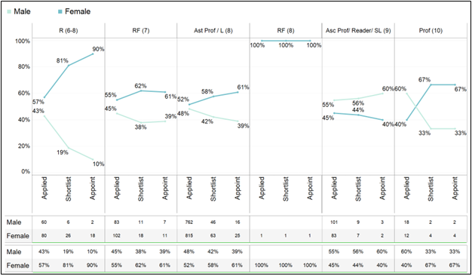

## 8. Applications, shortlist and appointments made in recruitment to PTO / PS posts by grade

### **8.1. PS recruitment by grade – applications**

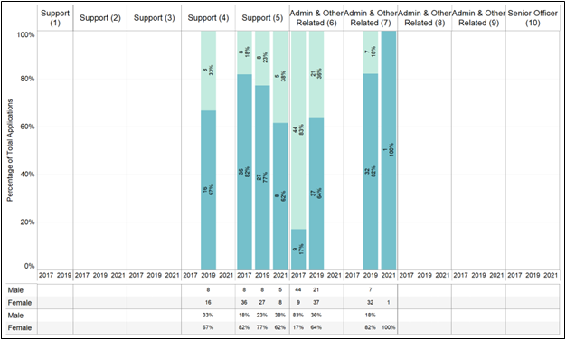

### **8.2. PS recruitment by grade – shortlisted**

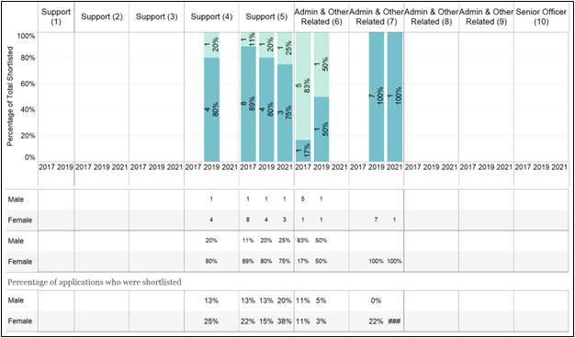

### **8.3. PS recruitment by grade – appointed**

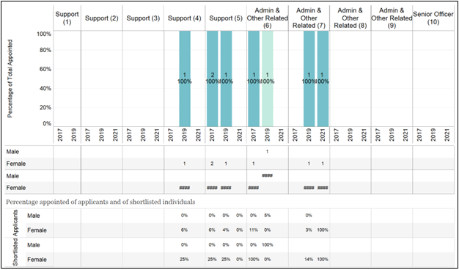

### **8.4. PS recruitment pipeline**

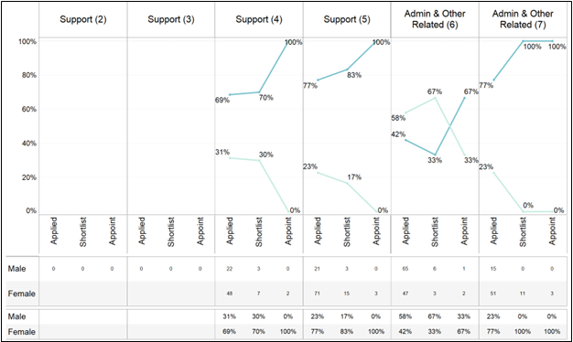

## 9. Applications and success rates for academic promotion by grade

### **9.1. Academic promotions**

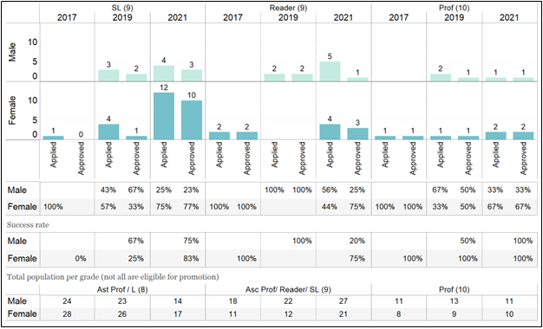

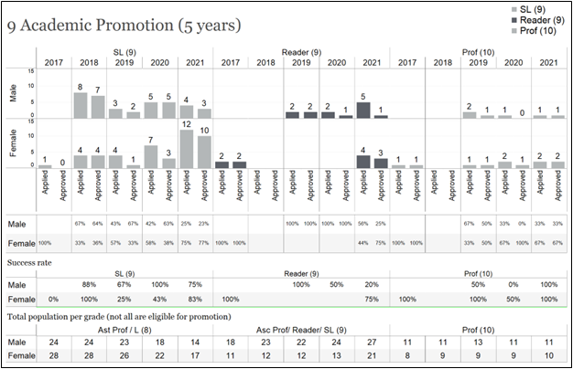

### **9.2. Academic promotions by mode**

## 10. Applications and success rates for PTO / PS progression by grade (where there are formal routes for progression)

Professional Services staff apply for more senior positions via the usual recruitment process. As such, there is no promotions process in place for these staff members.

**Appendix 3: Glossary**

Please provide a glossary of abbreviations and acronyms used in the application.

|  |  |  |
| --- | --- | --- |
| Abbreviation | Term | Colour coding |
| A1 | Appendix 1 | **A1** |
| A2 | Appendix 2 | **A2** |
| A2B | Access2Birmingham |  |
| AP | Action Plan |  |
| AP-B | Action Plan – Bronze Award (2018) | **AP-B** |
| AP-S | Action Plan – Silver Award (2023) | **AP-S** |
| AS | Athena SWAN |  |
| AS SAT | Athena SWAN Self-Assessment Team |  |
| BACF | Birmingham Academic Career Framework |  |
| BIRMS | Banner Interface Record Management System |  |
| CAL | College of Arts and Law |  |
| DPVC | Deputy Pro-Vice-Chancellor |  |
| DTA | Department of Drama and Theatre Arts |  |
| E | Education contract (academic) |  |
| ECO | Early Career Officer |  |
| ECR | Early Career Researcher |  |
| EDIC | Equality and Diversity Committee |  |
| EDIO | Equality and Diversity Officer |  |
| EDACS | School of English, Drama, and Creative Studies |  |
| EEI | Enterprise, Engagement and Impact contracts (academic) |  |
| ELAL | Department of English Language and Linguistics |  |
| ELIT | Department of English Literature |  |
| FCW | Department of Film and Creative Writing |  |
| HESA | Higher Education Statistics Agency |  |
| HoC | Head of College |  |
| HoD | Head of Department |  |
| HoOp | Head of Operations |  |
| HoS | Head of School |  |
| LWG | Leadership Working Group |  |
| MCR | Mid-Career Researcher |  |
| NSS | National Student Survey |  |
| PGR | Postgraduate Research student |  |
| PGT | Postgraduate Taught student |  |
| POD | People and Organisational Development |  |
| PS | Professional Services, UoB’s term for PTO (Professional, Technical, and Operational) |  |
| PTES | Postgraduate Taught Experience Survey |  |
| RC | Research Centre |  |
| R+E | Research and Education contracts (academic) |  |
| SEC | School Executive Committee |  |
| SI | The Shakespeare Institute |  |
| SCS | Staff Culture Survey |  |
| SSF | Staff Student Committee |  |
| SEO | Student Experience Officer |  |
| UG | Undergraduate student |  |
| UoB | University of Birmingham |  |
| UEB | University Executive Board |  |
| VLE | Virtual Learning Environment (Canvas) |  |
| WAM | Workload Allocation Model |  |
| WC | Wellbeing Collective |  |

1. Although only 8 PS colleagues are listed as part of EDACS’s staffing establishment, the School benefits from the support of many more professional services colleagues embedded in EDACS departments and offices but with line management structures reporting elsewhere within the College and University.
2. UoB’s Charter, Statutes, and Regulations are publicly available here: <https://www.birmingham.ac.uk/university/leadership/governance/legislation/index.aspx?_ga=2.1550514.286409398.1681811982-1337107172.1637235709>.
3. SCS 2020 was circulated before AS published their revised charter with suggested ‘Core questions’. Appendix 1 is therefore presented with our closest answers to the new ‘Core questions’ in Section 1, demographic questions in Section 2, and EDACS’s additional questions in Section 3.
4. Details of the developmental needs analysis and researcher development framework required of PGs are available on UoB’s Intranet: <https://intranet.birmingham.ac.uk/student/graduateschool/pgr/skills/dna.aspx>.
5. The EDACS AS SAT privileges ‘awarding’ over ‘attainment’ gap for the emphasis the former phrase places on institutional policy and process. Gary Loke, ‘Time’s up for the awarding gap’, *WonkHE* (22 October 2020), <https://wonkhe.com/blogs/times-up-for-the-awarding-gap/>.
6. Like discussions of ‘attainment’ gaps, references to ‘pipeline’ problems can imply that career progression is smooth as standard, when the problem is imbedded in the ‘process’ itself. See: Megan Rose Dickey, ‘Examining the ‘pipeline problem’’, *TechCrunch*, 14 February 2021, [bit.ly/417cER1](https://techcrunch.com/2021/02/14/examining-the-pipeline-problem/?guccounter=1&guce_referrer=aHR0cHM6Ly93d3cuZ29vZ2xlLmNvbS8&guce_referrer_sig=AQAAAM15wMku6JFkhYAbISA5kC7-x4Jk0kh1kp6ZDAeBDByquakYm2txPRrKMCiJmGMFNJ9yCtQvGwmSBQEQ-oW-cIKkQ5Phm9xZnvQph2KEfL7j51JHImOqSyon2WKTSM153l9JzpDtrVgne8sowZzuAOSiTG29UhSKLy21hTpaN2M9).
7. HESA suggests that 63% of non-academic staff in UK HE are women and 37% male. HESA, ‘Higher Education Staff Statistics: UK, 2021/22’ (17 January 2023), <https://www.hesa.ac.uk/news/17-01-2023/sb264-higher-education-staff-statistics>.
8. Rianna Croxford, ‘Ethnic minority academics earn less than white colleagues,’ *BBC News*(7 December 2018), <https://www.bbc.co.uk/news/education-46473269.amp>.  
9. It remains the case that many externally funded grants create short-term TF positions (i.e., Leverhulme or British Academy fellowships) for fixed funding periods.
10. Karen Cardozo, ‘Academic labor: Who cares?’, *Critical Sociology* 43.3 (2017), pp. 405-28; Patricia A. Mathew (ed.), *Written/Unwritten: Diversity and the Hidden Truths of Tenure*, Chapel Hill: University of North Carolina Press, 2016.