

**Equality, Diversity & Inclusion**

**Our Staff Population 2024**

# Introduction

This report shows the University staff body as in January 2024 in relation to the Equality Act 2010 protected characteristics of:

* Sex
* Race/ethnicity
* Disability
* Gender reassignment
* Religion or belief
* Sexual Orientation

Staff data is shown at 3 levels, except where numbers are low and disaggregating data would potentially make individuals identifiable. These are:

* All staff (i.e. institution-level data)
* Professional Services (data on staff on Admin & Other-Related and Support terms and conditions)
* Academic (data on staff on teaching and/or research terms and conditions, including clinical staff)

# Disclosure Rates

Staff are asked to provide the University with information about their equality characteristics on joining the University and can then update their data throughout their employment via Core systems. Providing this information is optional (with the exception of sex, which is required by HRMC). The information in this report is based on the following disclosure rates:

|  |  |  |  |
| --- | --- | --- | --- |
| **Protected characteristic** | **Academic Staff** | **Professional Services Staff** | **All Staff** |
| Sex | 100% | 100% | 100% |
| Race/Ethnicity | 93% | 95% | 94% |
| Disability | 62% | 77% | 69% |
| Gender reassignment* | 50%/46% | 48%/46% | 49%/46% |
| Religion or belief | 62% | 70% | 66% |
| Sexual orientation | 66% | 70% | 68% |

*We ask two questions in relation to gender reassignment. The first figure is disclosure rates for gender identity and the second is disclosure rates for whether gender identity is different from sex as recorded at birth.

# Sex

## Staff groups by Sex (female and male)

|  |  |  |  |
| --- | --- | --- | --- |
|  | **Female (no.)** | **Male (no.)** | **Total (no.)** |
| **Academic staff** | 2249 | 2617 | 4866 |
| **Professional Services staff** | 3139 | 1982 | 5121 |
| **All staff** | 5388 | 4599 | 9987 |

## Academic staff by grade and sex (female and male)

|  |  |  |  |
| --- | --- | --- | --- |
|  | **Female (no.)** | **Male (no.)** | **Total (no.)** |
| **Grade 6-7** | 1121 | 1133 | 2254 |
| **Grade 8** | 512 | 466 | 978 |
| **Grade 9** | 407 | 565 | 972 |
| **Professorial Grade** | 209 | 453 | 662 |
| **Total** | 2249 | 2617 | 4866 |

## Professional Services staff by grade and sex (female and male)

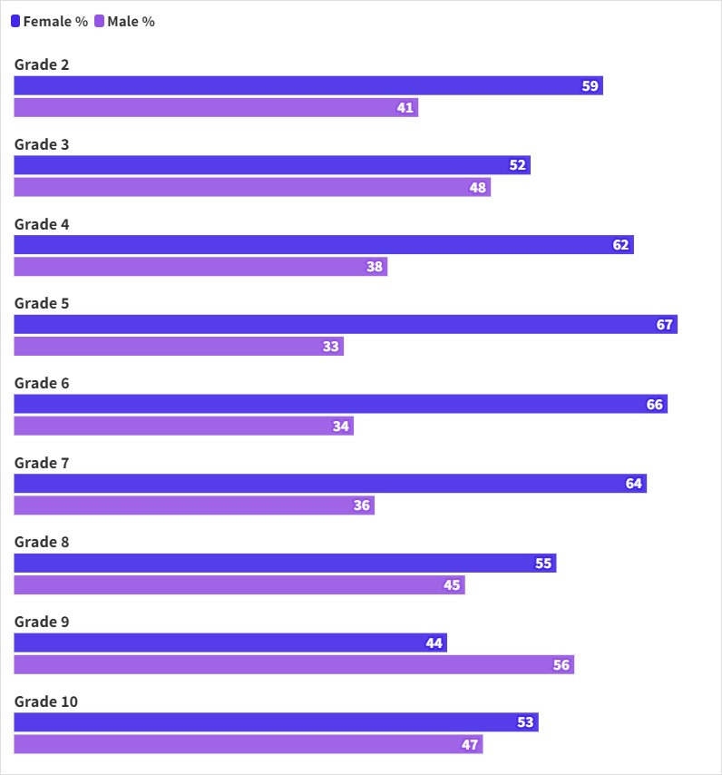

|  |  |  |  |
| --- | --- | --- | --- |
|  | **Female (no.)** | **Male (no.)** | **Total (no.)** |
| **Grade 2** | 289 | 198 | 487 |
| **Grade 3** | 179 | 165 | 344 |
| **Grade 4** | 445 | 268 | 713 |
| **Grade 5** | 672 | 334 | 1006 |
| **Grade 6** | 551 | 287 | 838 |
| **Grade 7** | 553 | 315 | 868 |
| **Grade 8** | 337 | 280 | 617 |
| **Grade 9** | 85 | 110 | 195 |
| **Grade 10** | 28 | 25 | 53 |
| **Total** | 3139 | 1982 | 5121 |

# Ethnicity

## All staff by ethnicity (%)

## Staff group and ethnicity (%)

|  |  |  |  |  |  |  |
| --- | --- | --- | --- | --- | --- | --- |
|  | **Academic staff** | | **Professional Services staff** | | **All staff (total)** | |
|  | No. | % | No. | % | No. | % |
| Asian – Bangladeshi | 23 | 0.5 | 68 | 1.3 | 91 | 0.9 |
| Asian – Indian | 273 | 5.6 | 328 | 6.4 | 601 | 6 |
| Asian – Pakistani | 82 | 1.7 | 155 | 3 | 237 | 2.4 |
| Asian – Chinese | 452 | 9.2 | 87 | 1.8 | 539 | 5.4 |
| Asian – Other | 164 | 3.4 | 68 | 1.3 | 232 | 2.3 |
| **Total Asian** | **994** | **20.4** | **706** | **13.8** | **1700** | **17** |
| Black – African | 128 | 2.6 | 163 | 3.2 | 291 | 2.9 |
| Black – Caribbean | 23 | 0.5 | 185 | 3.6 | 208 | 2.1 |
| Black - Other | 12 | 0.3 | 23 | 0.4 | 35 | 0.4 |
| **Total Black** | **163** | **3.4** | **371** | **7.2** | **534** | **5.4** |
| Multiple/Mixed – White and Asian | 45 | 0.9 | 48 | 0.9 | 93 | 0.9 |
| Multiple/Mixed – White and Black African | 11 | 0.2 | 20 | 0.4 | 31 | 0.3 |
| Multiple/Mixed – White and Black Caribbean | 6 | 0.1 | 48 | 0.9 | 54 | 0.5 |
| Multiple/Mixed – Other | 71 | 1.5 | 52 | 1.1 | 123 | 1.3 |
| **Total multiple/mixed** | **133** | **2.7** | **168** | **3.3** | **301** | **3** |
| Arab | 87 | 1.8 | 13 | 0.3 | 100 | 1 |
| Other ethnicity | 61 | 1.2 | 35 | 0.6 | 96 | 1 |
| **Total other ethnicity** | **148** | **3** | **48** | **0.9** | **196** | **2** |
| White - British | 2074 | 42.6 | 3219 | 62.9 | 5292 | 53 |
| White – Gypsy or Irish Traveller | 1 | <0.1 | 0 | 0 | 1 | <0.1 |
| White - Irish | 79 | 1.6 | 53 | 1 | 132 | 1.3 |
| White - Other | 926 | 19 | 302 | 5.9 | 1229 | 12.3 |
| White – Roma | 1 | <0.1 | 1 | <0.1 | 2 | <0.1 |
| **Total white** | **3081** | **63.3** | **3575** | **69.8** | **6656** | **66.6** |
| **Prefer not to say or unknown** | **347** | **7.2** | **253** | **5** | **600** | **6** |
| **Total staff** | **4866** | **48.7** | **5121** | **51.3** | **9987** | **100** |

1. **Academic staff by grade and ethnicity**

|  |  |  |  |  |  |  |  |
| --- | --- | --- | --- | --- | --- | --- | --- |
|  | **Asian (no.)** | **Black (no.)** | **Multiple or Mixed (no.)** | **Other ethnicity**  **(no.)** | **White (no.)** | **Prefer not to say or unknown (no.)** | **Total (no.)** |
| **Grade 6-7** | 589 | 110 | 72 | 90 | 1185 | 208 | 2254 |
| **Grade 8** | 227 | 22 | 25 | 29 | 615 | 60 | 978 |
| **Grade 9** | 120 | 26 | 27 | 15 | 737 | 47 | 972 |
| **Professorial** | 58 | 5 | 9 | 14 | 544 | 32 | 662 |
| **Total** | 994 | 163 | 133 | 148 | 3081 | 347 | 4866 |

1. **Professional Services staff by grade and ethnicity**

|  |  |  |  |  |  |  |  |
| --- | --- | --- | --- | --- | --- | --- | --- |
|  | **Asian (no.)** | **Black (no.)** | **Multiple or Mixed (no.)** | **Other ethnicity**  **(no.)** | **White (no.)** | **Prefer not to say or unknown (no.)** | **Total (no.)** |
| **Grade 2** | 65 | 153 | 23 | 6 | 209 | 31 | 487 |
| **Grade 3** | 49 | 33 | 13 | 4 | 232 | 13 | 344 |
| **Grade 4** | 116 | 38 | 18 | 9 | 480 | 52 | 713 |
| **Grade 5** | 163 | 45 | 36 | 3 | 710 | 49 | 1006 |
| **Grade 6** | 125 | 47 | 38 | 11 | 585 | 32 | 838 |
| **Grade 7** | 110 | 31 | 23 | 13 | 664 | 27 | 868 |
| **Grade 8** | 66 | 19 | 16 | 1 | 483 | 32 | 617 |
| **Grade 9** | 11 | 2 | 1 | 1 | 165 | 15 | 195 |
| **Grade 10** | 1 | 3 | 0 | 0 | 47 | 2 | 53 |
| **Total** | 706 | 371 | 168 | 48 | 3575 | 253 | 5121 |

# Disability

|  |  |  |  |  |
| --- | --- | --- | --- | --- |
|  | **Disabled (no.)** | **No disability (no.)** | **Prefer not to say (no.)** | **Total (no.)** |
| **Academic staff** | 203 | 2792 | 1871 | 4866 |
| **Professional Services staff** | 427 | 3501 | 1193 | 5121 |
| **All staff** | 630 | 6293 | 3064 | 9987 |

# Gender Reassignment and Gender Identity

1. **Gender Identity**

|  |  |  |
| --- | --- | --- |
|  | **%** | **Number** |
| **Woman or female** | 27.3% | 2729 |
| **Man or male** | 21.2% | 2114 |
| **Gender fluid** | 0.1% | 6 |
| **Non-binary** | 0.3% | 33 |
| **Other gender identity** | 0.1% | 9 |
| **No gender identity** | 0.1% | 10 |
| **Prefer not to say** | 50.9% | 5086 |
| **Total** | 100% | 9987 |

## Gender identity and sex as registered at birth

|  |  |  |
| --- | --- | --- |
|  | **%** | **Number** |
| **Gender identity and sex registered at birth are the same** | 45.4% | 4532 |
| **Gender identity and sex registered at birth are different** | 0.4% | 40 |
| **Prefer not to say** | 54.2% | 5415 |
| **Total** | 100% | 9987 |

# Religion or Belief

|  |  |  |
| --- | --- | --- |
|  | **Number** | **%** |
| **Buddhist** | 62 | 0.6% |
| **Christian** | 2028 | 20.3% |
| **Hindu** | 197 | 2% |
| **Jewish** | 20 | 0.2% |
| **Muslim** | 588 | 5.9% |
| **Sikh** | 159 | 1.6% |
| **Spiritual** | 110 | 1.1% |
| **Other religion or belief** | 111 | 1.1% |
| **No religion or belief** | 3342 | 33.5% |
| **Prefer not to say** | 3370 | 33.7% |
| **Total** | 9987 | 100% |

# Sexual Orientation

|  |  |  |
| --- | --- | --- |
|  | **Number** | **%** |
| **Bisexual** | 298 | 3% |
| **Lesbian or gay woman** | 110 | 1.1% |
| **Gay man** | 173 | 1.7% |
| **Other orientation** | 95 | 1% |
| **Heterosexual** | 6091 | 61% |
| **Prefer not to say** | 3220 | 32.2% |
| **Total** | 9987 | 100% |