Defining Our Identity – Identity Design Principles

Background
The “Defining our Identity” project was focused on ensuring that there is a common use of words to describe the University in a consistent but flexible way, whilst ensuring all areas of activity can adapt it to suit their needs. This work helps ensure the University of Birmingham’s work has the profile and awareness it deserves, both internally and externally. During this process the very large number of logos became apparent which were often not linked in any way to the University of Birmingham. When logos appear independently, the University risks losing profile, reputational enhancement or connection with an initiative.
To address this and strengthen the University’s identity and overall recognition, regionally, nationally and globally, we have consulted with College Boards and Professional Services to agree identity principles. The aim is to ensure individual areas can appeal to their audiences whilst maximising the benefits of the University. We have therefore developed a series of identity principles which are outlined below:

Identity Principles
- Crest lock up
In the majority of cases individual logos should not be required and the name of the school or service can be locked up with the crest and word marque using straight-forward typography.

Crest lock up University Word marque
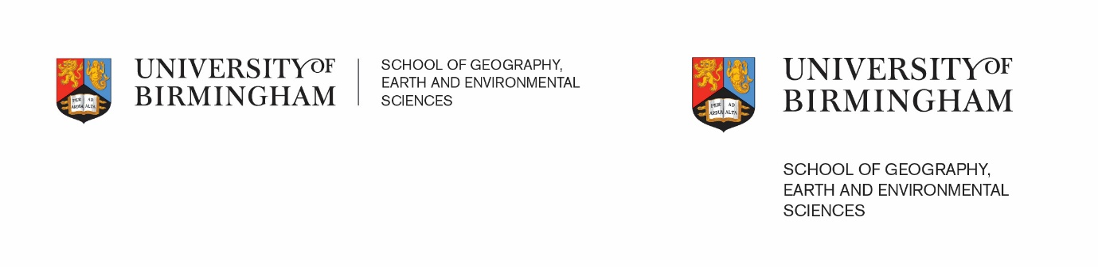
- The word marque should always be positioned to the right of the crest, with the school, institute or service at the same height as the word marque
- Font type is ITC New Baskerville for the word marque and Akzidenz Grotesk for typography – this is the same as currently used
- Name of school or service should not be separated from the lock up, except for the University website where the word marque and crest will be top left
- The Crest should always appear top left
- There is a dividing line on the horizontal version

- Word marque lock up : Where individual logos are appropriate, the following principles apply:

Word marque lock up (horizontal and vertical)

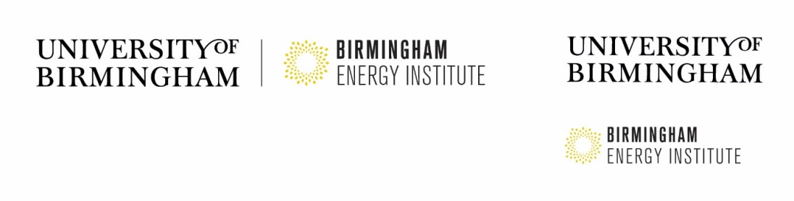
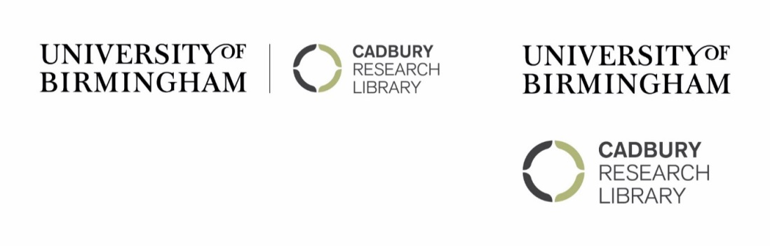

- All logos should be locked with the University of Birmingham word marque
- The University of Birmingham word marque should be at least the same size as any sub-brand
- The size of the logo should be proportionate and no larger than one-third of the overall sub-brand
- In the majority of cases, the background colour will be white. Depending on the colour of the graphical logo where a background colour is used, it is recommended the font is reversed to white
- Over time, all sub-brands should be in line with this approach
- The word marque should always appear top left
- There is a dividing line on the horizontal version
- Please use Creative Media in designing any graphical logo

Exceptions
- External partnerships - where it may not be appropriate for the University identity to be as prominent e.g. the ITM. Where an external partnership is funded by a range of parties and the University is not necessarily the lead partner. In these cases there may not be a lock up with the word marque and the position of the word marque should be appropriate for the partnership.

- Business cards – the crest and word marque lock up should appear together. The logo can be represented on the reverse of the business card (see below).

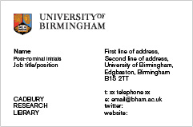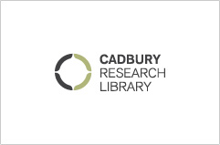

- Letterheads – crest and word marque options should appear on the right hand side. The crest should not appear with the logo. In this scenario, there is the option to use typography to represent the logo.
- E mail - crest and word marque options should appear on the left hand side.

Timings
- Unnecessary expense should not be incurred in adopting these principles.
- Digital material should be replaced by 30 April 2016. All new print will be designed using these principles, and any existing print material should be replaced by 30 September 2016 to allow for the running down of stock.

Frequently asked questions
Q: When should you use a logo?
A: When competing outside of the University HE sector e.g. Lapworth, Winterbourne or where there is a solid historical rationale or where a research group/institute are competing externally with a commercial provider. In these instances, it is recommended the logo should be used as part of the lock up with the University of Birmingham word marque.

Q: Can a School, course or centre have a logo?
A: Option 1 with the word marque and typography would be the approach in this instance.

A detailed technical specification is available from Creative Media.
Should you have any questions on any of the above, please speak to your College Marketing and Communications Manager (CMCM), Head of Marketing in HAS or the Creative Media team.

