Science Warehouse
Unit B2, The Half Roundhouse
Roundhouse Business Park
Wellington Road
Leeds
LS12 1AH

0333 600 6300

eMarketplace
Administrator Guide

Revision | Reason for Issue | Recipient(s) | Date
V2 | Review by C Watson | T Tattersley | 26/01/17
V2 | Added page numbers | T Tattersley | 22/5/17

Confidentiality
This document has been prepared for the use of Science Warehouse Ltd’s contracted customers. This document is not intended for and should not be used by any third party. Distribution or reproduction of this document to such parties must not take place without written consent from Science Warehouse.
Table of Contents
Document Purpose 1
Considerations Before Use 1
Areas Covered 1
Admin Users – An Overview 2
The Interface 3
Overview of the Interface 3
Home 3
Business Unit Administration 3
User Search 3
Documents 3
Reports 3
Help 3
Create New Users 4
End User Creation – Not Required 4
New Administrator Users 4
New Price Approver Users 4
The Hierarchy 5
Copying Existing Users 5
Creating a Price Approver User 5
Creating an Administrator User 6
User Maintenance 8
Forgotten password/locked out 8
Name Changes 8
Leavers 9
Order Administration 10
View Purchase Orders 10
Print Purchase Orders 12
Cancel Purchase Orders 12
Reports 13
Grant/Change Reporting Access to New Admin Users 14
Supplier Visibility 16
Deselect Supplier Catalogues 17
Select Supplier Catalogues 17
Prefer Supplier Catalogues 18
Restricting Catalogues by Category 18
Granting/Restricting Access to Punchout Suppliers 19

Document Purpose
This document details the processes and steps involved to administer the eMarketplace, including creating new administrator and price approver users, user maintenance, reporting, and supplier visibility. Please refer to your organisation’s processes for details on the actions that take place outside the eMarketplace (leavers process, order administration, etc.).
The CORE functions of an administrator user are covered in this document. If you require any documentation or training for some of the more advanced functions of the administrative interface, please contact SWL for further information.

Considerations Before Use
Before accessing the eMarketplace Administrative area, please ensure that cookies and popups are allowed from the *sci-ware-customer.com and *sci-ware.com domains. Without this, certain functions may not work. Please seek assistance from your IT support team for further information and guidance.
The administrator interface is a universal interface to service the administrative needs of the full suite of SWL products; as such, there are some elements/menus that are not applicable. This document covers those functions that are relevant only to the core product your organisation has contracted.

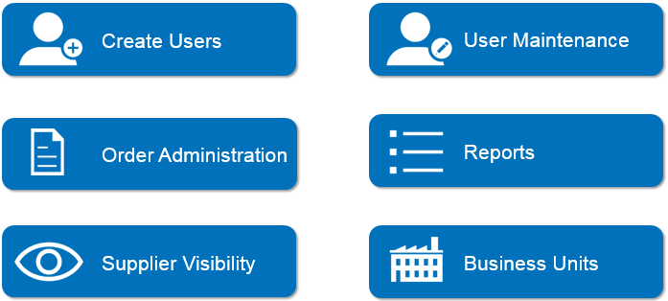
Areas Covered

Admin Users – An Overview
Administrator Users access the administrative interface directly, not via a finance system. Unlike end users, unique SWL login credentials are required to access the system.
Administrator users should access the site using the following URL: http://www.sci-ware.com/sword/login.do , where the appropriate country can be selected by choosing the appropriate flag next to the User ID field.
Please note, your credentials will only work for the country they are assigned to.
The background image refreshes daily, and as such, the image may differ from the above.

The Interface
The administrator interface differs from the end user interface in look and feel. . Only a small handful of users at your organisation should be granted permission to access the Administrator Interface.

Overview of the Interface

Home
The homepage will show the hierarchy of your organisation; all users that have an account created with SWL.
To expand the hierarchy quickly, type “punchout” into the “search for a name” box towards the top of the homepage.

Business Unit Administration
This area contains catalogue controls at a high level; by supplier, category, or business unit (department)

User Search
Tools to search for a user, rather than expanding the user hierarchy on the homepage

Documents
View POs raised by your organisation via SWL

Reports
Report on your organisation’s spend by a number of variables

Help
Access the SWL help module for assistance

Create New Users

End User Creation – Not Required

End users are created silently, due to the configuration work that is completed as part of the initial implementation with SWL. When a user punches out, your finance system is configured to send access credentials to us, along with the individual’s Finance System user ID, and their email address. SWL carries out a search on the system to validate whether these details already exist. If they do, the user is directed to their account homepage, linked to their spend history (subject to your organisation’s configuration). If the details do not match, SWL creates a new account for the user.

New Administrator Users

As administrative users access the system directly, there is no automatic setup in place. Therefore, these users will need to be created by an existing administrative user. Due to the limited number of administrative users, this exercise will be infrequent.

New Price Approver Users

Similarly, price approver users will access the system directly, although they will see a similar interface to end users. However, as they will not access via your finance system, their users will need to be created by an administrative user.

The Hierarchy
- Admin Users must be in a hierarchy for reporting purposes
- End Users are grouped into the same level as they do not report on spend other than their own
- There must be a clear reporting line, unbroken, from the bottom to the top
- Users outside of this hierarchy will not be able to report or see POs across the whole organisation

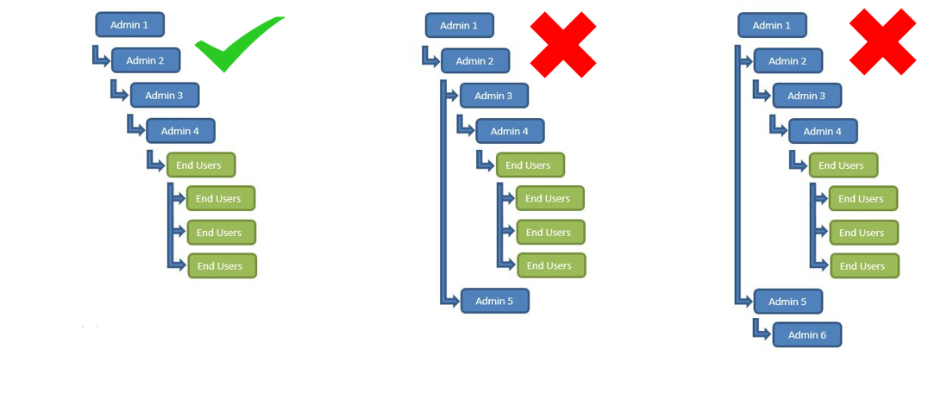

Copying Existing Users
SWL has already created users for you with the correct settings and configurations to work for your organisation.
Therefore, the easiest way to create a new user is to copy an existing one. Copying price approver users requires fewer steps, the additional steps required for administrate users are covered separately below.

Creating a Price Approver User
- From the homepage, find a price approver user
  - Alternatively, use the “User Search Function”
- Click on the user
- In the User record, at the top right, you will find the option to copy a user:
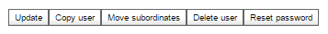

- On copying the user, this will copy all settings, but there are a few extra things you will need to update:
- When updating the Login ID, please bear in mind that this should be different to any ID in use within your finance system
  - If you utilise the same login, there is a risk that if the user also has access to the eMarketplace as an end user from your finance system, then they may be directed to the admin interface in error.
  - As with most online systems, if the User ID already exists, SWL will prompt you to enter another
  - The ID should be prefixed with your organisations unique identifier within SWL, normally four letters, see existing Login IDs for this.
- Once all information has been entered, remember to click on “Update”:

- To notify the user that their account has been created and to allow them to set their own password, now click on “reset password”:

- When resetting the password, please note, the login URL will not be shared with the user, for security purposes. You will need to share this with the user directly.
  - The user will receive an email with their login ID and a temporary password, which they will need to change at initial login.
  - Please ensure the correct email address is entered into the user record to ensure the user is able to receive the email.

Creating an Administrator User
- Before copying an administrator user, take note of the existing hierarchy. The creation of the administrator user is a two stage process, you will need to note the following:
  - The user your new administrator will need to sit underneath
  - The user that will need to sit below your new administrator users, remembering that the end users need to be at the bottom.
- Follow steps 1-5 of Copying a Price Approver User, remembering to copy an administrative user.
- Now, you will need to update the supervisor to be the user you noted in step 1a above:

- Remember to “Update” your changes
- Check the hierarchy of users on the homepage, expanding the hierarchy by typing in “punchout” into the “Search for Name” box
- You should now see the user you have created, which is not yet in the hierarchy. This is indicated by an icon with a globe, which is a good flag to identify if setup is incomplete.

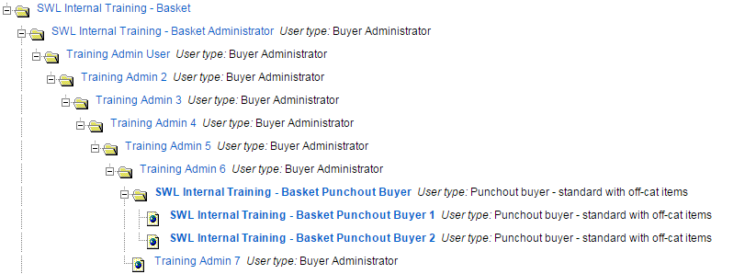

- Now, you will need to move the users (in the example above, the folder “SWL Internal Training – Basket Punchout Buyer”) so they are below your new user in the hierarchy.
- Navigate to this user, the user you noted in step 1b above, and edit their supervisor to be the user you have just created:

- Remember to “Update” your changes before navigating back to the homepage.
- Expand the hierarchy again to see your new user in the correct place. All administrator users should sit directly beneath one another, all with folder icons. Only end users and price approver users should have an icon of a globe:
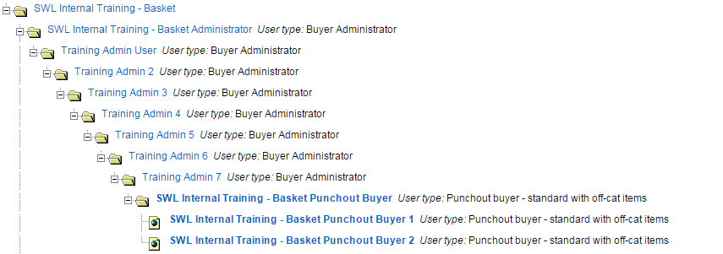

- NOTE: reporting access is not copied by default. Please refer to Reports for further info.

User Maintenance
There is minimal user maintenance required in the eMarketplace, however, there are occasions when an administrator may need to update a user’s record:

Forgotten password/locked out

This only applies to admin users/ price approver users, as the end users never know the login credentials. If a fellow admin user, or a price approver user locks themselves out of their account, they can reset their own password following the link on the login page.
However, if, for any reason, their email address is incorrect on their user account, they will not receive the password reset email. Therefore, another administrator user will need to carry out the following steps:
- Find the user in the admin interface using the “User Search” function
- Check the email address is correct
- Update Account Status from “Locked” to “Active”
- Click “Update”
- Now, click “Reset Password”
- This will email a temporary password to the user.

Name Changes

Once a user account is registered on SWL, no updated user data will be carried over from your finance system. Should a user’s name and/or email address change, this will need to be altered manually, to ensure the correct name appears on their homepage, and they continue to receive order-related emails.
- Find the user in the admin interface using the “User Search” function
- Update their name/email address
- Click “Update”
NOTE: if the finance system ID changes, our system will not associate this with the user’s existing account and they will lose their order history (SWL will auto-create a new account based on the new ID). If the user ID changes and the user requires their order history to be visible from the new ID, the existing ID MUST be updated manually within SWL.

Leavers

Should an end user leave, as they don’t have direct access to SWL, it is not necessary to inactivate their account. However, for good housekeeping, this can be carried out by an administrator. Administrator and Price Approver user account MUST be inactivated should they leave. NEVER delete a user as this will delete their order/spend history.
- Find the user in the admin interface using the “User Search” function
- Update status from “Active” to “Inactive” and click “Update”
- A ‘Leavers’ folder can also be created by Customer Support, should you wish to move these users into for further housekeeping.

Order Administration
The majority of order administration will continue to be carried out via your finance system. However, some high level administration can be carried out within Science Warehouse:

View Purchase Orders
Administrator users can view all purchase orders that have been created in the hierarchy beneath them. Typically, these will be for the entire organisation.
To view purchase orders as an administrator, take the following steps:
- From the administrator interface, navigate to “Documents”, and “POs”:
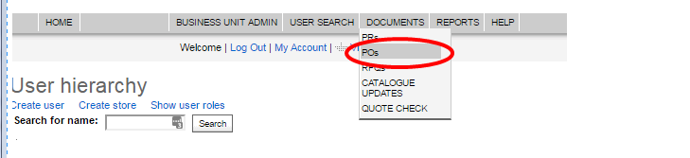

- Search criteria can refine your PO results to be more specific, but you are able to leave all fields blank to return all POs. Please note, “Requisition (PR) number” and “Payment type” are part of the universal interface and not searchable fields for the SWL product your organisation has contracted:
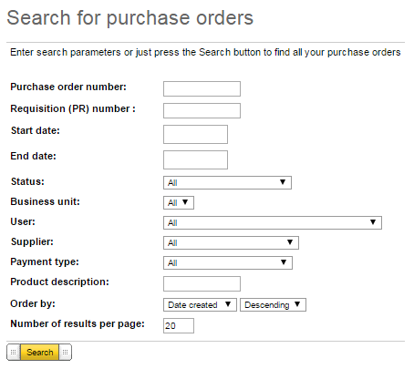

- The search results will display all POs meeting your search criteria.

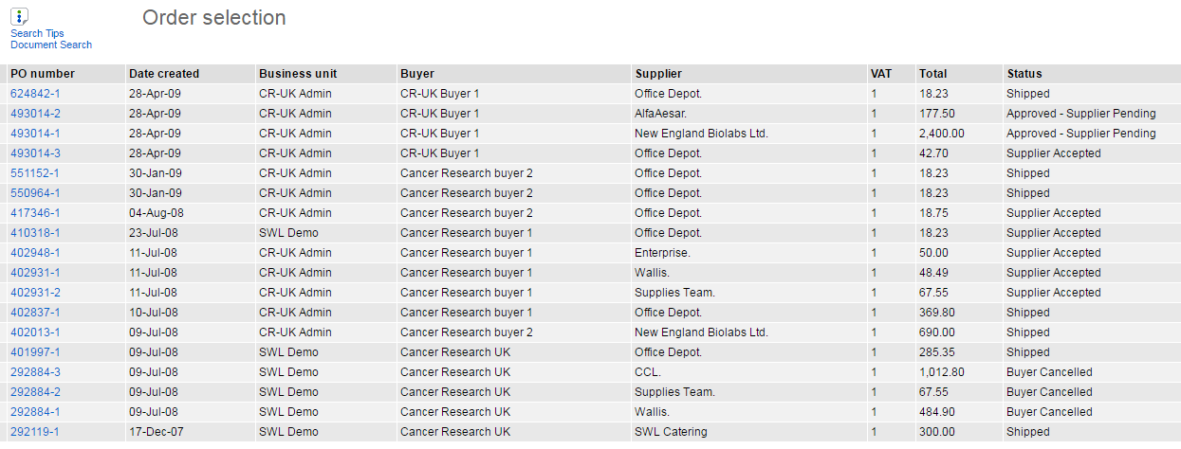

- The following information is displayed at summary level:
  - PO number
  - Date created (date received by SWL)
  - Business Unit (your organisation, or department)
  - Buyer (user transmitted with the order)
  - Supplier
  - VAT (status 1 = default, 20%)
  - Total
  - Status
    - Approved – Supplier Pending (awaiting supplier acceptance)
    - Supplier Accepted (supplier is or has processed PO)
    - Shipped (not all suppliers utilise this feature)
    - Buyer Cancelled (an administrator user has cancelled the order in SWL)
    - Rejected (the supplier has rejected the PO)
- Further detail of each PO can be viewed by selecting the PO number.
- At the bottom of each PO is an audit log, noting the changes that have occurred to the PO, the user that carried them out, and the timestamp:
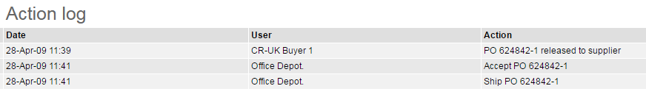

Print Purchase Orders

When viewing the detail of a PO (step 5 above), it is possible to print a copy of the PO. This is the same template that a supplier is also able to print from their SWL account, or that is attached to an email. Those suppliers that integrate with SWL will receive the PO as raw data that is fed directly into their ERP for automatic processing.
- Following the steps in View Purchase Orders, access a PO and navigate to “Print” in the top right corner”:

- This will generate a pdf in a new tab/window that can be printed.

Cancel Purchase Orders

Once the PO is submitted to SWL, it is often picked up and processed by the supplier immediately. As a result, it is often too late to cancel a PO electronically. It is recommended that unwanted lines are managed via credit note processes with the supplier, following your existing process, outside of SWL.
However, if an entire order is cancelled within your finance system and the supplier has agreed not to progress with the order, then the order will also need to be cancelled off within SWL, so the two systems have consistent reporting.
Please note, only the entire order can be cancelled.
- Following the steps in View Purchase Orders, access a PO and navigate to “Cancel” in the top right corner:

- The PO will be cancelled and an action will be logged in the audit log at the bottom of the PO screen.
- NOTE: only carry out this step if the PO has firstly been cancelled in your finance system, and some communication has taken place with the supplier.

Reports
The SWL reporting suite allows you to carry out various reporting exercises on spend going through SWL.

Extension of your existing finance system reports

Report by spend

Report by supplier

Grant reporting access to new admin users

The Reporting Suite can be accessed from the administrator interface:
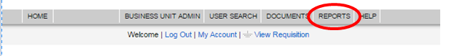
This opens a session in a different interface, where a variety of reports can be accessed. To return to the administrator interface, select “marketplace home”:

Grant/Change Reporting Access to New Admin Users

New Administrator users are not automatically setup with access to reports. This is because you may wish for a user to have access to the system to perform maintenance activities (create/maintain users etc), but not have access to sensitive spend data for the whole organisation.
- To grant access to a new administrator user, access the reporting suite from the administrator interface.
- In the list of Pre-Set Reports, find “Change User Access Rights to Reports”:

- Run this report and search for the user you wish to grant access to:
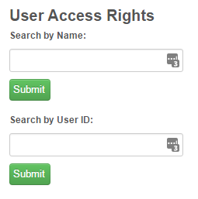

- From the list of users returned in the search, you will be able to view what level of access that user has:

- Click into the user to change their reporting access. Please note, administrator users should all be set up as Super Users in order to report on the organisation as a whole. If you have a hierarchy and require users with access to departmental data only, please contact SWL for guidance:
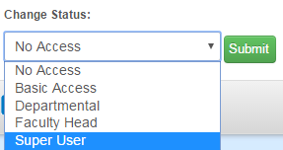

Supplier Visibility
Administrator users have the permission to change the visibility of entire supplier catalogues, whereas price approver users are able to make changes at item level only.
Administrator users are also able to control this visibility at departmental level (subject to set up of a business unit/departmental hierarchy – see Business Units for further info), superdomain and category level.
Within Business Unit Administration, there are quick links to navigate to the area to update. The remaining settings are part of the core configuration and should not be edited unless expressly informed to do so by SWL.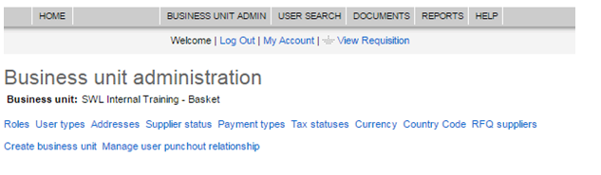
This will take you to a summary of the suppliers SWL has connected your organisation to:

Administrator users are able to carry out the following changes to supplier catalogue visibility:

Deselect Supplier Catalogues

Changing the status of a supplier catalogue to deselected will remove visibility from all end users, apart from any superdomain, category or individual product selections. It should be noted that the lowest level of selection, deselection or preferred will override those above, thus a catalogue may be deselected, a superdomain selected, a category preferred and an item deselected.
- In Business Unit Administration, navigate to Supplier Status
- Navigate to the Supplier you wish to make changes to
- Change the Status to “Deselected”:

- Select “Update”
- Email Customer Support to confirm if this is a permanent deselection of the supplier’s catalogue as there are background processes which need to be initiated in this instance.

NOTE: any changes made here require an overnight refresh to take effect.

Select Supplier Catalogues

Changing the status of a supplier catalogue to Selected will make the catalogue visible to all end users, apart from any individual products that the price approver has specifically switched off.
- Contact Customer Support to make them aware that you want to select a supplier, there are background processes which may need to be initiated prior to the selection.
- In Business Unit Administration, navigate to Supplier Status
- Navigate to the Supplier you wish to make changes to
- Change the Status to “Selected”:

- Select “Update”
- NOTE: any changes made here require an overnight refresh to take effect.

Prefer Supplier Catalogues

Changing the status of a supplier catalogue to “preferred” will promote the entire supplier catalogue in search results. This is particularly useful if you have multiple suppliers on SWL supplying the same products, but you wish to steer your users towards a particular supplier for contractual reasons, or to achieve higher volume spend to help negotiate better pricing.
- In Business Unit Administration, navigate to Supplier Status
- Navigate to the Supplier you wish to make changes to
- Change the Status from “Selected” to “Preferred”:

- Select “Update”
- If the supplier is currently deselected, contact Customer Support to make them aware that you want to prefer a supplier, there are background processes which may need to be initiated prior to the selection.
- NOTE: any changes made here require an overnight refresh to take effect.

Restricting Catalogues by Category

For suppliers that have categorised data hosted on SWL, administrators can control visibility at superdomain and category level. This is particularly useful if your organisation has a contract or framework agreement for a specific category of goods with a supplier. Please contact SWL for guidance on which of your contracted SWL suppliers can be managed in this way.
- In Business Unit Administration, navigate to Supplier Status
- Scroll to the bottom of the supplier status section and select “Create Supplier Status”:
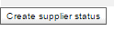

- Choose the supplier you wish to restrict the category for from the available list in the create supplier status section (you can only see your organisation’s connected SWL suppliers):
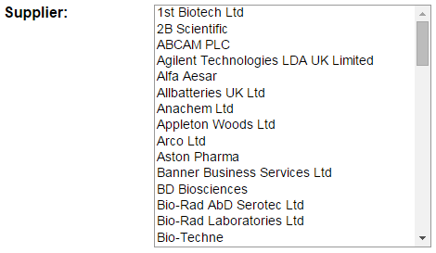

- In the “Superdomain”, select the title you wish to make changes to.

- If you wish you are then able to select a category, allowing the management to be more granular, the superdomain alone may be sufficient .
- Change the status to “Deselected” (to switch off) or “Preferred” (to promote rankings in search results)
- NOTE: any changes made here require an overnight refresh to take effect.
- Please note, price approver users will still be able to change the item status of individual items from this superdomain/category if required.

Granting/Restricting Access to Punchout Suppliers

Some suppliers that your organisation has contracted with may provide products that are not suitable for a hosted catalogue. These include suppliers with products that change daily, or with highly configurable products (e.g. Laptops). These suppliers appear as a button on the homepage for end users to access the supplier website directly and return their item(s) back to SWL to continue shopping with other suppliers.
Your organisation may wish to restrict access to these suppliers by user. Administrators can control these permissions.
- In Business Unit Admin, navigate to Manage User Punchout Relationship:

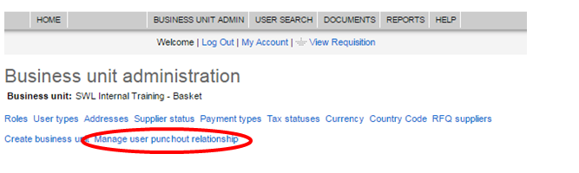

- Here, you can select your available punchout suppliers:
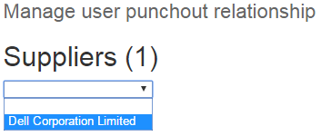

- Now, you can select the users to grant access to, or remove access from already enabled users. To select multiple users, press and hold the ctrl key and select the users and save changes:
