­

eMarketplace

End User Guide v2.0

Science Warehouse

Unit B2, The Half Roundhouse

Roundhouse Business Park

Wellington Road

Leeds

LS12 1AH

0333 600 6300

|  |  |
| --- | --- |
| Client |  |
| Author |  |

|  |  |  |  |
| --- | --- | --- | --- |
| Revision | Reason for Issue | Recipient(s) | Date |
| 1.0 | First copy |  |  |
| 1.1 | Re-Branded |  | November 2016 |
| 2.0 | New Search Features |  | 17th May 2017 |

|  |  |
| --- | --- |
| Science Warehouse Contact | |
| Name |  |
| Position |  |
| Phone |  |
| Email |  |

**Confidentiality**

This document has been prepared for the use of CUSTOMER NAME and takes into account their particular instructions and requirements. This document is not intended for and should not be used by any third party. Distribution or reproduction of this document to such parties must not take place without written consent from Science Warehouse. Similarly, Science Warehouse agrees to treat all information provided by CUSTOMER NAME in the strictest confidence and will not distribute this information to any external parties without prior written approval.

Table of Contents

eMarketplace 1

End User Guide v2.0 1

Document Purpose 1

Considerations Before Use 1

Areas Covered 1

End Users – An Overview 2

The Homepage 2

Top Ribbon 2

Marketplace home 2

My Account 3

Help 3

View Basket 3

Checkout 3

Search 3

Side Menu 3

Marketplace News 3

Browse Categories 3

Browse Suppliers 3

Recent Orders 3

Saved Baskets 4

Favourite Products 4

Search 4

Things to consider 4

Ways to search 4

Product code, description, manufacturer part number, supplier name, category 4

Browse By Supplier 5

Browse By Category 5

Filtering Results 5

Refine by Keyword and Refine by Excluding Keyword 7

Sorting Results 8

Comparing Items 8

Adding Items for Comparison 8

The Comparison Table 9

Saved Baskets 10

Creating a Saved Basket of Products 10

Sharing Baskets 11

Collaborative Ordering 11

Favourites 12

Delivery Charges 13

Viewing Delivery Charges 13

Delivery Charge Prompt 14

Free Format Order 16

Supplier selection 16

Supplier Details 17

Add Items to Basket 19

# Document Purpose

This document details the processes and steps involved to navigate the eMarketplace, including searching, comparing, adding items to a basket and checking out. Please refer to your organisation’s processes for details on the actions that take place outside the eMarketplace (workflows and approval, PO creation and submission etc).

# Considerations Before Use

Before accessing the eMarketplace, please ensure that cookies and popups are allowed from the *sci-ware-customer.com and *sci-ware.com domains. Without this, certain functions may not work. Please seek assistance from your IT support team for further information and guidance.

# Areas Covered

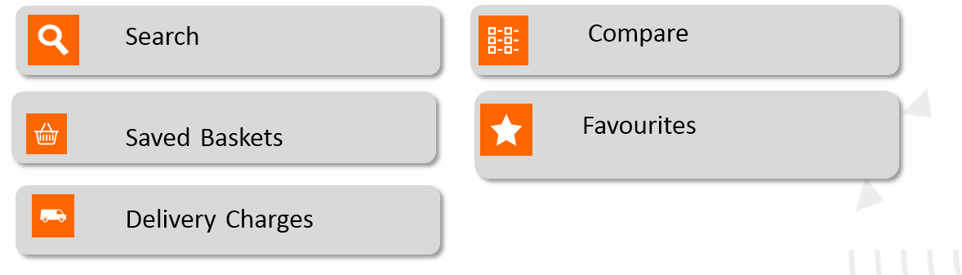



Free Format

# End Users – An Overview

## The Homepage

When you access the eMarketplace from your finance system you will see a homepage similar to the below example. Please note, some, all or more of the below modules or “buttons” may be available to you, depending on the combination of modules your organisation is licenced for.

When you access the eMarketplace for the very first time, you will see a help video. This can be accessed at any time subsequently by accessing the “help” icon at the top of the page.

Your homepage is unique to you; you can see your own order history, favourites and saved baskets. The homepage will be branded with your organisation’s logo.

Note; Additional icons may appear if you have access to other modules available within the marketplace.

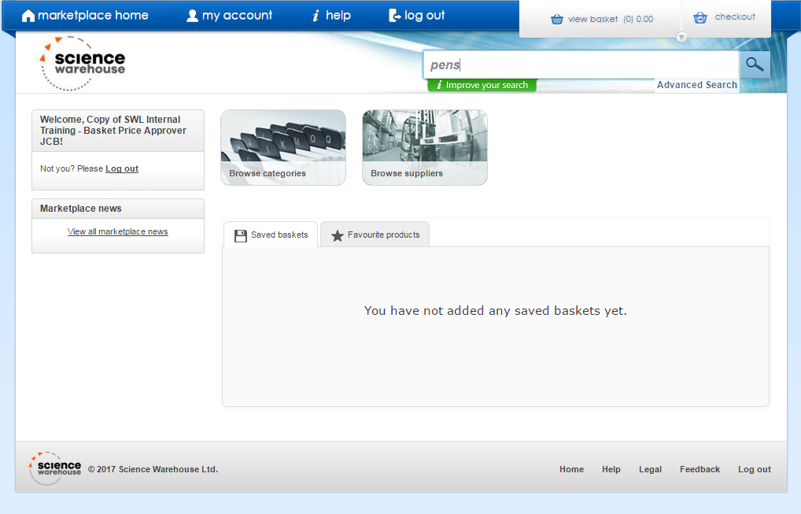

## Top Ribbon

The top ribbon is accessible from anywhere in the marketplace.

### Marketplace home

Quick Link to return to the homepage

### My Account

By hovering over My Account, you can access quick-links to your recent orders, saved baskets and favourite products (further detail provided later in this guide)

### Help

Many features of the site have been recorded as help videos or help material for your convenience. These can be accessed here.

### View Basket

As items are added to the basket, a popup will appear here. You can access your basket from anywhere in the eMarketplace.

### Checkout

Checkout your basket and return to our finance system to complete your requisition.

### Search

Search box for a simple search, with the option for an advanced search beneath.

## Side Menu

On logging in, your name or ID should appear here. If another user’s name is displayed, log out and please contact your organisation’s support team for assistance.

### Marketplace News

If a supplier has a special offer on certain products, or wishes to notify you of any other information related to their catalogue, this will display here.

You can also make use of the marketplace to promote any internal news. Please contact Customer Support for more information.

## Browse Categories

Alternative search method, but traditional search techniques are recommended (not available in the test environment)

## Browse Suppliers

Alternative search method, but traditional search techniques are recommended for a true marketplace experience

## Recent Orders

Also accessible form My Account, any requisitions

## Saved Baskets

Also accessible from My Account, any baskets of products you have saved for ease of future ordering will appear here (see later in the document for further information)

## Favourite Products

Also accessible from My Account, any products you have marked as favourites for ease of future ordering will appear here.

# Search

There is help material available via the help icon. Additionally, when beginning to type into the search box, “Search Tips” will appear beneath, offering tips on how to search for items.

## Things to consider

* This is a Marketplace, therefore there will be considerably more data than a supplier’s individual website. Consider this when searching.
* The item may not be listed – use free format.
* There is no “one size fits all” when the results are displayed. Typically, the search will return the most relevant results. This is based on a variety of factors, but mostly it will be influenced by what you search for. Therefore, be specific and tailor your search to your requirements.

## Ways to search

There is no right or wrong way to search. Different products require different search techniques. However, here are some tips on how to search in the eMarketplace:

### Product code, description, manufacturer part number, supplier name, category

Search shows your results in order of relevance. In the first instance, search will return Product Matches with the option to see related matches if less than 10,000 product matches are returned. If no product matches are found, then Search will return related matches. Products are matched principally on:

* Description
* Category Attributes
* Alias Fields (alias 1, 2, 3 and disc item alias…)
* Supplier Name
* Manufacturer Name Field

***OR*** Exact term matches the Catalogue Number

***OR*** Exact term matches the Manufacturer Part Number

***OR*** Exact term matches the CAS Number (Chemical Abstracts Service if used)



### Browse By Supplier

Available on the homepage. Not recommended as his detracts from the purpose of a marketplace, but a useful “browsing” tool, or if you cannot remember specific details of the item you are looking for.

### Browse By Category

Available on the homepage, but not recommended. Not all suppliers will categorise their data, and you could exclude a great deal of products by selecting a specific category. Therefore, using the basic search function will yield better results.

### Filtering Results

Useful tool to refine our search results.

**Applied filters example**

**Searching for Pen returns 1962 products.**

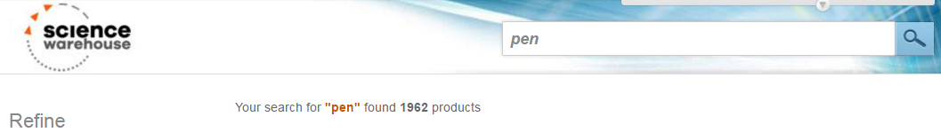

**By refining my search criteria, in the example below I have applied 4 filters to narrow my search criteria down to just 3 products. How to do this is illustrated below.**

* + *Excludes Red*
  + *Only show me products with an image*
  + *Only interested in marker pens*
  + *Between £1 - £2.*

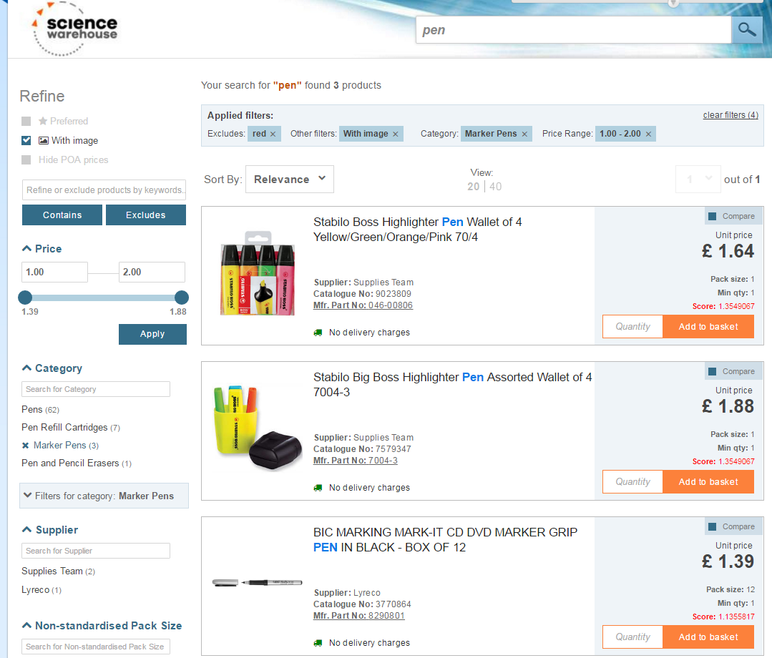

|  |
| --- |
| * *Filtering Search Results: Your selected filters are shown above the search results, as a reminder after applying them, and these can be removed by clicking the ‘X’ by the relevant term.* |
| Suppliers  Tick your chosen supplier to reduce the  results even further |

### Refine by Keyword and Refine by Excluding Keyword

You can search for a word (or multiple words), select filters and/or exclude keywords to refine the search.

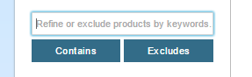

Refine or exclude products by keywords using the search function seen here.

**Example:**

User searches for a Chair but wants to retrieve the search results containing the words ‘office’ and ‘arms’.

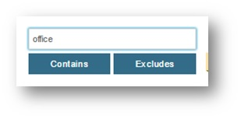

User selects ‘contains’.

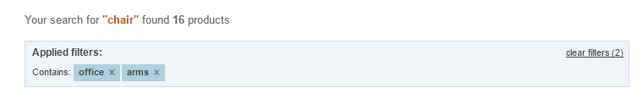

The user also wants to exclude the word ‘blue’.

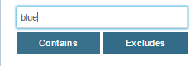

As a result, the user’s search only brought up the chairs containing ‘office’ and ‘arms’ in the description, and excluded the chairs containing the word ‘blue’.

### Sorting Results

Results will default by the most relevant, based on your search term. You may, therefore, wish to sort by price, product name, supplier, catalogue number or MPN.

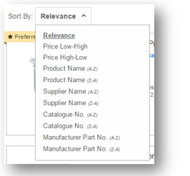

# Comparing Items

One of the main features of an eMarketplace is the ability to have comparative results, to allow you to make an informed purchase.

## Adding Items for Comparison

Between 2 and 4 items can be compared at any one time. They can be added from the search results, by ticking “compare”, or within the product information itself:

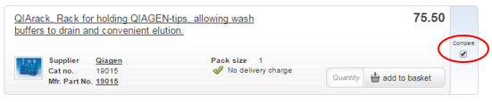

When items are added for comparison, they are added to a “holding area” at the top of the page. You can then remove items or add any other before comparing your final list:

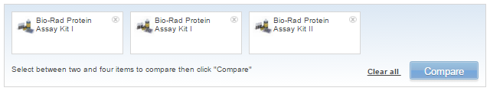

## The Comparison Table

The comparison table presents the available data for each product in tabular view, making like-for-like comparison easy.

* You can add items to your basket from here
* You can view any applicable delivery charges from here
* You can navigate into the individual products themselves for additional info if required.

When the comparison is complete, the marketplace will retain your comparison until you clear them. This is a useful feature f you wish to purchase multiple items from your comparison list, or if you navigate away from the comparison screen by accident.

# Saved Baskets

As the eMarketplace will only show your purchasing history (i.e. requisitions that have been approved and converted to a PO), it will not automatically save any basket history.

Therefore, if you have repeat requisitions, for ease of ordering, it is useful to save these baskets of products for future. Although useful, you should still be aware of market changes and should continue to search the marketplace for alternative or better priced products before defaulting to previously purchased items.



## Creating a Saved Basket of Products

Add your items to a basket as normal

In “View Basket”, you will find an option to create a saved basket:

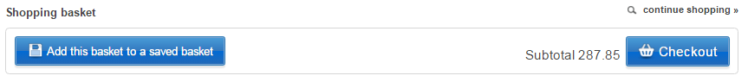

You will be presented with the option to add this basket to an existing saved basket, or create a new one.

Items can also be added to an existing saved basket from within the product detail:

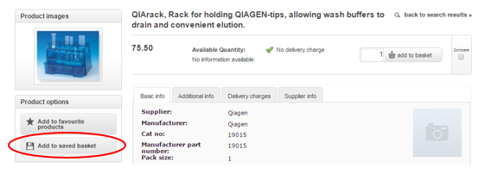

Saved baskets will then appear on the home page, or by hovering over My Account.



## Sharing Baskets

Saved baskets can be shared with other users if required. For example, a team leader may wish for their team to order specific products.

To share a basket, navigate to the saved basket, where you will find the option to share:

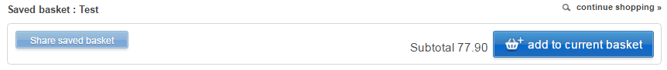

Click on “Add New User” and type the user’s name to share the basket with that user. You may grant permissions to a user to update the basket, but please note, this will update the basket for all users who can see the basket. This is useful for collaborative ordering (below).

Once shared, the user will see this basket in their section of “saved baskets” on the homepage or via My Account



## Collaborative Ordering

When procuring items for a specific project, sharing the basket is a useful tool to allow users to add items to one basket, and one user can then check out the entire basket of goods. This can also be used to achieve volume quantity discounts by allowing multiple users to contribute items before the basket is checked out.

As with sharing baskets, follow the same process, but when adding a user, grant them permission to edit the contents. This will then update the contents of the basket for all users who have access to it.

The user who checks out the order will be the user who will progress the requisition through your finance system.

# Favourites

As with Saved Baskets, favourites can be added for ease of ordering in future. However, you should still search the marketplace for any market changes and better products rather than repeat ordering of the same item.

Favourites can be added from within the product information:

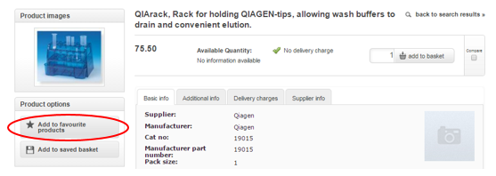

Favourites can then be accessed from the homepage, or by hovering over My Account.

# Delivery Charges

Some suppliers may charge delivery. If so, there may be a requirement to add a delivery charge. Doing so will mean that your order is processed more swiftly, as there is less chance of order queries coming back to you.

## Viewing Delivery Charges

There are several places you can review delivery charges:

* Search Results
* Product Information
* Comparing Results

Where delivery charges are NOT applicable, you will see the following:

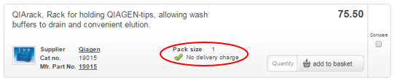

Where delivery charges ARE applicable, you will see the following:

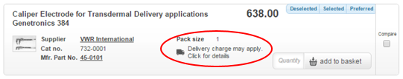

You can click to Expand the delivery charge information, which will display the relevant charges and select the appropriate charge.

However, unless you are comparing results, it is best practice to leave this step to the end.

Charges are also detailed in the appropriate tab within the product information:



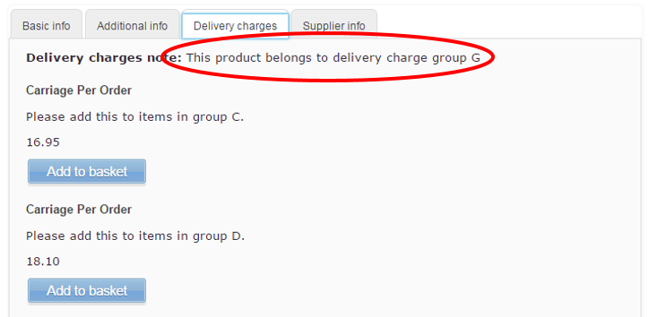

When reviewing the contents of a basket, there is a further opportunity to view delivery charges:

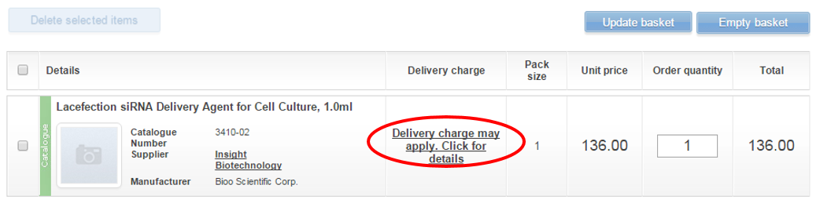

## Delivery Charge Prompt

At checkout, if purchasing products from a supplier that charges delivery, you will be prompted to review charges. Please note, this prompt will not appear for any suppliers who do not charge delivery.



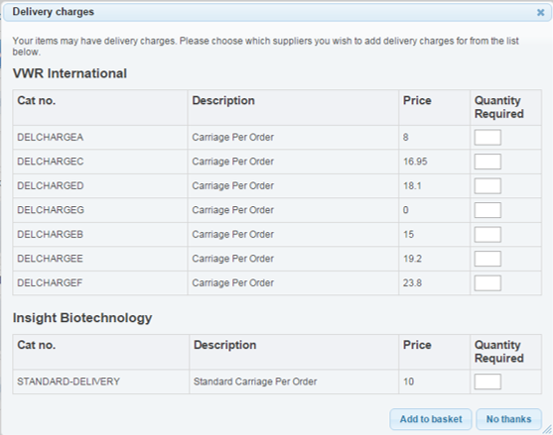

Choose the correct delivery for each supplier, or opt for “no thanks” if none of the delivery charges apply. You will then be able to check out and continue through your finance system. The delivery charge will have been added as a line item.

# Free Format Order

Free Format can be used when an item does not exist on catalogue. As a minimum, all catalogue suppliers will be available for you to create a free format order with. Your organisation may have provided a list of non-catalogue suppliers as part of their contracted eMarketplace solution; if this is the case, these suppliers will also be listed. Note this

## Supplier selection

Only pre-loaded or catalogue suppliers are available. If the supplier you wish to order from is not listed, please contact your procurement team who have the functionality to upload new suppliers.

Suppliers can be selected either alphabetically, or by a search function:

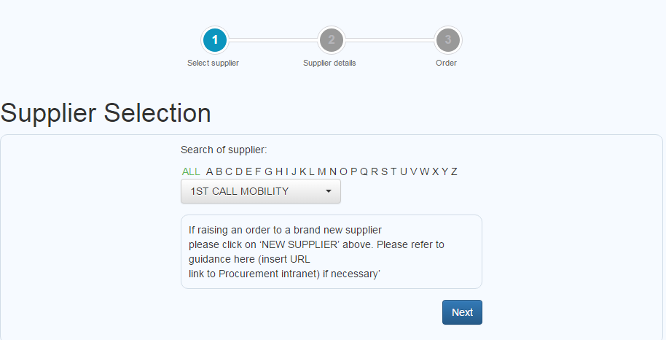

Note: you will be prompted here if the supplier is a catalogue supplier, selecting No thanks continues with the free format process.

## Supplier Details

Once a supplier is selected, the system will take you to Supplier Details screen and pull the supplier information from the previous selection.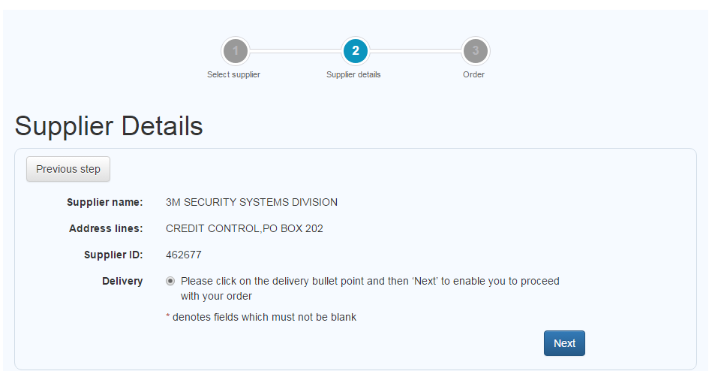

Click Next takes you to the Order screen. (note this form has been created for training purposes, and can be configured to meet the requirements of the customer within the capabilities of the form specification)

As you start to complete the form, Part Number” and “Item description” the form will go off and search for the catalogue to find those products. You have the option here of choosing the product from the catalogue, alternatively, by finishing the form completion you can continue through the free format process and Add to Basket.

* Order type – Select Item order unless placing a call off order then select Call off (see screen shot below)
* Part number – Manufacturing part number (not mandatory)
* Item Description – Description of the item (note once you start typing the description the system will display available products within the catalogue for selection (on the right)
* Pack size – Pack size (not mandatory)
* eClass – This is a dropdown and displays the name and code of the product classifications
* Unit Price – This is the unit price excluding VAT
* Quantity – Volume of order
* Comments to Supplier – any comments entered here will be visible to the supplier on the order

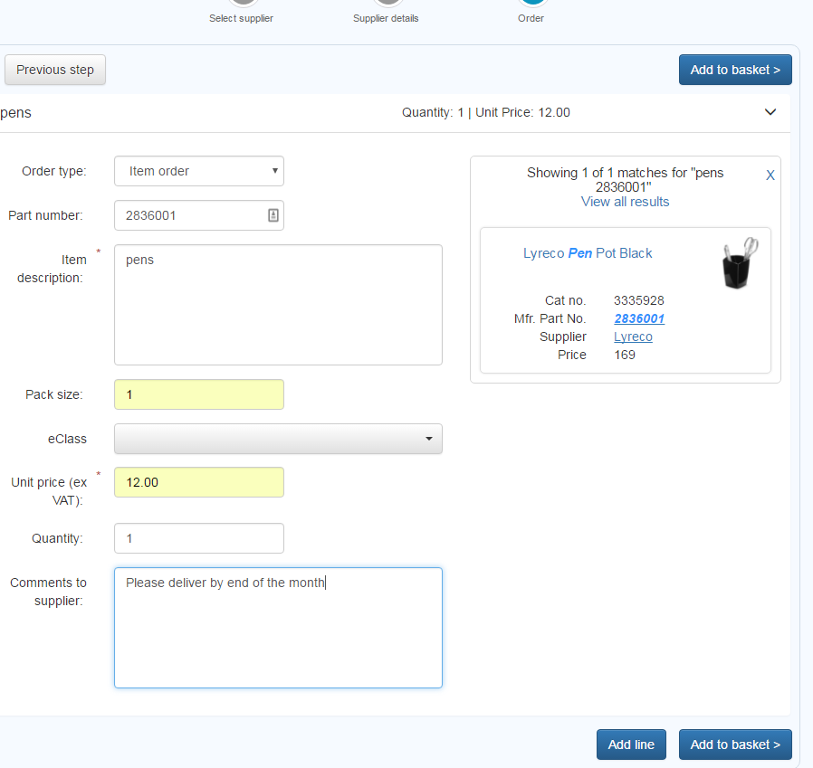



## Add Items to Basket

The free format line(s) appear in the basket, where you can opt to do any of the following:

* Continue Shopping (further catalogue items can be added)
* Add free format lines (further free format lines for the same or a different supplier)
* Change Unit Price or Quantity of free format lines and Update Basket
* Empty Basket
* Select and Delete Lines
* Checkout (takes the whole basket back to your finance system)

Free format lines are indicated by a blue ribbon on the left of each line:

