VAT
NOTES FOR END USERS PURCHASING ITEMS WHICH ARE CONSIDERED TO BE VAT RECOVERABLE
When is VAT Recoverable?
For the vast majority of goods and services ordered by the University, VAT is not recoverable.
This is because the majority of activities undertaken by the University do not generate taxable income e.g. teaching and research.
However, for certain purchases, specifically those that relate to onward VAT supplies and specific activities e.g. consultancy contracts, onward taxable supplies to third parties (including other Universities), VAT on such costs can be specifically recovered.
These may have been items which were previously ordered against the Tax Code PSR1110 in Proactis.
In Oracle, it will now be necessary for End Users to select VAT recoverable when raising a requisition. If this is not selected, then VAT will be charged to the account code against which the cost of the goods will be debited.
If you are not sure whether VAT is recoverable, please check before selecting VAT recoverable in your requisition with your usual Finance contact or you can contact the VAT Helpdesk at;
Vathelpdesk@contacts.bham.ac.uk
Oracle Process for selecting VAT Recoverable on Requisitions
End Users will go through the requisition process to identify the item(s) and suppliers that they wish to use and will add the items to their cart.
Once the End User gets to the View Cart part of the requisition, the following screen will appear (example items shown below);
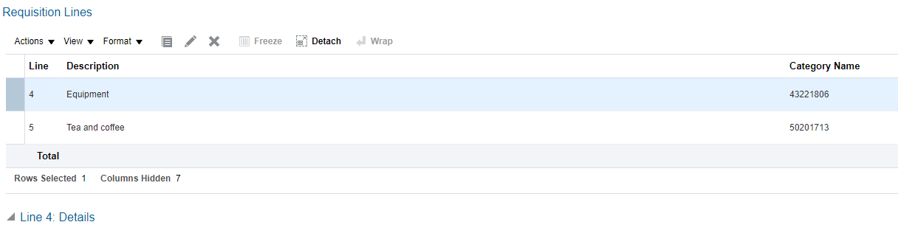

Oracle will usually expect most items to be STANDARD unless it is specifically expected to be a different VAT rate (e.g. tea and coffee). The approval amount will therefore show the net amount plus VAT for approval.

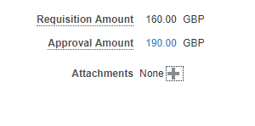
If the End User considers that the project is VAT recoverable
If recoverable, (as set out above or based on advice), the End User will scroll down to the following box towards the bottom of the screen:
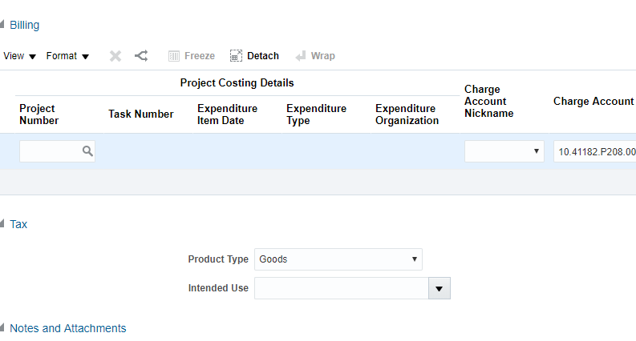

Under the Intended Use box – the User must select the Drop down option “RECOVERABLE – SUNDRY OTHER”.
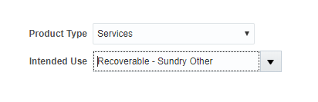
The End User will then need to return to the top of the screen and click “Calculate Amount with Tax” in the Approval Amount box;
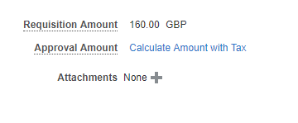
Once this is clicked, the tax should be recalculated as recoverable and the Approval Amount for the budget holder should be the net amount of the item as shown below;
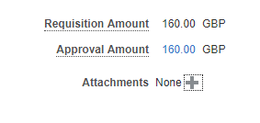
Where to go for advice?
If in doubt about the VAT liability of an item or whether it is recoverable, please contact your usual Finance contact.
End Users may also contact the VAT Helpdesk for further guidance as below;
Vathelpdesk@contacts.bham.ac.uk

