NOTES FOR END USERS PURCHASING ITEMS ELIGIBLE FOR VAT ZERO RATING
End Users will go through the requisition process to identify the item that they wish to purchase and will add the item to their cart.
Once the End User gets to the View Cart part of the requisition, the following screen will appear;
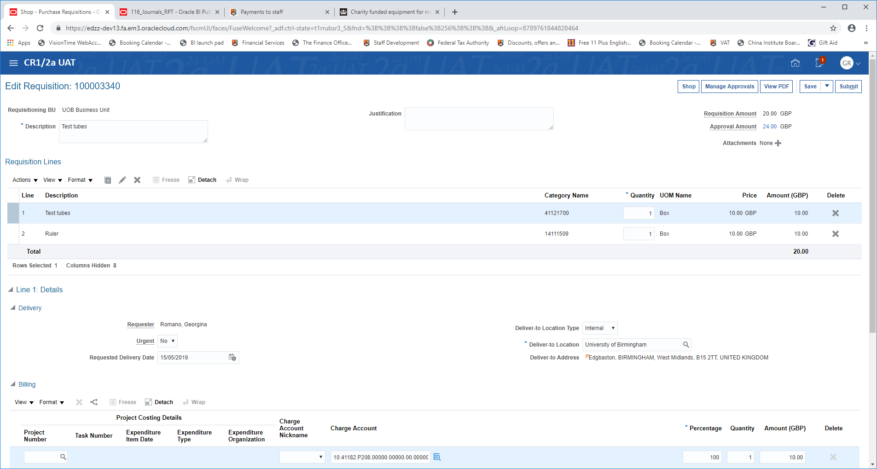
The approval amount will usually show VAT (assuming the item is usually Standard Rated). If the End User considers that the goods, substances or medicinal products being purchased are eligible for VAT zero-rating because they are being used for medical research (training, treatment or diagnosis) (see attached guidance), then they will scroll down to the following box towards the bottom of the screen;
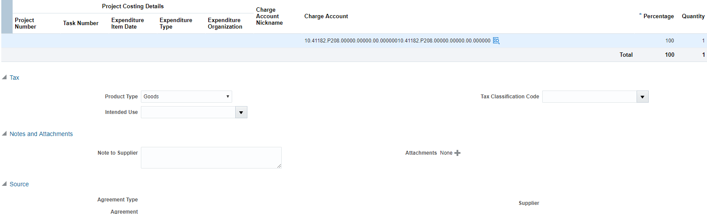
- In the Intended Use drop down box – pick Medical Research.
- Complete Zero Rate VAT Certificate (available from the Purchasing News on front page of Requisitions screen) by using the writeable PDF boxes including digital signature.
- Save and attach the completed Certificate as an attachment to the requisition as shown above.
PLEASE NOTE, IT IS NOT NECESSARY TO COMPLETE ANYTHING IN THE “TAX CLASSIFICATION” BOX WHEN SELECTING “Intended Use Medical Research” – PLEASE DO NOT SELECT ANY SPECIFIC TAX CLASSIFICATION.

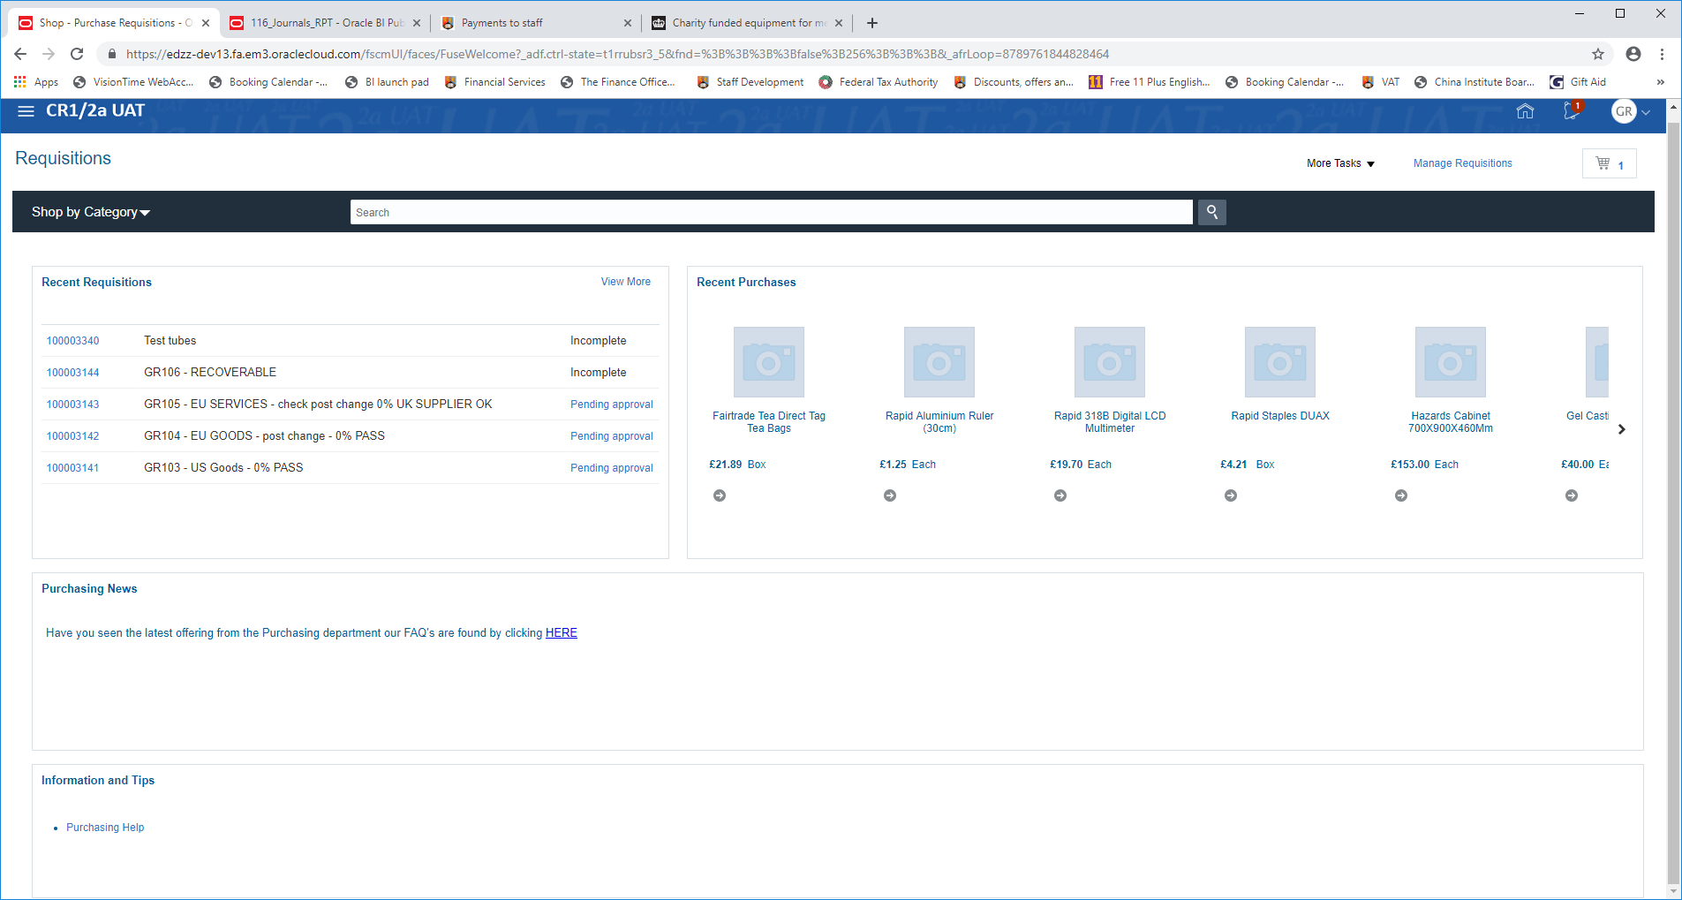
ZERO RATE CERTIFICATES WILL BE AVAILABLE HERE – TO BE COMPLETED AND ATTACHED
Plus Guidance and links to where to go for advice in your College

Please note; It is proposed that in the short to medium term, the need for Certificates will be dispensed with. This will be replaced with an automatic statement which will be added to a Purchase Order once “Intended Use – Medical Research” is selected at the Requisition stage.
In the interim, End Users are expected to complete and attach their certificate in order to ensure that the Supplier is aware that the End User considers the item eligible for zero-rating.

