How to raise a non-marketplace requisition
Log into proactis at: https://www.proactis.bham.ac.uk and hover your mouse over the purchase tab – you will see options available to you depending on your role.
To start a requisition hover over the purchase tab and click on “Request”
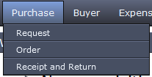
On the right hand side of the screen you will see templates, again it depends on where you are in the University as to what templates you see, the one you need is the Non Marketplace Requisition template.
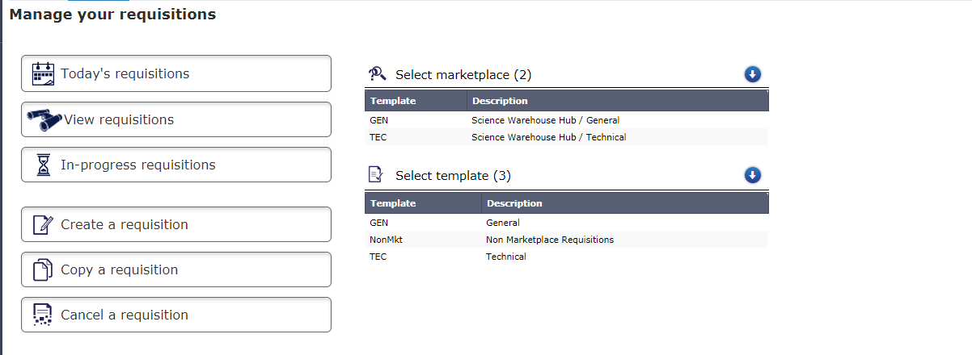
On the right of the screen you will see some blank boxes, the simplest way to find what you are looking for is by typing the description in the box marked “Desc”
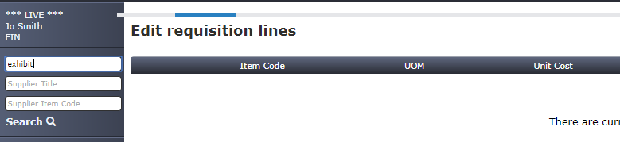

Select the item by clicking on the shopping basket icon next to the description, then click on “return selected items”
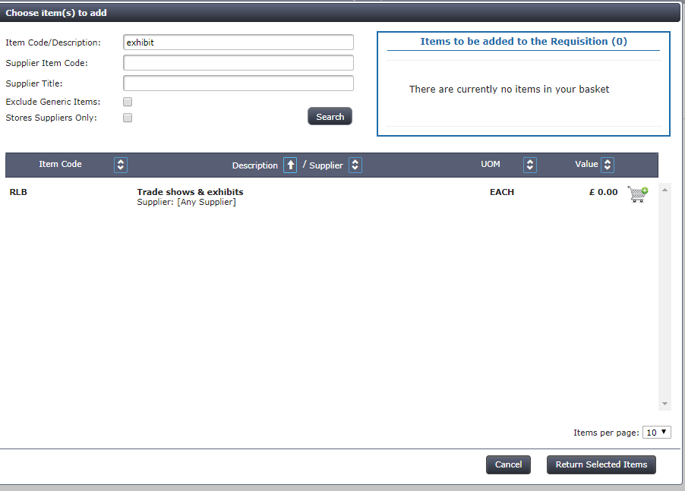
You now have the opportunity to add the detail to the line
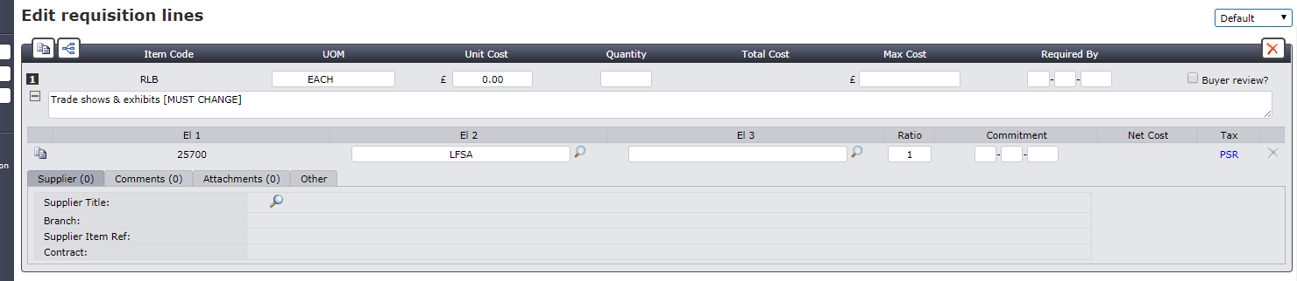
Type in the full description of goods or services required including any names and dates if applicable.
Add the Unit Cost & Quantity. The Max Cost will be the same as the Unit Cost.
Treat the Required by date the same as you would a delivery date. Note this is a mandatory field.
Under the Supplier heading, click on the magnifying glass icon and type the name of the supplier in the Supplier Title search criteria and select.
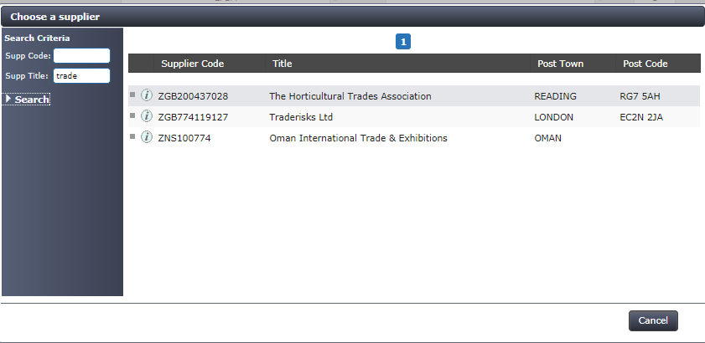
Enter your El2 and El3 Budget Code
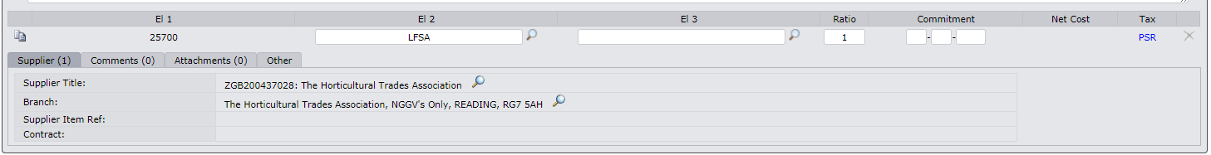
The Commitment Date is automatically generated but you can change this to coincide with the accounting period.
The Tax is also automatically generated but you may need to change it for foreign payments to:
EU Goods – PZRGEU
EU Services – PZRSEU
Non EU Goods – PZRPOE
Non EU Services – PZRSOE

In the comments field you can add the quotation number or booking reference number.

If you’re in receipt of an invoice or quote you can attach the document here.

Now go to the Header Section:
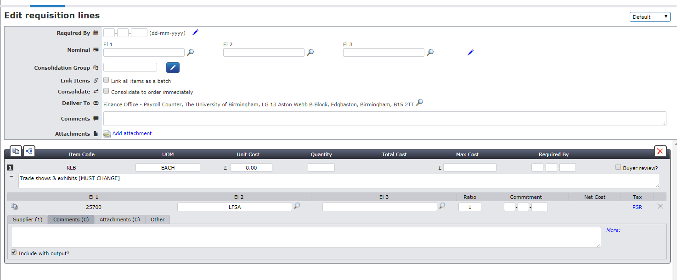

Ensure your delivery to address is correct and add your name followed by a comma.

In this comments field add any specific details for the Hub Team’s attention. For example,
invoice already received or please forward purchase order to me to send to Supplier.

Once you’re happy with all the details Submit Requisition for authorisation.

