Price Approval Users

User Guide

Science Warehouse Ltd
Unit B2, The Half Roundhouse
Roundhouse Business Park
Wellington Road
Leeds
LS12 1AH

0333 600 6300

Revision | Reason for Issue | Recipient(s) | Date
V2 | Review by C Watson | T Tattersley | 26/01/17
V3 | Amended to reflect new item visibility functionality in New Search |  | 15/3/17

Confidentiality
This document has been prepared for the use of Science Warehouse Ltd’s contracted customers. This document is not intended for and should not be used by any third party. Distribution or reproduction of this document to such parties must not take place without written consent from Science Warehouse.
Table of Contents
Price Approval Users 1
User Guide 1
Document Purpose 1
Considerations Before Use 1
Areas Covered 1
The Process 2
The Interface 3
Reviewing Updates 4
Update Status Definitions 4
Reviewing Individual Updates 5
Reviewing Historic Updates 6
Downloading Updates 7
Types of download 7
Reports available 7
Approving / Rejecting Updates 9
Viewing new UNSPSC codes 10
Item Visibility 11

Document Purpose
This document details the processes and steps involved to review and approve/reject price and product changes. Also documented, are the steps involved in editing individual items’ visibility, to maintain catalogue control within your organisation.

Considerations Before Use
Before accessing the eMarketplace, please ensure that cookies and popups from the *sci-ware-customer.com and *sci-ware.com domains are allowed. Without this, certain functions may not work. Please seek assistance from your IT support team for further information and guidance.
Users will require the price approval permissions. Please refer to your systems administrator for further guidance.

Areas Covered
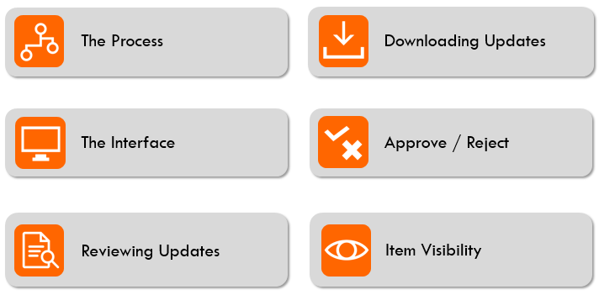

The Process

Suppliers are able to load in updates to their products and pricing. Product files and price files always appear as separate updates.
To ensure your organisation maintains control over what products and pricing your users can see, changes require your approval before they are made visible to your user-base.
Once a file is loaded into SWL, you will receive an email notifying you. If additional users require notification of such emails, please contact customersupport@sci-ware.com to ensure these users are added to the notification alerts.
Emails will indicate the number of updates applied:
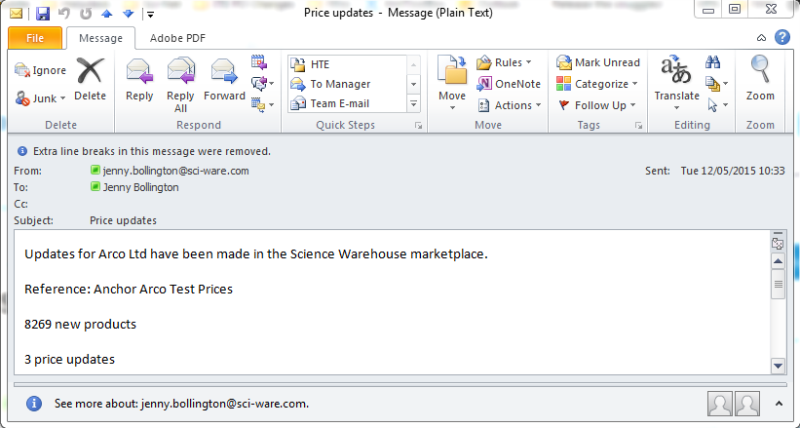
On receiving the update, the user should access the SWL interface to review the changes.

The Interface
For ease of finding products when applying item status changes (see Item Status), the price approval users utilise a similar interface to end users. Please note, depending on how your organisation has chosen to configure your users, you may not be able to order any products from your price approver interface. Please refer to your systems administrator for further guidance.

Price Approval users have some additional responsibilities, not available to end users. Update files can be accessed via ‘my account’, where the additional responsibility of ’price updates’ is accessible:
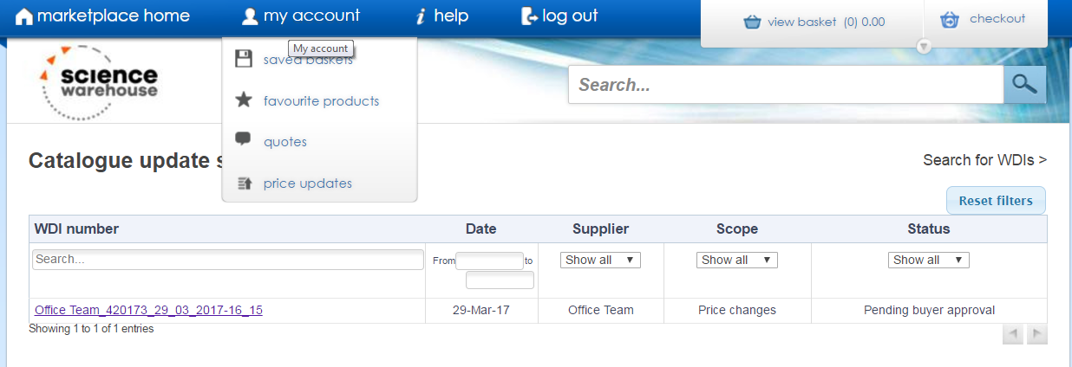

Reviewing Updates

When accessing Price Updates, the Catalogue Summary Page is displayed. This screen shows the most recent updates that have been loaded. Additional updates can be viewed by clicking the arrows at the bottom right, or by searching for a specific update, using Search for WDIs (see below).
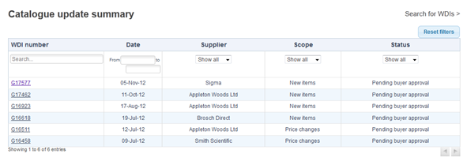
The update summary shows the status of a specific file.

Update Status Definitions
Status | Definition
Pending Supplier Approval (initial) | Whilst the file has been loaded, it may require secondary approval from the supplier, or the supplier may be loading pricing in advance of a new contract, and it is not yet ready to release for buyer approval.  If an update remains at this stage for a considerable time, contact the supplier for further information.
Pending Buyer Approval | Awaiting your review.
Pending Supplier approval (final) | Not all suppliers have this step, but some require a final validation to ensure the pricing is correct at time of release, as it may have been superseded or requires syncronisation with the supplier’s ERP.
Rejected | Either you, the supplier or SWL has rejected the price file.
Complete | The update has been applied & released to your users.

Reviewing Individual Updates
Once you’ve clicked on a WDI number, the Catalogue update screen shows the details of the update. At the stage below you can see that the upload of prices has been approved by the Suppier and is waiting for the buyer to approve the file.
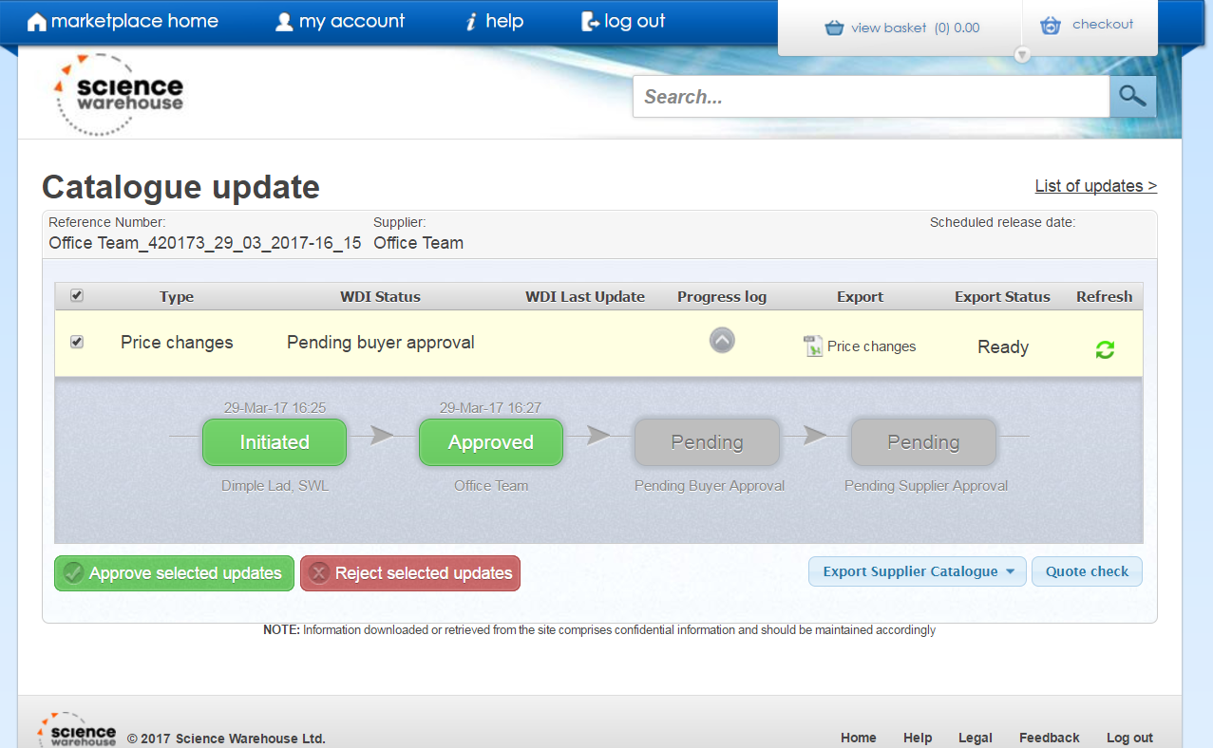

Reviewing Historic Updates
To search for an update or to view previously reviewed items, click on the Search for WDIs link.

On the Search for WDIs page, you can either enter your required search parameters or just click Search to show a list of all WDIs.

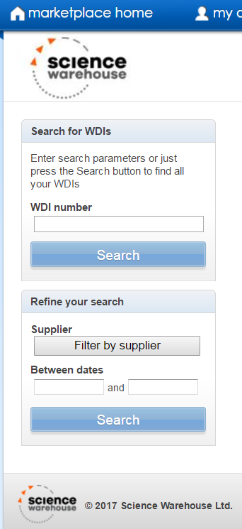

Downloading Updates
Once the supplier has approved the file loaded by SWL, you will see that this step is marked in green. At this point you can click on the relevant icon to open the file for review. There is also the option here to export the supplier’s entire catalogue into an Excel spreadsheet.

Types of download
Files will download as .xls or .txt, depending on the size of the file. When opening a text file in excel, ensure that you specify that all columns should be treated as TEXT, to avoid excel trying to auto-format any data. Excel typically removes preceding zeros and formats product codes as a number, so it is advisable that you take steps to avoid this.
Please contact your IT team if you require guidance in opening .txt files in Microsoft Excel.
Please note: larger files take some time to download, therefore a prompt will appear to notify you that the file is generating in the background. It is necessary to exit the interface and return at a later time to access the file.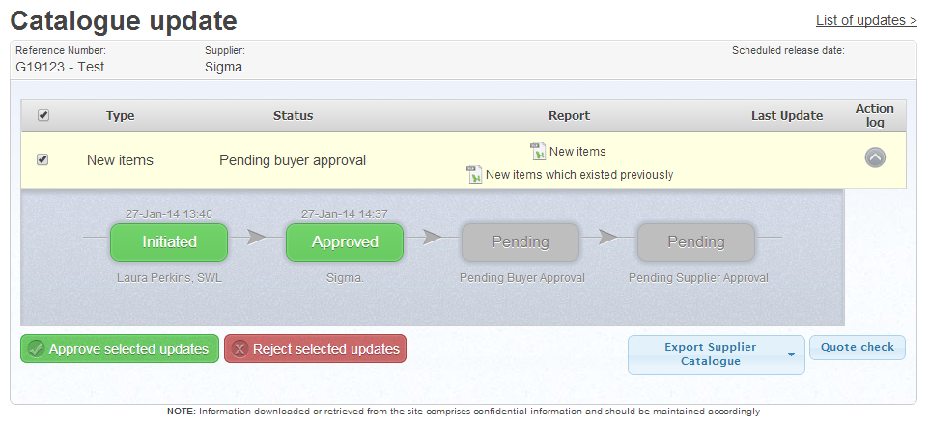

Reports available
From the detailed Catalogue Update screen, you are able to download the following reports:
Type | Definition
New Items | New items that are not yet visible to your organisation.
New Items which existed previously | Items that a supplier has deleted from their catalogue and have been reinstated.
Price Updates | Price changes to existing products.
Hides | Items that a supplier has hidden (items may no longer be available).
Supplier Catalogue (Current) | The entire supplier catalogue, with prices for the products the supplier has provided (and have been accepted) by your organisation
Supplier Catalogue (Including Proposed Changes) | The entire supplier catalogue, including any proposed changes applied.

Approving / Rejecting Updates

Once you have reviewed the price file you can choose to either Approve selected updates or Reject selected updates.

IMPORTANT: Prior to rejecting any price file, please contact our Content Team (via customersupport@sci-ware.com)

The reason for this is that when a price file is rejected the whole price file has to be re-uploaded once corrections have been made, whereas it is often possible for the Content Team to correct specific errant data without having to re-upload the entire file. This can save many hours processing.

If an update does need to be rejected, it is recommended that a comment is added as this will provide information to the supplier on the reason for the price file rejection.

You can see in the next screen shot that this price file has been approved initially by Sigma (the supplier) and then by Bob the Approver (the buyer). There now is a final stage of approval that needs to be carried out by the supplier.
Note: some suppliers choose only to approve files at one of the two stages and others choose not to carry out any approval. This is down to the individual supplier.
Once approval is complete the price file is ready to be released by our Content Team so that the prices are available in the catalogue. To approve further price files, click on the List of updates link at the top right hand of the screen.

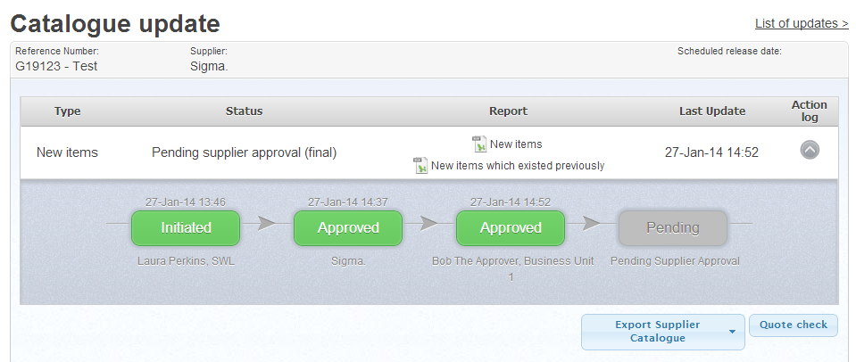

Viewing new UNSPSC codes
Select Price updates from My account tab and then click on the relevant WDI number that you would like to view new UNSPSC codes for. These are typically used to map to your own categorisation schema in your Finance system. Please refer to your Procurement or Finance team for guidance on whether or not UNSPSCs are mapped in your system.
Click the New UNSPSC codes button on this screen. Codes can also be seen by opening the actual update file.
Note also that when the price file is approved an automatic email is generated, typically to a Procurement mailbox, notifying of any UNSPSCs which need to be mapped.

Item Visibility
If your user type includes Item Status Edit (such as Approver with price approval and item status edit) then you will also be able to apply settings to individual catalogue products (note that this cannot be done through an Admin account). Search for the products in question and click on the desired button below the product, to set the status (preferred, selected, deselected). A request will run overnight and the item will be updated within 24 hours.
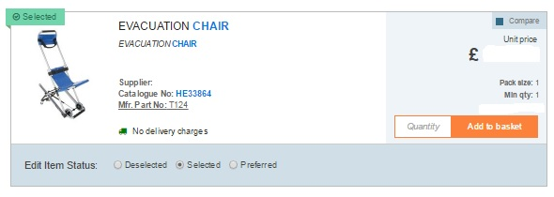

If you want to Multi-Select click on Enable Multi - select
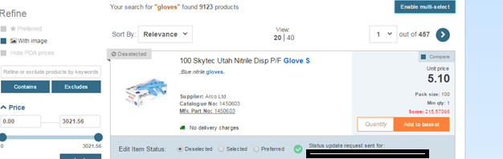

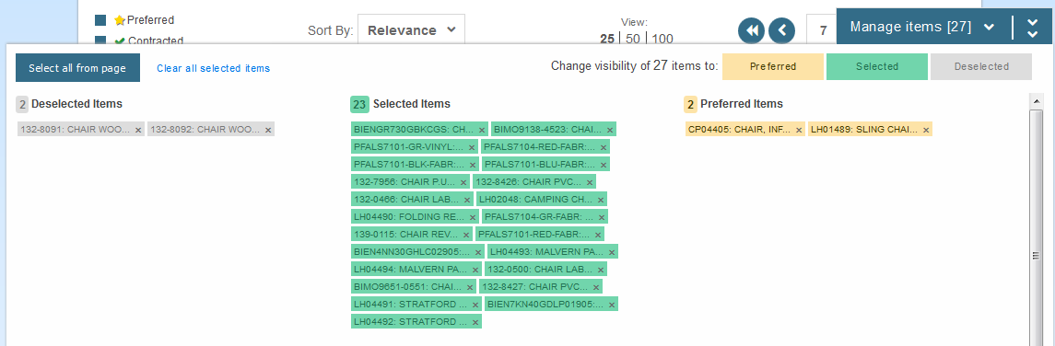
This will enable a new pop-up screen to manage the status of many items at once and across multiple pages. For example, you can view a couple of pages of search results and change the status of various items across these pages, with an upper limit of 1000 products. This feature remains active until you close it or log out of the eMarketplace.

