Raising an expense claim in Proactis 2014
As before the claim needs a title – a currency and if claiming on behalf on someone else change the claimant
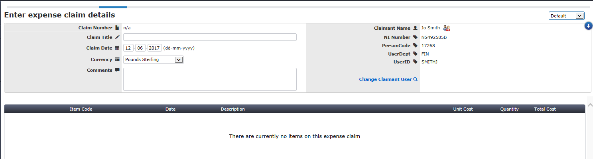

In the left menu you will see these options, first pre-set the account codes you are going to use to save you from having to do this line by line
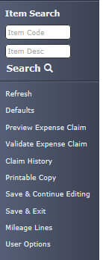
If you forget to do this you can always do it at a later stage, enter the Element 2 and 3 codes then click store and apply nominal.
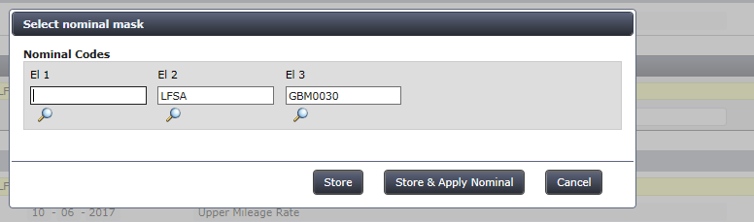
Now add your claim lines

if you leave the boxes blank and click on search you will get a list of items to add
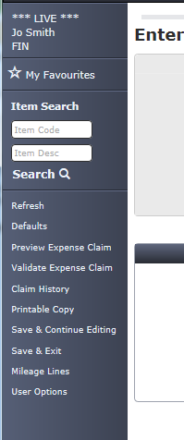
You can add in the normal way, for multiple items, click the basket at the side of the description, then click return selected items
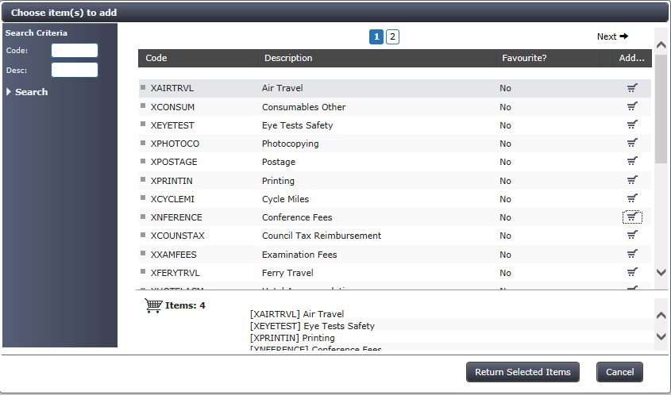

If you want to add the account codes line by line they can be found on the “coding” tab now
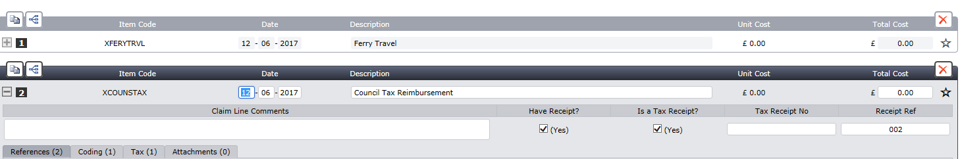
Click the item code description and then the coding tab to open the line
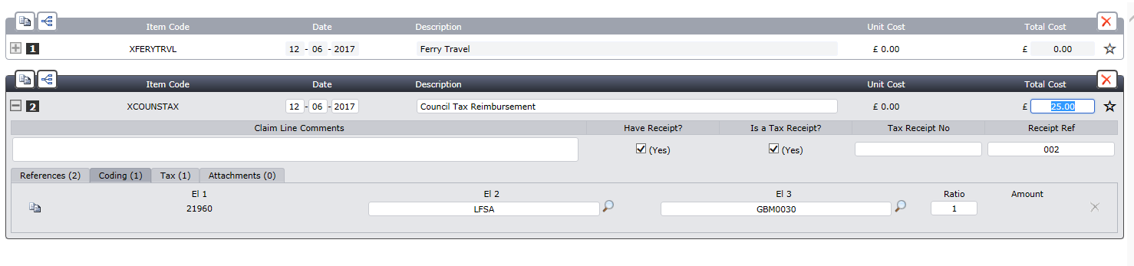
Mileage lines are now grouped together
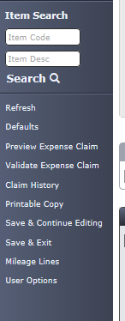
You enter the date of the travel, put from and where detail and the number of miles. Choose the mileage rate and if it was a single or return journey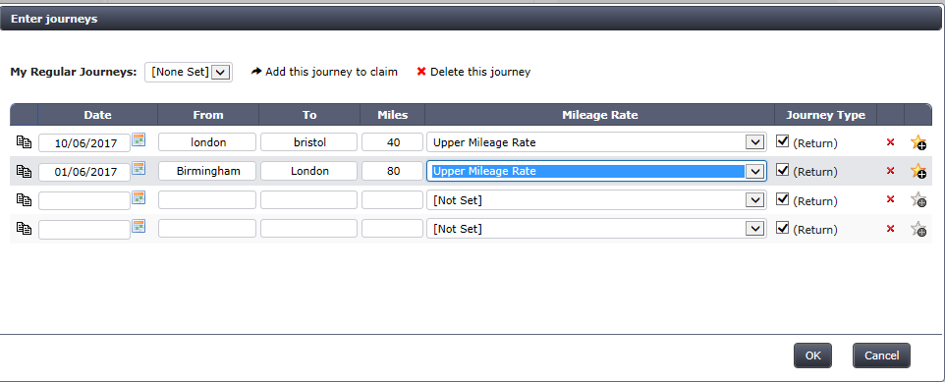
When complete click on OK
When your claim is complete you can submit
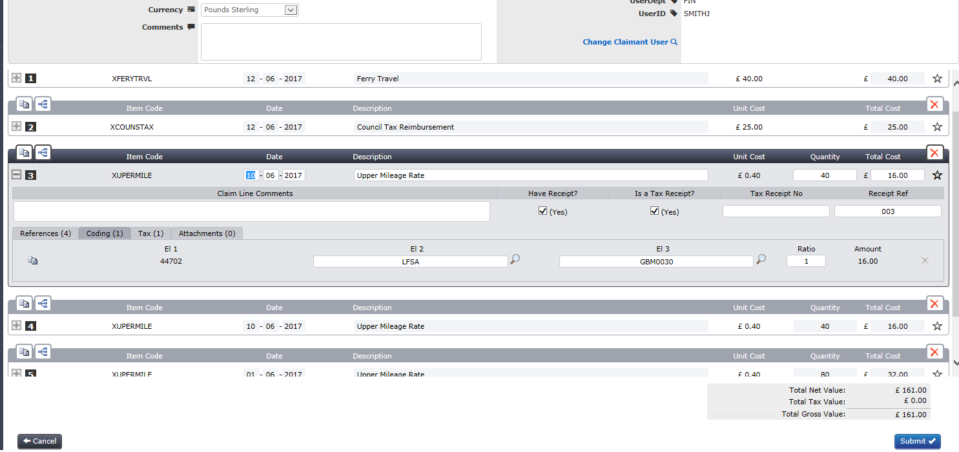
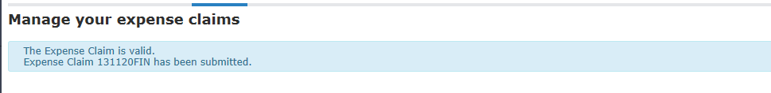
Don’t forget that you will need to send any receipts with a printed version of your claim to your finance office and once authorised THEY will need to send on to the payroll office.

