Receipting
Go to the procurement section of fusion and click on my receipts
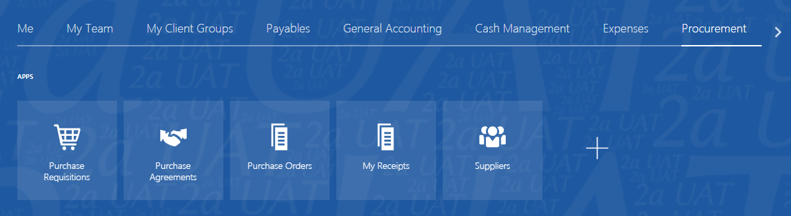
Your name will appear in the requester box, but you may not be the original requisitioner for the item. Remove the name. The items due box may default to next 7 days – change that to any time.
You can also set it as your preference. Click on the icon at the far right of your screen and click on manage receipts.
Set the items received box to any time and click save,
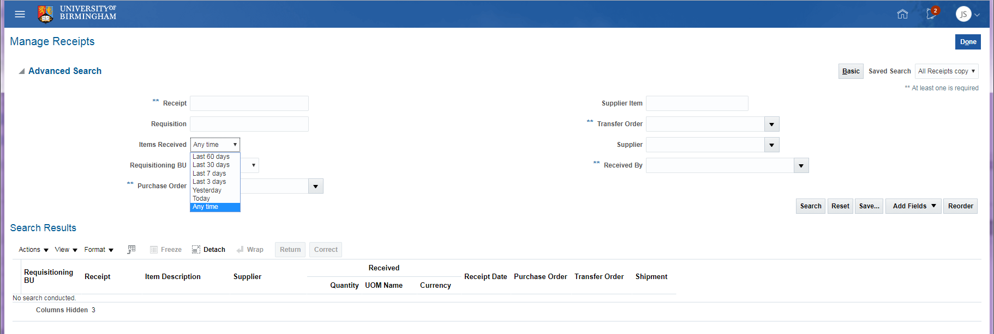
Tick the box to set as your default then click ok
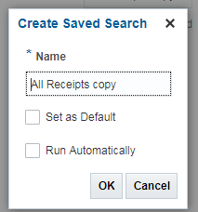
Enter your order number and click on search
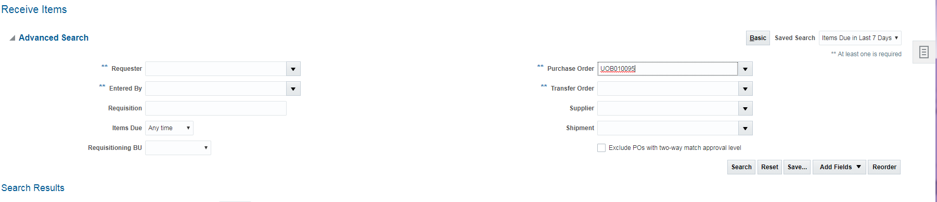
All the outstanding lines on that order are displayed
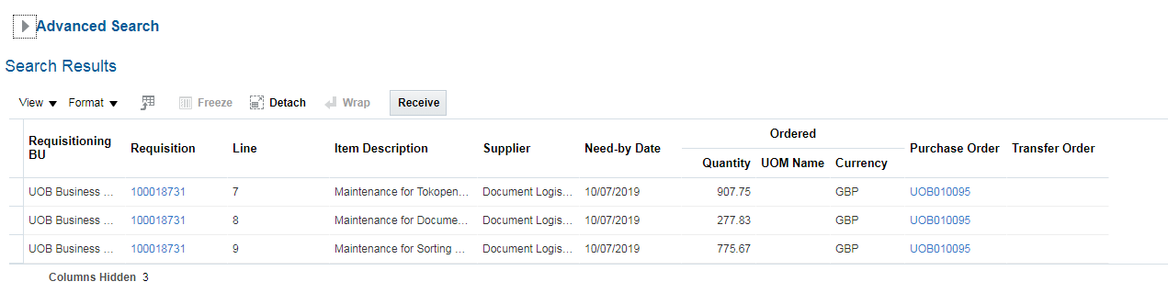
Highlight the line you wish to receive by clicking in the box next to the line and click the receive button
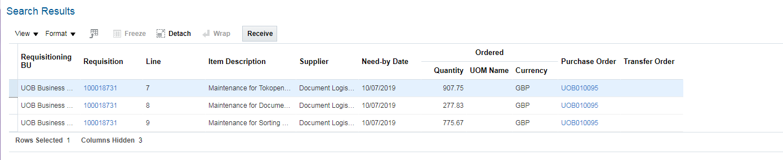
As this requisition was for an amount, the value of the line is displayed; if you had raised a requisition with a quantity then you would have a quantity box where you could enter the number of items you have received. You can also press the show receipt quantity box to see what you have left on that line. Press submit.
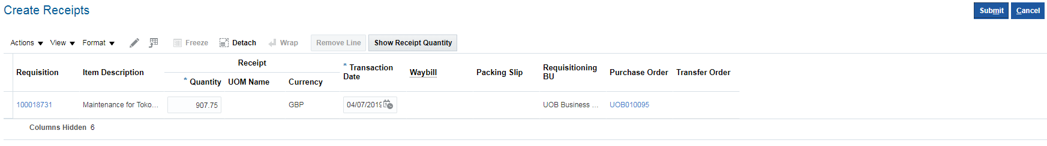
You can also receipt multiple lines by holding the shift key down as you select the lines, then press the receive button.
