Setting email reminders for expense claims
Enter proactis at: www.proactis.bham.ac.uk
Click on the admin tab and choose “Manage system feedback message and scheduling”

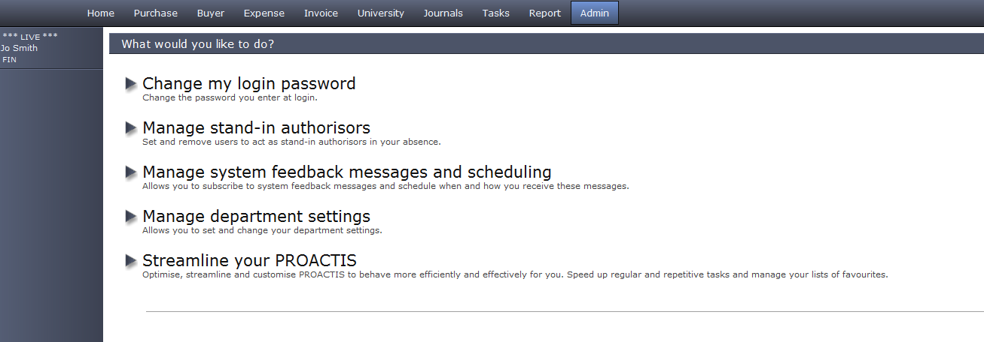
Edit my message subscription
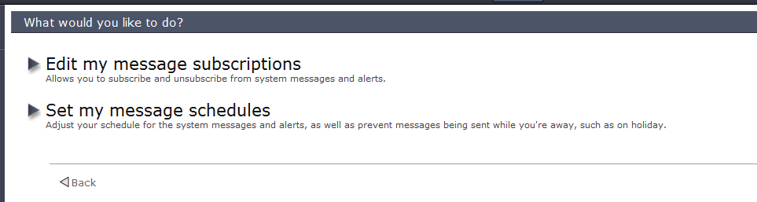

Tick the boxes next to the messages relating to expenses and the click on save subscriptions at the bottom of the page.

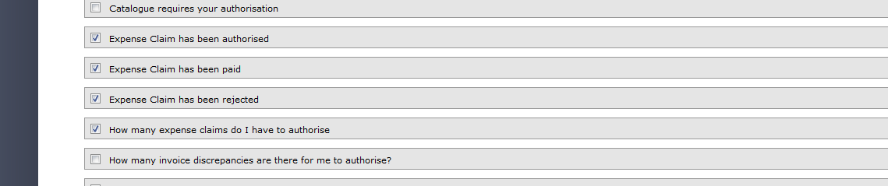

You can also set how often you want to be emailed – click on set my message schedules
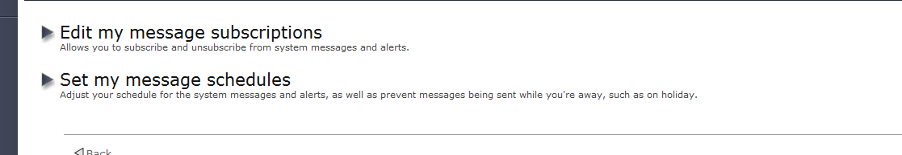

Proactis works on the 24 hour clock, tick the box next to “Enable message subscription scheduling and then enter the number of hours between checks, 1 = 1 hour, 2 = 2 hours etc. then click on Advanced settings

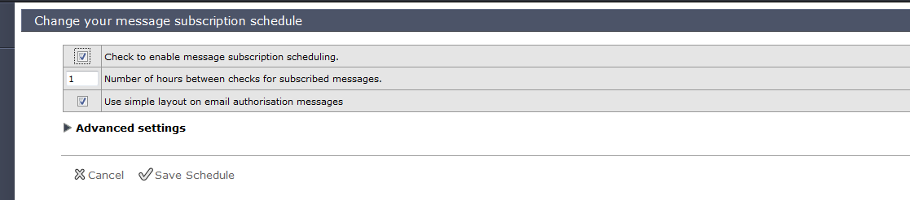

You can choose which days of the week you want to receive emails and also the times

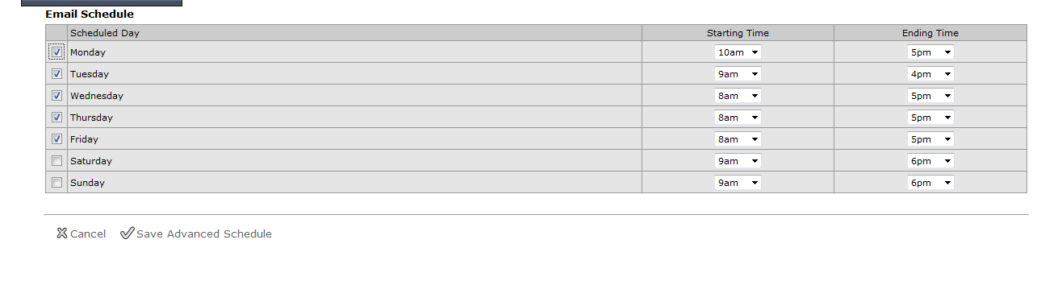
Once selected click on save advanced schedule

