The eMarketplace will display products from multiple suppliers. Therefore, it will not be the same as finding a product in a supplier-specific website. Here are some tips for finding what you need and to help reduce the number of results returned.

**Product Matching**: Search shows your results in order of relevance. In the first instance, search will return Product Matches with the option to see related matches if less than 10,000 product matches are returned. If no product matches are found, then Search will return related matches. Products are matched principally on:

* Description
* Category Attributes
* Alias Fields (alias 1, 2, 3 and disc item alias…)
* Supplier Name
* Manufacturer Name Field

***OR*** Exact term matches the Catalogue Number

***OR*** Exact term matches the Manufacturer Part Number

***OR*** Exact term matches the CAS Number (Chemical Abstracts Service if used)

|  |
| --- |
|  |
| Product Codes  Try searching alpha-numeric only  You can broaden your search by looking for part of the codes i.e. 32195 (min 4 characters) |
| |  | | --- | | If you enter a broad term, such as **“paper”**, the results will return everything where that term appears. Try being more specific with your search. i.e. **“a4 white paper 80gsm”** Place an asterisk at the end of a search term to use a wildcard search result e.g. paper*. |   Product Description – Be More Specific |

**Additional Filters** are provided to help you further refine your search – results can now be filtered by:

* Preferred status
* With image
* POA prices can be filtered out (if these are present)
* Refine by keyword and refine by excluding keyword
* By typing max / min price or using the slider bar

**Applied filters example**

**Searching for Pen returns 1962 products.**

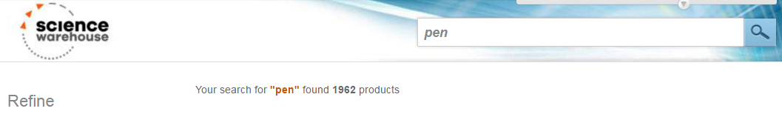

**By refining my search criteria, in the example below I have applied 4 filters to narrow my search criteria down to just 3 products. How to do this is illustrated below.**

* + *Excludes Red*
  + *Only show me products with an image*
  + *Only interested in marker pens*
  + *Between £1 - £2.*

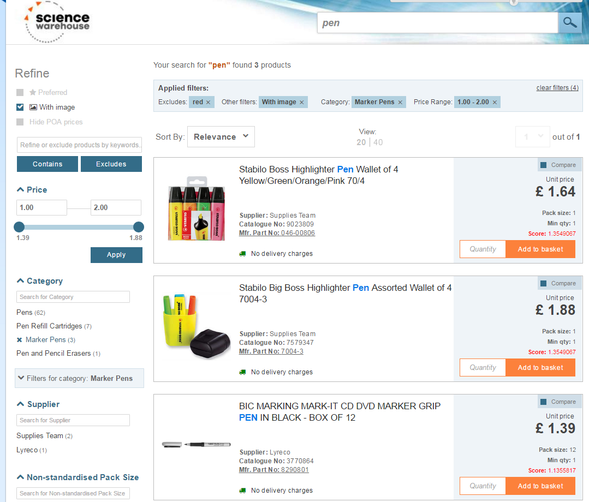

|  |
| --- |
| Filtering Search Results: Your selected filters are shown above the search results, as a reminder after applying them, and these can be removed by clicking the ‘X’ by the relevant term. |
| Suppliers  Tick your chosen supplier to reduce the  results even further |

|  |
| --- |
|  |
| Pack Size  Set further parameters to select your chosen pack size |

Refine by Keyword and Refine by Excluding Keyword

You can search for a word (or multiple words), select filters and/or exclude keywords to refine the search.

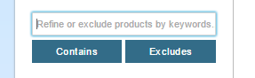

Refine or exclude products by keywords using the search function seen here.

**Example:**

User searches for a Chair but wants to retrieve the search results containing the words ‘office’ and ‘arms’.

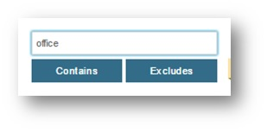

User selects ‘contains’.

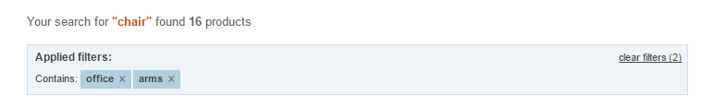

The user also wants to exclude the word ‘blue’.

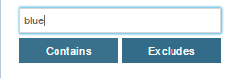

As a result, the user’s search only brought up the chairs containing ‘office’ and ‘arms’ in the description, and excluded the chairs containing the word ‘blue’.

There are Boosts under Sort by relevance available once your product matches are returned

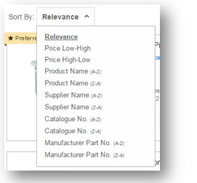

# **Lastly, if you are unable to find the items you are looking for:**

* Refine your search term further to produce better results.
* The more search terms you include to describe the item you are looking for, the more relevant your results will be.
* The search results will prioritise results in terms of:
* Items will contain all the entered search terms, followed by
* Items which contain ANY of the search terms.

If you are still unable to find the item you are looking for, it may no longer be available or your administrator may have deselected it. Please contact your Procurement team.