VAT
NOTES FOR END USERS PURCHASING ITEMS RELATING TO CATERING ITEMS WHICH ARE VAT RECOVERABLE e.g. CONFECTIONERY & ALCOHOL
Where is VAT Recoverable on Catering Items?
For the majority of catering purchases such as food and beverage items, VAT is not charged by the supplier on the item being ordered.
However, for confectionery and alcohol, suppliers will usually charge VAT. In most cases, this VAT is recoverable – in these cases, “Recoverable – Catering” must be selected when the Requisition is raised in Oracle. The process for doing this is set out below.
The exception to this rule is where confectionery or other items are ordered plus VAT but those items are not being sold on separately as confectionery items in their own right. Instead, they are being amalgamated into onwards sales of hot/cold drinks or food e.g. syrups used for coffees or smoothies. In these cases, VAT is not recoverable.
In addition, purchases of VATable items of consumables or disposables which are either not sold separately or consumed as an overhead in catering outlets are not eligible for VAT recovery e.g. purchases of disposable cups, cleaning products or other equipment that are overheads of the catering outlet itself.
Confectionery | VAT recoverable if sold separately
Alcohol | VAT recoverable if sold separately
Syrups and other items incorporated into drinks or other catered food etc | NOT RECOVERABLE
Other consumables e.g. cleaning items, disposable cups, equipment etc | NOT RECOVERABLE

If you are in doubt whether an item is VAT recoverable, then please refer to your usual Finance contact or contact the VAT Helpdesk at vathelpdesk@contacts.bham.ac.uk.
Oracle Process for selecting VAT Recovery on Catering Requisitions
End Users will go through the requisition process to identify the item(s) and suppliers that they wish to use and will add the items to their cart.
Once the End User gets to the View Cart part of the requisition, the following screen will appear;

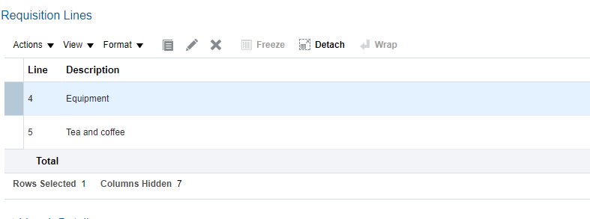
Standard Rated
Zero Rated
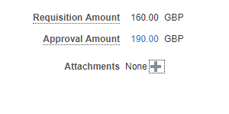
End User selects Tax Classification
- Certain items will automatically be identified as Zero-Rated e.g. tea and coffee – no VAT will be shown in the Approval Amount.

- However, if the item is expected to be VATable, the approval amount will usually show VAT.

- In some cases, the End User may expect that the item ordered is not subject to VAT i.e. should be Zero Rated e.g. the supplier does not charge VAT on these items but Oracle is not set to identify them as Zero Rated.

- In these cases, the End User can over-ride the pre-set Oracle VAT amount by selecting a Tax Classification of ZERO RATED (or Exempt/Outside the Scope if applicable).

- The End User should scroll down on the Cart to the section for Tax Classification Code and should select ZERO (if applicable);

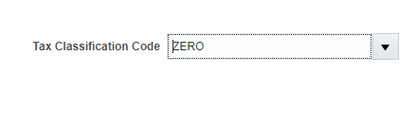
- The End User should then go back up to the Approval Amount and click Calculate Amount with Tax and the requisition should update the approval amount to remove the VAT from that item. This can be done on an item by item basis if necessary.

If the End User considers that the project is VAT recoverable
- This will only apply to VATable items like Confectionery, Alcohol or other VATable purchases (since other items will not be subject to VAT in the first place).

- If recoverable, (as set out above or based on advice), the End User will scroll down to the following box towards the bottom of the screen:
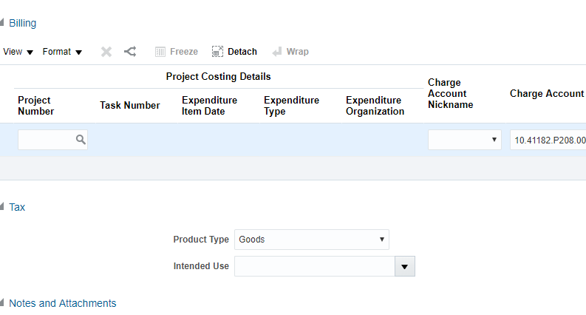

- Under the Intended Use box – the User must select the Drop down option “RECOVERABLE - CATERING”.

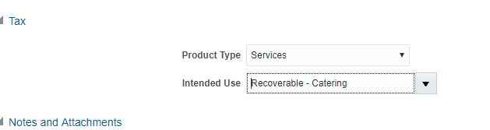

- The End User will then need to return to the top of the screen and click “Calculate Amount with Tax” in the Approval Amount box;
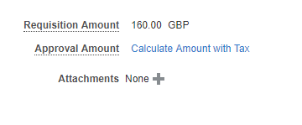
- Once this is clicked, the tax should be recalculated as recoverable and the Approval Amount for the budget holder should be the net amount of the item as shown below;
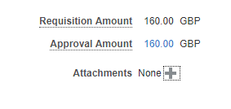
Where to go for advice?
If in doubt about the VAT liability of an item or whether it is recoverable, please contact your usual Finance contact.
End Users may also contact the VAT Helpdesk for further guidance as below;
Vathelpdesk@contacts.bham.ac.uk

