Finding your payroll number, Payslip and changing your bank account
Go to the me tab
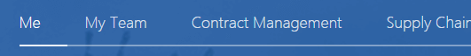
Click on personal information
Go to the payroll option in the left hand navigation
Click on your payslip icon
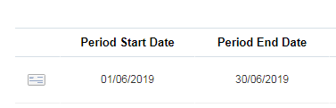

Your payroll number is the Person number at the top right of your payslip

Changing your payroll bank account

At the right of the screen click on the payroll bank account link
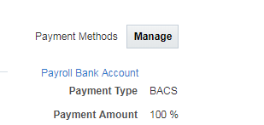
Your current bank account information is displayed, to add a new account select the new account option
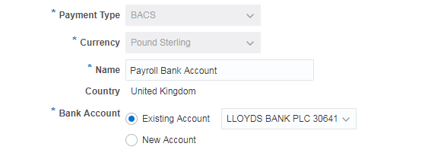
Enter your account number and then click on the arrow next to bank
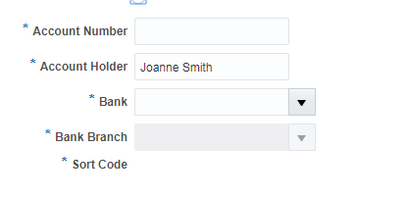
Click on search at the bottom
Some common errors when searching for your bank:
Don’t type Nat west
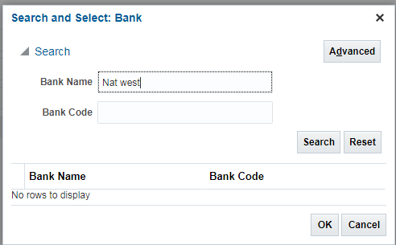
use National Westminster
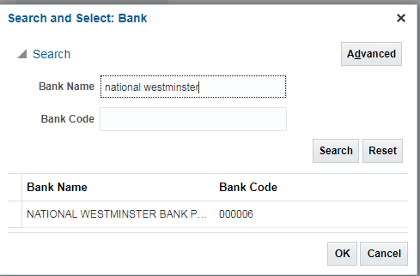
If you bank with the Co-Op, search for “The co-op” not just co-op
Abbey National is owned by Santander
First direct is owned by HSBC

