# Requisitioning in Marketplace

Hover on the Purchase tab

And click on the request option

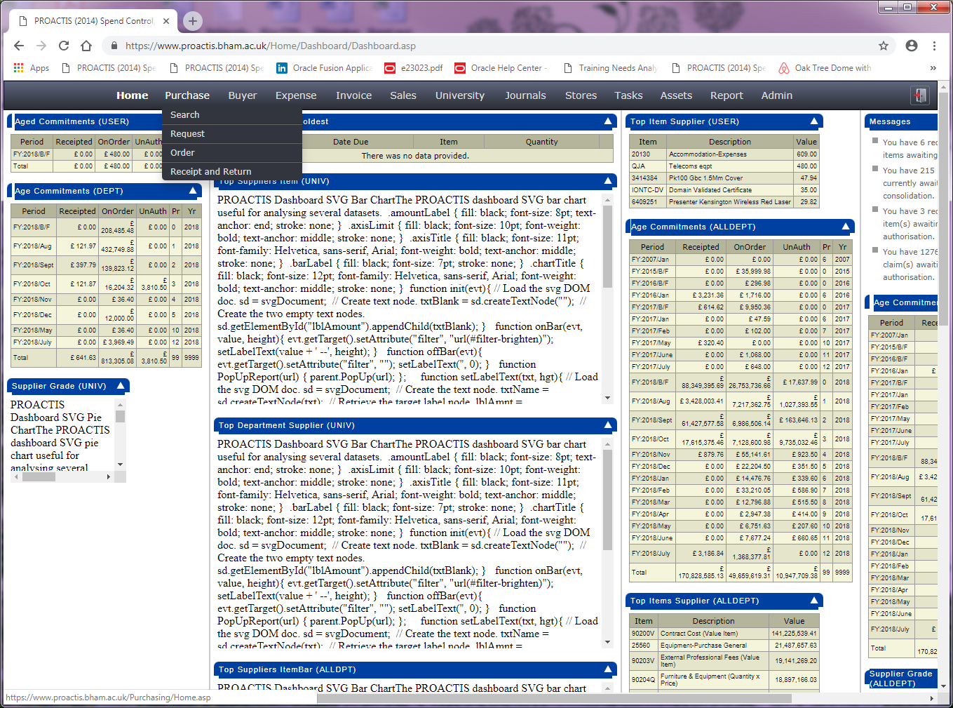

Then click the arrow here to open your marketplace templates. Depending on which college/corporate service you work in will determine which templates you see here. Some Colleges like LES and MDS may only see the TEC template – the templates work the same way, albeit the TEC template has an extra step of authorisation built in.

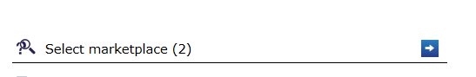

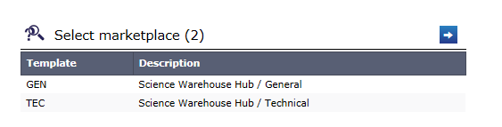

Open the template and it will take you through to the sciencewarehouse portal where you can see any saved baskets or favourite items from previous requisitions.



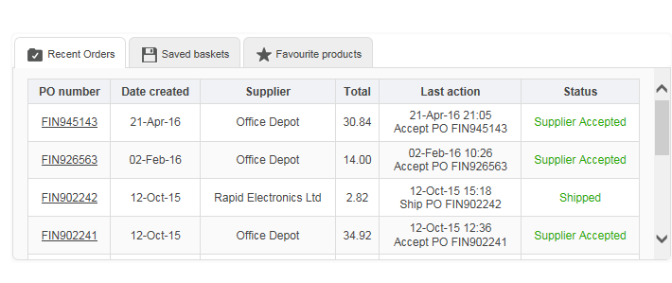

# 

# Ordering a brand new item



You can use the search box to enter a description or product number and your results will be returned with the University’s preferred items listed first.

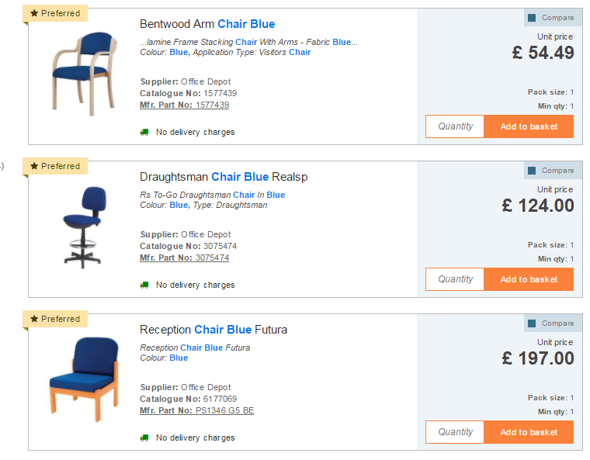

### Sorting Results

Results will default by the most relevant, based on your search term. You may, therefore, wish to sort by price, product name, supplier, catalogue number or MPN.

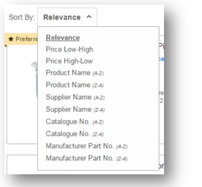

# Comparing Items

One of the main features of an eMarketplace is the ability to have comparative results, to allow you to make an informed purchase.

## Adding Items for Comparison

Between 2 and 4 items can be compared at any one time. They can be added from the search results, by ticking “compare”, or within the product information itself:

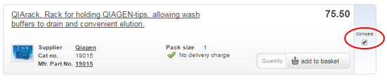

When items are added for comparison, they are added to a “holding area” at the top of the page. You can then remove items or add any other before comparing your final list:

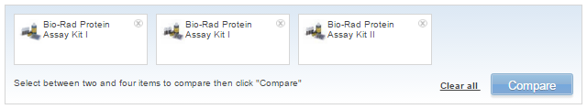

# Delivery Charges

Some suppliers may charge delivery. If so, there may be a requirement to add a delivery charge. Doing so will mean that your order is processed more swiftly, as there is less chance of order queries coming back to you.

## Viewing Delivery Charges

There are several places you can review delivery charges:

* Search Results
* Product Information
* Comparing Results

Where delivery charges are NOT applicable, you will see the following:

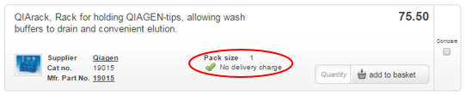

Where delivery charges ARE applicable, you will see the following:

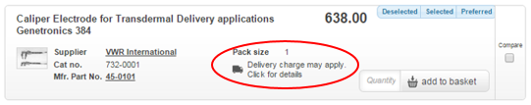

You can click to Expand the delivery charge information, which will display the relevant charges and select the appropriate charge.

However, unless you are comparing results, it is best practice to leave this step to the end.

Charges are also detailed in the appropriate tab within the product information:

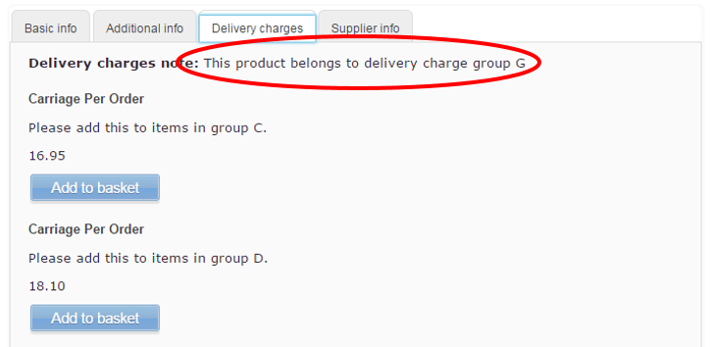

When reviewing the contents of a basket, there is a further opportunity to view delivery charges:

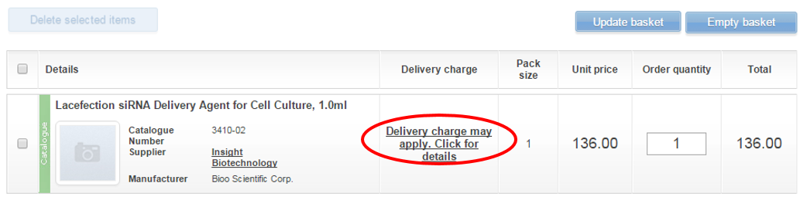

## Delivery Charge Prompt

At checkout, if purchasing products from a supplier that charges delivery, you will be prompted to review charges. Please note, this prompt will not appear for any suppliers who do not charge delivery.

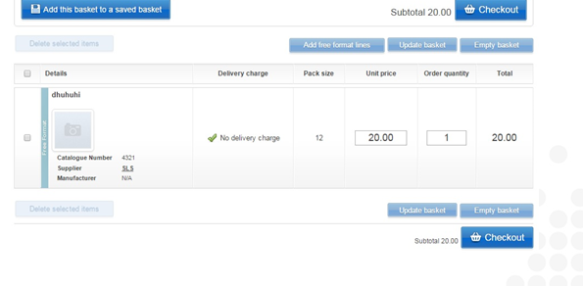

Click on show header at the bottom of the requisition

Add element 2 and 3 codes in a formation similar to this example, then click the pencil icon to apply the code to all items on the requisition

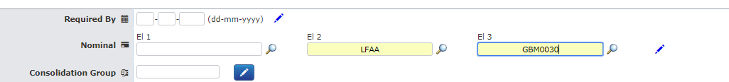

If you need to change the VAT code on the line, click on the tax code, choose the correct VAT treatment from the list that is displayed.

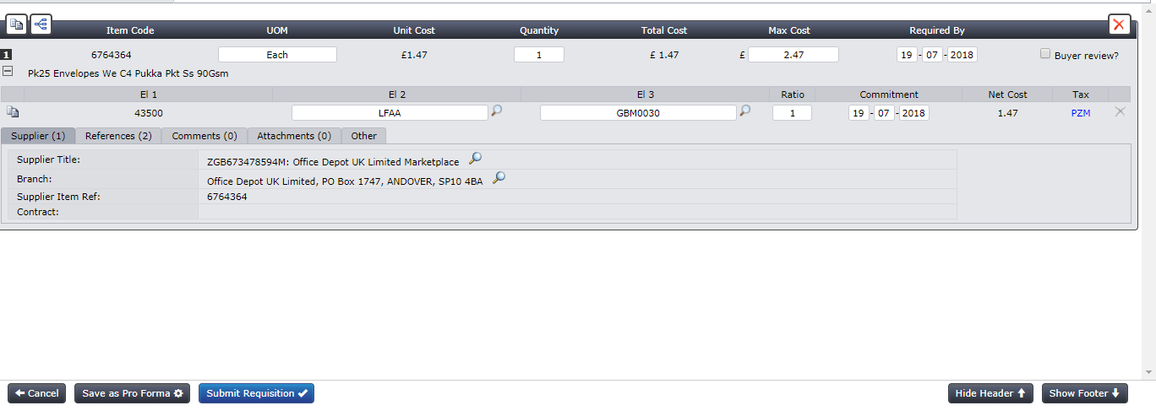

Now click on submit requisition at the bottom of the screen.