Guidance for the MRC CiC Fund 2018/19

Background

Ensuring that fundamental science is translated into new therapies, diagnostics and medical devices is central to the MRC’s mission. The Confidence in Concept scheme aims to accelerate the transition from discovery science to the early stages of therapeutic/diagnostic development by providing locally-administered, responsive and flexible funding to support preliminary translational work. The projects supported should aim to provide sufficient preliminary data to establish the viability of an approach – i.e. to provide confidence in the underlying concept – before seeking more substantive funding.

All disease areas, especially those relevant to global health challenges and modalities of intervention are eligible for support from the scheme, including small molecules, peptides, antibodies, vaccines, gene therapy, devices, surgical techniques and engineering/medical technology, bioinformatics and psychological approaches. We therefore encourage applications from across the Colleges of MDS, LES and EPS, and are particularly keen on interdisciplinary collaborative approaches. Teams that actively involve clinicians from partner NHS Trusts (particularly Birmingham Health Partners) are also welcome.

Application process
The call for applications will consist of two stages – Expression of Interest (EoI) and full-stage for shortlisted projects – to ensure that sufficient input is given to the design of robust translational projects with a high likelihood of delivering significant outcomes. Depending on the level of funding available, there may be a further call (however this is not guaranteed).

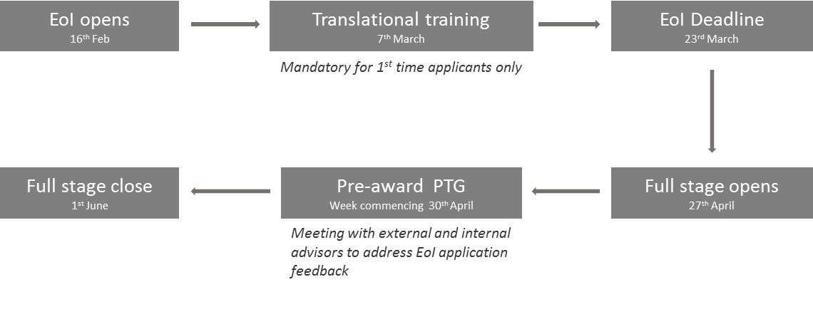
Figure 1: Schematic Diagram of CiC Application Process.

New applications to the MRC CiC award must be discussed with Vicky Kosti (MDS TTO, v.kosti@bham.ac.uk) or Jonathan Watkins (UoB Enterprise, j.watkins.1@bham.ac.uk).

Investigators with no prior applications to MRC CiC must also attend a mandatory translational training session (detailed below) prior to submitting the expression of interest application.

Those projects shortlisted from EoI will have extensive input into further development of the case and formation of an appropriate support team (see below). Support will be provided to those applications not shortlisted, either to develop new EoIs for the second call if appropriate or for external funding streams.
CiC Panel membership

Scoring - Ferenc Mueller (Chair, MDS), Jonathan Rowe (EPS), David Hannah (LES), Simon Wyn Jones (MDS), Gareth Wallis (Sport & Exercise Science), David Wraith (MDS), Ruth Roberts (LES), Liam Grover (EPS), Lloyd Czaplewski (External, ChemBioVentures).

Non-scoring advisors: Christina Yap (MDS), Peter Brocklehurst (MDS), Kate Bishop (R&KT, MDS), Vasiliki Kosti (R&KT, MDS), Anne Simper (BE, MDS), Jonathan Watkins (UoB Enterprise), Jen Jennings (LES), Paul Reay (EPS), Georgina Drury (MDS).

Translational funding – not your average project grant

Applicants should be aware that translational research funding differs from a typical project grant in that the underpinning basic research will already be in place. Proof of concept data must be included in the application and up to 2 pages may be appended to the EoI. Programmes of work should be focused around a number of key milestones that ‘de-risk’ specific elements of further development towards commercialisation/implementation. These milestones are associated with the funding requested – if these cannot be delivered on time and on-budget, then funding may be withdrawn and the project terminated.

The significant potential for further funding and impact inherent in these projects means that support is more substantial than normal internal awards – typically we can support projects of 6-12 months of values between £50k and £100k. Value for money is a key aspect to be assessed and all costs should be fully justified. Work should be fully economically costed through your usual Research Finance contact. Estimates are acceptable at EoI stage, however, a copy of the Research Finance costings should be appended at full application stage. Estates and indirect costs must be included where appropriate.

The MRC wishes to promote academic-industry interactions through the CiC scheme; applicants are encouraged to consider how awards could be used to develop these interactions. People exchange (in either direction) is permitted, where focused on delivery of project objectives. Other routes (e.g. co-funding projects, developing early-stage collaborations) are also encouraged. Interactions with small and medium enterprises are particularly welcomed.

Translational Training
Recognising that translational projects are non-typical and outside the comfort zone of many researchers, we will provide a programme of ‘Translational Training’ to support project development for CiC internal funding as well as the multitude of other external funding possibilities available. This will range from open sessions – some of which will be mandatory for those researchers leading an EoI bid for CiC funding – to one-on-one feedback and mentoring sessions that will be available to support individuals and projects. In some cases these will be specifically recommended, but they are open to all researchers on request.

The mandatory 1hr translational training session (for new applicants) will be held on Wednesday 7th March (2pm, CM16 MDS). Please contact Vicky Kosti (v.kosti@bham.ac.uk) or Guojin Liu (g.liu.1@bham.ac.uk) for more information and to confirm your place.

Project Translation Groups
For each project invited to submit a full application, we will form a small Project Translation Group (PTG) comprising the lead academic applicant together with internal and external experts and professional support. These PTGs provide the expertise required to plan in detail the fundamental science, preclinical and clinical development, IP and commercialisation. For projects already engaging with industry collaborators, representatives of the latter may also be involved, and external advisors with industry backgrounds will chair each PTG.

Key date for pre-award PTG meetings (approx. 30 mins) will be held in the first week of May 2018.

Additional information
Due consideration must be given to the milestone structure of projects – there should be 2-4 milestones and where possible these should be closely tied with the funding (particularly staffing) in such a way that projects can be terminated for non-delivery. This will be a key consideration in funding decisions.

The funding is not intended to support:
- Entire translational projects; applicants seeking funding for entire projects are directed to the MRC’s BMC:DPFS and BMC:RMRC schemes
- Staff between posts/funding (i.e. as “bridging” funds), or PhD studentships
- Continuation of normal research grants
- Costs relating to protection of intellectual property

Named individuals may be given within the application, however justification as to their importance to the project should be given and due consideration to the impact this will have on other projects they may be associated with. You may also find subcontracting out portions of the project to be a good option. Though judged against each other, each project is unique and as such there is no formula for the perfect application.

Applicants should consider relevant IP arrangements – and Jonathan Watkins of UoB Enterprise (j.watkins.1@bham.ac.uk) can advise on this – but should also be assured that projects and PTGs will be covered by confidentiality agreements that will protect IP and these relationships.

Projects should ideally be complete by 28th February 2020, as this is the duration of the institutional funding award however the Panel are aware that delays can occur for various reasons and are realistic about timeframes.

