Ethical Review Manager (ERM)

Applicant Guide: Amendments

Note: Specific manuals also available for:
- System/Technical use for applicants at: https://intranet.birmingham.ac.uk/finance/documents/public/ERM-Technical-Guide.docx
- Form questions for main application form at: https://intranet.birmingham.ac.uk/finance/documents/public/ERM-Form-Questions-Guide.docx

Contents
What can I make amendments to? 3
How do I make an amendment? 3
How do I navigate amendments? 4
How to answer the form questions 4
Routing Questions: Original Application Checklist 5
Changes to Project Information 5
Researcher Details 5
New information for UREC approved studies 5
New information for combined NHS UREC studies 6
New information for externally approved studies 6
Declarations and Signatures 6

Which applications can be amended within ERM?
The amendment form in ERM can be used to apply for changes to an existing approved project that was originally submitted via ERM. If the original project is not yet approved, you will not be able to create and submit an amendment form. Many changes can be considered at once and all processed within the same application for amendment.
A full new application for review will be required for any of the following (i.e., we cannot accept an ERM amendment form for the following):
- Brand new studies linked to the original application.
- Significant changes in risk (a warning will appear at the bottom of the first page of the form to inform you if this is case, so please scroll to the bottom)
- If you will be including human participants when the original application did not
- Inclusion of NHS elements when previously there was none (including the recruitment of NHS staff)
- If the original study only contained animal work but you now wish to expand to include other elements
- An amendment to a project originally submitted via an AER rather than ERM. Please note that for these, there will be a transition period during which applicants can either submit an amendment on an amendment form outside of ERM, or they will have the option of submitting a full new ERM application. From 2023 onwards these will all need full new ERM applications and it will not be possible to amend an application originally submitted via an AER.
Please note that changes to projects solely requiring NHS REC approval should not be done using this system and should instead be sent directly to the governance team (researchgovernance@contacts.bham.ac.uk).
Changes to projects solely involving animal work should be directed to biomedicalservices@bham.ac.uk
If you are unsure if this form is suitable, please contact the ethics team using aer-ethics@contacts.bham.ac.uk

How do I make an amendment?
Creating an amendment form is very simple, please follow the following steps:
- Log into the applicant side of the system.
- Click the project title of the project you want to amend.
- On the left-hand side of the page there will be a button which is called ‘Create sub form’ (highlighted yellow in the image below), click this.
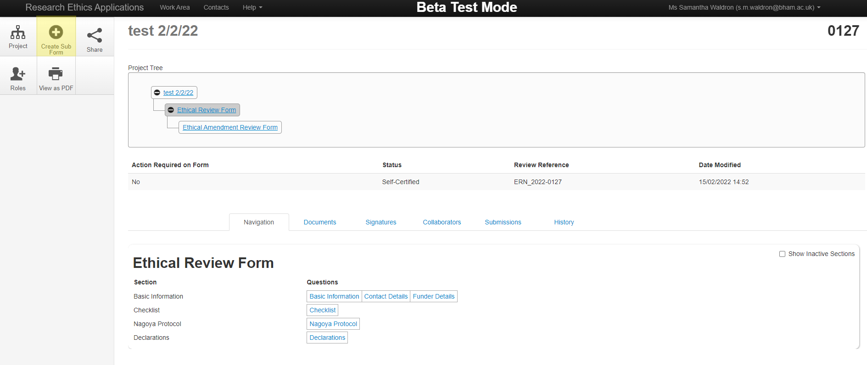
- Select ‘Ethical Amendments Review Form’ from the drop-down list and hit create.
- This will automatically generate you an amendment form to fill in

How do I navigate amendments?
When you first create an amendment form, the system will automatically take you to the new blank form.
You can use the project tree to navigate back to the original form (or other previous amendments). You can do this by simply clicking the title of the form you want.
To get to the project tree, click ‘Navigate’ on the left-hand side whilst viewing a form. Or, if on the main log in page, please click the title of the relevant project.
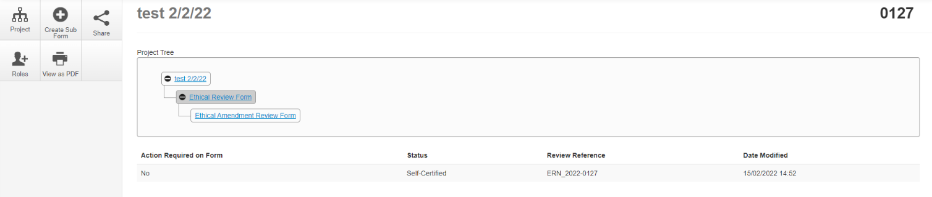
In the above example of a project tree, the title of the whole project is ‘test 2/2/22’, and under this there are two forms. The first is the main ethical review form, and below this is the ethical amendment form. If the project had multiple amendments, there would be multiple amendment forms underneath it (there is no limit). To navigate to the relevant form, you would simply have to click the blue text of the form you wish to review. The form that is highlighted in a darker grey, is the one the system currently has open.

How to answer the form questions
The form will alter slightly depending on the type of application you initially submitted.

Routing Questions: Original Application Checklist
The first page of the form contains information on what studies can be approved, and provides information on the original application you submitted (please note that these are not editable and are for reference only).
If your original project was solely reviewed by the Governance Team (i.e., received an NHS ethics review), a warning will appear stating you should apply directly to the Governance Team and not via ERM. If you submit an application when this warning shows, it will be rejected.
You may receive a warning notice at the bottom of this page. This will happen if your original study highlighted that there were no significant risks associated with the work. If you receive this notice, please carefully re-read the checklists shown on this page. If there are any risks now associated with the work (i.e., you would now need to tick one of the risk boxes) you will need to submit a full new application rather than an amendment form. If you submit an amendment form when this warning notice shows, and the risk is deemed to have increased significantly, your application is likely to be rejected.

Changes to Project Information
The next page will bring up details of the existing approval which are editable.
You can make changes to:
- The full research project title
- The short titles (or acronym)
- Project start/end dates
Please ensure the details are correct, and make any necessary changes.

Researcher Details
The details originally provided will automatically populate this page but, will be fully editable. You will be able to make changes as follows:
- If the project is considered a staff or student project
- Change lead investigator/supervisor (terminology will change within the form depending on if the project is marked as a staff or student project)
- Chang the lead PGR student working on the project
- Change and/or add any internal UoB Co-investigators
- Change and/or add any external co-investigator (please note, external investigators will not be able to access the system; to share information with them, you will need to download PDF’s of forms and send them manually).

New information for UREC approved studies
These set of questions will only appear if your original application was reviewed solely by the UoB Research Ethics Committee (UREC). This page will not show any existing information from the original form, and will be solely for the purposes of providing new information to the UREC. Information you will need to provide includes:
- Text explaining any changes to be made to the study. Each change will need to be entered into a separate box within the form. One box will initially be presented, but beneath it will be a green ‘Add Another’ option. You can request as many changes as you want at once but, each change must be separated into a new text box. In each box, please state what the change is and if it impacts on the ethical conduct of the project or the risks involved. If additional ethics concerns/risks are identified, you must explain how you will manage and mitigate these in the same box as the relevant request. Examples of changes include (but are not limited to), new methodology, new participant groups, new risks.
- You will need to confirm if there have been any changes to the following participant documents:
  - Recruitment documents
  - Participant information sheets
  - Consent documents (including verbal scripts)
If you select ‘yes’ to any of the above, you will be required to upload copies of the new versions.
- You will also be asked if you would like to upload any other changed/new documents to support your application. This may include new questionnaires, interview guides etc.

If the documents are similar to those initially approved, it would be helpful to provide versions where the changes are highlighted or using Word’s track change feature, if possible.

New information for combined NHS UREC studies
Only studies which receive a joint UREC and governance review will see this page. If your original application was reviewed by both the UREC and Governance team (e.g. for research with NHS staff), you will be asked to upload a copy of the HRA amendment document and any amended participant facing forms. Please see https://www.hra.nhs.uk/approvals-amendments/amending-approval/ for more details.

New information for externally approved studies
Only applicants with studies which have an external approval (i.e. from another institution) on file rather than a UREC approval, will see this page.
You will be asked to briefly summarise the changes approved by the external institution in a free text box.
You will also be asked to upload copies of the newest versions of your external approval notice, the external amendment review form and any participant facing documents. The Committee Chair will review the ethical approval and will decide whether it can be accepted in lieu of further UoB review and approval. Please note that the Committee Chair needs to review the work prior to continuing the project at the University of Birmingham.
If the documents are similar to those initially approved, it would be helpful to provide versions where the changes are highlighted or using Word’s track change feature, if possible.

Declarations and Signatures
The declaration and signature page will be exactly the same as the one presented on the main form. Please note that if you have changed the project/student lead, then the new leads will be required to sign the form.
To sign the form, click the relevant signature, you will then be asked to input your e-mail address and password. If multiple signatures are required, the form will lock so no changes can be made. The form can be unlocked by anyone with access to edit the project. Please note that unlocking the form will invalidate all signatures.
Please note that once all signatures for the project have been gained, the project will automatically be submitted to the ethics team.

