Ethical Review Manager (ERM)

Applicant Manual: Technical

Note: Additional help on how to answer form questions is available in a separate document: https://intranet.birmingham.ac.uk/finance/documents/public/ERM-Form-Questions-Guide.docx
For technical queries/troubleshooting please contact: ethics-queries@contacts.bham.ac.uk

Contents
1. Introduction 3
2. Quick Start Guide 3
3. Log in 4
4. Work Area 5
5. Actions (tabs on the left side of the Work Area screen) 5
5.1 Folder Actions 5
5.2 Project Actions 6
6. Tiles (boxes in the main part of the Work Area screen) 8
6. 1 Notifications 8
6.2 Signatures 9
6.3 Transfers 10
6.4. Sharing 11
7. Adding a Form 11
8. Form Navigation Tabs 12
8.1 Navigation Tab 12
8.2 Documents Tab 12
8.3 Signature 12
8.4 Collaborators 13
8.5 Submissions 14
8.6 History 14
9. Form Actions (far left of navigation page) 14
9.1 Project 14
9.2 Create a Sub Form 14
9.3 Share 14
9.4 View as PDF 15
9.5 Completeness Check 15
9.6 Refresh 15
9.7. Submit 15
9.8 Withdraw 16
10. Navigation within the form 16

1. Introduction
ERM is the University of Birmingham’s online platform for research ethics review, provided by Infonetica. It is designed to automate the submission of applications, their review and the feedback process. Anticipated benefits of ERM include faster, more transparent review for applicants and increased efficiency for reviewers. ERM replaces both the old ‘SAF’ (self-assessment form) and the ‘AER’ (application for ethical review form). The form is designed to have all of the questions in the same place so that applicants only need to use one system to request ethical approval and/or University of Birmingham Sponsorship. The system has also been set up so that you can upload any existing external ethics approvals for your projects.

The University has two central Research Ethics Committees (RECs) – one for the Humanities and Social Sciences (HASS) and one for Science, Technology Engineering and Mathematics (STEM) in addition to the Animal Welfare Ethics Review Body. The ERM system is used for both, the HASS and STEM Committees and covers all research projects undertaken by staff and postgraduate research students (please be aware that undergraduate and taught postgraduate student projects are reviewed at School/College level).

This guide is intended to provide all information that applicants using the system are likely to require. Section 2 offers a ‘Quick Start’ guide that may be all that’s needed to help prepare and submit an application. Following sections provide more in-depth guidance and detail about the system that can be used for reference as required.

2. Quick Start Guide
The full information on form navigation can be found in the sections following this. This section provides a quick brief overview of key actions required to set up and submit an ethics application. Please note, hyperlinks are included to later, more detailed section of the form for certain points

- Log in by going to Applicants-ERM.Bham.ac.uk and using your University e-mail and password (see section 3 for more details).
- Create a form by clicking ‘Create Project’ then giving it a name (see section 7 for more details).
- Enter information into the form. Click ‘Basic Information’ to go to the first page of the form, then enter information on each page. Please note the form only saves when you click ‘Next’ ‘Back’ or ‘Save’.
- Assign co-investigators and/or students on the contact page by selecting ‘Share’ then giving them the relevant level of access you would like (see section 6.4 for more details).
- When all information is entered into the form, sign the declarations at the end. Please note that as soon as all required signatures are gained the project will automatically submit (see section 6.2. for more information).
- Await an e-mail confirmation of submission. The e-mail will state if further actions are required at this time.
- If the application requires review by one of the University’s Research Ethics Committees (RECs), you will receive an e-mail and system notifications when the review is completed and what actions/changes may be required.
- When the final approval for a project is given, you will receive a confirmation via e-mail and a system notification.

3. Log in
All University of Birmingham academics and postgraduate research students will automatically be given an account in the system. If you do not have an account and you wish to submit an application, you will need to request an account. Please contact Ms Sam Waldron on S.M.Waldron@bham.ac.uk who can liaise with ITS services on your behalf. Please note this can take up to 48 hours.

To log in as an applicant please go to https://Applicants-ERM.Bham.ac.uk and sign in using your University of Birmingham e-mail address and password. The log in details for this system will be the same as for all other University of Birmingham systems which use the single sign on process.

Please note that Internet Explorer is not a supported browser; if using a Microsoft browser please update to Edge (or use Chrome/Firefox).

Please see the log in page below. You will know you’re at the right website if the word ‘Applicants’ is shown beneath the University logo.

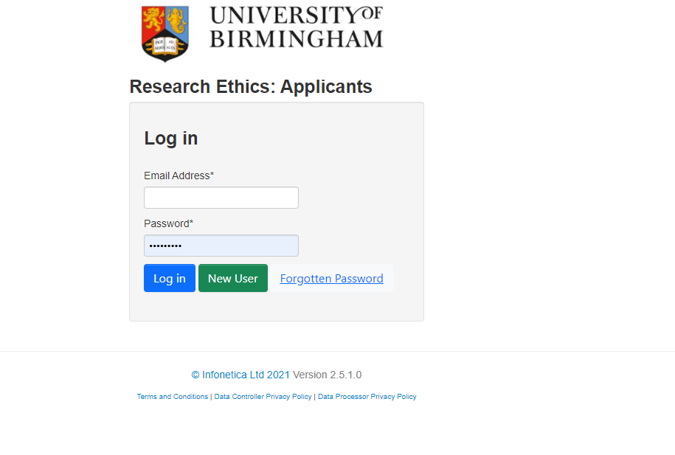

4. Work Area
The Work Area will display both active and submitted projects, as well as folders created by the user. It will look similar to this (please note future system updates may alter the layout slightly):
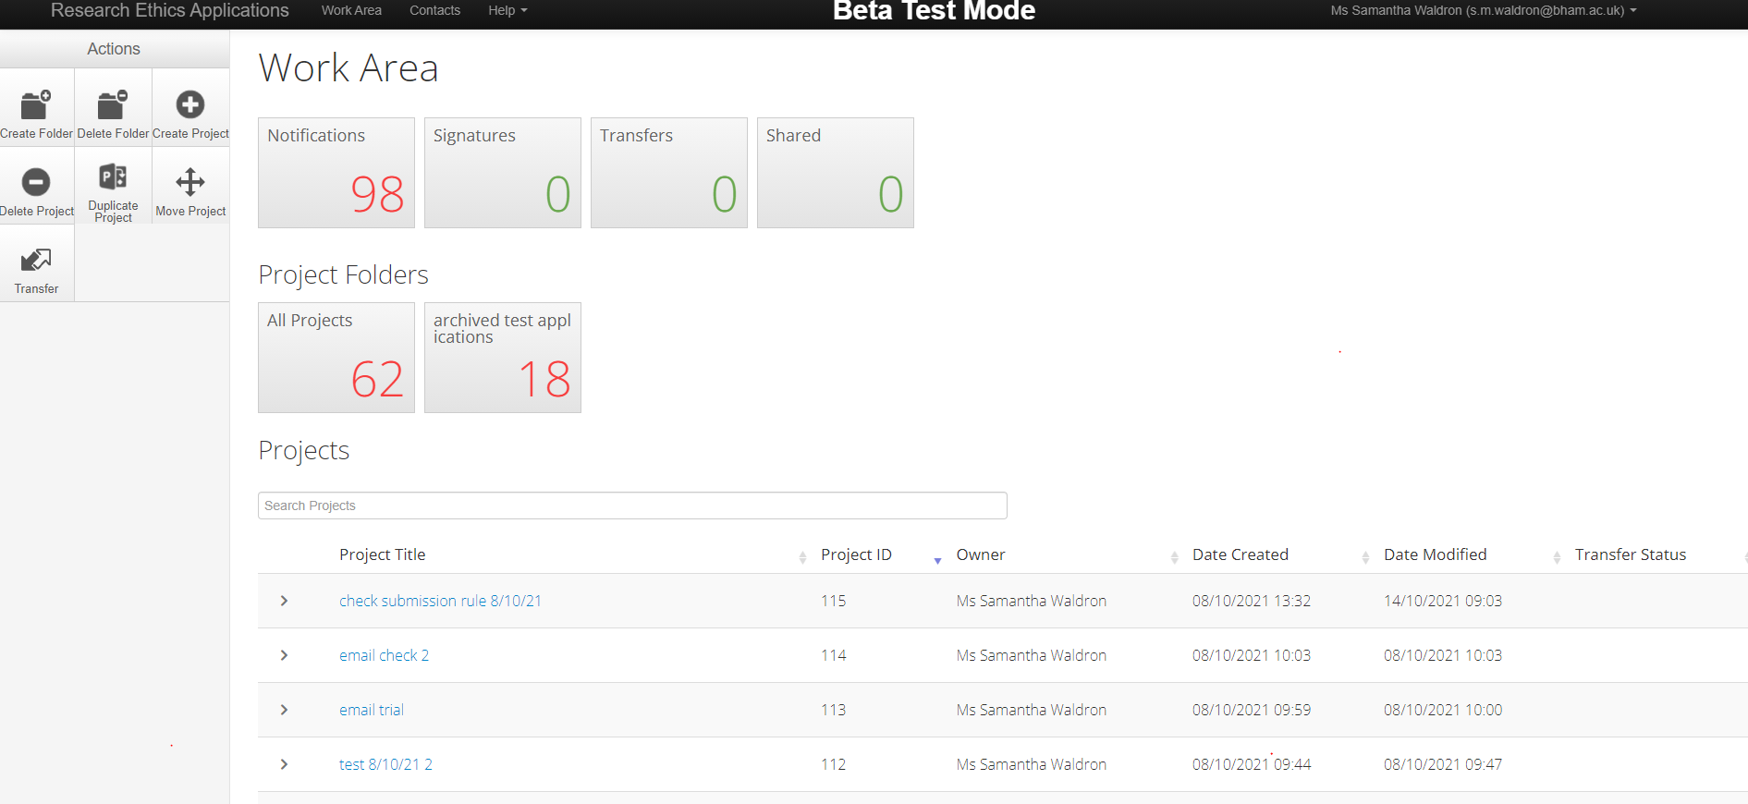
There are a number of actions that can be performed on this page. The actions tab can be found on the left-hand side of the screen.

All of your projects in the system (in preparation, active and closed) will show in a list at the bottom of the screen. You can search for key words in your project using the search bar just above the list. You can also organise your applications into folders of your choosing (see next topic for more details).

The row of boxes at the top of the Work Area (notifications, signatures, transfers, shared) and the folder boxes below this are all called ‘tiles’. More details on these specific tiles are provided further on.

5. Actions (tabs on the left side of the Work Area screen)

5.1 Folder Actions
You can create folders which can store multiple project ethics together in groups. For example, this may be useful if you want to group all of your student applications together (if you are a supervisor) or, if you are working on a large project with many sub-projects, you could create a separate folder to keep all of these together. In the example above I have created a folder for ‘archived test applications’ to store projects I am no longer currently working on.

The creation of folders does not impact on the review process in any way; it is just a way for you to organise your applications.

5.1.1 How to create a folder
- Ensure you are logged in as an applicant and are on the Work Area page.
- Click on the ‘Create Folder’ action (on the left-hand side of the screen).
- Name the folder.
- Click ‘Create’.

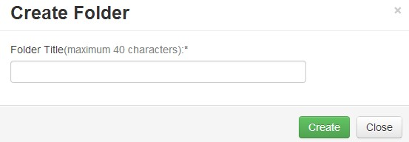

5.1.2 Deleting Folders
- Ensure you are logged in as an applicant and are on the Work Area page and click on the ‘Delete Folder’ tile.
- Select folder you wish to delete from the dropdown menu.
- Click ‘Delete’.

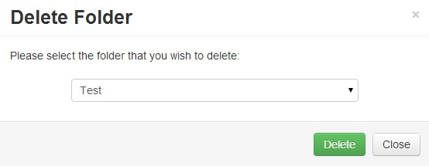

5.2 Project Actions

5.2.1 Create a project
- Ensure you are logged in as an applicant and are on the Work Area page, click on the ‘Create Project’ tile.
- Name the Project and select a main form; the form to select is called “Ethical Review Form”.
- Click ‘Create’.
- Details on how to fill in the form are available in a separate document entitled ’Form Questions’.
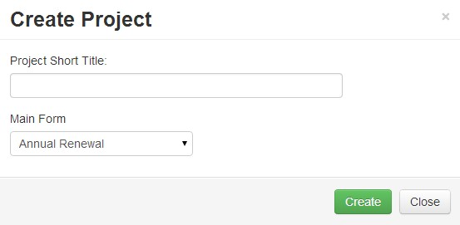

5.2.2 Delete a Project
- Ensure you are logged in as an applicant and are on the Work Area page, click on the ‘Delete Project’ tile.
- Select the project you wish to delete from the dropdown menu.
- Click ‘Delete’.
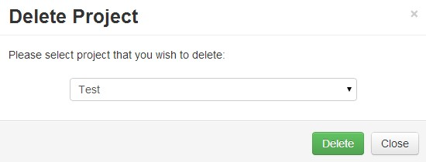

5.2.3 Duplicate a Project
In the new system you have the option to completely copy a project. This may be useful if you are planning a new project with a lot of similarities to a previously approved study. So you do not have to start from scratch, you can essentially copy all of the information into a new form, then go in and edit the relevant sections prior to submission. To do this, please follow these steps:
- Ensure you are logged in as an applicant and are on the Work Area page, click on the ‘Duplicate Project’ tile.
- Select the project you wish to duplicate from the dropdown menu.
- Click ‘Duplicate’.
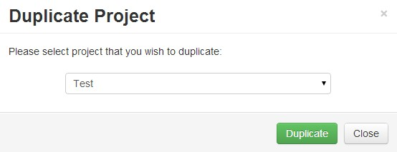

5.2.4 Move Project
- Ensure you are logged in as an applicant and are on the Work Area page.
- To move a project into a folder you simply need to drag and drop it.
- If project is already contained in a folder, click on the folder you wish to move project from.
- Click the ‘Move Project’ action in the sidebar.
- A box will appear asking you to choose the project you wish to move as well as the new location folder.
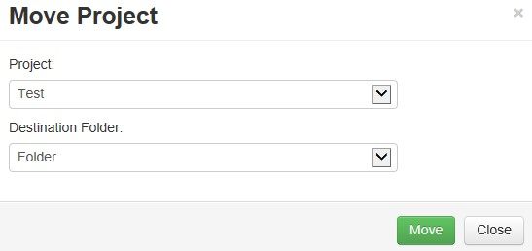

6. Tiles (boxes in the main part of the Work Area screen)

6. 1 Notifications

6.1.1 Viewing Notifications
You will receive a notification every time an action is performed with a project you own (e.g. if it is submitted for review, signed, approved etc.) There are two ways to view notifications:
- One way is by clicking the ‘Notifications’ tile located in the Work Area.
- The other is by clicking the ‘Notifications’ tile located in the sidebar.
- The notification can be viewed by clicking the message writing, where a box will then display it.

6.1.2 How to view a project attached to a notification
You can easily see which specific project any notification is related to:
- Ensure you are logged in as an applicant and are on the Work Area page, click on the ‘Notifications’ tile.
- While clicking the message writing will display the message in a box, clicking anywhere to the left of the message column will open the project that is attached the notification.

6.1.3 How to alter notifications
You can easily change and highlight notifications in the following ways:
- Ensure you are logged in as an applicant and are on the Work Area page, click on the ‘Notifications’ tile.
- You can delete a notification by clicking
- A notification can be flagged by clicking on the
- A notification can be marked as read by clicking on the
- Alternatively multiple notifications can be selected by clicking the symbol, followed by clicking the desired function button:

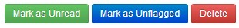

- When a notification is deleted or marked as read, it will no longer contribute to the number shown in the ‘Notification’ tile on the Work Area page.

6.2 Signatures
Once you are happy with the form, you will need to sign it to confirm you are happy with it. In order to sign the form, you click ‘Sign Form’ on the last page of the form, you will be prompted to re-enter your e-mail and password. A signature is required from the project lead only on staff projects. For student projects we require both, the lead supervisor and the student to sign the form. Once all signatures have been gained the form will automatically submit. If multiple signatures are required the form will lock as soon as one signature is given, if the form is unlocked to make further edits, please note that any existing signatures will be invalidated.

6.2.1 Signing someone else’s form
When someone requests your signature on a form, a number will appear in the tile on the Work Page area. You can sign forms by:
- Clicking on the ‘Signatures’ tile in the Work Area.
- Click on ‘View Form’.

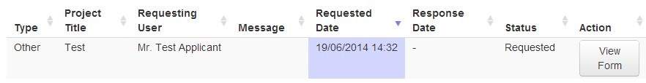

- Click the ‘Sign’ or ‘Reject’ action on the side bar.
- Fill in your username and password and click ‘Sign’.
- If rejecting, a reason as well as your username and password is required.
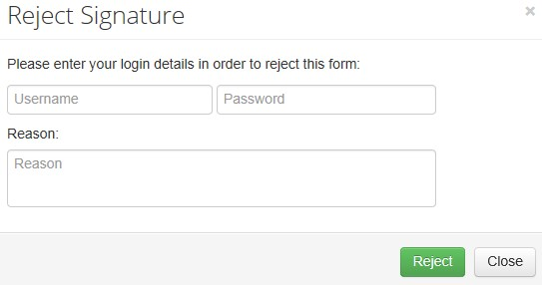

6.3 Transfers

6.3.1 Transferring a project
You can transfer whole projects to other researchers (for example if there is a new lead researcher or supervisor), to do this:
- Ensure you are logged in as an applicant and are on the Work Area page, click on the ‘Transfer’ action on the left side bar of the Work Area.
- Enter the email address of the person you wish to transfer to.
- Select the projects(s) you wish to transfer.
- Click ‘Transfer’.
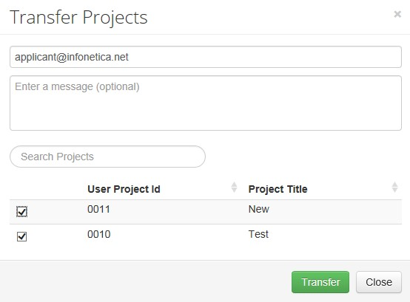

6.3.2 Receiving Transfers
You can view projects that have been transferred to you by:
- Ensure you are logged in as an applicant and are on the Work Area page, click on the ‘Transfer’ tile in the Work Area (the main part in the centre of the screen)
- Click on’ View Project’.

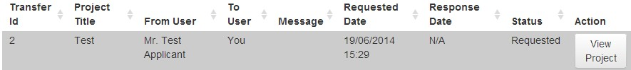
- On the left side bar click the desired action, ‘Accept Transfer’ or ‘Reject Transfer’.
- A notification will be sent to the other user to inform them of the action.

6.4. Sharing
You can also share forms with other researchers (without initiating a transfer of ownership) and give other various abilities within the shared form. All shared forms will show in this tab. To see how to enact sharing, please see the section on sharing below (in forms). To see forms which have been shared with you:

- Ensure you are logged in as an applicant and are on the Work Area page, click on the ‘Shared’ tile in the Work Area.
- The form can be viewed by clicking ‘View Form’ and you can reject the sharing request by clicking the ‘Reject’ button.
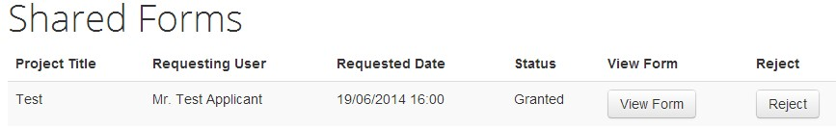
If you are rejecting a sharing request, a reason is required. Enter a comment and click ‘Reject’ (e.g., sent to wrong person, no longer supervisor etc.)
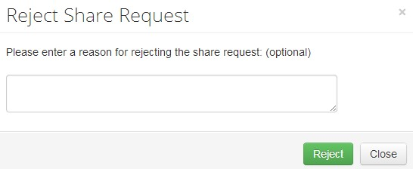

7. Starting a New Application For Ethical Review Form
- Ensure you are logged in as an applicant and are on the Work Area page.
- Click ‘Create form’.
- Select the form you wish to add from the dropdown menu (Ethical Review Form).
- Click ‘Add’.
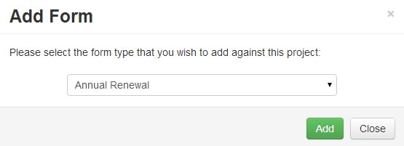

8. Form Navigation Tabs
Once you have created an ethics form you will be presented with this page (or, to view this page for a previously created form please click on its title when in the Work Area). Various tabs will be displayed towards the middle of the screen, which will be explained here.
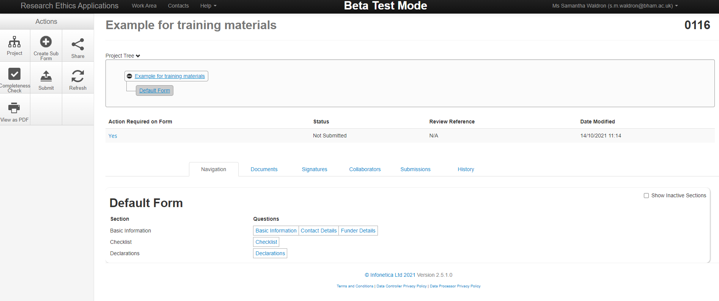

8.1 Navigation Tab
This shows all the various pages in the ethics form where you need to enter information (note that different pages will appear/disappear depending on answers to certain checklist questions). You can navigate to any page quickly by clicking the relevant section.

8.2 Documents Tab
Clicking this will show any documents which have been uploaded up to the current form. You will also be able to individually download these.
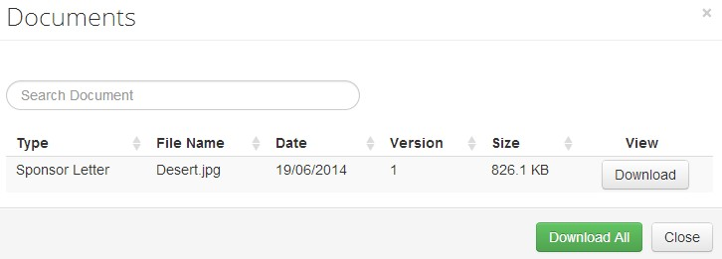

8.3 Signature
This tab will show all the signatures which have been given and requested on the project (e.g. supervisors/ lead investigators).
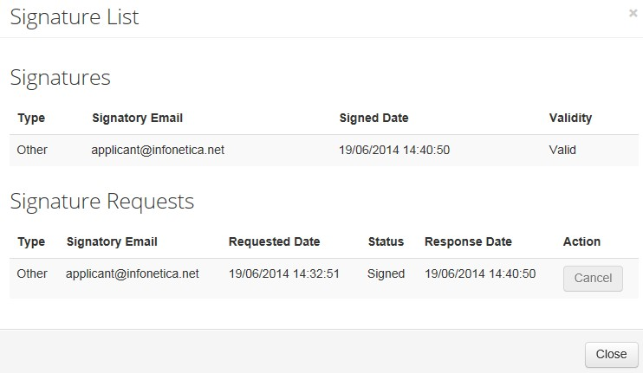

8.4 Collaborators
This will list all collaborators named on a project. From here you will be able to see what access they have and revoke any sharing rights you have granted by hitting the ‘Revoke’ button on the right-hand side.
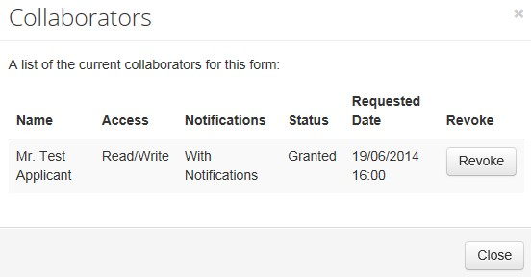
*Collaborator Access definitions:
- Read Only: only allows the collaborator to read the form
- Read and Write: allows the collaborator to read and make changes to the form.
- Full Access: allows the collaborator to read, make changes to the form, as well as submit it for review.

8.5 Submissions
This tab will allow you to see all final submissions made to the Research Ethics Team for this project. You can view individual submissions within the system (by clicking each one) or by downloading them as a PDF. Each time a submission is made, it will be viewed here.
For example, the first time you submit to the Research Ethics Team it would be considered the first submission. If further changes are requested changes, this will unlock the form and allow you to make changes. When you then re-submit to the Ethics Team, the form will show as submission 2 (and all changes will automatically be flagged by the system).

8.6 History
The history tab will allow you to quickly see all the main actions which have been performed within the project, giving the dates of these actions and allowing you to download any associated documents.

9. Form Actions (far left of navigation page)

9.1 Project
Clicking project will take you to a more detailed version of the project tree (also shown at the top middle of this navigation page). Here you will be able to see all forms associated with the project (for example any sub forms such as amendments). You will also be able to see any project transfers.

9.2 Create a Sub Form
This is only available on approved applications. Clicking this form will give you the option to create an amendment form. All existing amendments will be visible under the ‘Project’ action.

9.3 Share
This allows you to share the form with other researchers. To do this, click the button, enter the relevant e-mail address and select the access requirements (see below for definitions).
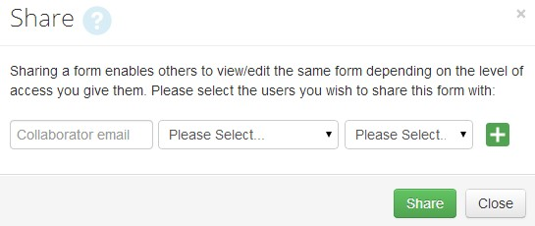

*Collaborator Access definitions:
- Read Only: only allows the collaborator to read the form.
- Read and Write: allows the collaborator to read and make changes to the form.
- Full Access: allows the collaborator to read, make changes to the form, as well as submit it for review.

9.4 View as PDF
Clicking this allows you to download the whole form (and contents) as a PDF for your own records.

9.5 Completeness Check
Clicking this will run an analysis and quickly point you to incomplete sections of the form. You can click anything highlighted by this scan to quickly navigate to the relevant section

9.6 Refresh
You are unlikely to need this; this action ensures that the form you are currently using is the correct version of the form. The only time you will need to click this is if you are informed by the Research Ethics Team that the form questions have been updated.

9.7. Submit
When you are ready to submit click the ‘Submit’ tile from the sidebar. If the form is incomplete the box that appears will show the questions that are still required to be completed. Once the form has been submitted it will be locked from editing until the Research Ethics Team have provided a response. Once a project is approved, it will also no longer be editable.

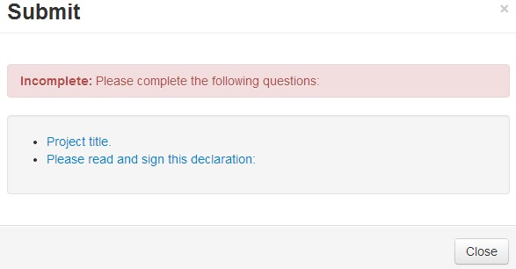

- If complete, the box will display:

- Click ‘Submit’.

9.8 Withdraw
An action called ‘Withdraw’ will be visible only on applications which have already been submitted to the Ethics Team and are under review. If you click this button, the form will immediately be returned to you. Please note that on re-submission to the Research Ethics Team the review process will start again from the beginning.

10. Navigation within the form
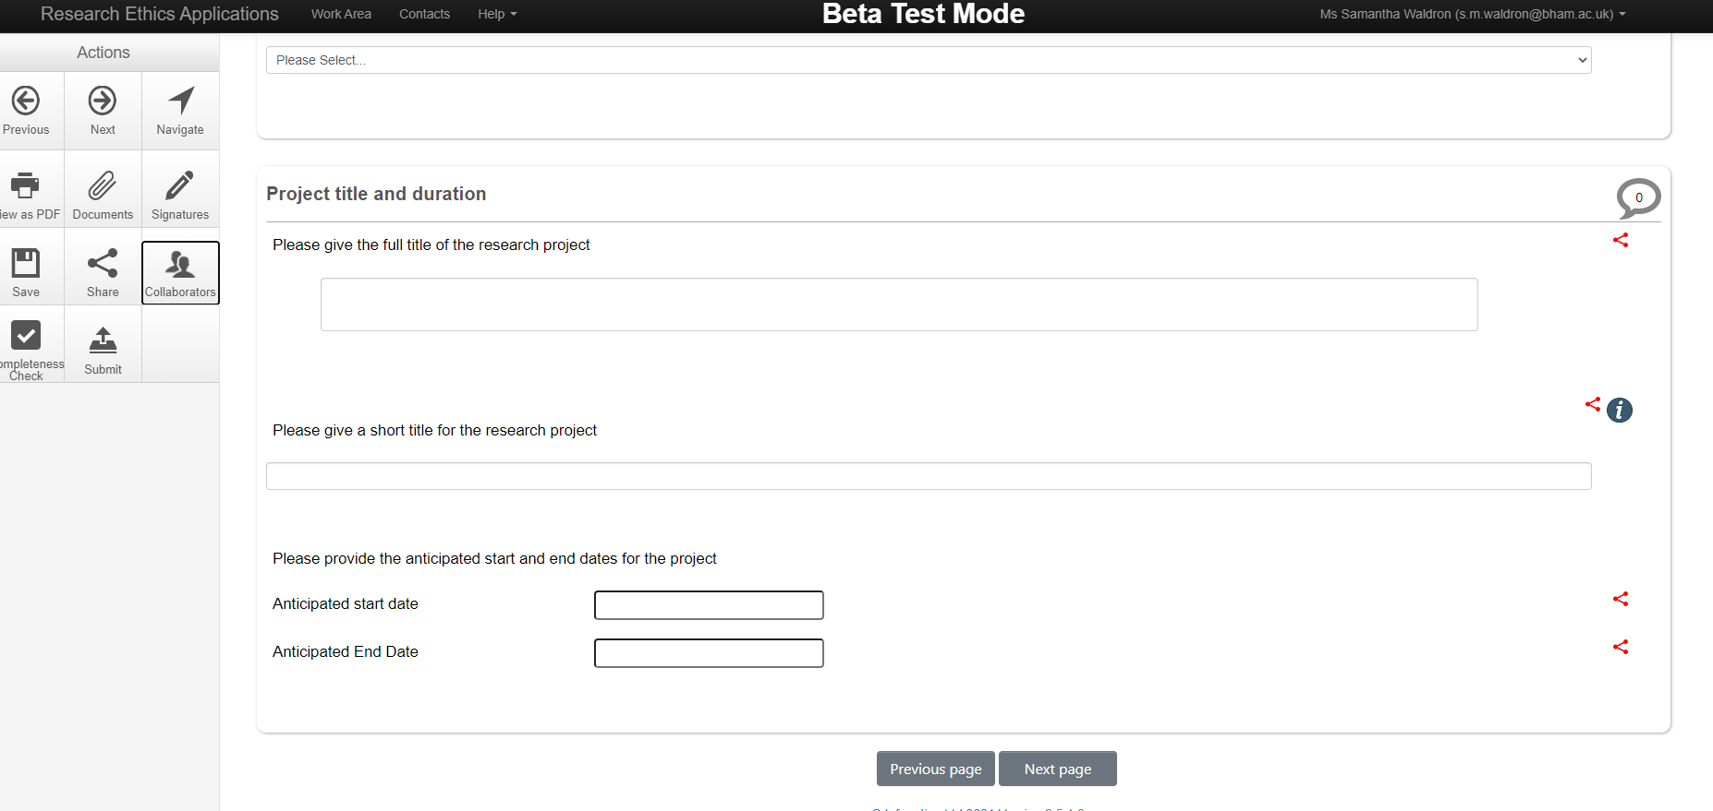

When you are completing the form, simply click on the relevant box to enter text (please note most questions require an answer in the box otherwise submission will be prevented).

You can navigate to the next/previous page either using the buttons at the bottom of the page or the buttons on the far-left action tab. Clicking ‘Navigation’ in the action tab will take you back to main project overview (where you can quickly navigate to any other part of the form).

Action overview (More detailed action overview is available in section 7 above):
- View as PDF: turns the current form into a PDF for your records.
- Documents: allows you to view all uploaded documents in a list.
- Signature: shows a list of all signed/requested signatures.
- Save: allows you to save your application (note, hitting next/previous also saves the form).
- Share: allows you to share the form with collaborators (see above for more details).
- Collaborators: shows a list of all project personnel and who has access to the form.
- Completeness check: shows what still needs to be completed within the form.
- Submit: submits the form.

Notes:
- Some questions have an ‘i’ box on the left in blue; clicking these will bring up more information on how to fill in a question.
- Some questions have a red symbol to the right; this means the questions will automatically be shared with any amendment forms you may submit in the future.

