MRC Confidence in Concept Guidance

Introduction
Translating fundamental science into new interventions is central to the MRC’s mission to prevent illness, develop therapies and improve human health. The Confidence in Concept scheme (CiC) aims to support innovation and accelerate the transfer of the best ideas from discovery research into new interventions that reach patients and improve the return on investment in fundamental research. It is intended to rapidly de-risk projects across the translational pathway so that they become competitive for substantial funding for further development.

CiC projects should aim to deliver key studies to strengthen existing preliminary data, establish the viability of an approach and provide confidence in the underlying concept. Projects are expected to seek further funding to continue de-risking of the innovation, or more substantial, follow-on funding from public funders, charities or industry.

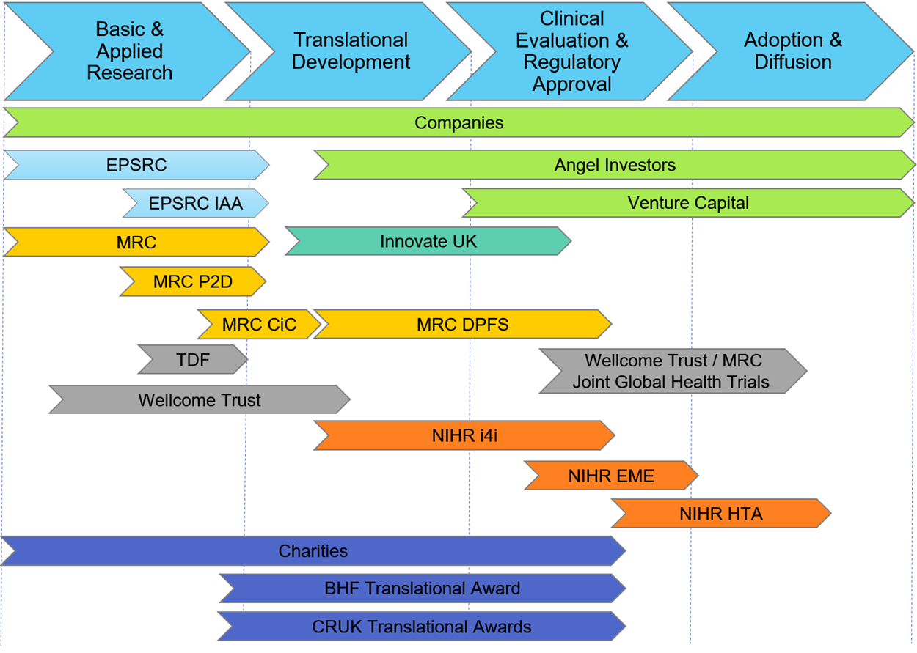
Figure 1: Examples of translational research funds positioned along the translational development pathway
Find out more about the MRC’s remit, research priorities and guidance on the MRC website.

MRC CiC funding will be superseded by the MRC Impact Acceleration Account (IAA), with the first IAA call expected in September 2022. If your project is for longer than 6 months, requires a level of funding higher than available in this final CiC round, or you are unable to commit to the spending deadline for this round, we encourage you to apply for the IAA call later in the year.

Who Can Apply?
We encourage applications from across the Colleges of Medical and Dental Sciences (MDS); Life and Environmental Sciences (LES); and Engineering and Physical Sciences (EPS) and are particularly keen on interdisciplinary collaborative approaches. Teams that actively involve clinicians from partner NHS Trusts (including Birmingham Health Partners) are welcome.

Principal Investigators (PI) must be a member of academic staff employed by the University of Birmingham. We also welcome applications from Early Career Researchers (ECRs). The minimum formal qualification required for an award is a PhD.

Co-investigators (CoI) must meet the same eligibility criteria as PIs, but in addition may include postdoctoral researchers and honorary staff.

Researcher Co-investigators (RCoI) are those who have made a substantial intellectual contribution to the formulation and development of the project but are not eligible to be either PI or CoI in their own right, e.g. they do not have an employment contract with the University. This could apply to clinical fellows, PhD students and technology specialists or equivalent roles.

For more information about who can apply, please refer to MRC Guidance for Applicants.

All disease areas and modalities of intervention are eligible for support. This includes but is not limited to:
- the early stages of therapeutic, biomarker and diagnostic development,
- small molecules, peptides, antibodies, vaccines, gene therapies,
- devices, surgical techniques, engineering and medical technology,
- bioinformatics,
- psychological approaches.

The funding is not intended to support:
- Entire translational projects – applicants seeking funding for entire projects are directed to the MRC Developmental Pathway Funding Scheme (DPFS),
- Administration costs,
- Industrial partner costs,
- Staff between posts or funding (i.e. as “bridging” funds), or PhD studentships,
- Continuation of normal research grants,
- Costs related to protection of intellectual property (IP),
- Staff exchange into a spin-out company of the host institution.

How do I Apply?
Prior to submission, all projects must have been discussed with a member of the Translational Research Team to ensure the project is suitable for the CiC scheme. Ahead of discussion, please use the Intention to Submit Form in order to help frame discussions with a suitable member of the team. This form will close to new responses at 17:00 on Friday 10th June 2020.

All project costings must be approved by your College Research Development and Support Team. We encourage you to contact your team as soon as possible.

Applications must be made using the ‘MRC Confidence in Concept Application Form’ and submitted by email to the Translational Research Team (TranslationalResearch@contacts.bham.ac.uk) by the submission deadline:

12 noon, Wednesday 22nd June 2022

Project Timeframe and Funds Available
This round of CiC funding will provide up to £60,000 at 100% fEC (Cost to Funder) for projects no longer than 6 months. Projects must be costed using Worktribe. Directly Incurred Costs should be broken down per milestone (see Section 6: Application Guidance and Advice). Directly Allocated Costs may be given as values for the full duration of the project. Project cost queries should be directed to your College Research Development and Support Team.

Projects must be complete and fully spent no later than 31st March 2023 to comply with the conditions of the institutional fund award. The MRC have made it explicitly clear there will be no further opportunity for costed or no-cost extensions for this award, so we are unable to consider projects that cannot commit to this deadline. Please consider applying later in the year for the new MRC Impact Acceleration Account.

Where projects include costs for new equipment or external organisations (e.g. contract research organisation work) recent quotes must be appended to your application and must include VAT. If you are purchasing services or equipment for medical research and the supplier confirms that they will not charge VAT, you may exclude it. Awards will only honour the quoted value provided in this application. For the avoidance of any doubt, if you have excluded VAT at this stage, it will not be included in your award.

Ethics, Use of Animals and Clinical Samples
It is not expected that an ethical review will be in place ahead of the submission deadline, but applicants should be aware that appropriate ethical approval will be a condition of starting the award and must not delay the start of the project. Ethical approval is a requirement of the university’s Code of Ethics and Code of Practice for Research.

For any projects involving the use of animals, it is expected that the Biomedical Services Unit (BMSU) will have been contacted, who can also provide advice on NC3Rs Guidelines. Contact the BMSU by email at BMSU@contacts.bham.ac.uk.

Application Guidance and Advice
Programmes of work should be focused around a number of key milestones that de-risk specific elements of further development towards commercialisation or implementation. Project milestones should be written as SMART goals (definition below) and relevant go / no-go decision points should be included.

S
M
A
R
T
Figure 3: Definition of SMART goals
Table 1: Examples of tasks re-written as SMART goals
Example 1
û | Task: Establish fit for purpose primary screening assay.
ü | SMART goal: Primary screening assay established with transient transfection in 384 well format with Z’ > 0.7 (acceptable 96 well assay, Z’ > 0.5) at month 6.
Example 2
û | Task: Evaluate hits from HTS.
ü | SMART goal: Re-evaluate hits in single shot and full EC50 mode in primary assay. Re-confirmed hits ranked according to EC50 and chemical characteristics (see target product profile for measurables). Completed at month 12.

Projects typically have 2-3 milestones and your go / no-go decision points should be closely tied with the funding (particularly staffing) in such a way that projects can be terminated for non-delivery. Please provide a justification of any resources requested in supporting this project and ensure it is aligned with the resources identified in the Project Cost Breakdown. This will be a key consideration in funding decisions.

A completed Gantt chart must be appended to your final submission, using the template provided. Milestone and task details should then be filled in, with dates for individual tasks indicated. Further milestones and tasks may be added to the template as necessary. Go / no-go decision points should be indicated.

Translational research funding differs from a typical project grant as the underpinning basic research will already be in place. Research to further the underpinning basic science (e.g. mechanistic studies) can be run alongside your translational research and should not usually be included in the translational research application.

Up to 2 pages of preliminary data must be included in the application. Text provided with the preliminary data should only address the interpretation of the figures. If any inappropriate text is included in the preliminary data, this will be redacted before sending to the Panel for review.

Where appropriate, a justification of the proposed sample size must be given along with details of the planned statistical analyses. Please include details of any professional statistical advice that has been sought.

Applicants should provide a description of likely subsequent proposals directly related to this project if this work is successful. Applicants are expected to have engaged with external funders before submitting this application to establish what proof of concept, translational viability, or any other data they would wish to see to support future applications.

Describe any clinical, commercial, or organisational dependencies necessary to help translate your work into practice.

Industry Partnerships and Collaborations
The MRC wishes to promote academic-industry interactions through the CiC scheme. Successful applications are expected to lead to increased interactions with and understanding of industry as demonstrated by research collaborations, joint funding applications, licencing of IP and mutually beneficial knowledge exchange.

Any project involving an industrial partner (contributing either in cash or in kind), which does not have an existing collaboration agreement in place, will be expected to comply with the MRC Industry Collaboration Framework (ICF) as a condition of award. The ICF replaces the MRC Industry Collaboration Agreement (MICA) process.

The ICF supports applicants submitting collaborative research projects between academic and industry researchers, helping to ensure that the necessary discussions have been initiated and that the nature of the collaboration is compliant with MRC guidelines.

The ICF facilitates collaborations by supporting academic and industry partners to work out and clearly specify arrangements, before a project starts, for:
- relative responsibilities,
- intellectual property rights,
- financial contributions,
- access to data, materials and equipment.

The content of the ICF form and the Letter of Support from the company partner will form the basis for the terms of the collaboration agreement between the parties.

Applicants can use the decision tree to check if an ICF is required for their application.

Intellectual Property and Freedom to Operate
Please ensure you have freedom to operate in your project and that you have considered any intellectual property (IP) that may be generated. This applies to all forms of IP, including patents for inventions, such as new drugs or medical devices, copyright in software, database rights in large datasets, rights in designs, e.g. for new equipment and rights in confidential knowhow. Where appropriate, we expect you to have engaged with the Translational Research Team and University of Birmingham Enterprise.

Governance and Management
The CiC institutional fund is managed by the Translational Research Team (TRT), part of the MDS Research & Knowledge Transfer Office. The TRT provide pre-award application support and post-award project management support to awarded projects. General enquiries should be directed to TranslationalResearch@contacts.bham.ac.uk.

CiC projects are reviewed and scored by a panel of translational scientists and clinicians, including independent experts, chaired by Professor Ferenc Mueller, Deputy Director of Research for the College of MDS. The Panel consists of scoring members and non-scoring advisors from MDS, LES and EPS Professional Services.

All applicants (successful and unsuccessful) will be provided written feedback following Panel review. All unsuccessful applicants will be able to access TRT support either to develop grant proposals for external funding streams or new applications for alternative internal translational funding calls.

