Wellcome Translational Development Fund

Full Stage Guidance
Contents
About the Wellcome Translational Development Fund 2
Projects Eligible for TDF Funding 3
Out of Remit Activity 3
Who Can Apply? 3
Project Duration and Cost 4
Project Cost Breakdown 4
Application & Review Process 4
Full Stage Application Form Guidance 5
1.3 Project Duration and Cost 5
2.1 Ethics and Approval 5
2.3 Project Background and Development Team 5
2.4 Project Plan and Milestones 5
2.5 Translational Development Plan 6
2.7 Intellectual Property 6
3 Project Cost Breakdown 7
4 Authorisation and Feedback Session 7
Key Dates & Contact 7

About the Wellcome Translational Development Fund
The University of Birmingham has been awarded Wellcome Trust funding in the form of an Institutional Translational Partnership Award (iTPA). The award is intended to accelerate the transition from discovery research to translational development by removing specific translational research barriers and creating a culture change in the academic community to further translate their research findings into impact in human health. The iTPA supports various activities aimed at upskilling academics and creating culture change.
From discussions with the Wellcome Trust, we recognise that small awards aimed at early stages of translation are not easily accessible. The Translational Development Fund (TDF) provides funding to address early-stage barriers, enabling projects to progress along the translational development pathway to ultimately achieve impact. The TDF is focused on the first step from discovery research towards identification or initial validation of potential clinical, practical or commercial outcomes. 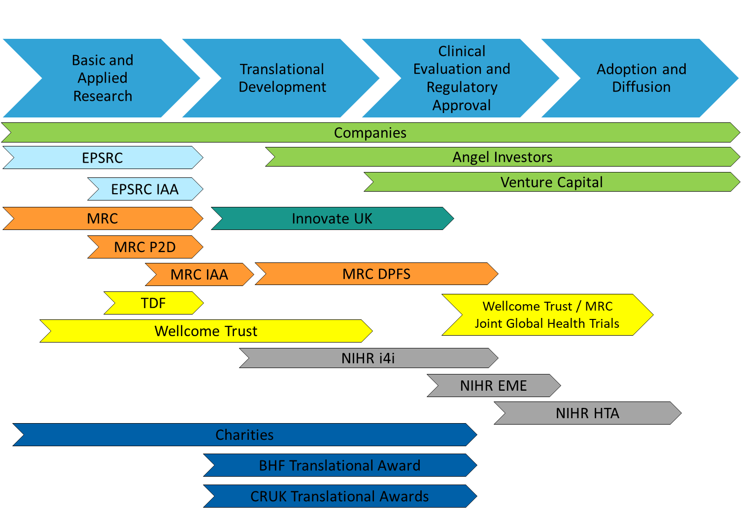
Figure 1: Diagram of translational funding opportunities, aligned to a translational development timeline.

Projects Eligible for TDF Funding
The Translational Development Fund is intended to be very flexible in terms of the activities it will support. Applicants should be aware that translational research funding differs from a typical project grant in that the underpinning basic research will already be in place.
All disease areas and modalities of intervention are eligible for support from the scheme, including small molecules, peptides, antibodies, vaccines, gene therapy, devices, surgical techniques and engineering / medical technology, bioinformatics and data science, epidemiology and evidence- based approaches.
The most important aspect of the award is that the project will progress to a higher stage of translational development. Projects must address an unmet need in healthcare and offer a potential new solution. Projects are expected to take the innovation to a stage at which it is sufficiently developed to be attractive to another party, such as not for profit organisations and commercial organisations. The project must overcome a translational barrier – this activity may include, but is not limited to:
- Developing a pre-clinical model of disease for target validation purposes,
- Seeking regulatory advice from the MHRA with support from a consultancy company,
- Developing tool compounds / biologics to explore the feasibility of a therapeutic approach.
Applicants must complete an Intention to Submit (ItS) form which will shape the discussion of the project with a Translational Research Project Manager prior to submission, to ensure the intended project is within the remit of the scheme.

Out of Remit Activity
The funding is not intended to support:
- Fundamental or basic research that is not translational,
- Projects with no clear translational agenda or applied outcomes,
- Continuation or extension of existing research grants,
- Entire translational projects,
- Administration costs,
- Industrial partner costs,
- Staff between posts / funding (i.e. “bridging” funds), or PhD studentships,
- Costs relating to protection of intellectual property.

Who Can Apply?
We encourage applications from across the Colleges of MDS, LES and EPS, and are particularly keen on interdisciplinary collaborative approaches. Applicants should normally be a University academic employee or be the holder of a personal research fellowship awarded competitively, with a contract lasting the duration of the project. We encourage researchers to identify a clinical colleague from Birmingham Health Partner NHS Trusts as a collaborator, to be part of the team to address the clinical unmet need and progress the project to a higher stage of translational development.
Partner NHS Trust Clinicians that are UoB Honorary are also eligible to lead on the application but must still engage with the TRT and provide costings via Worktribe.

Project Duration and Cost
The Translational Development Fund can provide up to £30,000 for directly incurred costs only.
Projects must be fully spent by 14th October 2023, to comply with the conditions of the core institutional fund award.
The 2023 round will be very competitive, as there are limited funds remaining from the iTPA block grant.

Project Cost Breakdown
All projects must be costed using Worktribe and costs must be given as ‘Price to Funder’. Where projects include costs to external organisations (e.g. CROs), quotes must be appended and must include VAT.
Project cost queries should be directed to your College Research Development and Support Team in Research Support Services.

Application & Review Process
The funding call is now a single stage process following an initial Intention to Submit (ItS) online form. Applicants will be required to attend a short meeting (30 minutes) with a member of the Translational Research Team (TRT) to ensure their project is suitable for the chosen scheme and to offer advice and support as required before moving to Full Stage submission. This ensures sufficient input is given to the design of robust translational projects with a high likelihood of delivering significant outcomes.
Applications are reviewed and scored by a panel of translational scientists and clinicians, including independent experts. The panel consists of scoring members and non-scoring advisors from MDS, LES and EPS Professional Services.
All applicants (successful and unsuccessful) will be provided written feedback following the panel decision. Unsuccessful applicants will still be able to access TRT support, either to develop grant proposals for external funding streams or new Expression of Interests (EoIs) for the next internal translational funding call. Additionally, all applicants will be offered a meeting with an external consultant with translational expertise.

Application Form Guidance

1.3 Project Duration and Cost
The Translational Development Fund can provide up to £30,000 for directly incurred costs only. Projects must be completed by 14th October 2023, to comply with the conditions of the core institutional fund award. There will be no funding extensions beyond this date.

1.4 Previous Wellcome Funding - Who is a Wellcome Researcher?
Please note this is not a prerequisite for funding. A Wellcome researcher is anyone who is named on and in direct receipt (i.e. PI, Co-PI) of Wellcome funding excluding those who have a Wellcome PhD studentship (including clinical research training fellowships), an equipment grant and anyone in receipt of funding from our Culture and Society funding schemes. With regards Wellcome Trust Centres, only include the Centre Director rather than the individual group leaders – unless they have funding from Wellcome independently of the Centre award.

2.1 Ethics and Approval
For any projects involving the use of animals, indicate your active PPL number. It is expected that the Biomedical Services Unit will have been contacted, who can also provide advice on NC3Rs Guidelines (bmsu@contacts.bham.ac.uk).
It is not expected that an ethical review will be in place ahead of the Full Stage submission deadline, but applicants should be aware that appropriate ethical approval will be a condition of starting the award. Please also be aware that ethical approval is a requirement of the University of Birmingham’s Code of Practice for Research (birmingham.ac.uk). For further detail see: Research ethics - what do I need to do? (birmingham.ac.uk).

2.3 Project Background and Development Team
Explain how each of the investigators named in the proposal will work together and outline other major collaborations important for the research. Describe how each person’s role will develop the project.

2.4 Project Plan and Milestones
Explain how you will implement your project plan. Programmes of work should be focused around key milestones that de-risk specific elements of further development towards commercialisation / translation. Please provide a justification of any resources requested in supporting this project and ensure it is aligned with the resources identified in Section 3.
If preliminary data is to be included, text provided should only address the interpretation of the figures. If any inappropriate text is included in the preliminary data, this will be redacted before sending to the Panel for review.
Project milestones should be written as SMART milestones (see details and examples below). Where relevant, go / no-go decision points should be included. If you feel you need any further support or advice please contact your Translational Project Manager.
Figure 2: Definition of SMART (Specific, Measurable, Achievable, Relevant and Time-bound)
Table 1: Examples of tasks rewritten as SMART milestones
Example 1
✗ | Establish fit for purpose primary screening assay
✓ | Primary screening assay established with transient transfection in 384 well format with Z’ > 0.7 (acceptable 96 well assay, Z’ > 0.5) at month 2.
Example 2
✗ | Evaluate hits from HTS
✓ | Re-evaluate hits in single shot and full EC50 mode in primary assay. Re-confirmed hits ranked according to EC50 and chemical characteristics (see target product profile for measurables). Completed at month 6.

2.5 Translational Development Plan
Wellcome ask anyone applying for funding to consider their approach to managing and sharing anticipated outputs at the research proposal stage. This section can include a plan of what steps you will take in delivering the ultimate goal for your project. Where relevant, you may wish to include how you will interact with clinical, patient and industry audiences. Please include details of any conversations with funders. Also note that there will be an equal focus on commercial and non-commercial enterprises, for example clinical interventions.

2.7 Intellectual Property
This section applies to all forms of IP, including patents for inventions, such as new drugs or medical devices, copyright in software, database rights in large datasets, rights in designs, e.g. for new equipment and rights in confidential know-how.
Please ensure you have freedom to operate in your project and you have considered any IP that may be generated. Where appropriate, we expect you to engage with the Translational Research Team and UoB Enterprise.

3 Project Cost Breakdown
The Translational Development Fund will provide up to £30,000 of directly incurred costs only and is intended to be very flexible in terms of the activities it will support. All costs need to be spent by 14th October 2023. All values reported in Section 1.3 (Project Duration and Cost) and Section 3 (Project Cost Breakdown) must match the Price to Funder values as reported in your Worktribe project record.
Please note that we will only honour the quoted value provided in this application. All quotes must be appended and should always include VAT (e.g. equipment, contract research services, sequencing costs etc.). If you are purchasing services and equipment for medical research and the supplier confirms that they will not charge VAT, you may exclude it.
For the avoidance of any doubt, if you have excluded VAT at this stage, it will not be included in your award.

4 Authorisation
Following completion of the Intention to Submit form, and prior to application submission, all applicants must discuss their project with a Translational Project Manager from the Translational Research Team to ensure the intended project is appropriate for this funding scheme.
Authorisation will be provided by the Translational Research Team on the proviso that projects have been discussed with a member of the TRT.
Email authorisation from your Institute / School’s Research Development and Support Team on behalf of your Head of Institute / School must be submitted with your application.

Key Dates & Contact
Activity | Date
Intention to Submit Deadline | 17:00, Wednesday 25th January 2023
Application deadline | 17:00, Wednesday 15th February 2023
Panel outcomes expected | No earlier than Thursday 2nd March 2023

All enquiries in the first instance should be directed to the Translational Research Team at TranslationalResearch@contacts.bham.ac.uk. Project cost queries should be directed to your College Research Development and Support Team in Research Support Services.
For further information and advice, see the Translational Research website at: https://www.birmingham.ac.uk/TranslationalResearch

