Summary Case Report
Aerial Video Survey of Urban Search & Rescue (USAR) Site, Waddington, Lincolnshire Rail Crash Zone for Pix4D 3D Recreation. 11 May, 2017.

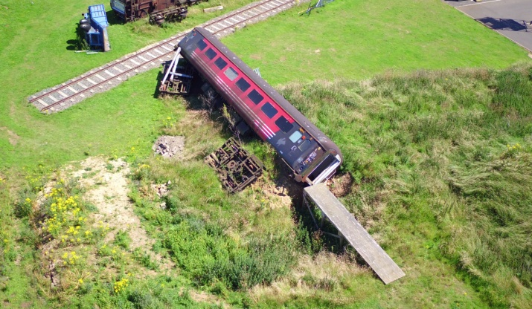
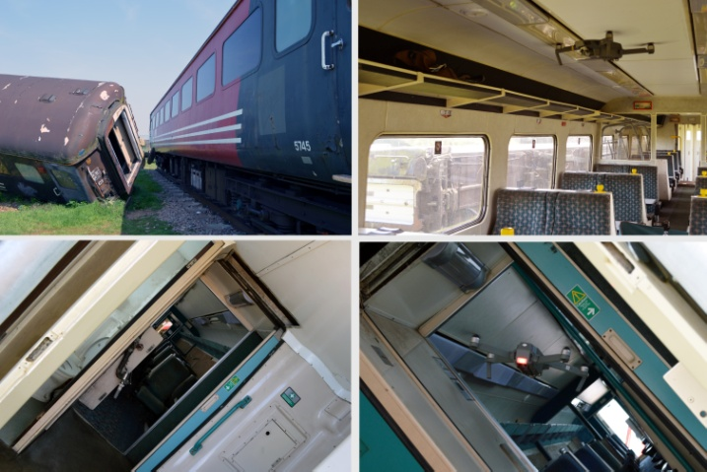
Permissions Obtained:
USAR Personnel (Lincolnshire Fire & Rescue)
RAF Waddington Security and ATC (via MoD contact)

Known Exclusion Zones:
DJI firmware-imposed, RAF Waddington (zone intersects part of the USAR Site in which flying was planned to occur). http://www.noflydrones.co.uk/

sUAVs Deployed:
DJI Mavic Pro

Documents Completed:
Risk Assessment (Ref.: UAVWaddington-
2017-1; 10/05/2017)
sUAV Method Statement (based on earlier document dated 18/07/2016)

Flight Summary (Planned and Actual):
Flights were designed to obtained better quality video footage (for Pix4D 3D reconstructions) of the simulated rail crash site than on previous visits and to test the performance of the DJI Mavic inside one of the carriages. Flights over the carriages (at altitudes not exceeding 100ft) went off without incident, although a full coverage of that part of the USAR site was not possible due to the RAF exclusion zone (DJI firmware). All flights were manual.

Incidents:
Internal collisions between the DJI Mavic and carriage structures, assumed to be as a result of the failure of the onboard collision detection / terrain avoidance systems to recognise the tilt of the carriage selected for internal survey. Mavic sUAV was damaged (camera unit and 2 propellers) and required subsequent specialist repair.

Further Information, Images and Video:
Prof. Robert J. Stone (r.j.stone@bham.ac.uk)

