BUZZ 189 – February March 2021

Inside:
- History of the Commonwealth Games
- VICTAR – Supporting Young People with Visual Impairment
- UoBe Festival
- Images of Research
- Launch of the EDI Scheme and Equality Change Programme

Vice-Chancellor’s View
Watch the latest video recording from the Vice-Chancellor.

New Haworth Chair appointed

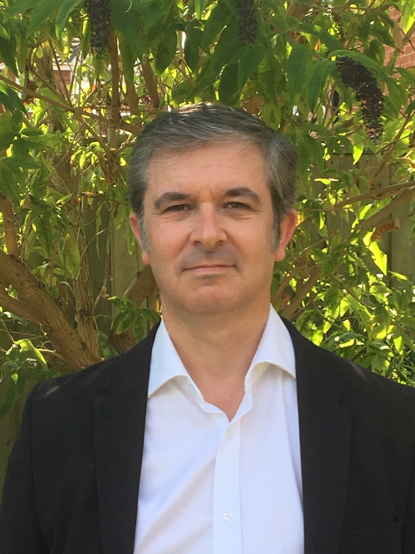

The School of Chemistry is delighted to welcome Professor Neil R Champness, who has joined the University as the new Haworth Chair.
Previously, Professor Champness was Professor of Chemical Nanoscience at the University of Nottingham.
During his career, Professor Champness has been recognised by a number of medals and awards, including the Corday-Morgan Medal of the Royal Society of Chemistry, and has been named as one of the world’s top 100 most-cited chemists. He researches molecular organisation and supramolecular chemistry: through crystal engineering in the solid-state and the self-assembly of nanoscale structures in solution and on surfaces. His research has diverse applications including molecular electronics and hydrogen storage.
The Head of the School of Chemistry, Professor Rachel O’Reilly, said: ‘I am truly delighted that Professor Champness is joining the School. He is a significant research leader and a scientist of great calibre – and a fitting holder of the prestigious Haworth Chair. I look forward to working and collaborating with him.’
Professor Champness holds an EPSRC Established Career Fellowship, is a Member of Academia Europaea, a Fellow of the Learned Society of Wales and the Royal Society of Chemistry. He is known for his scientific communication and is a commentator on the societal impact of nanotechnology. A triple graduate of the University of Southampton, Professor Champness joined the University of Nottingham in 1995, where he served as the University’s Global Research Theme Leader for Transformative Technologies from 2014.
Professor Champness expressed his delight at being appointed to the Haworth Chair: ‘It is an honour to join such a vibrant university at an exciting time for the School of Chemistry. I am mindful of the rich history of supramolecular chemistry at Birmingham and look to follow in the footsteps of those who have made such great contributions to the field.’
As Haworth Chair, Professor Champness succeeds Emeritus Professor Nigel Simpkins, who retired in 2017.

Exciting New Vision Takes Shape for National College to join University Group
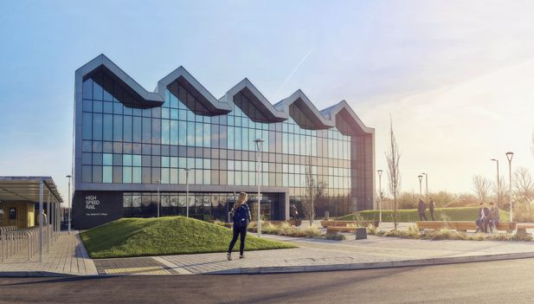

The University is reaching the final stages of a bid to create a bright new future for the National College of Advanced Transport and Infrastructure (NCATI).
If approved by the Department for Education, the proposals will see the University bring NCATI into the University group. Building on the University’s widely recognised rail expertise, the plans have strong industry backing and include a wide range of partners. NCATI, based in Birmingham and Doncaster, has had significant financial and educational difficulties. Last year, the Department for Education began the process to find a way forward for the College. The University was selected as the preferred bidder and its proposals were scrutinised and put out to public consultation.
The aim is to create a highly successful, financially sustainable and inclusive national college that provides high-quality education and training to meet the needs of learners, sectoral partners and local communities and to support local, regional and national economic growth.
Becoming part of the University group will be a step-change for the College, radically improving the quality of education delivery, embedding industry stakeholders into the College ecosystem and creating a sustainable ‘hub and spoke’ model supported by established local and national partners. This will provide a range of pathways and increase participation for groups under-represented in technical education.
With the University’s globally respected centre for education and research in the Birmingham Centre for Railway Research and Education (BCRRE), taking over the College will deepen and broaden leading industry partnerships. There will be opportunities for research and developing areas across the University such as leadership in education. The plans also build on the commitment to regional growth and the skills agenda beyond higher education.
The new NCATI will produce generations of highly skilled professionals to lead the UK’s future rail, transport and infrastructure workforce. It will provide a through-life learning opportunity supported by a full suite of railway, transport and broader infrastructure qualifications and competencies (Level 2 to Level 7) that meet national needs.
The approach to delivery is based on four development plans:
- Develop high-quality further education colleges in Doncaster and Birmingham with a distinctive local offering that specialises in railway, transportation and infrastructure engineering, and establish a ‘hub and spoke’ model with local partners throughout the UK
- Develop deep collaborations with key stakeholders including employers and local and national partner colleges and training providers to ensure that NCATI fully plays its role as a National College
- Create a Centre of Excellence in Railway Education and Skills alongside NCATI that is internationally recognised for its work in the development and delivery of railway education from Level 2 to Level 7 and beyond
- Create an outstanding learning environment at NCATI’s Doncaster and Birmingham sites that benefits students, local communities and industry partners alike
Commonwealth Games archive
The Birmingham 2022 Commonwealth Games is fast approaching with everyone looking forward to the exciting events ahead some of which will be held on our very own University of Birmingham campus.
The University of Birmingham Cadbury Research Library holds many archives on past Olympic and Commonwealth Games relating to the history and development of athletics in the United Kingdom throughout the late 19th to early 21st centuries. This includes the National Athletics Archive that comprises personal papers of athletes and athletic commentators and papers of athletics organisations.
The National Athletics Archive includes records of national organisations administering athletics such as the Amateur Athletic Association (AAA), the Women’s Amateur Athletic Association (WAAA), the Sports Council and the English Cross-Country Union (ECCU). There are also records relating to regional organisations including papers of the Midland Counties Amateur Athletic Association (MCAAA), the Midland Counties Women’s Amateur Athletic Association (MCWAAA), the Midland Counties Cross-Country Association (MCCCA), the Northern Cross-Country Association (NCCA), the Southern Counties Amateur Athletic Association (SCAAA) and the Southern Counties Cross-Country Association (SCCCA).
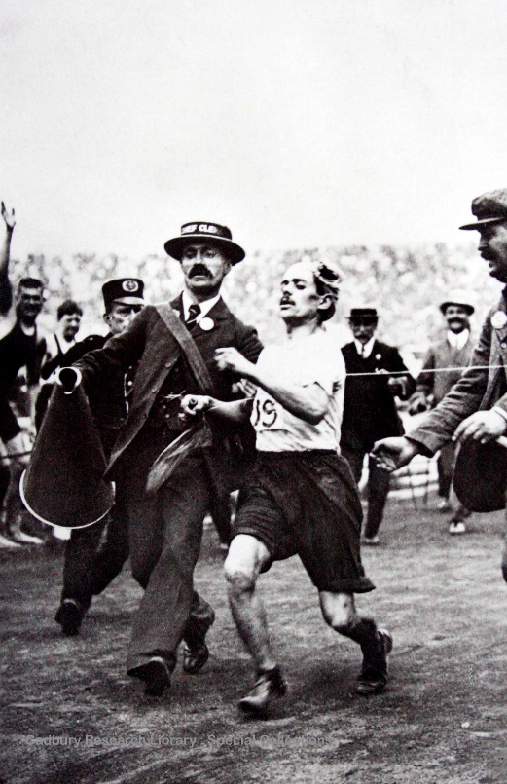

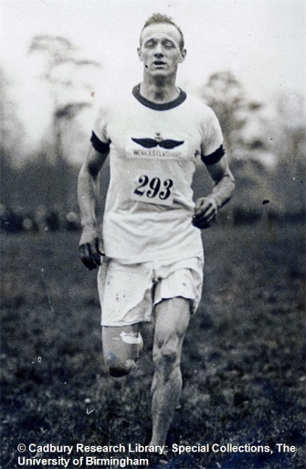

In addition to organisational collections, the National Athletics Archive includes various discrete collections of individual athletes and athletics commentators. These include the papers of Arthur Newton, Arthur Winter, Dennis Cullum, Dave Roberts, George Adam, Harold Abrahams, Howard Payne, Joe Binks, John Jewell, Joe Percy, Mel Watman, Phil Thomas and Squire Yarrow.
An artificial collection of ephemeral and grey literature includes an extensive sequence of almost 4,000 programmes, primarily relating to UK athletics meetings; typescript results; compiled statistics; material and ephemera relating to individual local clubs and organisations; papers relating to major athletics championships including the Olympic Games, British Empire and Commonwealth Games, World Championships and European Championships. Oral history recordings, often with accompanying typescript transcripts, feature interviews undertaken with numerous athletes and athletics commentators.
The first Commonwealth Games were held in 1930 in Hamilton, Canada, where 11 countries sent 400 athletes to take part in six sports and 59 events. Since then, the Games have been conducted every four years (except for 1942 and 1946 due to World War II) and the event has seen many changes, not least in its name.
From 1930 to 1950, the Games were known as the British Empire Games, from 1954 until 1966 the British Empire and Commonwealth Games, and from 1970 to 1974 they took on the title of British Commonwealth Games. It was the 1978 Games in Edmonton that saw this unique, world class and multi-sports event change its name to the Commonwealth Games. Team England is the second most successful nation in the history of the Games and has topped the medals table seven times (Hamilton 1930, London 1934, Vancouver 1954, Cardiff 1958, Kingston 1966, Edinburgh 1986 and Glasgow 2014). 2022 will be the first time the West Midlands gets to play host, following London 1934 and Manchester 2002. As preparations for the Birmingham 2022 Commonwealth Games take shape, the West Midlands becomes part of a lasting legacy, one that displays world-class teamwork, athleticism and friendship.

Launch of Commonwealth Scholarships
In celebration of the University being an official partner of the Birmingham 2022 Commonwealth Games, we are pleased to announce the introduction of two new scholarship programmes aimed at supporting students from the Commonwealth nations for entry in 2021.
- University of Birmingham Commonwealth Scholarship has been designed to help give international postgraduate taught students (PGT) – from every country of the Commonwealth – the opportunity to study at the University of Birmingham. All Commonwealth PGT applicants will receive a £3,000 fee discount if they meet the terms of their offer, standard eligibility criteria and are overseas for fees.
- Commonwealth Games Elite Sports Awards: We are excited to offer three 100% scholarships aimed at elite coaches and sport practitioners (games prospects) from Commonwealth countries. These include all the usual benefits of a Sports Scholarship which are tailored to meet particular student’s needs
It will be an exciting time to be in the city leading up to, during and after the Games and these scholarships create an amazing opportunity for students from the Commonwealth nations to be a part of Birmingham 2022. The students will not only enrich our community but they will help the University and the city foster and deepen links with the Commonwealth, producing benefits long after the games are over. Keep an eye on the website for more details about these initiatives.

Launch of the EDI scheme and the Equality Change programme
Welcome to the first of our regular Equality, Diversity and Inclusion features in Buzz, which is one of the ways in which I hope to keep you up to date with activity that is taking place across the University.
In this edition, I am delighted to introduce our new Equality Scheme and Equality Change Programme and to share information about how LGBT History Month and International Women’s Day will be celebrated at the University. There is also a spotlight on our Rainbow and Women’s Networks and College-based EDI initiatives, which this month features the College of Life and Environmental Sciences.
If you would like further information on any of the EDI activities at the university, and how to get involved, please see our EDI intranet page
Professor Jo Duberley, Deputy Pro-Vice-Chancellor (Equality, Diversity and Inclusion)
New Equality Scheme 2021-2024!
Following University-wide consultation, the new Equality Scheme will have a particular focus on:
- Creating an inclusive environment: developing a University community where everyone feels welcome, included and empowered to succeed
- Dismantling barriers: addressing the structural barriers faced by groups within the University in order to create more equitable outcomes
- Integrating equality, diversity and inclusion: issues and impacts are considered and addressed across our activities
We will undertake targeted activity to address a number of issues, including:
- The recruitment, progression and retention of staff from Black, Asian and other minority ethnic groups across the University
- The recruitment, progression and retention of female academic staff at senior levels
- The gender and ethnicity pay gaps
- Accessibility and the lived experience of staff and students with a disability
- The visibility of LGBTQ staff across the University

For further information can be found on our EDI intranet page

Equality Change Programme
This is a new, ambitious four-year programme aiming to create long-term and visible change at the University. Established following the University’s Bronze Athena and Race Equality Charter marks, the programme aims to ensure the action plans for these are implemented effectively to create long-term change. It will also integrate future equality actions regarding LGBT+ and disability.

The Equality Change Programme involves staff from across the University, embedding EDI through seven thematic workstreams, including: Family Friendly, Individual Development and Recruitment, Selection and Induction. The membership of these includes the Provost, as well as colleagues from both Academic and Professional Services staff, and a number of volunteers.

LGBT history month: Spotlight on Staff Networks (Rainbow)
RAINBOW NETWORK
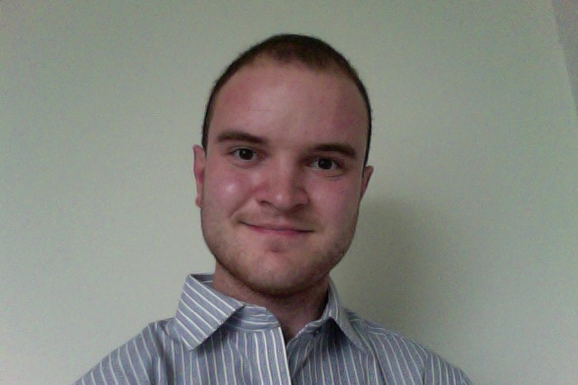
Caption: Tom Syder, Chair of the Rainbow Network
The Rainbow Network aims to represent and support all staff and PhD students who identify as lesbian, gay, bisexual, trans, queer, or questioning, as well as underrepresented LGBTQ identities, to ensure that their voices are heard and their needs are met by the University.
The Rainbow Network committee is an informal point of contact for workplace issues relating to being LGBTQ. We can also provide confidential support or advice to any member of staff requiring information about LGBTQ identities and issues. Find out more about the work of the Rainbow Network.
The Rainbow Network committee is involved in a series of events and activities throughout the year, including LGBT History Month. Each year the University celebrates LBGBT History Month throughout February. This month’s fantastic programme of events included ‘Gaybourhoods in Amsterdam and Birmingham’ a joint event with the University of Amsterdam, the Student STEM LGBT and You conference and a series of podcasts from the Rainbow Network.
Preparations for 2022 will kick off in October. If you would like to be involved, contact equality@contacts.bham.ac.uk

International Women’s Day: Spotlight on Staff Networks (women’s)
WOMEN’S NETWORK:
Caption: Ellen Shobrook Co-chair of the Women’s Network

The Women’s Network provides a positive, open space to support women in the workplace. It is open to any members of staff who share the aims of the Network, with a focus on promoting initiatives to celebrate and encourage women’s representation, achievements, and progression.
The network seeks to take an intersectional approach to challenging gender inequality, promoting and celebrating diversity, and supporting and empowering women in the workplace.
The Women’s Network is involved in a programme of events throughout the year, including International Women’s Day. Find out more about the Women’s Network.
International Women’s Day
International Women’s Day takes place on 8 March each year and this year’s theme is Choosing To Challenge.
There is a fantastic programme of events lined up from both the UK and Dubai Campuses, including a discussion on girls’ education featuring female Head Teachers leading International schools in three different countries.
Full details are in the International Women’s Day calendar of events.

A spotlight on one of the Colleges and their work
This month the spotlight falls on Life and Environment Sciences. We asked College EDI lead Sarah Beck to tell us a little more about the work that is taking place:
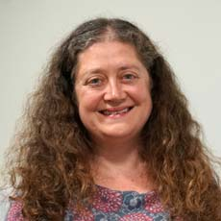
Caption: LES College EDI Lead, Sarah Beck

‘LES has an enthusiastic Equality, Diversity, and Inclusion team with EDI leads in each of our four Schools, a dedicated college lead for EDI who sits on College Board, and a college committee with representation from Professional Services staff and students. All Schools in the College hold Athena Swan awards and we are especially proud of the School of Sport, Exercise and Rehabilitation Sciences’ silver award. We are working together to make our college more inclusive for everyone with current actions around academic career development, flexible working, degree awarding gaps, and decolonising the curriculum. We also hold regular events to help us to increase our awareness and understanding of EDI issues.’

Supporting young people with vision impairment for educational and social inclusion.
The latest Unfiltered Lives campaign looks at how research from the Vision Impairment Centre for Teaching and Research supports young people with vision impairment.
Did you know that in England there are over 30,000 children and young people with vision impairment? These young people are classed as a low incidence group who often have limited representation within society. Specialist educational services are legally required to offer support to children and young people with vision impairment up to the age of 25.
Such educational services ensure that these young people can access the school curriculum and develop the skills they will need to live and work independently in adulthood. However, a number of barriers and a lack of resources and understanding around the transition process hinders employment opportunities and social inclusion.

Transforming the lives of young people with vision impairment
Research led by Dr Rachel Hewett and Professor Graeme Douglas from the Vision Impairment Centre for Teaching and Research (VICTAR) is helping to empower young people with vision impairment to address these barriers.
As part of their work, VICTAR has worked closely with young people with vision impairment by listening to their stories and collecting evidence to provide a better understanding of what works well and what needs to improve. The research is helping to give this population a stronger voice in society; by informing national policy on higher education access, changing current services in post-school transition and by informing the work of a range of practitioners. The findings are also being embedded into teaching on the Mandatory Qualification for Teachers of Children and Young
People course run by VICTAR.VICTAR, a research centre within the Department of Disability, Inclusion and Special Needs has worked closely with a number of charities, organisations and policy-makers to improve the lives of young people with vision impairment. Working with RNIB and Thomas Pocklington Trust, a charity which helps people with vision impairment to live better lives, together they have developed major national campaigns and support resources, which have increased the awareness of the experiences of young people with vision impairment and led to work with the Minister of State for Universities, Science, Research and Innovation and Steve McCabe MP.
Meet the young people VICTAR has supported
Shamima, Liberal Arts and Sciences Graduate from the University of Birmingham
Throughout her time at university, Shamima received the Disabled Students Allowance (DSA), a grant that provides support to enable students to study independently and to participate fully in university life. However, Shamima highlights that her ‘student journey wasn’t one that the majority of students may relate to’.
In her final year, Shamima discovered she required eye surgery, which had a huge impact on her studies. ‘When I was studying, I didn’t necessarily identify as being disabled, but when I was on my study abroad in Dublin, I found out that I had a vision impairment after a very-long-overdue eye test’. Reflecting on this period of her life, juggling work on her dissertation on how welfare reforms affect disabled people whilst coming to terms with her impairment, Shamima expresses the challenges faced by herself and others with vision impairments on completing a degree.
In 2019, VICTAR and Thomas Pocklington Trust organised a roundtable event on DSA with Rt Hon Chris Skidmore MP, following the launch of the ‘Our Right to Study’ report, which highlights the issues faced by students with vision impairment in England when accessing and using DSA. Shamima was keen to participate and share her experience.
Shamima thinks that ‘the research does absolutely reflect my experience and if the recommendations from the research were implemented, I think the situation for being in the workplace would be improved. I would absolutely agree that there is a cliff edge in terms of post-19 support.’

Eddy, Business Management Graduate from the University of Brimingham
Eddy has been involved in VICTAR’s longitudinal study for almost ten years, which he deems a really valuable experience: ‘the research has given me the opportunity to reflect, benchmark and collate the experiences I’ve had throughout my time in education’.
Eddy went to a mainstream primary school, which also had a vision impairment resource base. He says: ‘this was a good start to my education journey as I had the experience of mainstream immersion, which developed me socially and I was also able to learn how to touch type and other skills which were more focused around my impairment.’
At mainstream secondary school he experienced difficulties: ‘I had little to no support, so I struggled to access things that I needed in terms of education and provision. I was initially put in the bottom sets of groups, which was really frustrating. Just because I had a vision impairment, they assumed that I wouldn’t be able to access and understand the curriculum.’
Eddy studied at the University of Birmingham in 2015 after gaining three A levels in Business, English Literature and Sociology. He studied a BSc Business Management with a year in industry, where he undertook a placement in Cardiff for Lloyds Banking Group as a pricing analyst. Looking forward, Eddy would like to get involved in projects that help other visually impaired graduates get into high performing employment as he believes that: ‘fulfilment in the workplace is something many visually impaired people are missing out on.

’Hasun, Volunteering Manager for Volunteering Matters
Hasun is from Birmingham and one of three siblings; he has a younger sister and an identical brother and they both have Oculocutaneous Albinism with nystagmus, a condition they’ve had since birth, which affects the skin and causes sight loss.
During his time within the education system, Hasun faced challenges, some of which continued throughout his transition into employment. Despite these challenges, Hasun remained optimistic and determined to share his experiences to help vulnerable people in society meet their potential in both education and employment. Hasun talks passionately about BrumEye, a young leader’s programme run by RNIB, which provides a safe space for those who have experience of vision impairment to come together. Through this programme, Hasun went on to meet Dr Rachel Hewett.
Subsequently, Hasun, who has a passion to help others and volunteering, became involved with a group of young people who volunteered to work with Rachel to create workshop resources to support young people with vision impairment as they transition from education to employment, by providing them the opportunity to share their experiences with like-minded people.

About Unfiltered Lives
Unfiltered Lives tells the stories of real people whose lives have positively changed as a result of our research. Through photography and compelling stories, Unfiltered Lives goes beneath the surface to the heart of why our researchers do what they do.

UoBe Festival
Students connect at UoBe Festival with over 7,500 bookings across the week.
The inaugural UoBe Festival took place from 25 – 29 January 2021, marking the week after the assessment period and before the beginning of semester two. The aim of UoBe Festival was to offer a week-long programme of exciting activities, talks, workshops and events for students to develop and learn new skills, make connections and focus on their wellbeing and personal development. The Festival was a great collaborative effort between the Guild of Students and staff from all areas of the University including, but not limited to, Student Services, IT Services, Colleges, External Relations, the Library, Careers Network, UoB Sport & Fitness, DARO, and of course our students themselves , with hundreds of students involved from concept to completion.
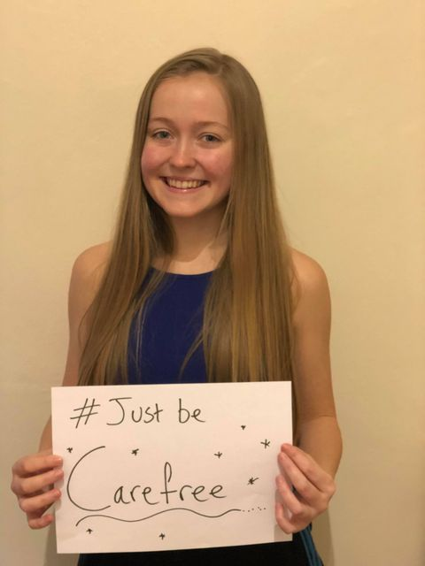

With the Festival initially designed to take place on campus, the ongoing pandemic and Government restrictions meant the UoBe Festival project team had to work agilely and creatively to reimagine the Festival as a purely virtual event. Being online also made it easier to involve students on other campuses, those unable to travel to the UK and students unable to return to campus due to ongoing Covid restrictions.
The Festival featured more than 100 events, which covered a wide range of topics, areas of interest and spanned the 5 themes of the Festival; Wellbeing, Varsity, Social, Community and Skills. Students could learn new skills with activities including yin yoga, arts and crafts sessions, mental health first aid training and much more. Students could develop career and employability skills with events such as ‘Be ready to make career choices with professional mentors’ and ‘Skills to land a graduate job’ and events supported by employers including PWC. Throughout the week students could also participate in the Varsity College Cup, which featured a range of different competitions for students to earn points for their College. After a (virtual!) race across the Atlantic, judging for creative writing, photography competitions, other College competitions and a Mastermind quiz, the winning college of the inaugural Varsity Cup was the College of Arts and Law.
UoBe Festival also featured some high profile speakers including ex-professional footballer Clark Carlisle talking about mental health alongside his wife Carrie, TV Chef Dr Rupy Auija demonstrating cooking healthy dishes, and alumnus and CEO of the Calm app Michael Acton Smith (BA Hons Geography, 1996) discussing the importance of looking after your mental health.
Despite all the current challenges, the Festival achieved great success with more than 7,500 bookings of activities across the week, and many sessions being fully booked. Attendance across the events was also high and averaged at 60-80%, the highest attended events being live music with Valefest, virtual tours of the Lapworth Museum and Winterbourne, eco-adventurer Andy Pag talking on the Realities of Sustainable Travel, our own University academics discussing Research that Matters, TV’s Emmanuel Asuquo providing finance tips and some of the other high profile speaker events.

In the run up to the Festival we asked students to share one word to describe what they wanted to be in 2021 to promote the week and to celebrate our diverse student population. Their #JustBe messages were shared on social media and to celebrate the launch of the festival a selection were projected on to the side of Old Joe (the ultimate bragging rights!).

Watch here.

If you have any comments or questions about UoBe Festival please contact uobefestival@contacts.bham.ac.uk.

“I think the part I enjoyed most about this event was trying to think of my own original story, since I haven’t been able to do creative writing for a while…it allowed me to relax from everyday life for a bit and tap into my creative side. Plus, it gave me bonding time with my flatmate who I persuaded to do it too.” Student who entered the creative writing competition in the Varsity College Cup

“I really enjoyed the session, it was really interesting and insightful into a sector I really knew nothing about before. All the speakers were great and provided some really helpful advice and resources." Student who attended the Charity Masterclass.

Alumnus Michael Acton Smith, CEO of Calm, ‘I loved the idea behind UoBe Festival and thought it was very ‘forward-thinking’.

Try one of Dr Rupy’s easy healthy recipes

Peri Peri Chicken Tray bake
Prep time 10 minutes / Cook time 40 minutes
(Serves 3-4)
Peri- peri marinade
1 tbsp. of honey/maple syrup
2-3 cloves of garlic, grated
1 tsp dried oregano
5cm ginger, grated
1 tsp smoked paprika
1 tsp cayenne pepper
1 tbsp. soya sauce
2-3 tbsp. olive oil
4 skin-on, bone-in chicken thighs/legs

For the vegetables:
200 g red peppers, sliced
300 g corn on the cob, cut in half
300g sweet potato cut into wedges
METHOD:
- Preheat the oven to 200°C
- Mix the marinade in a bowl
- Add the chicken thighs and toss gently making sure they are completely covered in the marinade. Season with salt and pepper and place in the tray.
- Toss the red peppers, corn and the sweet potato in the olive oil. Season with salt and pepper.
- Arrange the vegetables together with the chicken on the previously prepared baking tray and roast for 40 minutes until the chicken are cooked through and vegetables tender. Turn halfway through cooking to ensure an even cook.

Alternatives:
Red Peppers: green, orange or yellow pepper, cherry tomatoes, asparagus
Corn on the cob: broccoli, asparagus
Sweet potato: butternut squash, pumpkin, carrots

Images of Research

Each year the University Graduate School challenges our postgraduate researchers with a question: Can you capture your research project in a single image?
The images we receive represent the exciting breadth and quality of research our postgraduate researchers are working on at the University. From artistic representations of scientific subject matter, to detailed diagrams and ‘curated’ photographs; for more than five years our researchers have portrayed their work in fascinating and continually innovative ways.

The challenge
The Images of Research competition offers our postgraduate researchers a unique opportunity to showcase their research in a creative and innovative way, raise their research profile and to engage a public audience.
Researchers submit an image and accompanying narrative that effectively engages and communicates the impact of their research to a non-specialist audience. The challenge lies in researchers considering how complex and multi-faceted research can be creatively captured and communicated to the general public– and with reduced ways to engage due to the pandemic, this is a great way for researchers to open up their work to a wider audience.
The image entries are then judged on the following criteria:
- Overall impact of image: does the image engage the viewer and make them want to know more about the research?
- Relevance of the image to the supporting text: How effective is the supporting narrative in communicating the story behind the image to a non-specialist audience?
- Effectiveness in engaging viewer with research: Does the submission as a whole (image and narrative) engage you with the research?
Explore our gallery of previous entries:
Explore the research.
Help us to select our winners
The Images of Research prizes are awarded by a multidisciplinary judging panel, with the overall winner receiving £250, and several other runner-up and ‘special mention’ prizes. There is one prize that we need your help to award. We will be displaying a gallery of our shortlisted entries at the start of March and inviting UoB staff, students and the general public to get involved by voting for their favourite. Voting will be open for two weeks and the entry with the most votes will win the People’s Choices award and £200 prize money.
You will be able to see the gallery on our intranet pages or you can follow our People’s Choice voting thread on Twitter by following us at @UoBGradSchool.

Why do we run these initiatives?
The University Graduate School offers a range of opportunities to display engagement and communication of research projects, and contribute to national competitions to raise awareness and understanding of the important work our researchers do.
The skills that researchers develop through their image submission work towards goals set on their Development Needs Analysis form or help to reach personal goals relating to the Vitae Researcher Development framework.
Postgraduate Researchers are required to annually assess their current and future skills development needs. The Development Needs Analysis (DNA) process helps them to do this and to ensure they are meeting key milestones in their work. The DNA is based upon the Researcher Development Framework, which describes the knowledge, behaviour and attributes of successful researchers and is followed by all researchers within the UK, from PhD to Professor.

Other competitions include the Three Minute These (3MT), in which doctoral researchers have just three minutes to deliver an engaging presentation on their thesis topic and its significance. Alongside Images of Research, 3MT is one of the University Graduate School’s flagship events. The internal competition winner is submitted into the national Vitae 3MT® competition– and this year, our Birmingham winner, Lucy Thomas, was selected to perform at the finals and went on to win the overall competition.
Watch Lucy’s winning three minute thesis.

Images of Study
Last year we extended a similar challenge to postgraduate taught (PGT) students for the first time. We were so impressed with the contribution of PGT students and are excited to be continuing this event for 2021 and announcing our Images of Study competition dates after Easter.
What does the University Graduate School do?
The University Graduate School supports Birmingham’s postgraduate researcher (PGR) and postgraduate taught (PGT) community. We foster our postgraduate community and act as a gateway to support and advice.
For our researcher community, we support them through the Development framework, providing advice and guidance and opportunities to evidence their development, as well as encouraging them to take some much-needed time out with social and networking events.
“I’ve been quite heavily involved with the UGS in my time here. As a PGR, I joined as a Westmere Scholar in my first year, so I did work for the UGS organising events at Westmere House, which is the hub for PGRs. The UGS runs big events like 3MT but also smaller, more intimate events like free yoga sessions.
There are also events run by the Westmere Scholars, which are great for making friends, networking or even developing academic skills. The UGS is always in your corner and offers all of the things you need to be successful in your postgraduate degree.”
Ollie Odell, 4th year PhD researcher in School of Sport, Exercise and Rehabilitation Sciences, College of Life and Environment Sciences.
Chancellor’s Column

In my previous article, I predicted that by the end of 2020 the Pfizer/BioNTech and Oxford/AstraZeneca vaccines would start to get implemented and by the first quarter of 2021 the priority list of 20 million people in our country should have been vaccinated, with the rest to follow. As I write now this is all progressing as predicted. We also had news of the Oxford/AstraZeneca approval being announced before the New Year, and the first inoculation taking place on 4 January.

Furthermore, I had spoken about affordable rapid mass testing being rolled out across the country – this has been taking place, including at our University, with the Great Hall being transformed into a massive testing centre for students before they went home at the end of last term – a huge exercise set up and supervised by Professor Alan McNally who has been instrumental in COVID-19 testing throughout the Pandemic, having also been in charge of setting up the Lighthouse laboratories last year.

There is also more good news forthcoming with repurposed therapeutics, such as Ivermectin being trialled, which could potentially be game changers.

On 30 December, Parliament was recalled, and I spoke in the second reading of the EU Future Relationship Bill and what a relief it was to have completed the Brexit deal in time; no deal would have been hugely damaging for both the UK and Europe. We now have an agreement with the EU, and we can build on it in the future. We are thankfully going to carry on being members of Horizon – collaborative research throughout Europe has been hugely powerful over the years and we will continue to be a part of this going forward.

Although we have had the worst economic crisis in 300 years with our economy having shrunk by 11% in 2020 and although debt to GDP has crossed 100%, I am very confident that given the Brexit deal, the rolling out of mass testing, and the rolling out of vaccines we will be able to bounce back as an economy, all being well, starting from April onwards. This will of course, depend on the government continuing to provide the huge support to business and the economy already totalling almost £300 billion, continuing over the coming months.

We have been hit by the second wave, we have been hit by new variants of the virus, and we are now in lockdown 3. As a country, we have all have suffered hugely since March last year. Our university, including our faculty, staff and students have had to endure so much. The mental health challenges have been enormous and there has been the sad tragic loss of lives, yet we have been resilient, and we have worked as a community, continually putting back into the community – it has been inspirational.

In the midst, of this doom and gloom we have continued to excel on so many fronts. One example is Professor Clive Roberts and our Railway Institute, initiating the first Hydrogen powered train, which is running in our region and they have won the Guardians University Award for Business Collaboration of the year.

However difficult things may look now this is the dark before the dawn. I am confident that when I write the next edition of Buzz, the light at the end of the tunnel will be brighter than ever. According to the Stockdale paradox: “You must never confuse faith that you will prevail in the end—which you can never afford to lose—with the discipline to confront the most brutal facts of your current reality, whatever they might be.” — Admiral James Stockdale.

New School of Engineering completed
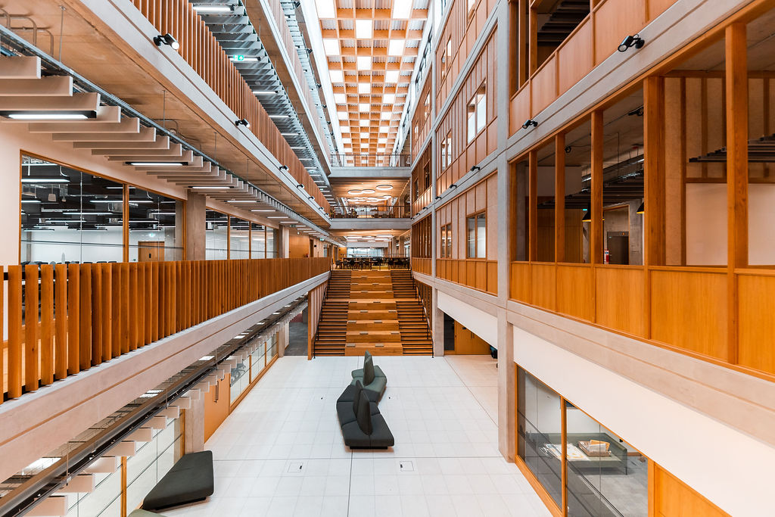

The School of Engineering is delighted to receive the keys to its new building. In the coming months, it will throw open its doors to welcome staff, students and industry partners.
Committed to providing the best facilities for our staff, students and researchers, the new build enables collaboration with our industry partners. It also encourages different and more flexible ways of working.
We are passionate about educating the next generation of engineers. Alongside accessing features such as the Design Centre and our expanded computer labs, our new building provides students with the opportunity to work with engineers across the disciplines. Their learning will mirror the workplace, encouraging and developing their understanding of industry and their role within it.
The new building also places industry at the heart of our campus as it sits alongside our new centre of excellence in railway innovation, the UK Railway Research Innovation Network (UKRRIN) Digital Systems Innovation Centre. This was the first phase of the building to open in November 2020.
To find out more visit the website.

