GENERAL HEALTH AND SAFETY RISK ASSESSMENT FORM
Site |  | The Raymond Priestley Centre |  |  |  | Department |  |  |  | Campus Services, UBSport |  |  | Version / Ref No. |  |  | 07
Activity Location |  | Coniston, Cumbria |  |  |  | Activity Description |  |  |  | Return to Campus COVID-19: Building Risk Assessment  Full time staff working at the Centre (mainly outside) – total 10  University staff and Alumni with families accessing the building - total 35  University students accessing the building - total 35
Assessor |  | Norman Beech |  |  |  | Assessment Date |  |  |  | 05/08/2021 |  | Date of Assessment Review | 01/11/2021
Academic / Manager Name |  | Norman Beech |  |  |  | Academic / Manager Signature |  |  |  | Norman Beech
Hazard Assessment |  |  |  |  | Control Assessment |  |  |  |  |  |  |  |  |  |  |  | Actions
Hazard Category | Hazards Identified |  | Who might be harmed?  Staff  Students  Contractors  Others | How might people be harmed? | Existing Control Measures |  | Initial Risk Rating |  |  |  | Are these adequate?  Yes/No | Changes to/ Additional Controls |  | Residual Risk Rating |  |  | Owner | Due  Date | Action Complete
 |  |  |  |  |  |  | S | L | R |  |  |  |  | S | L | R
Organisational | Psychological well being |  | Staff / Students | Anxiety and stress caused by concerns around returning to work and studies on Campus | Regular communication is in place (individual and group) via Zoom team meetings, phone calls, staff WhatsApp group, One Drive to share documents, health & safety meetings to ensure RPC staff and visiting UoB staff and students are not ill-informed about returning to work safely.  Advice is shared with staff members and visiting staff and students, who have been fully briefed and kept up to date with current advice on staying protected through the University’s lines of communications (i.e. line managers, Internal Comms) and shared with staff via Zoom team meetings, phone calls, health & safety meetings and the University’s Coronavirus FAQs click here.  Risk assessment shared with staff via email and a copy is available on the Centre’s share drive that staff can access. https://drive.google.com/drive/folders/1CoQzN8T6jUIkqhOnGayar5CK7tkRei9s?usp=sharing  New workplace/controls put in place to reduce risk of exposure to COVID 19 are documented in procedures and policies and disseminated to employees through Line Managers and available for staff to reference on the Centre’s share drive.  https://drive.google.com/drive/folders/1CoQzN8T6jUIkqhOnGayar5CK7tkRei9s?usp=sharing  These include:  - Local induction materials.  - COVID-19: Building Risk Assessment (This completed Risk Assessment)  Line managers are aware of how big changes to working arrangements may cause additional work-related stress and affect their employees’ mental health and wellbeing and individuals have been made aware via induction and team meetings of guidance available in relation to this:  https://www.hse.gov.uk/stress/  https://intranet.birmingham.ac.uk/staff/coronavirus/Coronavirus-wellbeing-support.aspx  http://www.selfhelpguides.ntw.nhs.uk/birmingham/leaflets/selfhelp/Strss.pdf  https://intranet.birmingham.ac.uk/hr/wellbeing/workhealth/stress-management-guidance.aspx  Managers hold regular informal discussions with their team during staff meetings and in 1:1 meetings and look at ways to reduce causes of stress as we consider the work scheduled for the week ahead and the work expected to be completed on specific days eg group arrival/departures.  Concerns on workload issues or support needs are escalated to line manager informally during the day or formally in staff meetings or 1:1’s.  Information on the full range of Coronavirus-Covid-19 support available for staff including those who were previously advised by Occupational Health or a medical professional (including a midwife in respect of pregnancy) not to work on campus and staff who are in the clinically extremely vulnerable group (i.e. those previously advised to shield), is available here. |  | 1 | 2 | 2 |  | Yes | These will be maintained going forward as valid and beneficial lines of communication and discussion.  WhatsApp group used for sharing information. One Drive for sharing documents eg risk assessment. |  | 1 | 2 | 2 | Norman Beech | 5/8/21 | 1/11/21
l |  |  |  |  | Information on the full range of Coronavirus-Covid-19 support available for staff including those who were previously advised by Occupational Health or a medical professional (including a midwife in respect of pregnancy) not to work on campus and staff who are in the clinically extremely vulnerable group (i.e. those previously advised to shield), is available here.  Existing risk assessments including those for new or expectant mothers reviewed and revised to reflect new working arrangements. Reasonable adjustments made, including those needed for PEEPs especially in relation to who will assist with their evacuation in an emergency, to avoid staff that require them including disabled workers being put at a disadvantage.  Employees who have concerns about either working on Campus or working from home/remotely have discussed these with their line manager or supervisor either using the University’s Covid-19 Return to Campus Discussion Form or an alternative method whereby concerns have been formally recorded and where necessary they have been signposted to the EAP for support and / or a referral to occupational health has been made using a standard Management Referral available via the HR Portal.  Employees are made aware of supportive mechanisms available to them (e.g. counselling, occupational health, HR, etc) through line managers, internal communications and University webpages:  https://intranet.birmingham.ac.uk/staff/coronavirus/faqs-for-staff.aspx  https://intranet.birmingham.ac.uk/hr/wellbeing/index.aspx  https://intranet.birmingham.ac.uk/hr/wellbeing/workhealth/index.aspx  This link is for students:  https://intranet.birmingham.ac.uk/student/coronavirus/Wellbeing.aspx
Biological  (Appendix 2 General background and risk management) | Virus transmission in the workplace |  | Staff/students/ any client group visiting the Centre/ members of the public/ delivery drivers | Exposure to respiratory droplets carrying COVID-19 from an infectious individual transmitted via sneezing, coughing or speaking. | Staff continue to work using the mixed model of site and home based (hybrid working) as agreed with line manager, in line with Government and University guidance.  Managers/supervisors ensure staff and students with any form of illness do not attend work/campus until the illness has been verified as not being Covid-19.  Managers/Supervisors keep track of when staff and students can return to work/Campus after the symptom free period.  Regular access to the Lateral Flow Device tests and kits are available to staff and students who are coming onto campus. Staff and students are strongly encouraged to test twice a week and to record their results on the Government’s reporting website site:  https://www.gov.uk/report-covid19-result  The University’s On-line induction materials for returning to campus combination of the guidance and videos have been provided and completed for all staff working in University buildings.  Schedules for essential services and contractor visits revised to reduce interaction and overlap between people and building managers and occupants informed of when the visits will take place and which services are being maintained e.g. carrying out services out of hours, or when few people are in the building on change over days or when people are out on activities.  Un-essential trips within buildings and sites discouraged and reduced e.g. access to some areas restricted, use of both radios and telephones encouraged, staff have mobile phones to avoid shared use also radios assigned to specific staff for personal use. |  | 3 | 1 | 3 |  | Yes |  |  | 3 | 1 | 3 | Norman Beech | 5/8/21 | 1/11/21
Environmental | Virus transmission in the workplace due to lack of social distancing |  | Staff/students/ any client group visiting the Centre/ members of the public/ delivery drivers | Exposure to respiratory droplets carrying COVID-19 from an infectious individual transmitted via sneezing, coughing or speaking.  Exposure to respiratory droplets carrying COVID-19 from an infectious individual transmitted via sneezing, coughing or speaking. | Workplaces and routines changed to reduce the number of people staff come into contact with including:  - Change to peak staff entry and exit times. Small number of staff involved and arrival meeting scheduled to be outside or in large covered area with open sides.  - Amended shift routines, staff handovers and team briefings -  - staff separated into catering and activity delivery teams to reduce contact between employees. Office area - reduced occupancy level with room capacity sign displayed to avoid overcrowding.  - Job and location rotation reduced. Staff have specific work areas in the building to limit inter-actions, also specific toilets to use.  To help contain clusters and outbreaks and assist the University with any requests for data by the NHS Test and Trace service a temporary record of shift patterns and teams and attendance in the building is kept for 21 days. NHS Test and Trace QR code is displayed in the building for visitors and staff to scan using the NHS Covid-19 app.  Work has been arranged so that staff are able to maintain the government guidelines for workplaces.  The latest Guidelines on these measures can be found by clicking the following link Workplace Guidelines.  Staff activities are segregated to promote 2 metres distance including:  - Workstations moved or staff relocated. Desks are arranged with employees facing in opposite directions. Display Screen Equipment (DSE) assessments reviewed and revised.  - Headcount capacity to ensure social distances standards have been achieved have been set and displayed in shared rooms e.g. offices, meeting rooms.  - Capacity limits have been set for common facility areas (e.g. toilets, welfare areas etc.) Posters display room capacity.  - Staff encouraged to remain on-site including bringing their own lunch and, when not possible, maintaining social distancing while off-site.  - Where available safe outside areas used for break.  - Welfare area for staff has been assessed in accordance with government guidance and tables/seating arranged to create 2m social distancing separation. All users are encouraged to wash their hands prior to using equipment (kettle) and to wash their hand after use. Additional signage for the correct method for handwashing displayed.  One-way flow systems implemented and visual aids, such as floor strips, signage are used throughout the building/workplace.  Visits from people outside of the building are managed via remote connection/working where this is an option. Where this is not an option visitor and contractor arrangements have been revised to ensure:  - Clear guidance on how to reduce the risk of spreading COVID-19 to people is given to them, for example, by phone, on the website or by email or with on-site signage and visual aids and the particular needs of those with protected characteristics, such as those who are hearing or visually impaired have been considered.  - Visitors are told they should be prepared to remove face coverings if asked to do so by police officers and staff for identification.  - Information provided to visitors does not compromise their safety.  These measures are monitored by the local supervising staff member- Deb Cook and where necessary concerns fed back to the third party manager.  Managers perform frequent evaluation against social distances controls. Evaluation is in relation to compliance to the guidance given to staff. Staff are reminded on a daily basis in socially distanced team meetings of the importance of social distancing both in the workplace and outside of it.  Near-miss reporting is encouraged to identify where controls cannot be followed or people are not doing what they should.  No working in close proximity to people and in particular a person’s face, mouth and nose, for an extended period of time (the majority of the working day) is permitted unless the work is essential such as in clinical settings, like a hospital, or other close contact roles for example, Occupational Health clinical services where there is an activity specific risk assessment and PPE is provided for individuals undertaking this work.  PPE is provided for first aiders. The taking of PPE home is not permitted.  Adequate training has been provided on what PPE is required i.e. gloves, masks, aprons, Filtering Face Pieces (P3), goggles, the correct donning/doffing of PPE and face fit testing. Government advice is followed:  https://www.gov.uk/government/collections/coronavirus-covid-19-personal-protective-equipment-ppe  https://www.gov.uk/government/publications/covid-19-decontamination-in-non-healthcare-settings/covid-19-decontamination-in-non-healthcare-settings  PHE quick guides for correct donning and doffing of PPE for non-AGPs. as well as for AGPs has been utilised for examples in best practice for putting on and taking off (donning and doffing).  Face coverings are not PPE and are not normally required to be worn in the workplace but the University strongly encourages staff, students, contractors and visitors to continue to wear face coverings inside buildings and where people choose to wear them they are supported.  Where face coverings may reduce the risk of transmission from one person to another e.g. in congested areas, crowded enclosed spaces and where people may come into contact with people they do not normally meet, signs are displayed requesting individuals to wear a face covering with the expectation that individuals will wear a face covering in these areas.  Individuals have been reminded through staff training prior to residential work restarting in July 2021 of how to use face coverings safely including the following:  When wearing a face covering you should:  - wash your hands thoroughly with soap and water for 20 seconds or use hand sanitiser before putting a face covering on and before and after removing it  - avoid wearing on your neck or forehead  - avoid touching the face covering or your face, as it could contaminate it with germs from your hands  - change the face covering if it becomes damp or if you’ve touched it  - continue to wash your hands regularly  - change or wash your face coverings daily  - if the material is washable, wash it in line with manufacturer’s instructions. If it’s not washable, dispose of it carefully in their usual waste  Extra non recycling bins to dispose of single use face coverings and PPE are provided, refer to the guidance on how to dispose of personal or business waste, including face coverings and PPE. |  | 3 | 1 | 3 |  | Yes |  |  | 3 | 1 | 3 | Norman Beech | 5/8/21 | 1/11/21
Biological | Suspected case of COVID-19 |  | Staff/students/ any client group visiting the Centre/ members of the public/ delivery drivers | Exposure to respiratory droplets carrying and contact with an object that has been contaminated with COVID-19. | Response plan in place in the event a confirmed or suspected case of COVID-19 and communicated and includes:  - If a person becomes unwell in the workplace with suspected COVID-19, they will be sent home in accordance to the University guidance. If any student appears unwell or make comment or complain to staff members that they are feeling unwell they will be asked to leave the building with immediate effect and to follow the University and Government advice. Managers will follow the NHS Test and Trace workplace guidance: https://www.gov.uk/guidance/nhs-test-and-trace-workplace-guidance  - The area will be cleaned in accordance with the specific Government guidance  - Provision and monitoring of adequate supplies of cleaning materials are in place.  - Team briefed in staff meeting on actions to be taken in the event of someone being suspected of having COVID-19.  - Staff must tell their line manager if they develop symptoms. Absence will be managed in accordance to the University guidance provided.  - Employees to follow the Government advice: https://www.gov.uk/coronavirus  - Line managers will maintain regular contact with staff members during this time and monitor for signs of symptoms in the remaining workforce and keep Senior Managers informed of the situation whilst following the Government’s guidance for contact tracing: contact with co-workers: https://www.gov.uk/guidance/nhs-test-and-trace-workplace-guidance  - If an individual tests positive for Covid-19 this will be managed in accordance with the University’s .Test, Trace and Protect Process.  - If multiple cases of coronavirus appear in a workplace, an outbreak control team from either the local authority or Public Health England will, if necessary, be assigned to help the University manage the outbreak. The University will seek advice from the local authority in the first instance.  - Individuals will be told to isolate because they:  - have coronavirus symptoms and are awaiting a test result  - have tested positive for coronavirus  - are a member of the same household as someone who has symptoms or has tested positive for coronavirus  - have been in close recent contact with someone who has tested positive and received a notification to self-isolate from NHS test and trace.  https://www.gov.uk/government/publications/covid-19-stay-at-home-guidance/stay-at-home-guidance-for-households-with-possible-coronavirus-covid-19-infection |  | 3 | 1 | 3 |  | Yes |  |  | 3 | 1 | 3 | Norman Beech | 5/8/21 | 1/11/21
Biological | Someone entering the workplace with COVID-19 |  | Staff/students/ any client group visiting the Centre/ members of the public/ delivery drivers | Exposure to respiratory droplets carrying and contact with an object that has been contaminated with COVID-19. | Companies who regularly attend or work in the building requested to provide their health and safety policy/arrangements / or RAMS (risk assessment and method statement) for review regarding COVID-19.  Anybody visiting site will be informed that they are not to enter if they’re experiencing COVID-19 symptoms or should be self-isolating under the government Guidelines.  If a person becomes unwell in a University workplace with suspected COVID-19, they will be sent home in accordance to their company’s guidance. University managers will follow the NHS Test and Trace workplace guidance for any University staff that may have come into contact with them:  https://www.gov.uk/guidance/nhs-test-and-trace-workplace-guidance |  | 3 | 1 | 3 |  | Yes |  |  | 3 | 1 | 3 | Norman Beech | 5/8/21 | 1/11/21
Environmental | Virus transmission in the workplace |  | Staff/students/ any client group visiting the Centre/ members of the public/delivery drivers | Contact with an object that has been contaminated with COVID-19 and which subsequently transmits this to another person e.g. surfaces, any inanimate objects & touch points including work surfaces, work equipment, door handles, banisters, chair arms and floors.  . | Individuals have been instructed in inductions and are regularly reminded in staff meetings to clean their hands frequently with soap and water for 20 seconds and the importance of proper drying in accordance with the NHS Guidance:  https://www.nhs.uk/live-well/healthy-body/best-way-to-wash-your-hands/  Soap and water and hand sanitiser are provided in the workplace and adequate supplies are maintained and are placed at the entrance to the building and in other areas eg kitchen and equipment store where they will be seen.  Individuals have been informed to check their skin for dryness and cracking and to inform their line manager or supervisor if there is a problem.  Individuals are reminded in arrival induction to catch coughs and sneezes in tissues – Follow: “Catch it, Bin it, Kill it” and to avoid touching face, eyes, nose or mouth with unclean hands. Posters are displayed around the workplace as agreed with Estates Project manager. See Appendix 3.  To help reduce the spread of coronavirus (COVID-19) individuals are reminded in staff briefings of the public health advice:  https://www.gov.uk/government/publications/coronavirus-outbreak-faqs-what-you-can-and-cant-do/coronavirus-outbreak-faqs-what-you-can-and-cant-do  A review of the cleaning regime for the building/area to ensure controls are in place to keep surfaces clean and free of contamination has been undertaken, cleaning products have been made available to all occupants and everyone has been briefed and everyone has been briefed during inductions on the importance of keeping surfaces and work equipment clean. Cleaning products are available in the lounge, games room, bedrooms and bathrooms.  Clear use and cleaning guidance for toilets, showers, lockers and changing rooms are in place to ensure they are kept clean and clear of personal items. This includes enhanced cleaning of all facilities regularly during the day and at the end of the day using normal cleaning products. Disposable or paper roll is provided to clean all hard surfaces especially frequently hand touched surfaces, in showers and changing rooms and hand sanitizer is available on entry and exit to the room.  Facilities are kept well ventilated. For example, by insuring any mechanical ventilation works effectively and opening windows and vents where possible.  Cleaning for busy areas in the building has been enhanced.  More waste facilities, and more frequent rubbish collection has been provided.  Sharing of equipment is restricted where possible and cleaned / disinfected before and after use.  Objects and surfaces that are touched regularly are cleaned frequently, with anti-bacterial sprays, such as door handles and keyboards, and making sure there are adequate disposal arrangements.  Internal doors that are not signed as fire doors (unless held open with a mechanical device) kept open whilst working (last person out shuts the doors) to prevent multiple people using door handles.  Use of hot desks and spaces avoided and, where not possible workstations are cleaned between different occupants including shared equipment by the user before and after use.  There is clear desk policy in place to reduce the amount of personal items on desks and work benches to be practiced when the space is in use or not in use.  There are cleaning procedures for goods and merchandise entering the site. Greater handwashing facilities have been introduced for workers handling goods and merchandise via provision of hand sanitiser at office and kitchen store areas. Non-business deliveries stopped, for example, personal deliveries to workers.  Area where people directly pass things to each other, for example safety kit for water sports, have been identified and ways to remove direct contact have been introduced. These include use of training videos on how to put on and adjust buoyancy aids and drop off points for equipment.  Everyone is encouraged in staff induction and group briefings to keep personal items clean including washing spectacles with soap and water, clean phones, keyboards and shared machinery handles etc before after and during work.  Storage for workers clothes and bags provided in staff changing area e.g. lockers and staff encouraged to use them.  Monitoring and supervision arrangements eg signature system to show when and who cleaned specific areas have been put in place to ensure people are following controls. Centre Manager does walk round checks to ensure compliance.  COVID-19 cleaning products used have a current valid chemical risk assessment in place and are used in accordance with all prescribed risk controls and monitoring requirements. They are stored so that they are readily available to all users and are labelled according to the Globally Harmonised System of Classification and Labelling (GHS). (See location specific chemical risk assessments for cleaning products used within the area).  All university staff are encouraged to avoid direct personal contact with others i.e. shaking hands etc.  Separation of individuals and personal items in all areas to allow for social distancing (through use of family/household bubbles. Designated equipment for individuals to use eg buoyancy aid and wetsuit, designated dining room table and bathroom with toilet and shower and wash basins assigned to individual families).  Specific areas to be used by staff (Catering staff only use kitchen and Centre Office bathroom. Have separate access to kitchen. Changing area specifically for instructional staff. Equipment store and boathouse store specifically for Centre staff. Staff only office area. Yurt for staff only as rest area).  Allocated social spaces for different family units.The lounge is divided into two areas for two family groups to use it and maintain social distancing. The Terra Nova Room is divided to provide space for two family groups to sit down and maintain social distancing.  Staggered arrival and departures for visitors. - Staggered arrival times, after 12pm. Families staying in bedrooms arrive 1 hour apart. (see visual reference in Appendix 2 for Housekeeping for Family camps)  Separate Family Bedroom Areas (4 in Dorm Area, 1 in Group Leader area, 1 in Yurt).  Families only to use 4 dorm rooms from the 8 available per camp, alternate dorm rooms unused to provide buffer in corridor.  Separate Family Bathroom facilities in Group Leaders Area, wheelchair accessible bathroom.  Hand Washing Stations set up with Sanitiser Gel at various places around the Centre (Outside main entrance and next to equipment store, on entry to the dining room and outside rear Centre entrance door).  Signage up in toilets for wiping down handles/door knobs/edges after each use.  Signage for correct handwashing methods at each sink. Signage to remind families of the need for social distancing measures in areas such as kitchen, main entrance, exits etc.  A thorough and specific cleaning programme. Appropriate PPE to enable this (gloves, apron, mask).  New prompt sheets for cleaning measures and daily expectations of cleaning in each area.  General cleaning of the centre (by RPC Staff) each day when use of the building is low i.e. 10-11am. Cleaning of fire escape rails, door handles, key pads, fridge handles.  Separation of kit in drying rooms. Use of outside clothes lines. - Drying Room – One rail per family, one family member responsible for going in/out of the drying room, one person in the room at a time. Whirly Gigs outside for extra drying  2m spacing marks on the floors of the Centre.  Centre to have a 72hr period between the end of one camp and the beginning of the next.  Centre to be cleaned by RPC staff after this 72hr period has elapsed.  Catering and Dining arrangements  (see visual reference in Appendix 2 for kitchen/catering plan)  Staff believe that to cut down on unnecessary contact and dramatically reduce the risk of cross contamination, the camps will be fully catered.  Each camp will have a maximum of 6 families to be catered for.  Families to notify RPC of any food allergies/dietary requirements in plenty of notice so this can be catered for.  Appropriate PPE (gloves, apron, mask) to be worn during food preparation.  Each family to be allocated a shelf in a fridge where they can store any special items of food they bring.  Separate times for meals. Procedure for meal times explained to visitors (detailed below).  Segregation of different family groups at meal times. Each family to be allocated a table in the dining room for the duration of their stay, they will be a minimum of 2m apart. There will be 2 sittings for each meal in the dining room.  Breakfast will be of a continental style and will be left prepped for each family and stored on their allocated fridge shelf the evening prior. (Toaster on each of the 3 tables.)  Lunch will be prepped after families vacate the kitchen in the morning and will be left prepped on the allocated fridge shelves for each family. If the Lunch has a warm component to it, this will be left on each allocated table, or on the serving side to be collected by the family for second sitting.  Dinner will be prepped after lunch has ended and families have vacated the kitchen area. The meal will be prepped for each individual family group and left on the allocated tables or on the side serving area for collection for second sitting.  Families are responsible for bringing their used pots/washing up to the sink (scraped and stacked neatly) so that they can be washed by a member of staff wearing PPE, gloves, apron and mask.  Families are responsible for wiping down their table and benches after every meal. Leaving it completely clear of any cutlery/pots/glasses. This is explained during the Centre induction when they come on site. They are reminded at each meal time.  Due to this arrangement the kitchen will not need a screened off area and the staff will not have to serve meals or be present in the kitchen area during meal times.  Daily clean down policy in-between meal times for kitchen (carried out by staff). New cleaning prompt sheet to be written and put up in main kitchen. Clean down policy to be adhered to with continued assessment and updating to abide with government guidelines.  Signage up for correct handwashing methods at each sink  Signage up for social distancing measures in areas such as kitchen, main entrance, exits etc.  Signage up for being vigilant on wiping door/fridge handles after using them. Sanitising hand gel very useful in these areas.  New prompt sheets for cleaning measures and daily expectations of cleaning in each area.  https://www.gov.uk/government/publications/covid-19-guidance-for-food-businesses  Provision of outdoor activities  (see visual reference in Appendix 2 for Generic Activities)  Briefing & introductions done at a social distance, contact always avoided. Briefings will take longer to allow for remote checking (e.g. harnesses/ buoyancy aids). Central coordinator to check.  Briefings with families staggered to avoid use of kit areas by more than one family, or by more than 1 instructor. Briefings performed outside whenever possible.  PPE issued at start of week to individuals i.e. buoyancy aids and wetsuits. Also waterproofs/boots etc. Own wetsuits, boots etc used if possible – encouraged.  Each instructor given own shelter/ first aid kit and PPE at start of week (or permanently for the time being?)  Each instructor has hand sanitiser & wears gloves (any type) where they can. Each family asked to bring hand sanitiser.  Use of paddles/ craft etc where gear must be re-used:  Have buckets with disinfectant for use by participants at end of session e.g for use on boats/ paddles. Reduce risks of cross contamination. Set up a kit used/quarantined area.  For land activities, have quarantine bin system for use of ropes/harnesses with clear labelling of ‘Last Used’.  Some craft out of commission or can only be used at start/end of weeks to allow 72 hour quarantine period. Clear labelling of ‘Last Used’ system.  If PPE is used by participants it is kept for the whole of the stay and then cleaned eg harness for climbing.  Avoid contact with others using public spaces eg cafes & restaurants (assuming they are open) Bluebird Café may operate a takeaway?  - Public footpath - keep gates open.  - Whole day activity – each family talks with instructor to agree options for journeys/ skills/ relaxing/ etc. |  | 3 | 1 | 3 |  | Yes |  |  | 3 | 1 | 3 | Norman Beech | 5/8/21 | 1/11/21
Organisational | Exposure to Existing Hazards |  | Staff/students/ any client group visiting the Centre/ members of the public/ delivery drivers | Increased risk of harm due to controls included in existing risk assessments & safety arrangements affected by COVID-19 measures | All relevant pre-existing (non COVID) risk assessments including lone working assessments and procedures have been reviewed to take into account the impacts of social distancing and other COVID counter measures.  PPE related risk assessments have been reviewed to ensure that PPE is provided on an individual basis. Usage is monitored to ensure suitable level of stock of certain PPE such as face masks etc during this time due to global shortages. Individuals maintain their own equipment in a sterile condition. Storage has been reviewed to provide individual storage arrangements. The taking of PPE home is not permitted.  Emergency Procedures reviewed and revised including:  - Communication: people have been made aware in staff briefings that in an emergency, for example, an accident or chemical spill or fire, people do not have to stay 2m apart if it would be unsafe.  - Fire procedures: number and details of nominated fire warden(s) in place, fire muster point confirmed and PEEP requirements defined including who will assist with their evacuation in an emergency. Required modifications to fire alarm practices and evacuation drills to cater for COVID-19 measures have been addressed; ensuring that the activity is still compliant with relevant building and fire codes.  - First Aid: First aid needs assessment reviewed to take into account the impact of any Local or National Government requirements and any new Guidelines issued by the University or HSE, and first aid information including the location of first aid kits and first aider contact information up to date.  Training to update staff on current protocols.  (see visual reference in Appendix 2 for First Aid)  Update clients on First Aid - expectations/ limitations/ delays.  If a minor incident occurs first aid should initially be done at a social distance, contact being minimized by guiding participants to help each other.  If a major first aid incident occurs, it will be dealt with by the instructor. This is a risk that is necessary. Although precautions will be taken such as no mouth to mouth etc.  PPE needs to be upgraded, so any closer contact will be undertaken using gloves, goggles or visors and a mask for both staff and clients.  PPE to include use of disposable aprons for use in/near centre, or waterproofs which can be safely removed and cleaned appropriately.  After responding to any closer contact first aid incident, decontaminate or depose of all kit. Then use a buddy system to safely remove PPE.  Resus council advice:  https://www.resus.org.uk/media/statements/resuscitation-council-uk-statements-on-covid-19-coronavirus-cpr-and-resuscitation/covid-community/  Government advice: https://www.gov.uk/government/publications/novel-coronavirus-2019-ncov-interim-guidance-for-first-responders  https://www.sja.org.uk/get-advice/first-aid-advice/covid-19-advice-for-first-aiders/  - Hygiene: Washing facilities with soap/gel available (see Cleaning below). People involved in the provision of assistance to others have been informed to pay particular attention to sanitation measures immediately afterwards including washing hands.  Safety critical roles will remain in place to aid safe operation. In the event of safety critical roles not being available then a dynamic risk assessment shall be performed by RPC staff on the scene to ensure measures are introduced to mitigate risk (for example, another area within the building or campus could have a critical role such as first aider that could cover as a temporary solution).  Security implications of changes made to operations and practices in response to Covid-19 Local or National Government requirements have been considered.  Business continuity and disaster recovery plans updated based on COVID-19 implications including Contingency plan in place for possible switch back to lockdown.  Life-saving rules, will continue to be governed, enforced and communicated during COVID-19 in particular “speaking up” if they witness any unsafe behaviours, conditions or symptoms related to COVID-19. |  | 3 | 1 | 3 |  | Yes |  |  | 3 | 1 | 3 | Norman Beech | 5/8/21 | 1/11/21
Environmental | Inbound & Outbound Goods including Post |  | Staff/students/ any client group visiting the Centre/ members of the public/ delivery drivers | Exposure to contact with an object that has been contaminated with COVID-19. | Logistics for the deliveries to the unit so that social distancing can be maintained at all times has been considered and include:  - Pick-up and drop-off collection points, procedures, signage and markings revised.  - Unnecessary contact at delivery bay has been minimised e.g. non-contact deliveries where the nature of the product allows for use of electronic pre-booking.  - Methods to reduce frequency of deliveries in place - ordering larger quantities less often.  - Where possible and safe, single workers load or unload vehicles or if not possible the same pairs of people, with additional mitigating measures including the wearing of face coverings, are used for loads where more than one is needed.  - Electronic paperwork is used where possible, and procedures reviewed to enable safe exchange of paper copies where needed, for example, required transport documents.  - Delivery & receipt confirmation made contactless, physical contact when handing goods over to the customer has been avoided.  - Strict hand washing procedure in place after handling all deliveries. |  | 3 | 1 | 3 |  | Yes |  |  | 3 | 1 | 3 | Norman Beech | 5/8/21 | 1/11/21
Organisational | Travelling to work |  | Staff/any client group visiting the Centre | Exposure to respiratory droplets carrying COVID-19. | Individuals travelling to University premises or on behalf of the University are encouraged to follow the Government’s safer travel for passengers to help them stay safe, and protect others by controlling the spread.  Where people are travelling together in any one vehicle, they are encouraged to:  - use fixed travel partners  - not sit face-to-face  - open windows and switch on ventilation systems that draw in fresh air. Open windows only partially if it’s cold.  - frequently clean their vehicle including objects and surfaces that are touched regularly, such as door handles and vehicle keys. |  | 3 | 1 | 3 |  | Yes |  |  | 3 | 1 | 3 | Norman Beech | 5/8/21 | 1/11/21
Organisational | Driving at work |  | Staff | Exposure to respiratory droplets carrying and contact with an object that has been contaminated with COVID-19. | Staff roles that are required to car share have been considered and whether this could continue. Alternative solutions to two-person delivery have been put in place, for example, mechanical / material handling equipment.  Where these are not possible the number of people travelling together in any one vehicle is minimised, using fixed travel partners, vehicles are well ventilated via open windows (windows are only partially opened if it’s cold) and with ventilation systems switched on so that fresh air is drawn in and occupants sit side by side or behind other people and sitting face-to-face is avoided. Seating arrangements to maximise distance between people in the vehicle has been considered.  Shared vehicles are frequently cleaned by the driver including between shifts or on handover. This includes cleaning of objects and surfaces that are touched regularly, such as door handles and vehicle keys, and adequate disposal arrangements are in place.  Sufficient quantities of hand sanitiser /wipes are retained within vehicles to enable workers to clean hands after each delivery / drop-off.  Staff are encouraged to wash hands before boarding vehicles. |  | 3 | 1 | 3 |  | Yes |  |  | 3 | 1 | 3 | Norman Beech | 5/8/21 | 1/11/21
Environmental | Ventilation |  | Staff/students/ any client group visiting the Centre | Exposure to respiratory droplets carrying COVID-19. | Ventilation systems are maintained in line with planned and preventative maintenance schedules, including filter changes.  An assessment of the ventilation in the building, and where necessary individual areas/rooms, has been undertaken which included checks such as:  - Is the space naturally or mechanically ventilated  - All areas within the building which are usually occupied and have poor ventilation have been identified and the use of the area re-assessed (see below).  - An assessment of Fresh air (ventilation) has been undertaken for the workplace and where necessary individual workspaces. This included how fresh air is provided (natural, mechanical or combination of both), how many people occupy/use the area, how much time people spend in the areas, how large the area is, what activities take place in the areas, the equipment and machinery in the workspaces, the use of fans and Local Exhaust Ventilation.  Recirculation of unfiltered air within the workplace has been avoided or reduced as far as possible. While this will continue to be minimised some area will need to have some recirculation, to improve thermal comfort.  Natural ventilation can be improved by fully or partially opening windows, air vents and doors, not signed as fire doors. This should be balanced against the need to maintain comfortable temperatures for all users of the space.  Rooms can be purged (aired) when not in use by leaving the windows and doors fully open. However, it is important to plan and close windows to minimise the risk of rodent and pigeon issues.  Staff have been informed, via this risk assessment of the following steps which they can take to make sure their workplace is adequately ventilated whilst maintaining a comfortable temperature:  - opening windows and doors partially can still provide acceptable ventilation while keeping the workplace comfortable. Opening higher-level windows will probably create fewer draughts.  - if the area is cold relax dress codes so people can wear extra layers and warmer clothing  - use natural ventilation alongside heating systems to maintain a reasonable temperature in the workplace.  Ventilation Instruction signs displayed throughout the building instructing individuals to “Please ensure you open all windows on arrival and close on departure.”  General considerations reflected on during reopening of the buildings in relation to the ventilation and fresh air to occupied spaces. Core strategy based on CIBSE Covid-19 Ventilation Guidance, HSE guidance, Government and other relevant industry guidance. The guidance is constantly under review by the University’s Estates, as SARS-CoV2 transmission routes become more clearly defined, and any updated recommendations assessed and implemented where relevant to University systems.  Links used above:  HSE - Ventilation and air conditioning during the coronavirus (COVID-19) pandemic 21st July 2021  https://www.hse.gov.uk/coronavirus/equipment-and-machinery/air-conditioning-and-ventilation/index.htm  CIBSE - COVID-19: Ventilation version 5 - Updated 16th July 2021  https://www.cibse.org/coronavirus-covid-19/emerging-from-lockdown  DfE - Higher education COVID-19 operational guidance - Updated 19 July 2021  https://www.gov.uk/government/publications/higher-education-reopening-buildings-and-campuses/higher-education-covid-19-operational-guidance  HSE - Keeping workplaces safe as coronavirus (COVID-19) restrictions are removed - Updated 19 July 2021  https://www.hse.gov.uk/coronavirus/roadmap-further-guidance.htm |  | 3 | 1 | 3 |  | Yes |  |  | 3 | 1 | 3 | Norman Beech | 5/8/21 | 1/11/21

Risk Assessment Guidance

Risk Scoring System

The scoring system is provided as a tool to help structure thinking about assessments and to provide a framework for identifying which are the most serious risks and why.

 | Consequence / Severity score (severity levels) and examples of descriptors
 | 1 | 2 | 3 | 4 | 5
Domains | Negligible | Minor | Moderate | Major | Catastrophic
Impact on the safety of staff, students or public (physical / psychological harm) | Minimal injury not requiring first aid or requiring no/minimal intervention or treatment.  No time off work | Minor injury or illness, first aid treatment needed or requiring minor intervention.  Requiring time off work for <3 days | Moderate injury requiring professional intervention  Requiring time off work for 4-14 days  RIDDOR / MHRA / agency reportable incident | Major injury leading to long-term incapacity/ disability (loss of limb)  Requiring time off work for >14 days | Incident leading to death  Multiple permanent injuries or irreversible health effects

Likelihood score | 1 | 2 | 3 | 4 | 5
Frequency | Rare | Unlikely | Possible | Likely | Almost certain
Broad descriptor | This will probably never happen/occur | Do not expect it to happen/occur but it is possible it may do so | Might happen or occur occasionally | Will probably happen/occur but it is not a persisting issue | Will undoubtedly happen/occur, possibly frequently
Time-framed descriptor | Not expected to occur  for years | Expected to occur  at least annually | Expected to occur at  least monthly | Expected to occur at least weekly | Expected to occur at least daily
Probability  Will it happen or not? | <0.1 per cent | 0.1–1 per cent | 1.1–10 per cent | 11–50 per cent | >50 per cent

The overall level of risk is then calculated by multiplying the two scores together.

Risk Level = Consequence / Severity x Likelihood (C x L)

 | Likelihood
Likelihood score | 1 | 2 | 3 | 4 | 5
 | Rare | Unlikely | Possible | Likely | Almost certain
5 Catastrophic | 5 | 10 | 15 | 20 | 25
4 Major | 4 | 8 | 12 | 16 | 20
3 Moderate | 3 | 6 | 9 | 12 | 15
2 Minor | 2 | 4 | 6 | 8 | 10
1 Negligible | 1 | 2 | 3 | 4 | 5

The Initial Risk Rating is the level of risk before control measures have been applied or with current control measures in place.
The Residual Risk is the level of risk after further control measures are put in place.

Appendix 1

One Way System To Operate In Centre, With Appropriate Signs

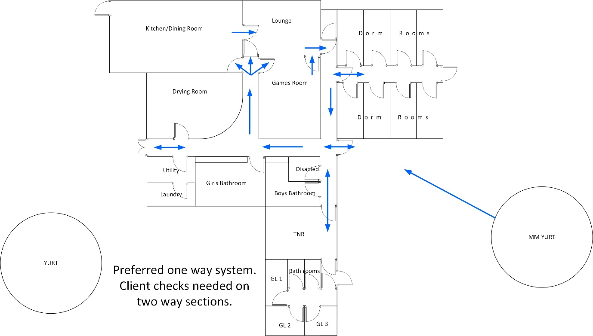
Appendix 2 General background and risk management with reference to: MREW The Unlocking Phase – PPE- Rationale.V2. May 20 MKG Medical
Covid-19 is an infectious viral disease that is spread between humans mainly from droplets that originate from the lungs. These enter the body through the nose, mouth and mucus membranes of the eyes. It can also be contained in saliva. If the virus lands on an external surface it can cause infection when a person moves this to their face. It does not enter through intact skin.
We can use PPE to:
1) Create a barrier to prevent entry – face mask, eye protection.
2) Containment – we have a clothing barrier that we can allow to become “dirty” but remove this in controlled conditions, isolate the virus and then destroy it by decontamination.
There are four possible sources of infection:
1) Ourselves – the potential to give the virus to others.
2) General Others – the potential to receive the virus from co-workers, group members, regular site visitors (delivery persons) and members of the public.
3) Specific Others – who may or may not have the virus but we need to interact within 2 metres. The main example here is giving first aid or conducting an activity specific rescue.
4) Solid objects e.g. door handles, equipment etc
The methods we have to manage the virus are:
1) Hygiene – e.g. hand washing, alcohol gel, surface decontamination.
2) Behavioural – e.g. social distancing, minimising group size.
3) PPE – e.g. creating barrier to prevent entry or contain spread.
1
2
3
These methods work in collaboration. Therefore when one method is compromised because it cannot be achieved, we must rely on the other two. The more methods we compromise the less “safe” we become.
When making a risk assessment, it can be useful to give a quick visual reference to which of these methods are being used. For example:
Use of the dining room by family groups

Our main control when using the dining room, is to isolate family groups so that so do not interact and to maintain good cleaning procedures.
Appendix 2 (continued)

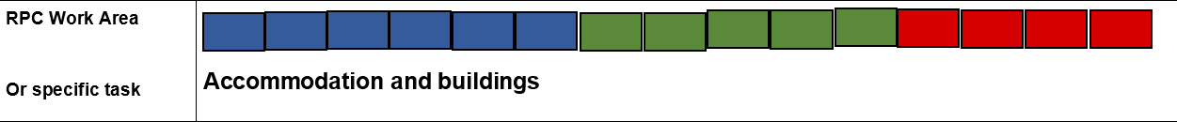

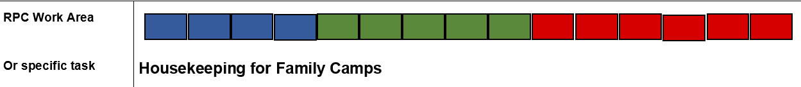

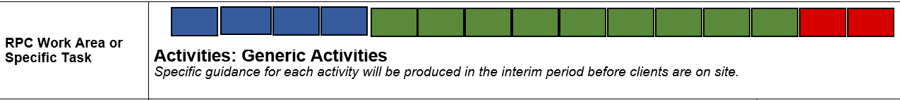

Appendix 3 Covid Poster/Signage Location Within the Raymond Priestley Centre Ground Floor
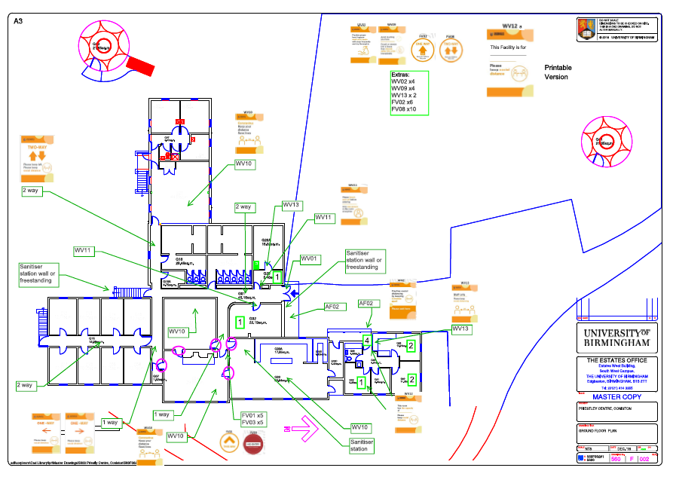

Appendix 3 Covid Poster/Signage Location Within the Raymond Priestley Centre Lower Ground Floor
