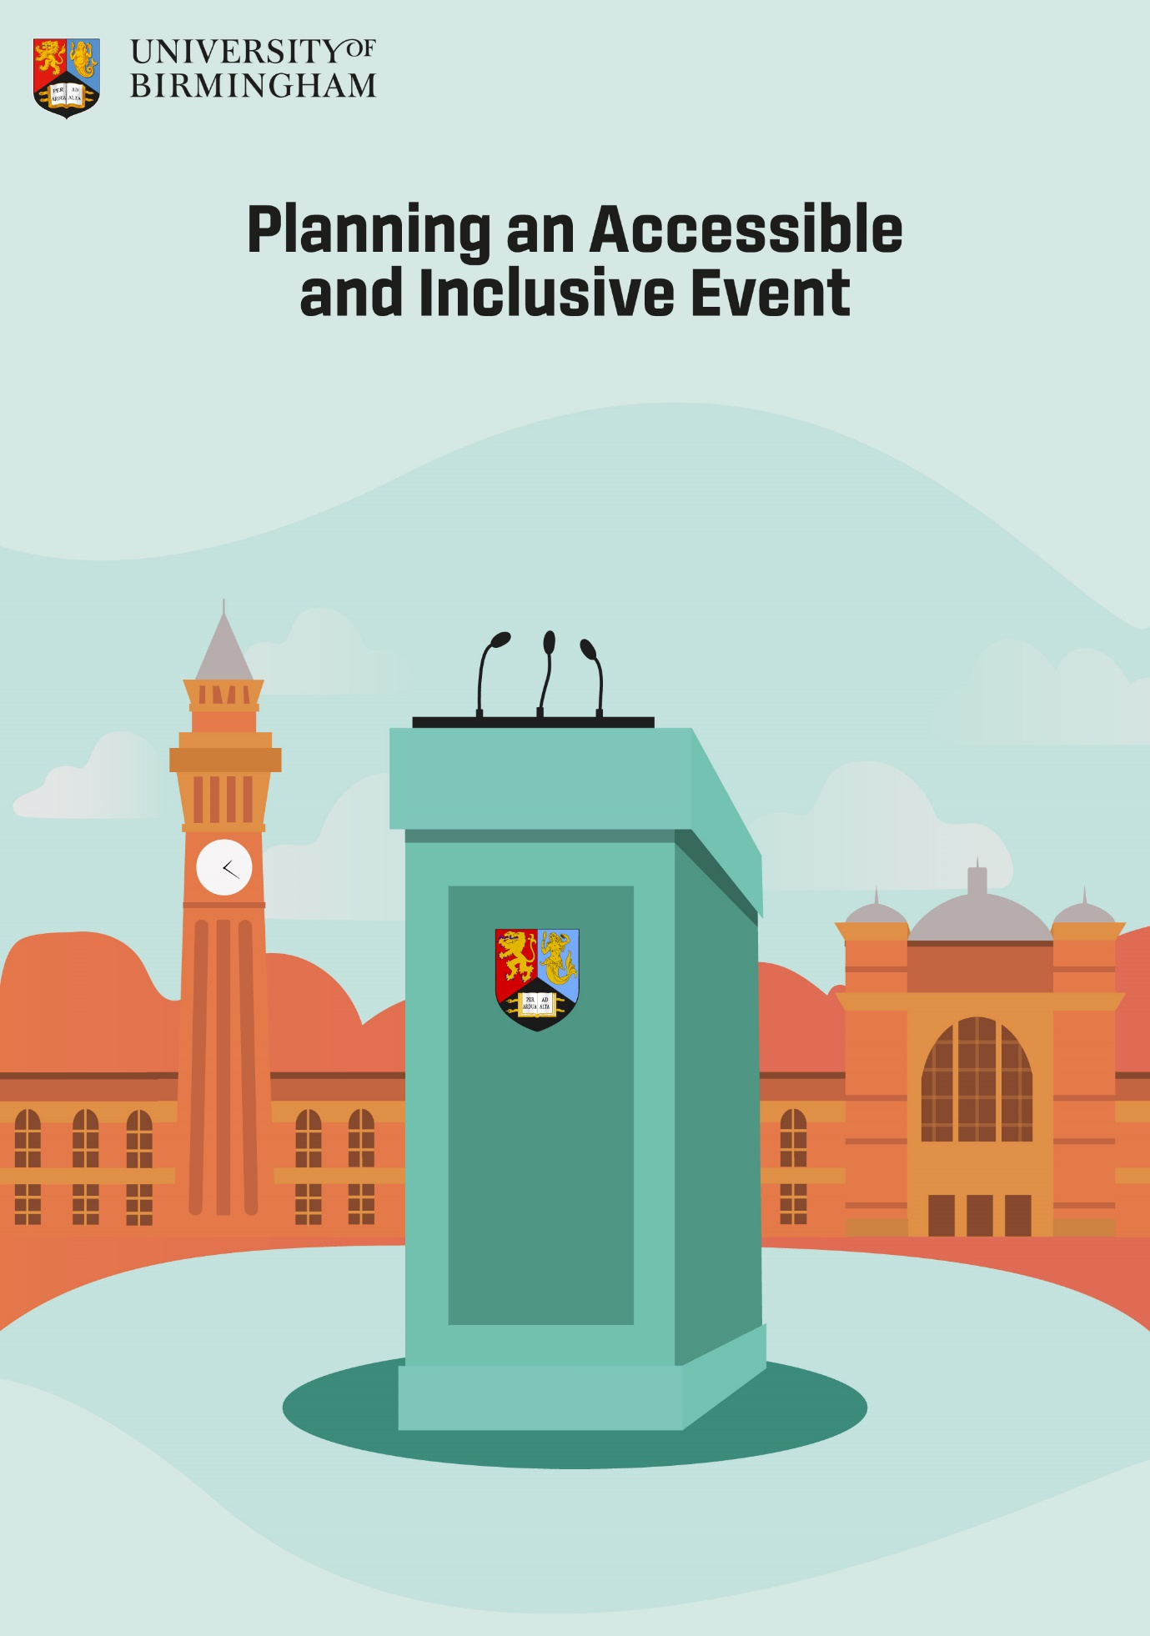

Planning an Accessible and Inclusive Event

This document should be read in conjunction with University of Birmingham Conferences & Events guidance - How to make your event accessible for all
If you require this document in an alternative format, please contact studentequality@contacts.bham.ac.uk
Contents
1
Planning an Accessible and Inclusive Event 2
Introduction 2
Scheduling, Timing & length 3
Considerations for planning online events 3
Planning an ‘in person’ event 4
Venue: 4
Speakers/presenters/facilitators 5
Delegates: Registration/joining instructions 5
On the day 6
Catering and refreshments 7
Feedback 7
Additional Information 7

Introduction
These tips are not exhaustive but should make planning and delivering an inclusive and accessible event easier. They are a starting point and highlight some of the main considerations to ensure ‘Access for All’ – where everyone is welcomed and able to fully participate in University of Birmingham events. Everyone - organisers and delegates will benefit from advanced planning, good organisation, and clear communication; whilst many of the points outlined are common-sense, they are often overlooked.
These considerations are applicable to events organised by staff and/or students, whatever the size or format. It is important to consider these when planning and running an event to ensure that it is inclusive and accessible for all participants including the speakers.
The University of Glasgow have produced a short, animated YouTube video which provides an overview about Embedding equality, diversity, and inclusion into university events

As a minimum, here is a list of five essential considerations for planning an event, more details are provided in later sections.
- Provide a named contact /single contact point for queries.
- Include a question about access/communication requirements on booking forms, or email invites, for both ‘in person’ and online events. Don’t assume that you know about the needs of all your participants, colleagues, or fellow students. Ask your speakers/presenters if they have any requirements.
- Don’t just consider access to the venue(s), think about the range of activities taking place including panel discussions, exhibitions, poster presentations, breakout sessions and networking opportunities, as well as social activities. Consider access to facilities, such as the location of accessible/gender neutral toilets, private or quiet space and refreshments. Think carefully about the layout of rooms and furniture; allow sufficient time to move between rooms/spaces. Do a walkthrough of the venue from arrival point to where activities/workshops are taking place including facilities, time how long it takes and double it.
- Provide information, such as copies of PowerPoint slides/reading materials/timings and outline of the session(s)/meeting notes in advance. These should be provided in an accessible format.
- If your event is in person could it also be made available online - livestreamed, or recorded for viewing later? Are there opportunities for online networking? Don’t forget captions and transcripts.

Scheduling, Timing & length

- Start and finish times of events may impact on the ability of delegates to participate. Build in flexibility for those with caring/childcare responsibilities, or those travelling from a distance at peak times.
- Ideally sessions/workshops should be no longer than an hour in length without a break. This is useful for everyone but particularly important for attendees/participants with disabilities who may become fatigued, lose concentration, or need to take medication. Notetakers, captioners or BSL interpreters will need a break.
- Allow ample time for delegates/attendees/speakers to move between rooms, floors, or different buildings. Walk the routes in advance and add extra time.

Considerations for planning online events

- Schedule regular ‘rest breaks’ into the programme of activities.
- Provide information, such as joining instructions, system requirements and PowerPoint slides in advance and troubleshooting/technology assistance on the day.
- Ensure the presenter is visible while presenting, even while sharing presentation content. Presenters and sign language interpreters can be ‘pinned’ and ‘spotlighted’ in Zoom, for example. This allows the user to keep the person who is signing on screen, even if someone else is talking and important where there are multiple speakers/presentations. See here for further information about pinning on Zoom and Spotlighting-participants-videos
- Use a simple background, check that you are not using a blurred virtual background.
- Consider background lighting levels, not too bright or too dimmed, this is important for those who lipread or have limited vision.
- Make sure that all materials are accessible. Remember to use inbuilt accessibility checkers – see Creating accessible documents: Making Digital Content Accessible (bham.ac.uk).
- Give participants the choice whether they have their cameras turned on/off; microphones should be muted by default to reduce background noise/ interference.
- Use of the ‘Chat’ function should be minimised as this feature can be problematic for those with a visual impairment as well as distracting for others.
- Use the ‘question and answer’ option for questions rather than ‘Chat’.
- Consider how participants will access breakout rooms, voting tools and online networking.
- Captioning is an inbuilt feature on many platforms; however, accuracy can be variable particularly where specialist vocabulary is used. If any participants require human real time captioning, interpreters or notetakers this needs to be planned well in advance. The organisers of the event are responsible for paying for this – consider adding a contingency fund to your budget for arranging this.
- Provide a transcript where possible.
- Consider how links to recordings of the session are circulated.

Click here for further information about Accessible media content: Making Digital Content Accessible (bham.ac.uk)

Planning an ‘in person’ event

Venue:
- Think about your target audience(s), the range of activities which you want to deliver and when, as well as the location of facilities, this should inform your choice of space/venue and its suitability.
- Don’t forget to consider arrangements for ‘off campus’ events and transport options to and from the venue(s).
- Providing a photograph of the outside of the building can be a useful visual cue when approaching from a distance. This is particularly important if someone is not familiar with the layout of the campus or needs a visible reference point for wayfinding.
- AccessAble provide external and internal photographs and details of accessibility features of buildings on campus. A link should be sent to delegates/participants. An interactive Campus Map is also available at WAI2Go™ Interactive Map (bham.ac.uk).
- Consider the flow of delegates; how will they access the main venue and additional space/rooms and facilities and navigate their way across campus if sessions are in multiple rooms across several buildings or locations?
- Do the rooms incorporate a hearing/induction loop and are those running the event aware of how it works? For further information click hearing-assistance.
- Consider the layout of any breakout spaces, as well as the furniture provided ensuring their suitability for the activity-taking place. Open communal spaces can be very noisy and distracting and are not ideal for participants who are Deaf or have limited hearing.
- To facilitate wheelchair access, aisles in all session rooms should be 38”/95cm or wider and clear of obstructions, including bags and coats.
- Make sure there are clearly marked reserved seats for those who need to sit in a particular location.
- For larger events, provide a quiet room or private area for those that need to take time away from the noise and pace of a face-to-face event.
- Provide some seating during refreshment breaks, lunch, and networking events for those unable to stand, even if this is not possible for all. Raised island tables without seats can be problematic for many people.

Speakers/presenters/facilitators

- Ask speakers if they have any specific requirements this may include access to a stage, height of the lectern and seating. Most rooms suitable for events, in the newer buildings, should have height adjustable lecterns.
- Consider the diversity of speakers and panellists – see REACH/University of Oxford -Best Practice Guide - Developing inclusive conferences 2019 .
- Organisers should ensure presenters and those facilitating workshop sessions, or breakout activities, are made aware of any access needs.

Delegates: Registration/joining instructions

- Registration forms/emails should include a question about access and communication needs and dietary requirements or allergies.
- If a third-party booking form, for example, ‘Eventbrite’, is used ensure that the question about access/communication requirements is added. Often, this is not included as ‘standard’. Consider how you will respond to such requests and who will be responsible for ensuring that any ‘adjustments’ are put in place before, during and leaving the event.

- A list of delegates, joining instructions, a session outline and presentation materials should be sent in advance; if an alternative format is requested this should be provided, where possible.
- It is good practice to send the links to campus maps, including the mobility map and AccessAble buildings guides.
- Name badges should include space for the option of adding preferred pronouns.

On the day

- Check that any equipment is working and there is technical support available, or that contact details are provided as a backup.
- Ensure that speakers wear microphones and that questions from delegates/panellists are repeated before they are answered. Consider using a roving microphone for audience questions.
- Check that the signage is clear and shows the most direct and accessible routes, including signs to the nearest accessible toilets. Laminated signs can be harder to read due to their reflective surface.
- Consider at what location(s) directional signage should start and end.
- Depending on the size of the event, is there is a temporary registration desk/information point, is it clearly visible and placed where it is accessible? Positioning the desk directly in front of the entrance can present a barrier for some participants and may also block access. Consider when the information point will be staffed.
- Make sure those individuals staffing or assisting with the event are easily identifiable; for example, could they be provided with a different colour name badge or lanyard?
- Staff should be briefed about emergency evacuation arrangements and places of safety for people who may not be able to use stairs in the event of a fire or other emergency. Click the link for more information about General Emergency Evacuation Plans (GEEPs) for UOB buildings
- Staff/volunteers/helpers should be briefed about the relevant accessibility options for the venue. This should include the location of the nearest accessible toilets and how to access to all event rooms. They should also be aware of the nearest changing places facilities and gender-neutral toilets. UoB has lots of information about access on campus; this includes links to the Campus App and Mobility Map and Information on AccessAble website for UOB buildings

Catering and refreshments

- Provide inclusive food choices and non- alcoholic drink options.
- As part of the booking process a question should be included about dietary requirements or allergies.
- Ensure that any specially prepared foods are clearly labelled and kept separate from other food or are given directly to the person who has requested them.
- If buffet refreshments are provided ensure that food can be eaten without the need for cutlery. Whilst a self- service option provides choice it can present difficulties for those with limited vision/mobility/dexterity. Servers should provide assistance if requested.
- It is good practice to include a relatively high proportion of vegetarian/vegan options as this is likely to meet most dietary requirements.

Feedback
Provide multiple means of obtaining feedback from the speakers/facilitators and attendees about their experience including ease of access and suggestions for improvement.

Additional Information
The following suppliers have been used by University of Birmingham in the past; the list is not exhaustive and other providers are available.
British Sign Language Interpreting
Sign Solutions UK
Clarion UK
Captioning
121captions
AI Media

