**The University of Birmingham Student Population by Protected Characteristics in the UK**

**2024/25**

For further information, please contact the University of Birmingham’s Student EDI Team: [studentequality@contacts.bham.ac.uk](mailto:studentequality@contacts.bham.ac.uk).

# **Introduction**

Central to the mission and vision of the University of Birmingham is the promotion of equality, diversity, and inclusion. On our founding in 1900, a core commitment was to accept women and people of all religious backgrounds as equal members of the University community. Today, the University of Birmingham has nearly 40,000 students with diverse backgrounds, identities, perspectives, and lived experiences. Understanding the composition of our student population helps us to create mechanisms to address inequalities and promote an inclusive campus culture for students.

This report shows the University of Birmingham’s student body as of the 1st of November 2024 in relation to the Equality Act 2010 protected characteristics. The University publishes this information annually on data collected which is related to age, disability, gender reassignment, race, religion or belief, sex, and sexual orientation. Students provide information on their protected characteristics at the start of each academic year and can update their data throughout their study via the student record system. The University does not collect or hold specific data for statistical analysis in relation to students who are married or in a civil partnership or are pregnant or on maternity leave.

Data on each protected characteristic is shown by the level of study, unless the number of students disclosing a particular characteristic is equal to or less than 10 per category.

# **Notes on the data**

The table below sets out the definition and disclosure rates for each protected characteristic. Within each protected characteristic, the University uses the descriptors provided by the Higher Education Statistics Agency (HESA) for students to select from.

|  |  |
| --- | --- |
| **Protected characteristic** | **Equality Act 2010 definition** |
| Age | A person’s specific age and age group |
| Disability | A person who has a physical or mental impairment that has a substantial and long-term adverse effect on the ability to carry out normal day-to-day activities. |
| Gender reassignment | A person is proposing to undergo, is undergoing, or has undergone a process (or part of a process) for the purpose of reassigning the person's sex by changing physiological or other attributes of sex.  The University asks students about their ‘gender identity’ and if this differs from their birth sex. This will include students who fall within the Equality Act 2010 definition of gender reassignment and students who do not. |
| Race | A person’s colour, nationality and ethnic or national origins |
| Religion or belief | A person’s religion, philosophical belief or lack of religion or philosophical belief |
| Sex | A man or a woman of the same sex |
| Sexual orientation | A person’s orientation to people of the same sex, of the opposite sex or of either sex |

# **Protected Characteristic: Age**

The table below shows all students by age of entry and level of study.

|  |  |  |  |  |  |  |
| --- | --- | --- | --- | --- | --- | --- |
|  | **Undergraduate** | | **Postgraduate Taught** | | **Postgraduate Research** | |
|  | Number | Percentage | Number | Percentage | Number | Percentage |
| **Under 21** | 22,714 | 60.49% | 90 | 0.24% | N/A | N/A |
| **21-24** | 984 | 2.62% | 5,827 | 15.52% | 1,022 | 2.72% |
| **25 and over** | 315 | 0.84% | 4,587 | 12.22% | 2,006 | 5.34% |

The bar chart below shows all students by age of entry.

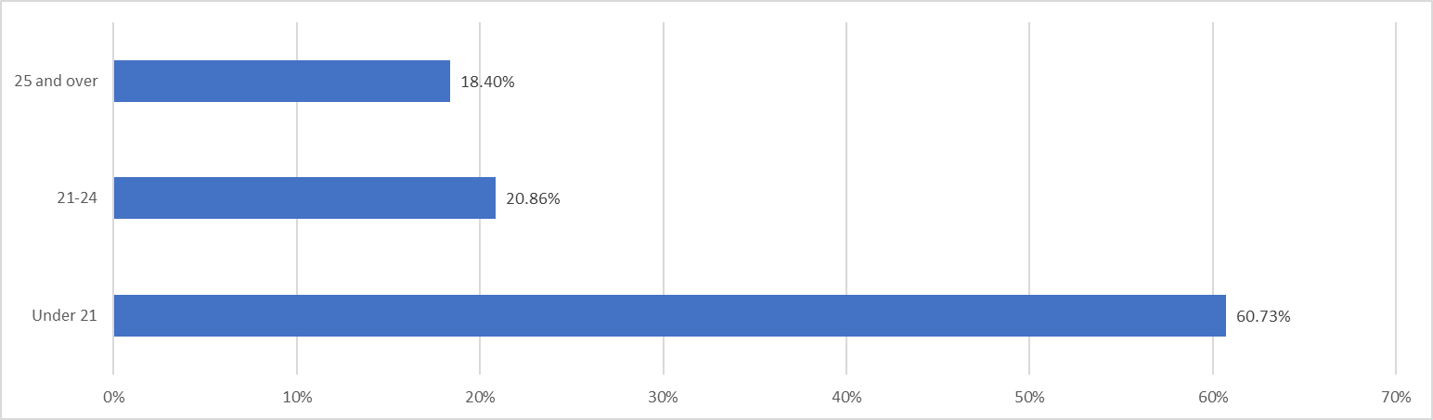

# **Protected Characteristic: Disability**

The table below shows all students by disability status and level of study.

|  |  |  |  |  |  |  |
| --- | --- | --- | --- | --- | --- | --- |
|  | **Undergraduate** | | **Postgraduate Taught** | | **Postgraduate Research** | |
|  | Number | Percentage | Number | Percentage | Number | Percentage |
| **Learning difficulties** | 1,127 | 3.00% | 239 | 0.64% | 117 | 0.31% |
| **Long-standing illness** | 470 | 1.25% | 149 | 0.40% | 89 | 0.24% |
| **Mental health difficulties** | 1,237 | 3.29% | 227 | 0.60% | 106 | 0.28% |
| **Physical disabilities** | 49 | 0.13% | 24 | 0.06% | 14 | 0.04% |
| **Sensory disabilities** | 142 | 0.38% | 43 | 0.11% | 27 | 0.07% |
| **Social impairments** | 527 | 1.40% | 138 | 0.37% | 95 | 0.25% |
| **Other disabilities** | 318 | 0.85% | 88 | 0.23% | 26 | 0.07% |
| **Information not provided** | 274 | 0.73% | 120 | 0.32% | 38 | 0.10% |
| **No known disability** | 19,869 | 52.91% | 9,477 | 25.24% | 2,519 | 6.71% |

The bar chart below shows all students by disability status.

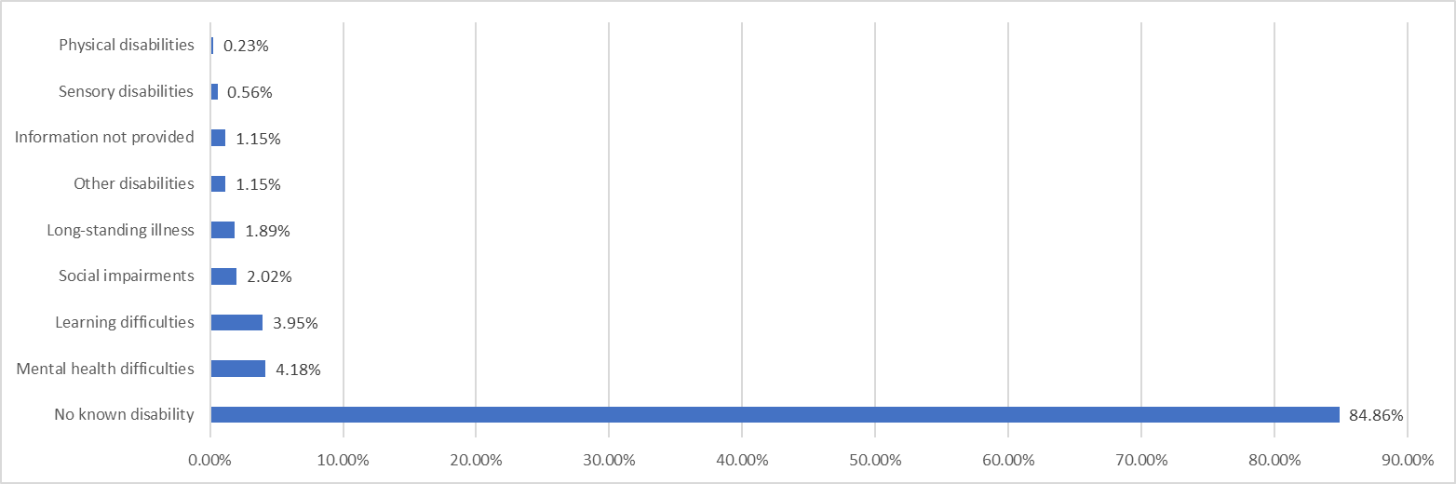

# **Protected Characteristic: Gender Reassignment**

The table below shows all students by gender identity and level of study.

|  |  |  |  |  |  |  |
| --- | --- | --- | --- | --- | --- | --- |
|  | **Undergraduate** | | **Postgraduate Taught** | | **Postgraduate Research** | |
|  | Number | Percentage | Number | Percentage | Number | Percentage |
| **Cisgender** | 23,477 | 62.53% | 10,201 | 27.17% | 2,910 | 7.75% |
| **Gender identity differs from assigned sex at birth** | 228 | 0.61% | 57 | 0.15% | 35 | 0.09% |
| **Prefer not to say** | 307 | 0.82% | 246 | 0.66% | 86 | 0.23% |

The bar chart below shows all students by gender identity.

The University do not collect or hold specific data in relation to students who have undergone a gender reassignment process, as defined by the Equality Act 2010 under the protected characteristic of “gender reassignment”. We do hold data on students’ “gender identity”. This will include students who fall within the Equality Act protected characteristic of “gender reassignment” and students who do not.

# **Protected Characteristic: Race**

|  |  |  |  |  |  |  |
| --- | --- | --- | --- | --- | --- | --- |
|  | **Undergraduate** | | **Postgraduate Taught** | | **Postgraduate Research** | |
| Number | Percentage | Number | Percentage | Number | Percentage |
| **Asian or Asian British - Bangladeshi** | 567 | 1.51% | 120 | 0.32% | 17 | 0.05% |
| **Asian or Asian British - Indian** | 2,386 | 6.35% | 1,179 | 3.14% | 167 | 0.44% |
| **Asian or Asian British - Pakistani** | 1,560 | 4.15% | 325 | 0.87% | 59 | 0.16% |
| **Chinese** | 2,760 | 7.35% | 3,963 | 10.55% | 471 | 1.25% |
| **Other Asian background** | 994 | 2.65% | 394 | 1.05% | 171 | 0.46% |
| **Black or Black British - African** | 1,678 | 4.47% | 471 | 1.25% | 122 | 0.32% |
| **Black or Black British - Caribbean** | 243 | 0.65% | 97 | 0.26% | 22 | 0.06% |
| **Other Black background** | 112 | 0.30% | 62 | 0.17% | N/A | N/A |
| **Mixed** | 1,272 | 3.39% | 273 | 0.73% | 121 | 0.32% |
| **White** | 10,554 | 28.11% | 3,183 | 8.48% | 1,562 | 4.16% |
| **Other ethnicity** | 816 | 2.17% | 294 | 0.78% | 233 | 0.62% |
| **Unknown ethnicity** | 1,071 | 2.85% | 144 | 0.38% | 79 | 0.21% |

The table below shows all students by race and level of study.

The bar chart below shows all students by race.

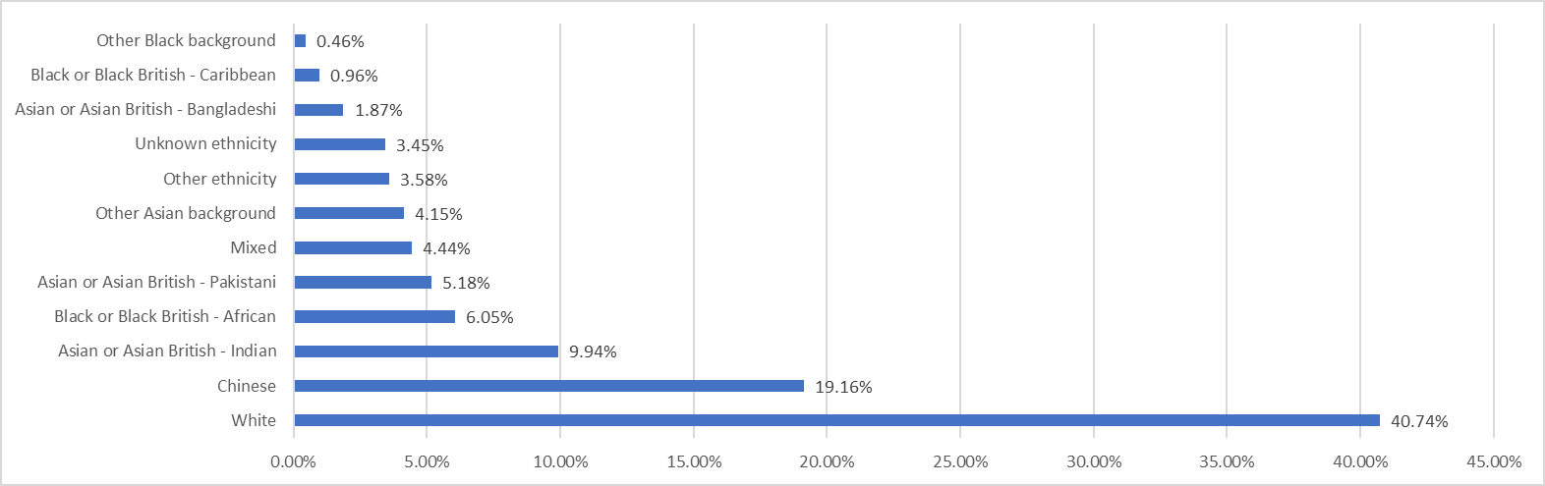

# **Protected Characteristic: Religion or Belief**

The table below shows all students by religion or belief and level of study.

|  |  |  |  |  |  |  |
| --- | --- | --- | --- | --- | --- | --- |
|  | **Undergraduate** | | **Postgraduate Taught** | | **Postgraduate Research** | |
|  | Number | Percentage | Number | Percentage | Number | Percentage |
| **Bahai** | N/A | N/A | N/A | N/A | N/A | N/A |
| **Buddhist** | 260 | 0.69% | 95 | 0.25% | 43 | 0.11% |
| **Christian** | 4,703 | 12.52% | 1,860 | 4.95% | 620 | 1.65% |
| **Hindu** | 964 | 2.57% | 664 | 1.77% | 98 | 0.26% |
| **Jain** | 30 | 0.08% | N/A | N/A | N/A | N/A |
| **Jewish** | 380 | 1.01% | 11 | 0.03% | 21 | 0.06% |
| **Muslim** | 3,823 | 10.18% | 1,028 | 2.74% | 401 | 1.07% |
| **Sikh** | 914 | 2.43% | 109 | 0.29% | 34 | 0.09% |
| **Spiritual** | 149 | 0.40% | 85 | 0.23% | 35 | 0.09% |
| **Any other religion or belief** | 139 | 0.37% | 90 | 0.24% | 32 | 0.09% |
| **No Data** | 23 | 0.06% | 27 | 0.07% | N/A | N/A |
| **No religion or belief** | 11,206 | 29.84% | 5,705 | 15.19% | 1,505 | 4.01% |
| **Prefer not to say** | 1,421 | 3.78% | 823 | 2.19% | 241 | 0.64% |

The bar chart below shows all students religion or belief.

# **Protected Characteristic: Sex**

The table below shows all students by sex and level of study.

|  |  |  |  |  |  |  |
| --- | --- | --- | --- | --- | --- | --- |
|  | **Undergraduate** | | **Postgraduate Taught** | | **Postgraduate Research** | |
|  | Number | Percentage | Number | Percentage | Number | Percentage |
| **Female** | 13,571 | 36.14% | 5,956 | 15.86% | 1,633 | 4.35% |
| **Male** | 10,360 | 27.59% | 4,541 | 12.09% | 1,386 | 3.69% |
| **Other** | 82 | 0.22% | N/A | N/A | 12 | 0.03% |

The bar chart below shows all students by sex.

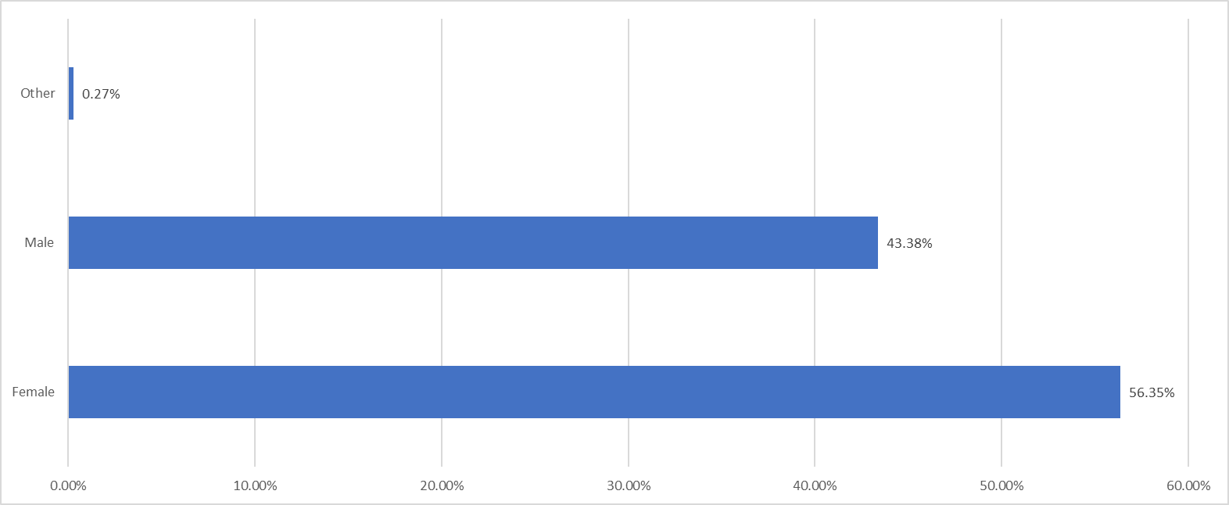

# **Protected Characteristic: Sexual Orientation**

The table below shows all students by sexual orientation and level of study.

|  |  |  |  |  |  |  |
| --- | --- | --- | --- | --- | --- | --- |
|  | **Undergraduate** | | **Postgraduate Taught** | | **Postgraduate Research** | |
|  | Number | Percentage | Number | Percentage | Number | Percentage |
| **Asexual** | 307 | 0.82% | 48 | 0.13% | 19 | 0.05% |
| **Bisexual** | 1,358 | 3.62% | 387 | 1.03% | 210 | 0.56% |
| **Gay man** | 219 | 0.58% | 103 | 0.27% | 58 | 0.15% |
| **Gay woman/lesbian** | 235 | 0.63% | 95 | 0.25% | 46 | 0.12% |
| **Heterosexual** | 19,092 | 50.85% | 8,219 | 21.89% | 2,224 | 5.92% |
| **Queer** | 265 | 0.71% | 32 | 0.09% | 21 | 0.06% |
| **Other** | 183 | 0.49% | 103 | 0.27% | 45 | 0.12% |
| **No data** | 25 | 0.07% | 27 | 0.07% | N/A | N/A |
| **Prefer not to say** | 2,329 | 6.20% | 1,491 | 3.97% | 407 | 1.08% |

The bar chart below shows all students by sexual orientation.