Development Needs Analysis (GRS1)

“Planning your personal development is key to developing as a researcher and progressing on your chosen career path. Vitae’s Researcher Development Framework is a powerful tool for identifying and prioritising the training you need.”   
– *Professor Jessica Blair, Director of Doctoral School*

This Development Needs Analysis (DNA) form uses [Vitae](https://www.vitae.ac.uk/)’s [Researcher Development Framework](https://www.vitae.ac.uk/researchers-professional-development/about-the-vitae-researcher-development-framework) (RDF) to help you reflect on what you can already do (your strengths) and areas where there is a need to improve your skills (your development needs). As part of this, you will create a personal development plan (PDP).

You can find advice on completing this form in Appendix 1, guidance on navigating the RDF in Appendix 2, and suggested development activities listed by RDF sub-domain on the [University Graduate School’s webpages](https://intranet.birmingham.ac.uk/PGRTraining). Some examples are also given in the form (in italics) to help you – edit these to fit your circumstances or delete these, as appropriate.

# Reflecting on your strengths

Choose at least one descriptor from each domain of the RDF where you have recent experience and record evidence of your ability in this descriptor. Focus on a specific example from the last 12 months, outlining the situation you were in, the actions you took, and the outcome. The actions you took may, but will not necessarily, include training. Your example can come from your research or from any other academic, professional, or social activity, provided it demonstrates a skill which is transferrable to research and is therefore represented in the RDF.

## RDF Domain: Researcher

|  |  |
| --- | --- |
| **RDF Descriptor(s)** | **The situation you were in, the actions you took and the outcome** |
|  |  |
|  |  |

## RDF Domain: Research

|  |  |
| --- | --- |
| **RDF Descriptor(s)** | **The situation you were in, the actions you took and the outcome** |
| *3.1 Funding and finance* | *I worked in a team with two PGR colleagues to organise a research colloquium.*  *I collaborated on writing the funding application which involved making a convincing case as to why the event was needed and accurately estimating the cost of the event. This led to us successfully being awarded £500 from the PGR Development Fund. Through this experience, I demonstrated commercial awareness by making a case as to how the event would meet the department’s goals, as well as the ability to contribute towards a successful funding proposal.*  *I was additionally responsible for ensuring that the event ran to budget, using a spreadsheet to keep track of catering, honorarium, and equipment costs. The event was delivered within the tight £500 budget demonstrating my ability to carry out basic financial management.* |
|  |  |
|  |  |

## RDF Domain: Research Communities

|  |  |
| --- | --- |
| **RDF Descriptor(s)** | **The situation you were in, the actions you took and the outcome** |
|  |  |
|  |  |

# Personal Development Plan

## RDF Domain: Researcher

Personal and professional values and behaviours

| **RDF Descriptor** | **Planned activity** | **What will I achieve?** | **Support / resources** | **Deadline** |
| --- | --- | --- | --- | --- |
|  |  |  |  |  |
|  |  |  |  |  |
|  |  |  |  |  |

## RDF Domain: Research

Knowledge and skills to undertake research and deliver outcomes

### RDF Sub-domain 2: Knowledge and practice

| **RDF Descriptor** | **Planned activity** | **What will I achieve?** | **Support / resources** | **Deadline** |
| --- | --- | --- | --- | --- |
| *2.3 Information and data literacy* | *Attend a workshop/online course on data management planning*  *Write a data management plan (DMP)* | *My DMP is signed off by my supervisor for GRS3* | *Library Services’* [*workshops*](https://intranet.birmingham.ac.uk/as/studentservices/graduateschool/skills/training/Data-Management-Plans-for-Postgraduate-Researchers.aspx) *and* [*Canvas course*](https://canvas.bham.ac.uk/enroll/CHEEPR)  *My supervisor* | *Within 9 months of programme start date* |
|  |  |  |  |  |
|  |  |  |  |  |
|  |  |  |  |  |

### RDF Sub-domain 3: Research management

| **RDF Descriptor** | **Planned activity** | **What will I achieve?** | **Support / resources** | **Deadline** |
| --- | --- | --- | --- | --- |
| *3.5 Research integrity and ethics* | *Discuss ethical implications of project with supervisor*  *Attend appropriate ethics training, if available* | *I understand and apply relevant codes for ethical conduct of my research*  *My supervisor has applied for ethical approval for my research project* | *My supervisor and relevant* [*ethical review forms*](https://intranet.birmingham.ac.uk/finance/RSS/Research-Support-Group/Research-Ethics/Ethical-Review-Forms.aspx) | *Within 6 months of programme start date* |
|  |  |  |  |  |
|  |  |  |  |  |
|  |  |  |  |  |

### RDF Sub-domain 4: Engagement and impact

| **RDF Descriptor** | **Planned activity** | **What will I achieve?** | **Support / resources** | **Deadline** |
| --- | --- | --- | --- | --- |
|  |  |  |  |  |
|  |  |  |  |  |
|  |  |  |  |  |

## RDF Domain: Research Communities

Knowledge and skills to engage and work with others

| **RDF Descriptor** | **Planned activity** | **What will I achieve?** | **Support / resources** | **Deadline** |
| --- | --- | --- | --- | --- |
| *5.6 Networking* | *Build my social network amongst my peers* | *I have one or two peers I regularly share my experiences with for mutual benefit* | *PGR Community at Westmere* | *ongoing* |
|  |  |  |  |  |
|  |  |  |  |  |
|  |  |  |  |  |

These development activities:

* are in the best interest of the postgraduate researcher;
* require support/resources which are available;
* will be reviewed regularly, at least annually.

The postgraduate researcher is responsible for ensuring these development activities are carried out.

|  | **Name(s)** | **Date reviewed** |
| --- | --- | --- |
| Postgraduate researcher |  |  |
| Supervisor |  |  |
| Co-supervisor(s) |  |  |

# Appendix 1: How to complete the DNA

* You should complete the form in discussion with your supervisor.
* Reflect on your strengths and record these in the first section of the form.
* For each of the sub-domains of the RDF, identify a few (2-3) priority areas for development and the development activities that will enhance your abilities in these areas.
* The form provides space for you to indicate how you will know when you have achieved your goal for development in this area (“what will I achieve?”) and a space for when you want to achieve this by (“deadline”). This is to help you ensure your action plan activities are SMART (Specific, Measureable, Achievable, Relevant, Timely).
* The form also provides space for you to indicate the people and resources which will support you in meeting your development needs.

## Carrying out a personal skills gap analysis

Set out here is a systematic, step-wise approach to identifying your strengths and development needs and putting together your personal development plan for your DNA form. You’re welcome to follow this process to complete your form.

### Identify areas of priority

Think about the skills, knowledge and behaviours that a postgraduate researcher in your position would particularly need to possess during the next 12 months. [Vitae](https://www.vitae.ac.uk/)’s [Researcher Development Framework](https://www.vitae.ac.uk/researchers-professional-development/about-the-vitae-researcher-development-framework) (RDF) is there to help you do this, by articulating in 31 descriptors (in 3 domains and 5 sub-domains) the values, knowledge, and behaviours of effective researchers, as compiled following extensive interviews with researchers and other key stakeholders in research. It is suggested that you select two or three descriptors from each sub-domain of the RDF; this will ensure your development aims are realistic, and also that you are developing as a well-rounded researcher. Do not forget to include priorities which relate to your future intended career, as well as those which will support your current research activity.

### Make notes on your previous experience and skill in these areas

For each of the areas of priority that you have identified, write down examples of your previous activity in this area, being as specific as possible. This is an opportunity to acknowledge your existing abilities and recognise your strengths. Discuss these with your supervisor to ensure you have accurately reflected your current abilities. Record some/all of these in the “Reflecting on your strengths" section of the form.

### Set out clearly what you want to be able to achieve in these areas within the next 12 months

The key here is to be specific and realistic about the outcomes you are hoping for. What exactly will you achieve? For example, “I’d like to be better at communicating my research” could be more usefully articulated as “I want to be able to confidently present my research to a specialist audience via an oral presentation”. Again, your supervisor can support you in identifying realistic and relevant goals.

If you are referring to the full RDF to help you understand what progression in these areas might look like, please remember that the RDF applies to researchers across their entire research career, so as a general guideline, you will be looking to achieve phases 1 & 2 over the course of a doctoral research programme.

### Is there a gap between your existing skills and where you need to be?

Looking at your notes from steps 2 and 3, you should be able to identify whether or not you feel there is a development gap. If your previous experience indicates that you are already capable of achieving your aim without further development, that’s great – you can record this in the “Reflecting on your strengths" section of the form.

### Identify SMART development activities and any support you need to help you close the gap

When choosing development activities, remember to take account of your learning preferences and [what’s available to you](https://intranet.birmingham.ac.uk/student/graduateschool/pgr/skills/training-opportunities.aspx). Ensure that your activities are SMART:

**S**pecific – record this under “planned activity”  
**M**easureable – referring to step 3, record this under “what will I achieve?”  
**A**chievable – this should be built in from step 3  
**R**elevant – this should be built in from step 1  
**T**imely – record this under “deadline”

If you will need any support (e.g. from your supervisor) or resources (e.g. conference fee), record this under “support/resources”. Be as specific as possible.

# Appendix 2: Navigating the Researcher Development Framework

[Vitae](https://www.vitae.ac.uk/) is a non-profit programme working in partnership with the sector for relevant, inclusive and meaningful professional and career development for all those involved in research. Their [Researcher Development Framework](https://www.vitae.ac.uk/researchers-professional-development/about-the-vitae-researcher-development-framework) (RDF) is a nationally and internationally recognized document which sets out the values, knowledge, and behaviours of effective researchers. It has researchers at the centre, and research communities as the outer circle to recognise the nature of research as a shared endeavour.

## Overview

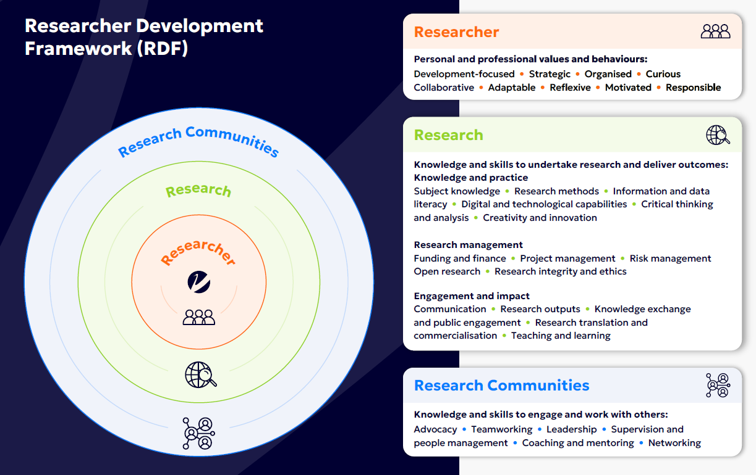

## Glossary

* **Domain**: one of the three top-level sections of the RDF – Researcher, Research, and Research Communities. The domains are concentric, with Researcher at the centre, Research encompassing the Researcher, and Research Communities encompassing all domains.
* **Sub-domain**: one of the five numbered sub-sections of the domains. The Researcher domain and sub-domain 1 are equivalent; the Research domain consists of three sub-domains, 2, 3 and 4; and the Research Communities domain and sub-domain 5 are equivalent.
* **Descriptor**: one of the 31 values, knowledge and behaviours of effective researchers. These descriptors are grouped according to themes and allocated to a domain/sub-domain.
* **Descriptor summary**: a brief statement giving an overview of the values, knowledge and behaviours encompassed by the descriptor. For a full understanding of a descriptor, review the detailed information in the phases for that descriptor.
* **Phase**: each descriptor contains up to four phases, representing distinct stages of development or levels of progression within that descriptor.

## Researcher Development Statement

|  |  |
| --- | --- |
| **Descriptor** | **Descriptor Summary** |
| **Researcher domain**: personal and professional values and behaviours | |
| 1.1 Development-focused | Takes ownership of professional development, acquiring and strengthening skills, and engaging in experiences across a range of chosen sectors to enhance employability. |
| 1.2 Strategic | Considers the contexts and landscapes in which research operates, developing strategic direction accordingly. |
| 1.3 Organised | Sets clear goals and objectives, plans and prioritises, conducts activities proactively and to time. |
| 1.4 Curious | Takes an inquiring, open, and imaginative approach. |
| 1.5 Collaborative | Actively engages with others to design, create and advance research and/or outcomes that can address complex issues and maximise impact. |
| 1.6 Adaptable | Is open, agile, and responsive to new ideas, ways of working, opportunities and solutions. |
| 1.7 Reflexive | Continuously examines own position, assumptions, motives and biases and how these influence approach. |
| 1.8 Motivated | Is a motivated, independent thinker, who is determined and committed to research. |
| 1.9 Responsible | Demonstrates responsible research practice, taking into account effects and potential impacts on participants, beneficiaries, society and the environment. |
| **Research domain**: knowledge and skills to undertake research and deliver outcomes | |
| **Sub-domain 2**: Knowledge and Practice | |
| 2.1 Subject knowledge | Develops knowledge of and contributes to research area and/or practice, the advances within it, and its relationship with other research areas and/or practice. |
| 2.2 Research methods | Develops knowledge of and is able to integrate suitable research methods, techniques and approaches, including interdisciplinary approaches where appropriate. Is able to explain and justify the chosen design and/or approach. |
| 2.3 Information and data literacy | Designs and implements techniques and systems to appropriately source, organise, synthesis, evaluate and manage information and data. |
| 2.4 Digital and technological capabilities | Uses existing and emerging technologies and tools as required for research, scholarly activity, dissemination and innovation. |
| 2.5 Critical thinking and analysis | Exhibits original, independent and critical thinking; analyses and evaluates information, research progress, data and findings. |
| 2.6 Creativity and innovation | Identifies new trends and creates opportunities to improve ideas, build knowledge and enhance outcomes. |
| **Sub-domain 3**: Research management | |
| 3.1 Funding and finance | Identifies funding mechanisms and income-generating opportunities, understands application processes, and adheres to funding agreements. |
| 3.2 Project management | Applies project management techniques to deliver research on time, within budget, and to agreed outcomes. |
| 3.3 Risk management | Effectively assesses and manages all risks related to a research project or activity. |
| 3.4 Open research | Makes research processes, results and outputs transparent and as freely accessible as possible, aiming to make research widely available and usable. |
| 3.5 Research integrity and ethics | Acts with integrity in all aspects of research governance. Recognises and addresses challenges in research design with rigour, honesty, transparency, and accountability; adheres to ethical, legal and professional standards. |
| **Sub-domain 4**: Engagement and impact | |
| 4.1 Communication | Uses suitable platforms, methods, and media to communicate research, ensuring language and approaches are tailored to target audiences. |
| 4.2 Research outputs | Develops and shares diverse outputs, practices, and activities to maximise the quality and impact of research. |
| 4.3 Knowledge exchange and public engagement | Shares knowledge to benefit policy, society, the environment and the economy through public engagement and other activities, ensuring mutual benefit through interaction and listening. |
| 4.4 Research translation and commercialisation | Identifies mechanisms and opportunities to transform ideas and outcomes into products, processes and services. |
| 4.5 Teaching and learning | Engages with and shares research through research-informed and/or -led teaching and supporting learning. |
| **Research Communities domain**: knowledge and skills to engage and work with others | |
| 5.1 Advocacy | Champions an inclusive, equitable, and supportive research culture where everyone's contribution is recognised. |
| 5.2 Teamworking | Leverages perspectives and skills of others, promotes shared ownership of research outcomes, fosters mutual respect and open communication. |
| 5.3 Leadership | Leads, motivates and influences where appropriate; sets expectations, delegates responsibilities, holds self and others accountable. |
| 5.4 Supervision and people management | Builds relationships and works with supervisees and/or line reports, interacting constructively and empathically to guide, support and empower. |
| 5.5 Coaching and mentoring | Supports others through sharing experiences and knowledge for their benefit. Uses coaching techniques to support others to develop specific skills or reach goals. |
| 5.6 Networking | Proactively builds and sustains networks to support professional and career development, fosters inclusive research communities and mutually beneficial connections. |